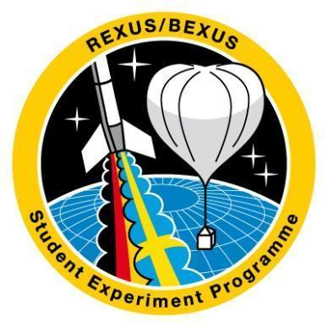



**SED**

**Student Experiment Documentation**

Document ID: RXBX_SED template_v6-3_25Aug23

**Mission: BEXUS 34**

**Team Name: SpiCy**

Experiment Title: Stratospheric investigation on combinatory Cyanobacterial biofilms

| **Team** | **Name** | **University** |
| --- | --- | --- |
| Student Team Leader: | Ilana Schürmeyer | Ludwig Maximilians University Munich (LMU) |
|  | Alexander Kubryk  Jacqueline Wiethaler  Pablo Martin Carillero  Jayanth Narra  Tian Lan  Eva-Maria Sontag  Elias Eggenberger  Fynn Gewiese  Sibtain Ali Thepdawala  Amanda Clot  Runjia Zhao | LMU  LMU  Technical University Munich (TUM)  TUM  TUM  University of Applied Sciences Munich (HM)  HM  HM  TUM  HM  TUM |

| Version: | Issue Date: | Document Type: | Valid from: |
| --- | --- | --- | --- |
| **5** | **07 January 2025** | **SED** | **07 January 2025** |

Issued by:

**Team SpiCy**

Approved by:

**Prof. Gisela Detrell**

# Change Record

| **Version** | **Date** | **Changed chapters** | **Remarks** |
| --- | --- | --- | --- |
| **0** | 2023-Aug-25 | New Version | Blank Book 2023 |
| **1**  **1.1**  **2** | 2024-Jan-20  2024-Feb-09  2024-Mar-07  2024-Apr-10  2024-Apr-14  2024-Apr-14  2024-Apr-16  2024-Apr-17  2024-Apr-18  2024-Apr-19 | All  1.3; 1.4; 2.1; 2.2; 2.3; 2.4; 2.5; 3.1; 3.3.3; 4.5; 6.1.5;  1.5.2  1.1  1.5.3  3.5  6.1.2  6.1.4  6.1.5  7.1  Preface  1.5.2  2.1  4.2.4  3.3.2  5.1  Whole doc  6.1  3.4; Appendix B  1.1; 1.4;  7.5  3.5  1.6  3.1  3.3.3  4.4  4.6  6.3.1  1.5.2  B.2.4  B.3.1  B.3.3  C  5.1  5.2  4.2.1 | **PDR**  post-PDR feedback  Changes are underlined with yellow color  Some Editorial edits have been shifted, need a rework (i.e. table of contents)  **CDR**  Team picture  Updated team member list  Minor changes  Member Restructuration  PE10 Mitigation Action adjusted  Launch risks added  Launch site requ. added  Flight requirements added  New bacterial strains and media added, minor changes  Minor changes  Role adjustment  Requirements revised  Thermal interfaces revised  Budget Plan  STR-002 update  Page numbers  Dimensions updated  Full update on outreach  Updated promising strains and minor changes to sc. background  Added changes in Concept  Updates on new lessons learned  Changed some risk assessments  Prof. Detrell´s picture added  Workload Schedule and SCRUM added  Supporters added  Mechanical part has been revised. Pictures were added.  Complete Motherboard Software/Hardware rework.  updated electronic interface  Changed Team Member pictures  Added section website  Added section posters  Added section wearables  added sensors and PROFETs  Added verification matrix  Complete verification plan  Added mechanical interfaces |
| **3** |  | 1.3  1.5.2  2  3.1  3.2  3.3.1  3.3.2  3.3.3  3.4  3.5  4.1  4.2.1  4.3  4.4  4.5  4.6  4.7  4.8  4.9  5.1  5.2  5.3  6.1.2  6.1.3  6.1.4  6.1.5  6.2  6.3  6.4  B.3.2  B.4  C | **IPR**  Team list update  Objective updated according to CDR remark  Team members and roles  Additional verification methods  Requirements updated  New Work Breakdown Structure  Updated Gantt chart  Manpower w/ all team members  Expenses updated  Updated sponsors list  Minor additions  Risk register w/ CDR remarks  Setup specifications added  Fixation methods specified  Experiment dimensions update  Mechanical design refinement  Hardware specifications  Thermal design rework  Updated power budget  Biological experiment design  Software updates  Verifications updated  Verification plan remodel  Verification results added  Safety risks elaborated  Electrical interfaces specified  Added launch site requirements  Flight requirements adjusted  Minor changes  Timeline specified  Post flight outreach added  New sticker design  Recent outreach events added  Oxygen sensor information |
| **4** | 2024-Aug-26 | 1.1  1.5.3  3.1  3.2  3.3.2  4.2  4.3  4.4  4.5  4.6  4.7  4.8  4.9  5  6.1  6.2  6.4  Appendix A  Appendix B  Appendix C  Appendix D  Appendix E | **EAR, Pre-Campaign**  Extended introduction  Previous members edited  WBS extended acc.to IPR  Schedule update  Expenses and budget update  Gondola fixation detailed  Minor updates  Total mass update  Mechanical design updates  Cable management  Inrush current limiter  Thermal testing added  Power systems elaboration  Major software redesign  Add. chapter: Biological exp..  Testing updated  Mass update  Flight requ. justifications  Timeline refined  Added Recovery instructions  Review Reports added  Outreach updates  MSDS  protocol for bac. Medium  Extended Gantt chart moved  Assembly checklist added |
| **5** | 2025-Jan-03 | All chapters  All chapters  All chapters  Abstract  1.1  1.4  1.5.2  3.3.2  4.5  4.6.8  4.9  5.1  7.2  7.3  7.4  7.5  8.1  B.3.1  B.3.2  C  D | **Final report**  Figure naming update  Minor grammatical updates  Past tense  Results added  Best candidates upd.  Flight samples detailed  Fig.1.5-2 added  Roles updated  Expenses finalized  PCB design process  Processor selection  Tvac test results  Sample prep explained  Final verification matrix + plan  Launch Campaign report  Results, analysis + outlook  No Campaign rep. input  Summary of Lessons Learned  Abbreviations added  Poster creation  New logo + stickers design  Biological preparation added  Updated Gantt chart |

**Keywords:** REXUS or BEXUS, SED - Student Experiment Documentation, cyanobacteria, oxygen production, human space flight, oxygen supply, SpiCy, biofilm

*Please keep the change record as detailed as possible. It helps the organisers to review your SED in a shorter time as well as you to keep track of your changes throughout the programme.   
When updating chapters, instead of saying chapter 1, state sections chapter 1.1. and so on for technical changes (design, numbers, status…). For linguistic changes you might write “minor changes in chapter 1/ throughout the document” etc…****We require you to additionally highlight changes you made from the last issue in a light colour (e.g. yellow) in addition to the regular version.***

Contents

Change Record 3

Preface 10

Abstract 11

1 Introduction 12

1.1 Scientific/Technical Background 12

1.2 Mission Statement 14

1.3 Experiment Objectives 14

1.4 Experiment Concept 14

1.5 Team Details 16

1.5.1 Contact Point 16

1.5.2 Team Members 17

2 Experiment Requirements and constraints 21

2.1 Functional Requirements 21

2.2 Performance Requirements 22

2.3 Design Requirements 22

2.4 Operational Requirements 24

2.5 Constraints 25

3 Project Planning 26

3.1 Work Breakdown Structure (WBS) 26

3.2 Schedule 27

3.3 Resources 28

3.3.1 Manpower 28

3.3.2 Budget 28

3.3.3 External Support 31

3.4 Outreach Approach 32

3.5 Risk Register 35

4 Experiment Description 38

4.1 Experiment Setup 38

4.2 Experiment Interfaces 40

4.2.1 Mechanical 40

4.2.2 Electrical 42

4.2.3 Thermal (optional) 42

4.3 Experiment Components 42

4.4 Mechanical Design 44

4.5 Electronics Design 51

4.5.1 Hardware 51

4.6 Thermal Design 66

4.6.1 Goals 66

4.6.2 Boundary Conditions 66

4.6.3 Heat Transfer Model 66

4.6.4 Equilibrium Analysis 70

4.6.5 Mission Envelope Analysis 72

4.6.6 Dynamic Analysis 73

4.6.7 PI Controller 76

4.7 Power System 82

4.8 Software Design 85

4.9 Biological Experiment Design 103

4.10 Ground Support Equipment 106

4.11 Changes from Former Flight (for Re-Flights only) 106

5 Experiment Verification and Testing 107

5.1 Verification Matrix 107

5.2 Verification Plan 112

5.3 Verification Results 123

6 Launch Campaign Preparation 129

6.1 Input for the Campaign / Flight Requirement Plans 129

6.1.1 Dimensions and Mass 129

6.1.2 Ground and Flight Safety Risks 130

6.1.3 Electrical Interfaces 130

6.1.4 Launch Site Requirements 131

6.1.5 Flight Requirements 132

6.1.6 Accommodation Requirements 132

6.2 Preparation and Test Activities at Esrange 133

6.3 Timeline for Countdown and Flight 135

6.4 Post-Flight Activities 135

7 Data Analysis And Results 137

7.1 Data Analysis Plan 137

7.2 Launch Campaign 138

7.3 Results 138

7.4 Input to Campaign Report 138

7.5 Lessons Learned 138

8 Abbreviations and References 140

8.1 Abbreviations 140

8.2 References 142

Appendix A - EXPERIMENT REVIEWS 145

Appendix B – OUTREACH AND MEDIA COVERAGE 175

Appendix C – ADDITIONAL TECHNICAL INFORMATION 188

Appendix D – EXTENDED GANTT CHART224

Appendix E – CHECKLISTS 227

# Preface

The REXUS/BEXUS programme is realized under a bilateral Agency Agreement between the German Aerospace Center (DLR) and the Swedish National Space Agency (SNSA). The Swedish share of the payload has been made available to students from other European countries through a collaboration with the European Space Agency (ESA). EuroLaunch, a cooperation between the Esrange Space Center of SSC and the Mobile Rocket Base (MORABA) of DLR, is responsible for the campaign management and operations of the launch vehicles. Experts from DLR, SSC, ZARM and ESA provide technical support to the student teams throughout the project. REXUS and BEXUS are launched from SSC, Esrange Space Center in northern Sweden.

SpiCy (Stratospheric investigation on combinatory cyanobacterial biofilms) is an experiment developed by a team of students from the Ludwig-Maximilians-University Munich, Technical University of Munich, and University of Applied Sciences Munich in Germany. Its aim is to test the photosynthetic rate of combinatory cyanobacterial biofilms when subject to increased ionizing and non-ionizing radiation levels. SpiCy is scheduled to fly aboard BEXUS 34 as part of cycle 15 of the Swedish-German program REXUS/BEXUS.

This document contains all relevant available information regarding SpiCy; including the experiment’s objectives and requirements, a breakdown of the experimental module’s design, design verification procedures, a timeline, plans for pre-launch campaign activities and post-flight results. Technical documents that pertain to the design are also included for reference, as appendix sections.

# Abstract

SpiCy (Stratospheric investigation of combinatory cyanobacterial biofilms) is a student-led mission to investigate the behavior of combinatory cyanobacterial biofilms under increased ionizing and non-ionizing radiation levels in the stratosphere to propose new alternatives of oxygen suppliance during space travel missions.

Cyanobacteria are among the oldest and most efficient photosynthetic organisms on planet Earth. They contribute 25% of the oxygen on Earth today and were crucial in forming our atmosphere in the early stages of Earth's development through oxygenation. As they are mostly aquatic or at least, need a certain degree of humidity, heterotrophic bacteria as a biofilm coordinator to mitigate their dependency are incorporated. These biofilms are a promising candidate in a plethora of space-related research (i.e. medicinal, life). Through forming adhesive biofilms, the bacteria are more resilient to radiation, thermal shocks, mechanical tearing and dry environments.

Project SpiCy intends to capitalize on the cyanobacterial ability to produce oxygen with minimum requirements and research their viability in long-term oxygen generation for human space flight and colonization missions.

The main finding of our experiment showed that pure culture *Nostoc sp.* oxygen production dropped immediately and significantly during flight in contrast to complementary cultured *Nostoc sp.* with *E. coli*. This is a first indication towards mediation of resilience in cocultivation and complementary formation of biofilms of cyanobacteria with heterotrophic bacteria.

# Introduction

## Scientific/Technical Background

Ever since a human entered space for the first time in 1961, humanity saw the possibility of a human presence in outer space. In order to achieve this goal, there must be implementations to improve duration and sustainability of elongated manned space missions. One of the major factors limiting the duration and thus distance from earth of a mission is oxygen supply for the crew.

Oxygen supply on the ISS is achieved through electrolysis of water. 40% of this water is derived from carbon dioxide breathed out by astronauts and cosmonauts on board via Sabatier reactors as well as from excreted waste waters. Since the oxygen derived from this is not enough to establish a sufficient oxygen level, additional freshwater tanks are delivered to the space station. This process is highly consuming of resources and energy and not suitable for further travel ambitions as the distances to other planets only exacerbate these problems. Life support systems on such vehicles must use a cyclic allocation of resources to simulate a steady earth-like environment without the need to provide them with a constant external supply. New ways of sustainable oxygen production on board a spacecraft need to be explored[1].

Approximately 2.4 billion years ago the earth's atmosphere had a low concentration of oxygen, so most organisms lived anaerobically. The rising population of the first phototrophic unicellular organisms, predecessors of today´s cyanobacteria performing photosynthesis, led to the Great Oxygenation Event (GOE)[2]. This oxygenation is thought to be one of the greatest extinction events in the history of the earth since the quickly rising high atmospheric oxygen levels were toxic for most microbes living at that time. The event fundamentally changed our atmosphere from a reducing to an oxidizing environment. This important step facilitated the evolution of aerobic organisms.

In photosynthesis, sunlight is used to fixate carbon dioxide and split water into electrons and oxygen, a process referred to as photolysis. This step is one step in an electron transport chain, commonly referred to as the light reaction, designed to produce ATP, the main energy carrier in organisms. The ATP molecules obtained through the electron transport chain provide energy for the dark reaction or Calvin-Benson-Basham Cycle in which carbon dioxide and further carbon hydrogen compounds are eventually synthesized into Glucose and Saccharides (i.e. Starch), the main energy storage for plants. The oxygen production is only a byproduct of this process.

The phylum of cyanobacteria uses photosynthetic pigments (i.e., carotenoids, chlorophyll A) and thylakoid membranes to perform oxygenic photosynthesis. They inhabit nearly every environment on earth and have specialized in various forms ranging from unicellular to filamentous growth patterns and from harmless to toxin-producing species[3]. They are small, can reproduce quickly, and need only a small amount of nutrients in comparison to plants. As they are prokaryotic, genetic modification (i.e., via plasmids) is generally easier than in eukaryotes. Various other substances can be produced by using the energy provided by photosynthesis[4]. As primary producers, select species of cyanobacteria are crucial contributors to marine life cycles.

Their ability to form biofilms is highly interesting for biotechnological applications. Biofilms are a consortium of microbes that use cell communication (quorum sensing) to produce a slimy adhesive extracellular matrix (EPS). This matrix consists of a conglomerate of various proteins, lipids, polysaccharides, and DNA. This composition allows the cells to function as a community where cells take on different functions in the complex.[5] This leads to an increased resilience towards low humidity, radiation, mechanical shearing, etc. As the formation of a biofilm is highly efficient for bacteria, they form very quickly and are most known as one of the biggest problems in industrial and medical systems (i.e., hydraulics, medical equipment, …). On the contrary, biofilms also have great potential to make cyanobacteria accessible as biocatalysts[6]. This was further investigated by *M. Bozan et al* when they researched bioreactor setups working with cyanobacteria for hydrogen production [7]. Here they used heterotrophic complements *Pseudomonas taiwanesis* and *E. coli* as biofilm coordinators in photobioreactors (PBR) to amplify the biomass of the composite cyanobacterial colonies. This idea is also tested for pre-colonization of surfaces with heterotrophic bacteria followed by an increased biofilm production of the cyanobacterial follow-up[8]. The complete inner workings of biofilm formation and sustainability are yet to be researched and are not fundamentally understood.

The viability of cyanobacterial biofilms for oxygen production depends on their ability to thrive in the extreme environment of space[1]. Most prominently constant ionizing and non-ionizing radiation from natural sunlight can lead to DNA damage, reproductive cyclic arrest, and release of harmful reactive oxygen species (ROS)[9]. On BEXUS, we want to evaluate the difference in survivability and oxygen production between cyanobacterial strands and combinatory strands with heterotrophic complements compared to laboratory tests on the ground.

The best performing strains in terms of survivability during high light exposure and oxygen production were determined through ground experiments. The strains tested were members of the Nostoc genus, Chroococcidiopsis cubana PCC 7433, Tolipothrix sp. PC 7712, Synechocystis sp. PCC 6803 and Synechococcus elongatus UTEX 2973 [10]. Promising biofilm-forming heterotrophic complements are members of the Pseudomonas phylum, Bacillus subtilis, Lactobacillus plantarum and Lactobacillus fermentum. However, since some of the more promising strains like Tolipothrix sp. PC 7712 are S2 while the laboratories at LMU and ESRANGE only allow S1 strains we decided to solely cultivate S1 bacterial strains.

In our experiment, the bacteria were cultivated in an aqueous medium. In summary, cyanobacteria are a strong contender for cyclic biological oxygen production.

## Mission Statement

Project SpiCy aims to investigate the viability of single-species and multi-species cyanobacterial biofilms for long-term cyclic life support systems regarding their oxygen production efficiency when stressed with constant ionising and non-ionising radiation of natural sunlight in the stratospheric environment.

## Experiment Objectives

| Obj. 1 | Technical | Manufacturing and conduction of experiment | Primary |
| --- | --- | --- | --- |
| Obj. 2 | Scientific | Measuring the photosynthesis to respiration rate of the biofilms | Primary |
| Obj. 3 | Scientific | Analysis of the EPS-matrix composition | Secondary |
| Obj. 4 | Scientific | Analysis of DNA, RNA and Proteins in comparison to ground levels. | Secondary |

## Experiment Concept

The experiment measures the oxygen concentration of different biological samples containing different biofilms and strains.

For this purpose, the system is made of different subsystems listed below:

* The biological samples are enclosed in test tubes exposed to natural sunlight. The cyanobacteria strain is Nostoc sp. Different heterotrophic bacteria were chosen for comparison. The flown samples are as follows:
  + 1x *Nostoc sp.* + *Bacillus subtilis*
  + 1x *Nostoc sp.* + *Pseudomonas taiwanensis*
  + 1x *Nostoc sp.* + *Escherichia coli (newly formed biofilm)*
  + 1x *Nostoc sp.*
  + 1x *Nostoc sp.* + *Escherichia coli* (scraped established biofilm, in the following “scraped”)
  + 1x BG11 medium only as control sample
* Temperature sensors placed inside each tube, within the electrical compartment and in the sample compartment outside the tubes measure the temperature in each compartment of the experiment.
* A UV sensor measures the UV radiation reaching the biological samples.
* Six oxygen sensors placed inside the tubes measure the dissolved oxygen concentration within each respective tube over the duration of the experiment.
* Heating elements (Kapton heaters) are wrapped around the tubes to ensure the fulfillment of the temperature requirement.

All electronic components are connected to a custom-built PCB. It features a microcontroller which houses the software architecture. All essential functionalities such as thermal control, data acquisition, and uplink/downlink communication processes are implemented here. The sensor readout component efficiently gathers and processes data from embedded sensors. Oxygen sensor and thermal sensor data points are sent to the ground station consisting of a tech stack via downlink where it is plotted and may be filtered for easy analysis. A PI controller adjusts the heater temperature to stabilize the temperature by measuring the temperature continuously and activating/deactivating the heaters one tube at a time accordingly. The top of the module consists of a translucent quartz-glass ceiling, allowing UV radiation to pass into the module. The casing of the module is built with aluminum profiles and an aluminum bottom plate to fix the module into the gondola. Styrofoam is used to thermally isolate the module on each of the non-translucent sides, as well as to separate/compartmentalize the electronics bay and the biological samples.

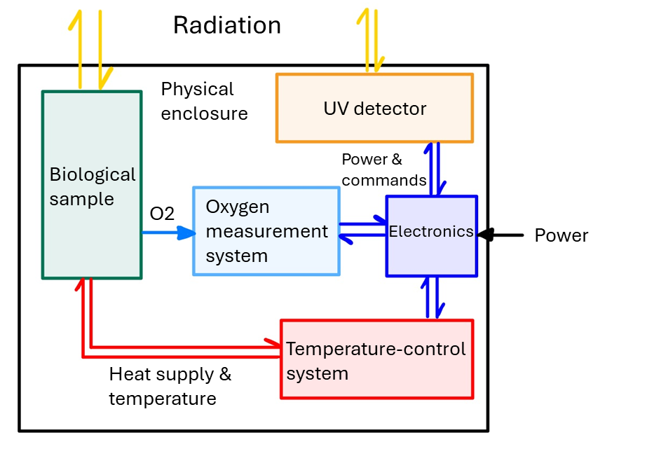

Figure 1.4-1: Outline of experiment concept

## Team Details

### Contact Point

Team E-Mail: spicy-bexus@bio.lmu.de

Contact point endorsing professor: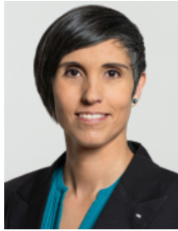

**Prof. Dr. Gisela Detrell**

[gisela.detrell@tum.de](mailto:gisela.detrell@tum.de)

Technische Universität München (TUM)

Department Human Spaceflight Technology

Lise-Meitner-Str. 8

85521 Ottobrunn (Germany)

Contact point student:

Ilana Schürmeyer

[ilana.sch1411@gmail.com](mailto:ilana.sch1411@gmail.com)

Implerstr. 10

81371 München (Germany)

Tel: 0176 84220520

### Team Members

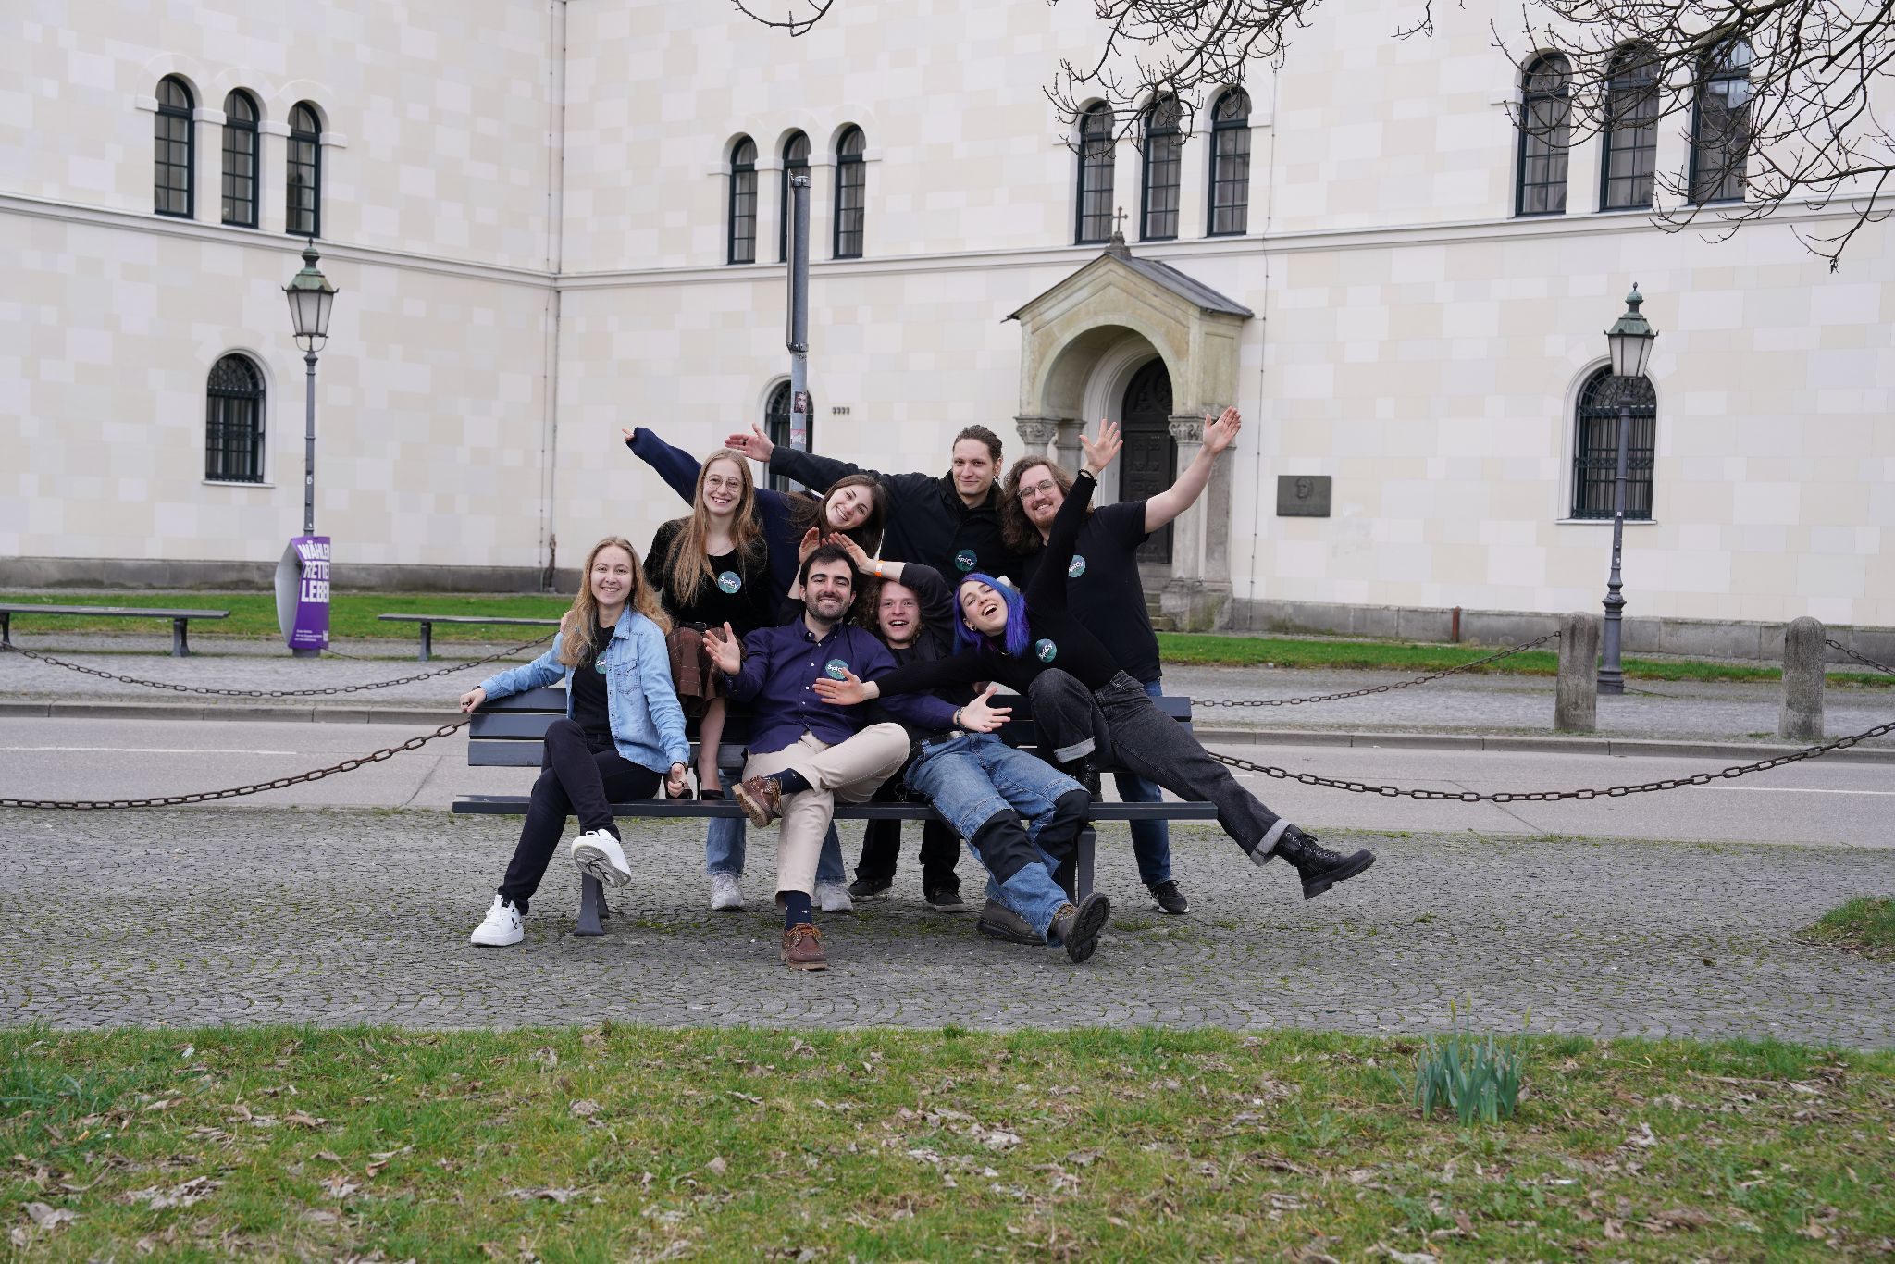Fig Fig. 1.5-1: SpiCy Team Picture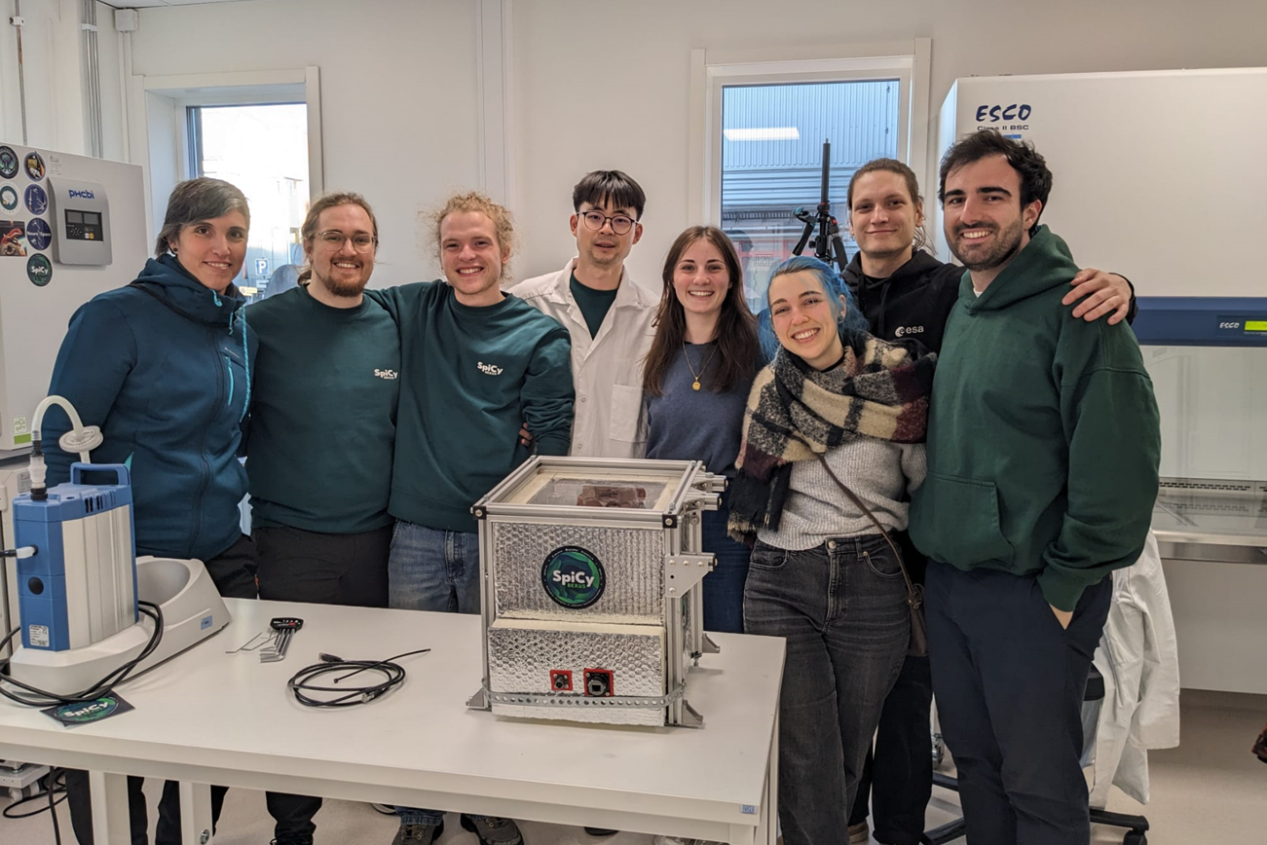

Fig. 1.5-2: SpiCy team picture with module after recovery

| **Project Management** | | |
| --- | --- | --- |
|  | **Ilana Schürmeyer**  Biology BSc, LMU  Date of onboarding: 2023-Jun-19 | **Roles:**  Project Management,  Biological Research  SCRUM Master |
| **Biology** | | |
|  | **Alexander Kubryk**  Biology BSc, LMU  Date of onboarding: 2023-Jun-19 | **Roles:**  Biological Lead Experimental Design  Assistant Project Manager |
|  | **Jacqueline Wiethaler**  Biology BSc, LMU  Biological Technical Assistant  Date of onboarding: 2023-Jun-19 | **Roles:** Laboratory Lead, Biological research |
| **Mechanical Engineering** | | |
|  | **Tian Lan**  MSc Aerospace Engineering, TUM  Date of onboarding: 2023-Jul-18 | **Roles:**  Experimental Design, CAD, Manufacturing, Mechanical & Sealing Solution |
|  | **Runjia Zhao**  MSc Aerospace Engineering, TUM  Date of onboarding: 2024-06-01 | **Roles:**  Experimental Design, CAD |
| **Thermal Engineering** | | |
|  | **Pablo Martín Carrilero**  MSc Aerospace Engineering, TUM  Date of onboarding: 2023-Jun-19 | **Roles:** Thermal Analysis, Control Engineering  SCRUM Product Owner |
| **Systems Engineering** | | |
|  | **Sibtain Ali Thepdawala**  MSc Aerospace Engineering at TUM  Date of onboarding: 2023-Dec-22 | **Roles:**  Systems Engineering |
|  | **Jayanth Narra**  MSc Aerospace Engineering at TUM  Date of onboarding: 2023-Jul-18 | **Roles:**  Systems Engineering |
| **Electronics** | | |
|  | **Fynn Gewiese**  BSc Electrical Engineering  at HM  Date of onboarding: 2023-Dec-18 | **Roles:**  Electrical Design,  Embedded Software, Downlink Communication |
| **Software** | | |
|  | **Elias Eggenberger**  BSc Software and Design at HM  Date of onboarding: 2024-Feb-24 | **Roles:**  Ground Station, Data Visualisation, SCRUM Implementation |
| **Outreach** | | |
|  | **Eva-Maria Sontag**  BA Communication Design at HM  Date of onboarding: 2023-Aug-08 | **Roles:**  Brand Identity, Social Media Management |
|  | **Amanda Clot**  BA Communication Design at HM  Date of onboarding: 2024-Feb-17 | **Roles:**  Website Development, Print and Apparel Design, Event Management |

**1.5.3 Previous Team Members**

|  | **Antonia Steinhoff**  BA Communication Sciences at LMU  Time of membership: 2023-Jul-13 to 2023-Dec-17 | **Roles:**  Social Media Appearance, Presentations |
| --- | --- | --- |
|  | **Alexander Ens**  Biology BSc at LMU  Time of membership: 2024-Dec-19 to 2024-Mar-10 | **Roles:**  Biological Research |

# Experiment Requirements and constraints

## Functional Requirements

| **Req. ID** | **Description** | **Verification Methods** |
| --- | --- | --- |
| F.1 | The biofilms shall be exposed to natural sunlight. | I,T, R |
| F.2 | The experiment shall measure the dissolved oxygen levels in the medium | A, T |
| F.3 | The experiment shall measure the temperature inside the tubes. | A, T |
| F4 | The experiment shall measure the temperature outside of the tubes. | A, T |
| F.5 | The experiment shall measure the temperature of the electronic compartment. | A, T |
| F.6 | The experiment shall measure the UV light entering the module. | A, T |
| F.7 | The experiment shall save the recorded data of diluted oxygen. | A, T |
| F.8 | The experiment shall save the recorded temperature data. | A, T |
| F.9 | The experiment shall save the light transmission data. | A, T |
| F.10 | The experiment shall have biological control samples. | I, R |

## Performance Requirements

| **Req. ID** | **Description** | **Type** | **Verification Methods** |
| --- | --- | --- | --- |
| P.1 | The Oxygen sensors shall operate with an accuracy of 0.4 mg/l ± 0.009. | Performance | R, T |
| P.2 | The temperature shall be maintained within the range of -20 to 50°C. | Performance | T, A |
| P.3 | The thermal sensors shall operate with an accuracy of <=1°C. | Performance | R, T |
| P.4 | The thermal sensors shall operate with a response time of <=1 seconds. | Performance | R, T |
| P.5 | The light sensors shall measure the incoming light with an accuracy of ± 20nm. | Performance | R, T |
| P.6 | The Oxygen sensors shall operate with a sampling rate of <3 seconds. | Performance | R, T, A |

## 2.3 **Design Requirements**

| D.1 | The top side of the module shall allow UV light to pass through. | Design | R, T |
| --- | --- | --- | --- |
| D.2 | The tubes shall be hermetically sealed to prevent leakage. | Design | R, T |
| D.3 | The electronics bay shall be accessible externally. | Design | I, R |
| D.4 | The tubes inside the module shall have an exposure to natural sunlight for an elevation angle larger than 0 degrees. | Design | A |
| D.5 | The biofilms shall cover the flat surface of the tubes. | Design | I, R |
| D.6 | The temperature of the biofilm medium shall be maintained at 25-30°C. | Design | A, T |
| D.7 | The temperature of the electronic compartment shall be maintained within the operational temperature range of the hardware components. | Design | A, T |
| D.8 | The biological samples shall be S1. | Design | R |
| D.9 | The experiment shall not interfere with other BEXUS experiments. | Design | A, R |
| D.10 | The experiment shall withstand the loads during the flight. | Design | A, I, R, T |
| D.11 | The experiment shall withstand pressure differences during flight as defined in the BEXUS manual. | Design | R, T |
| D.12 | The experiment shall withstand temperature differences during flight as defined in the BEXUS manual. | Design | R, T |
| D.13 | The experiment shall withstand the loads during the landing. | Design | A, I, R, T |
| D.14 | The experiment shall be compatible with the BEXUS vehicle. | Design | I, R |
| D.15 | The experiment shall provide an interface for power and LAN. | Design | I, R, T |
| D.16 | The experiment shall be grounded with the power connector. | Design | R, T |
| D.17 | The experiment shall work within the ambient temperature range of -60 to +30°C. | Design | R, T |
| D.18 | The experiment shall stay within the mass budget of 8kg. | Design | T |
| D.19 | The experiment dimensions shall not exceed 340x340x300mm. | Design | I, T |
| D.20 | The electronic system power consumption shall operate within the BEXUS power supply range. | Design | A, R, T |
| D.21 | The experiment shall operate within the BEXUS voltage supply range. | Design | A, R, T |
| D.22 | The data rate shall be lower than 50 kb/s. | Design | A, T |
| D.23 | The electronics compartment shall be accessible independently from the biological experiment. | Design | I, R |
| D.24 | The sensor data shall be sent to the ground station in accordance to the data rate specified in D.22. | Design | A, T |
| D.25 | The frontend shall provide a function to evaluate the collected data in the oxygen plot. | Design | A, T |
| D.26 | The frontend shall provide a function to help evaluate the collected data in the temperature plot. | Design | A, T |
| D.27 | The system shall store raw data in a database. | Design | A, T |
| D.28 | The incoming data shall be live plotted on the ground station. | Design | A, T |
| D.29 | The plot shall check for new data at least every 3 seconds. | Design | A, T |
| D.30 | The software interface shall visualize the temperature data on the ground station. | Design | A,T |
| D.31 | The software interface shall visualize the oxygen data on the ground station. | Design | A,T |
| D.32 | The software of the ground station shall be structured in frontend, backend and database. | Design | R |

## 2.4 Operational Requirements

| O.1 | The biosafety protocols for handling the selected biofilms before and after flight shall be followed. | Operational | I,R |
| --- | --- | --- | --- |
| O.2 | The biofilms shall be cultivated inside of the Esrange laboratory. | Operational | I, R |
| O.3 | The biofilms shall be transferred inside of the Esrange laboratory. | Operational | I, R |
| O.4 | The experiment shall operate autonomously, without human intervention | Operational | T |
| O.4.1 | The system shall instantly start running and continue to function when connected to power supply | Operational | T |
| O.4.2 | The system shall instantly shut down when disconnected from power supply on retrieval | Operational | T |
| O.5 | The tube's temperature measurements shall be shared via Downlink with the Ground Station. | Operational | A, T |
| O.6 | The handling of bacteria shall comply with the safety regulations of the facilities they are handled in. | Operational | I, R |
| O.7 | The handling of bacteria shall comply with the rules for international exports posed by the German war weapons control act. | Operational | I, R |
| O.8 | The backend shall ensure continuous data processing and management in the event of receiving invalid requests. | Operational | A, T |
| O.9 | Operational documentation detailing the backend functionality shall be maintained and made available for user reference and system explanation. | Operational | R |
| O.10 | The plot interface shall alert if the temperature data are exceeding the tolerance range according to D.14, D.15. | Operational | A, T |
| O.11 | The software system shall feature a fault detection system. | Operational | A, T |
| O.12 | The system shall support retrieval and export of plotted data for further analysis and reporting. | Operational | A, T |

## 2.5 Constraints

| C.1 | The laboratory shall be accessible pre-/post-flight for cultivation, sampling and pre-analysis. |
| --- | --- |
| C.2 | The external environment post-flight may affect the retrieval of experiment setup. |
| C.3 | The duration for recovery may delay the further analysis of secondary objectives |
| C.4 | Low manpower during exam period may lead to delays in meeting deadlines. |
| C.5 | Low sunshine conditions at the launch site may reduce sunlight exposure of the bacteria significantly. |

# Project Planning

## Work Breakdown Structure (WBS)

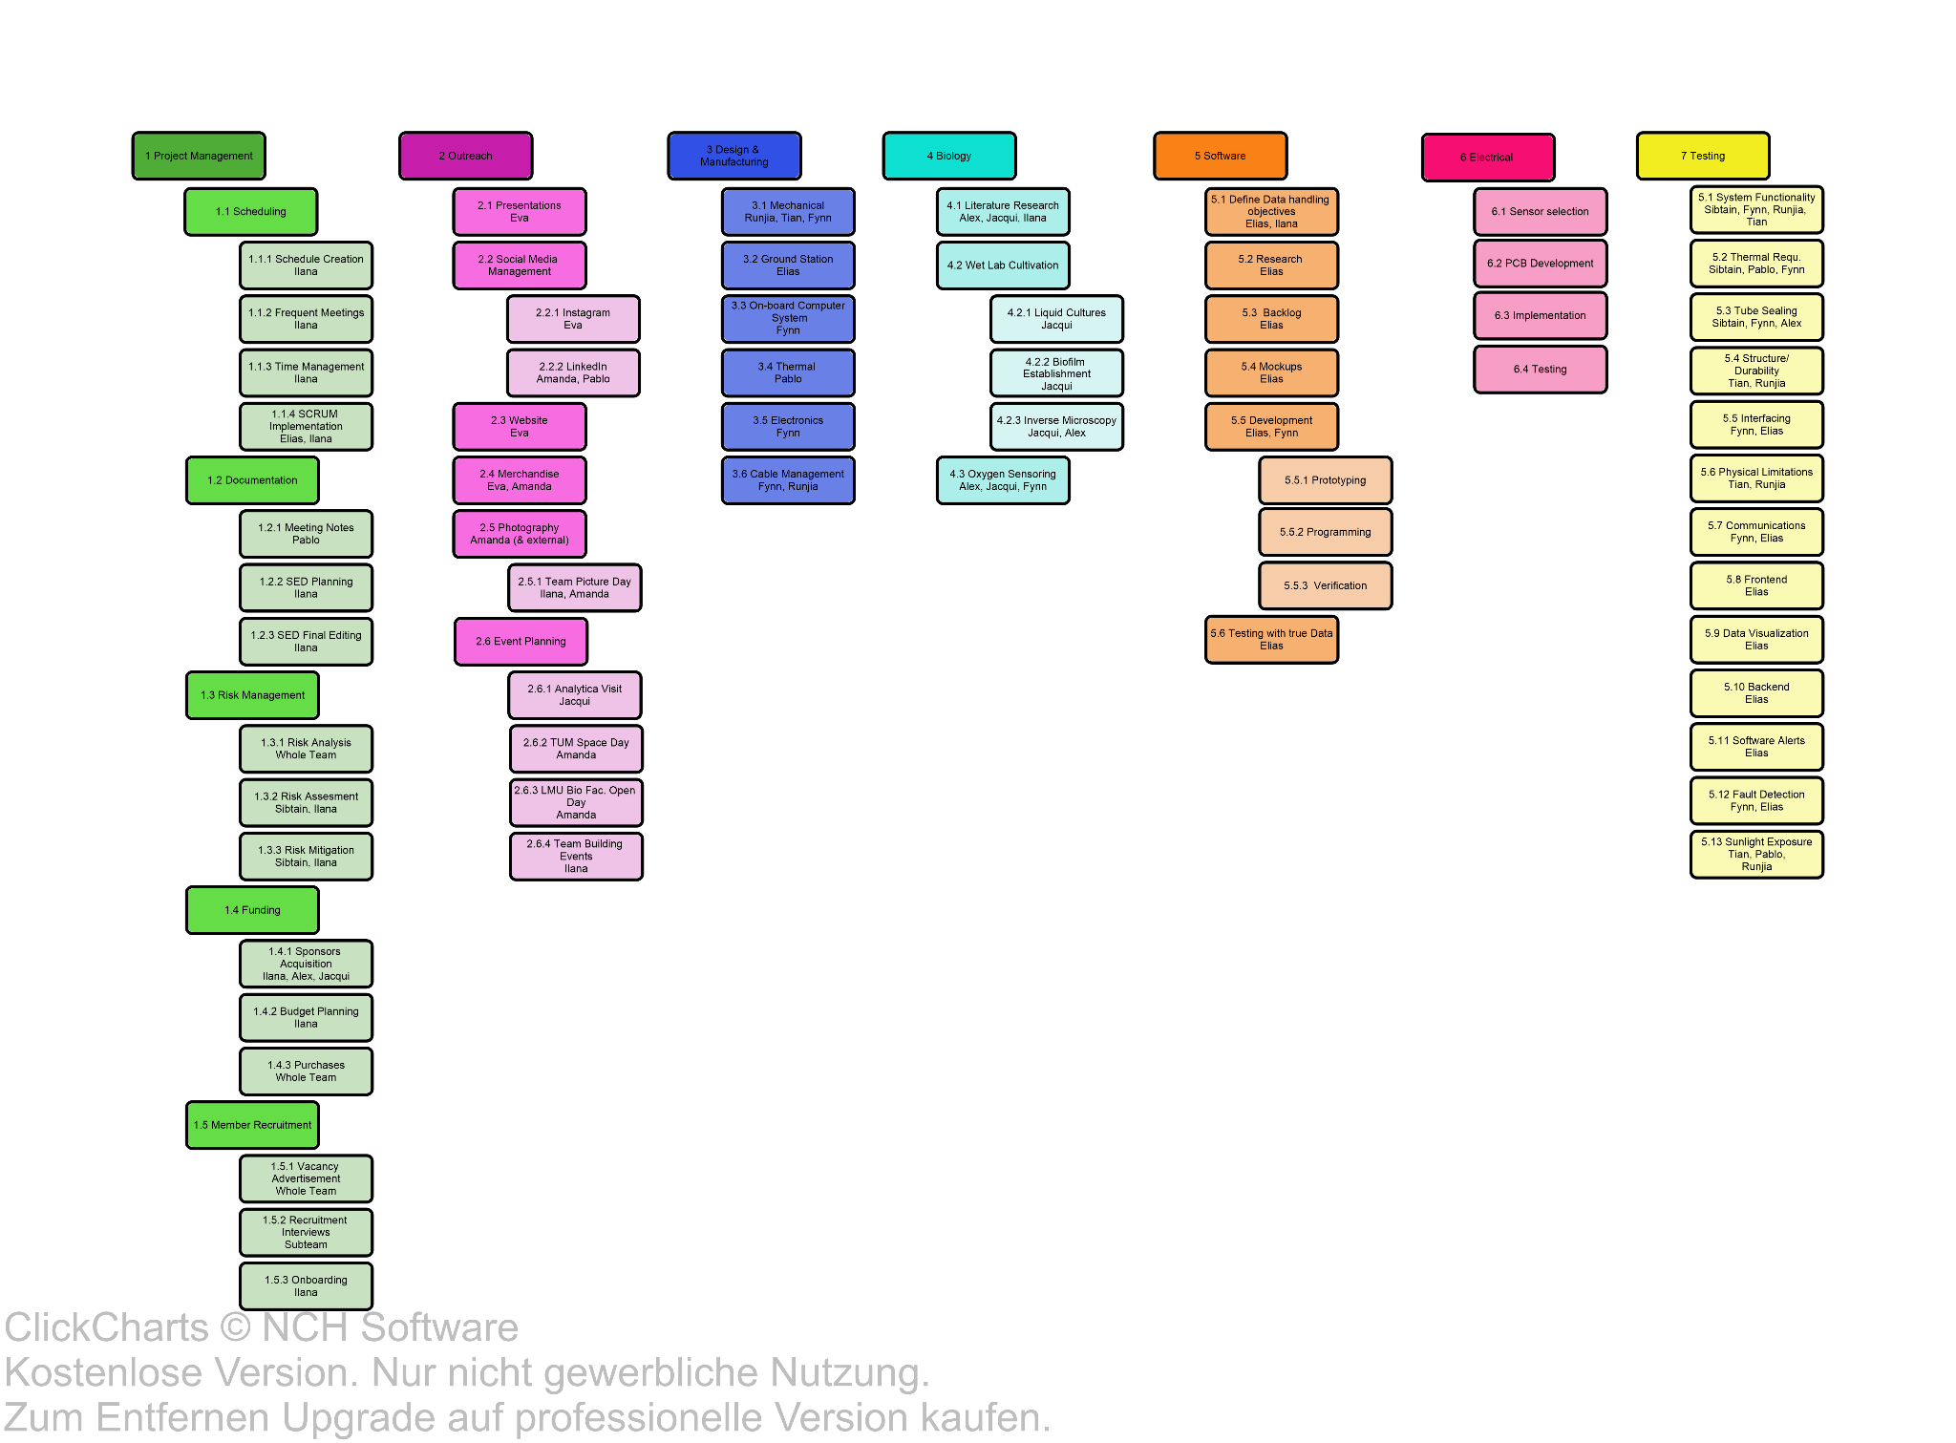

Fig. 3.1-1: Work Breakdown Structure

To increase transparency and efficiency in the workload we have adapted a SCRUM inspired work flow.

The duration for each sprint is 2 weeks with one weekly team meeting and additional subteam meetings.

## Schedule

Fig. 3.2-1: Summarized Gantt Chart

Please find the extended Gantt Chart in Appendix D.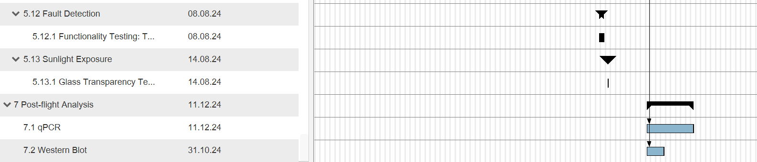

## Resources

### Manpower

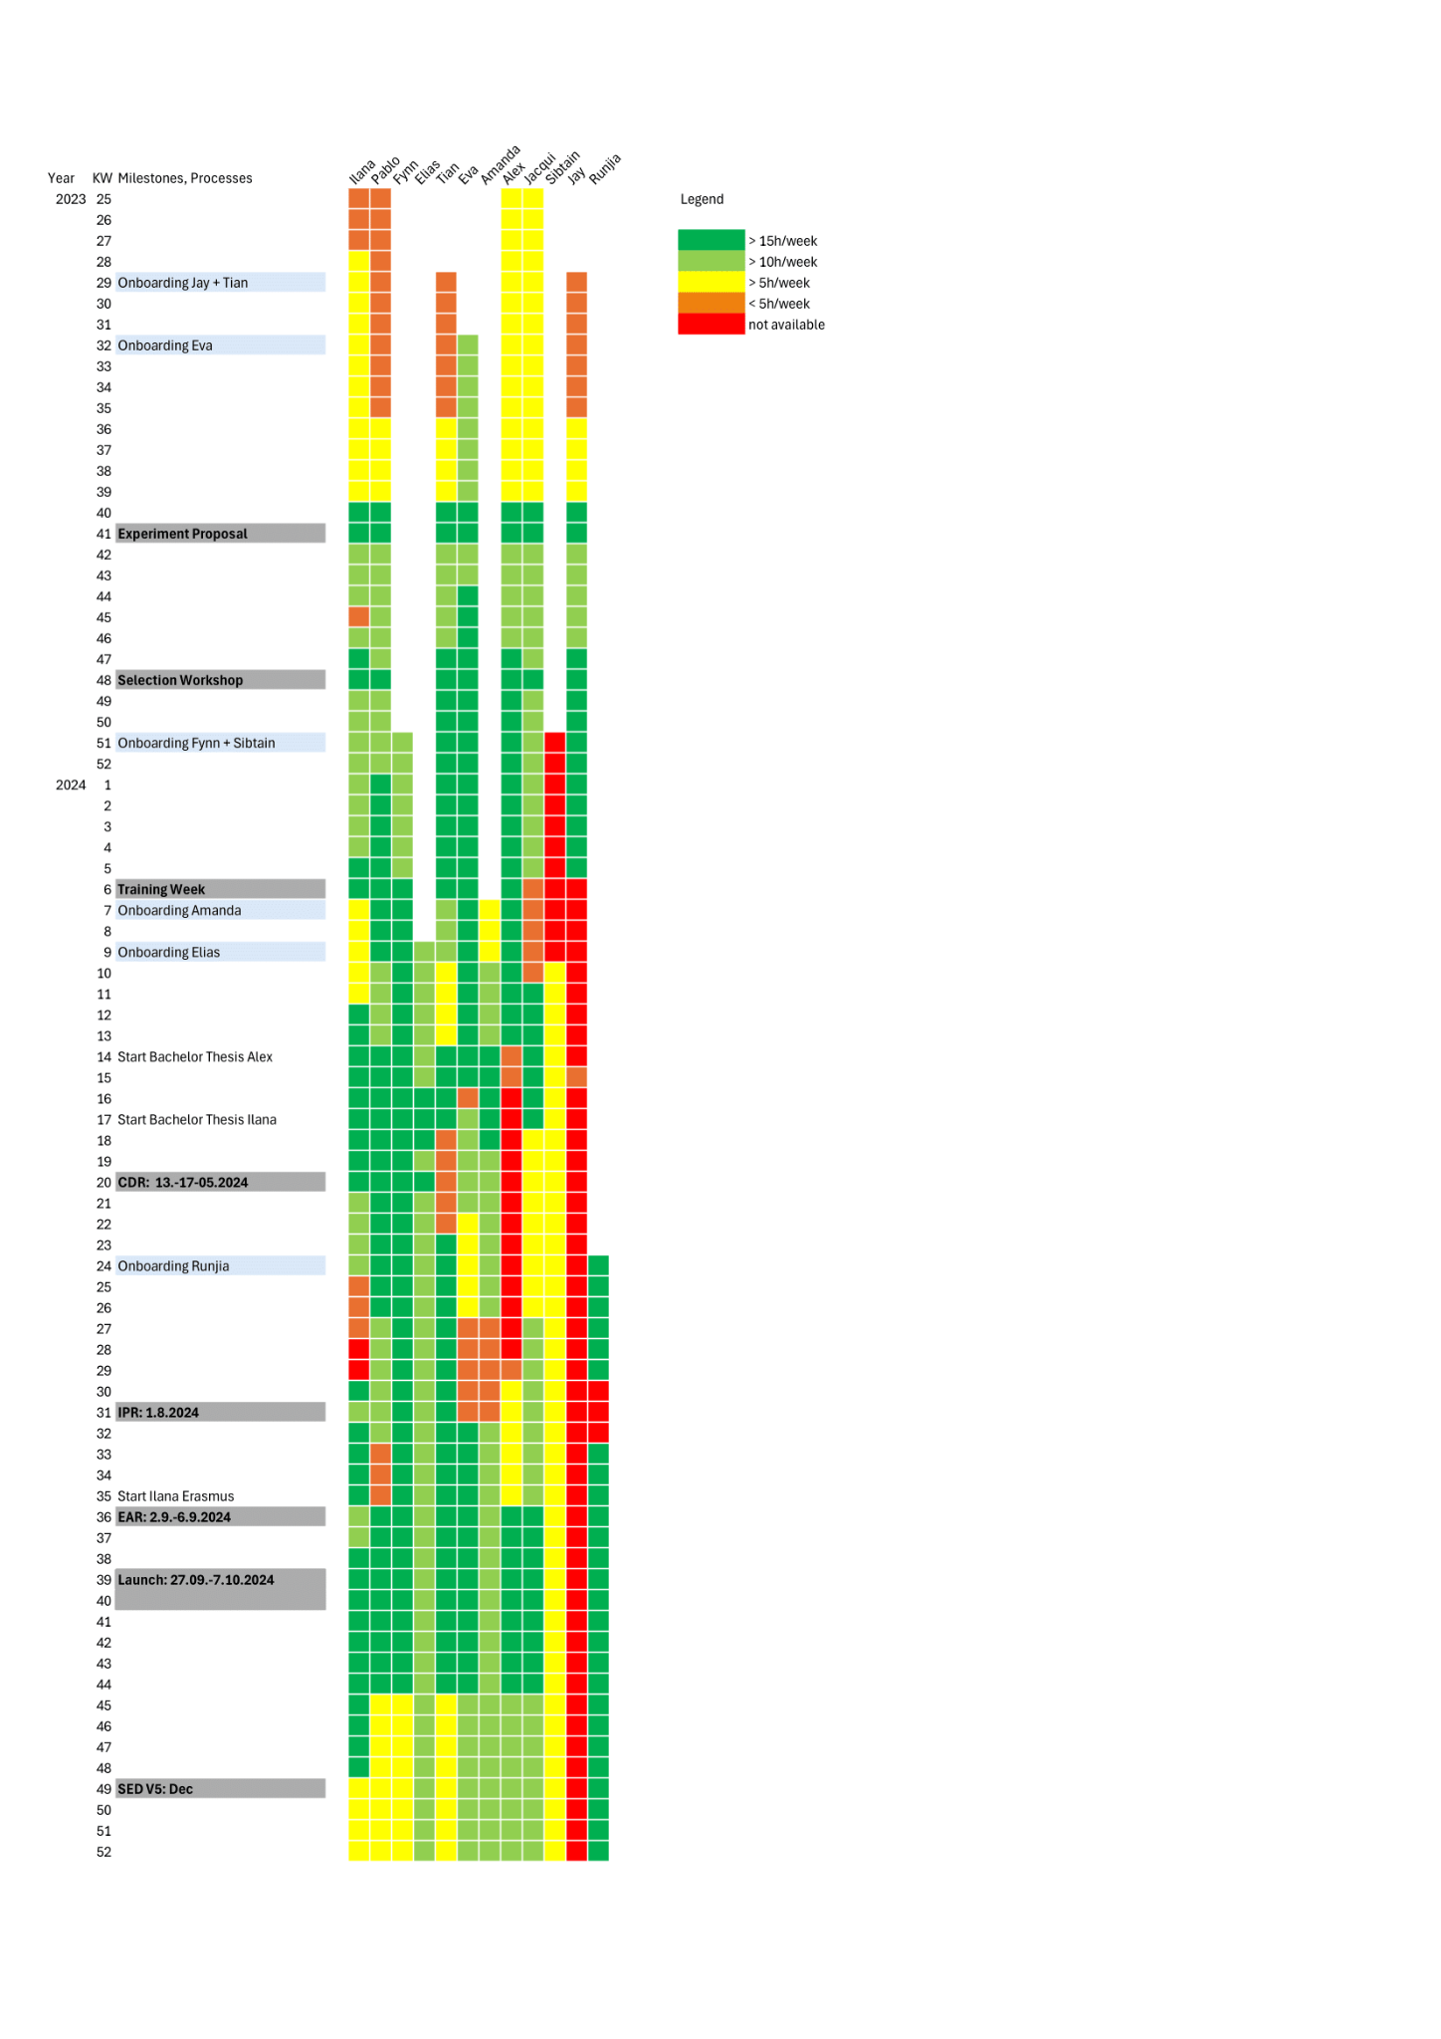

Fig. 3.3-1: Workload Estimation and Schedule for Team Members over duration of REXUS/BEXUS

### Budget

We are working with different money sources and sponsors. In the following table we defined which parts of our expenses are covered by which sponsors and how to acquire the money.

**Table 3-1: Money acquisition guide for SpiCy members**

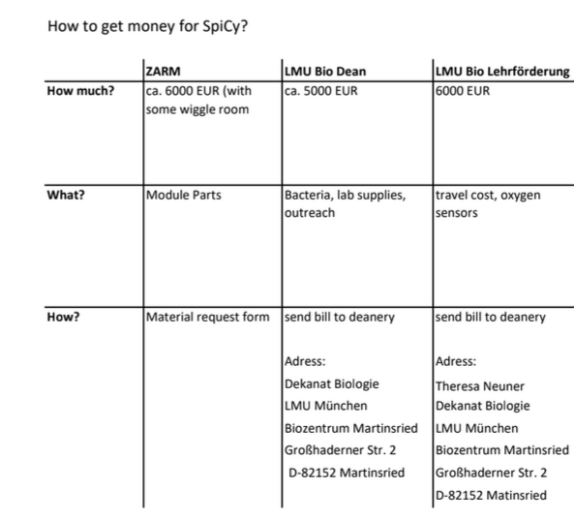

Our expenses and budgets are tracked in the following tables.

**Table 3-2: Expenses covered by DLR via ZARM**

| **Expenses: DLR via ZARM** | | | | |
| --- | --- | --- | --- | --- |
| **Specification /Name** | **Source** | **Paid by** | **Price** | **Status** |
| PCB v3 | multiple | DLR via ZARM | 90,14 € | Delivered |
| Electronic Components v3 | Mouser | DLR via ZARM | 217,49 € | Delivered |
| PCB v4 | Multi PCB | DLR via ZARM | 33,34 € | Delivered |
| Electronic Components v4 | Mouser | DLR via ZARM | 340,33 € | Delivered |
| test modules | Amazon | DLR via ZARM | 52,75 € | Delivered |
| RS485 test Modul | Amazon | DLR via ZARM | 5,99 € | Delivered |
| PyroScience Oxygen Sensor FD-OEM (6 pc.) | PyroScience | DLR via ZARM | 1.000,00 € | Delivered |
| Atlas Oxygen Sensor | [Roboshop.com](http://roboshop.com/) | DLR via ZARM | 350,00 € | Delivered |
| Box, cable harness and things to test | Amazon | DLR via ZARM | 315,58 € | Delivered |
| Styrofoam / PIR side panels and insides | Hardware store and FaóamOnline | DLR via ZARM | 40.77 (6.46+34.31) | Delivered |
| Alu profile and groove nuts for Gondola | [myaluprofil.de](http://myaluprofil.de/) | DLR via ZARM | 42,17 € | Delivered |
| Microfiber Gloves | SV Artikel | DLR via ZARM | 65,00 € | Delivered |
| Manufacturing Tools | Amazon | DLR via ZARM | 213.05 € | Delivered |
| Caps and silicone septa | Carlroth | DLR via ZARM | 128,00 € | Delivered |
| PCB 4.1 | Aisler | DLR via ZARM | 47,86 € | Delivered |
| Components PCB 4.1 | mouser | DLR via ZARM | 325,32 € | Delivered |
| Glue | Amazon | DLR via ZARM | 81,14 € | Delivered |
| Hardware store 24.07.2024 (Glue, Screws, SandPaper...) | Hardware store | DLR via ZARM | 56,60 € | Delivered |
| Quartz Glass tubes, 24 pc. | Chinese sus supplier | DLR via ZARM | 215,00 € | Delivered |
| Amazon order 08.08.24 | Amazon | DLR via ZARM | 168,29 € | Delivered |
| Amazon order post-flight (small-scale laboratory tools) | Amazon | DLR via ZARM | 272,83 € | Delivered |
| Replacement FD-OEM module | Pyroscience | DLR via ZARM | 260,00 € | Delivered |
| Amazon order 22.08.24 | Amazon | DLR via ZARM | 32,40 € | Delivered |
| Amazon order 04.09.24 | Amazon | DLR via ZARM | 62,67 € | Delivered |
| Amazon order 21.09.24 | Amazon | DLR via ZARM | 160,96 € | Delivered |
|  |  | **Available** | 6.000,00 € |  |
|  |  | **Sum** | 4.063,86 € |  |
|  |  | **What’s left?** | 1.936,14 € |  |

**Table 3-3: Expenses covered by LMU Faculty of Biology**

| **Expenses: LMU Faculty of Biology** | | | | |
| --- | --- | --- | --- | --- |
| **Specification /Name** | **Source** | **Paid by** | **Price** | **Status** |
| Chroococcidiopsis cubana, Active Culture | DSMZ | LMU Faculty of Biology | 191,53€ | Delivered |
| Oscillatoria sp. | LMU AG Jung | LMU AG Jung | 0,00 € | Picked up |
| Anabaena cylindrica | LMU AG Stibor | LMU AG Stibor | 0 | Picked up |
| Bacillus subtilis | DSMZ | LMU Faculty of Biology | 191,53€ | Delivered |
| 3x Quartz Glass plates | ProQuartz | ProQuartz, LMU Faculty of Biology | 740,18€ | Delivered |
|  |  | **Available** | 5.000,00 € |  |
|  |  | **Sum** | 1.338,24€ |  |
|  |  | **What´s left** | 3.661,76 € |  |

**Table 3-4: Expenses covered by Study Grant LMU Faculty of Biology**

| **Expenses: LMU Faculty of Biology Studienförderungsmittel** | | | | |
| --- | --- | --- | --- | --- |
| **Specification /Name** | **Source** | **Paid by** | **Price** | **Status** |
| Ilana CDR Travel Cost |  | LMU Studienförderungsmittel | 800,00 € | Paid |
| SpiCy Stickers Vol. 2 |  | LMU Studienförderungsmittel | 106,77 € | Delivered |
| Sweaters |  | LMU Studienförderungsmittel | 600,00 € | Delivered |
| Alex Launch Travel Cost (airplane) |  | LMU Studienförderungsmittel | 724,07€ | Paid |
|  |  | **Available** | 5.000,00 € |  |
|  |  | **Sum** | 2.230,84 € |  |
|  |  | **What´s left** | 2.769,16 € |  |

**Table 3-5: Expenses covered by Verein für Förderung der Raumfahrt (VfR)**

| **Expenses: VfR** | | | | |
| --- | --- | --- | --- | --- |
| **Specification /Name** | **Source** | **Paid by** | **Price** | **Status** |
| Pablo Travel cost Launch Camp. | - | VfR, Team SpiCy | 1.300,00 € | Paid |
|  |  | **Available** | 1.300,00 € |  |
|  |  | **Sum** | 1.300,00 € |  |
|  |  | **What´s left** | 0 € |  |

### External Support

The project is supported by many entities who have expressed their interest and support in our research and provide either material, financial, spatial, or scientific aid.

The following institutions support us:

* LMU Faculty of Biology: Monetary support, laboratory space and supplies, professional advisory, technical advisory, material for manufacturing module
* TUM ChemSPACE: Laboratory Space, Founder´s Advisory
* TUM MakerSpace: Material for the module, technical appliances for manufacturing
* Gerhard C. Starck Foundation: financial and ideational support of Ilana Schürmeyer through student scholarship
* Hochschule München Faculty of Electrical Engineering: Official meeting and storage room
* SP Bel-Art: Vacuum Chamber Sponsorship
* PyroScience: Oxygen sensing setup
* ProQuarz: Glas plates (manufacturing cost only)

The following professors support us:

* Prof. Gisela Detrell, Professorship Human Spaceflight Technology at TUM: Endorsing Professor
* Prof. Ralf Heermann, Professorship of Microbiology at Uni Mainz:

Expert on biofilms, consultation on experiment design

* Prof. Heinrich Jung, Dean of Studies at Faculty of Biology at LMU:

Support with sponsoring and communication within faculty

* Dr. Daniela Meilinger, Lecturer of Human Genomics at LMU:

Academic networking support

* Dr. Frank Landgraf, Lecturer of Microbiology at LMU:

Safety officer for biological laboratory

* Prof. Dr. Benjamin Kormann, Dean of Faculty of Electrical Engineering at HM:

Provision of official SpiCy meeting room, connection to HM press

## Outreach Approach

The foundation of our outreach approach lies in the combination of the biological and technical backbone together with the results of an in depth target group analysis. Depending on the media/platform used to communicate, this influences both our verbal and visual language (see platform description below) as we aim to engage people of various educational backgrounds and interest about scientific content on social media.

To cover all these goals, we implemented an iconic and intuitive visuality for all platforms and formats, and since we want to engage as many people as possible on instagram to raise interest in the REXUS/BEXUS programme and scientific content, we use as many barrier free tools as possible, in particular alt-texts, tags and screen reader-friendly writing.

The Outreach of Team SpiCy shall target different types of audience. The tools of choice for reaching a broad audience are the following social media platforms:

**Instagram**

[**https://www.instagram.com/spicy_bexus/**](https://www.instagram.com/spicy_bexus/)

Aimed for a wider audience with an approachable, professional but also easy-to-understand mentality. Sentences shall be phrased in an easier language and the pictures shall either show the team or support the written content. The last slide is alway open for a call-to-action or a humorous slide.

Our goal is to post once a week to show progress and maintain attention, however, this schedule is temporarily changed to daily posts from 08. April until 13. April, as we have been invited to join the [LMU-Takeover](https://www.instagram.com/lmu.takeover/) programme. The goal of this was to expand our effective reach and raise interest within a new target sector.

Find more details in the Appendix or our instagram channel @spicy_bexus (launched in December 2023).

**Website**

<https://spicybexus.de/>

The website shall especially provide more detailed explanations of the experiment, the project, our team, and institutions as well as a deeper insight into the scientific research behind the project. Moreover our website shall encompass an overview about all our sponsors and external supporters so it lay out an overall insight for professional interest in our project.

The website was launched in March 2024. Ever since March we’ve included an overview of our team-members, a page dedicated to our sponsors, partners and important people, a contact formular and details regarding our project. We update our website at least every two weeks with our latest news.

[**LinkedIn**](https://www.linkedin.com/company/101396457/admin/feed/posts/)

LinkedIn is a platform of secondary priority for us and built for business and sponsoring connections. It shall introduce our project development, provide insights, references, attended events and connect teams and team members for further collaborations.

Additionally, lectures, exhibitions and presentations (at universities) are planned before and after the launch. SpiCy aims to contribute to scientific education due to sharing our experience and knowledge gained during this project. One of the main goals is to catch the students' attention for the REXUS/BEXUS programme and later establish a continuous academic competition team or students club within our universities. To reach that goal, SpiCy takes and will take part in various public events. The following paragraph, shall give an insight into what events we’re attending:

April 13th 2024: [**TUM "Space Day"**](https://www.tum.de/aktuelles/alle-meldungen/pressemitteilungen/details/default-f4cc9045839b97368df978b25fd191b5)

* The Space Day as part of the international Yuri’s Night takes place on April 13th at the TU Campus in Ottobrunn
* Planned for SpiCy: Talk, booth, and activities for students, families, and children
* Organized by: Prof. Gisela Detrell and Yuris Night Deutschland e.V
* Find details in the Appendix and/or our instagram channel

July 3rd 2024: **“Open Day” at LMU’s Bio Faculty**

* Self-organized booth at the Open Day with educational exhibits and our project merch
* Planned for SpiCy: Provide insight into our project with a focus on the biological part and presenting the REXUS/BEXUS programme to the audience
* Open Days often attract pupils who consider studying in a certain field. Thus, we prepared ourselves and our overall outreach approach for that specific target group f.e. with a button machine with individual motives as a playful way to get to talk to each other, stickers and real, living cyanobacteria that they could have a look at.
* Find details on our instagram channel

Furthermore, to suit the interests of our target audience, our concept of representation is translated to not only digital but also physical components such as clothing, posters, flyers, stickers, rollups and more.

**See Appendix B – Outreach and Media Coverage for further details.**

## Risk Register

**Risk ID**

TC – technical/implementation

MS – mission (operational performance)

SF – safety

VE – vehicle

PE – personnel

EN – environmental

…etc.

Adapt these to the experiment and add other categories.

Consider risks to the experiment, to the vehicle, and to personnel.

**Probability (P)**

A. Minimum – Almost impossible to occur

B. Low – Small chance to occur

C. Medium – Reasonable chance to occur

D. High – Quite likely to occur

E. Maximum – Certain to occur, maybe more than once

**Severity (S)**

1. Negligible – Minimal or no impact

2. Significant – Leads to reduced experiment performance

3. Major – Leads to failure of subsystem or loss of flight data

4. Critical – Leads to experiment failure or creates minor health hazards

5. Catastrophic – Leads to termination of the REXUS and/or BEXUS program, damage to the vehicle, or injury to personnel

The rankings for probability (P) and severits (S) are combined to assess the overall risk classification, ranging from very low to very high and being coloured green, yellow, orange or red according to the SED guidelines

**Table 3-6: Risk Register**

| **ID** | **Risk & consequence** | **P** | **S** | **P x S** | **Mitigation Action** |
| --- | --- | --- | --- | --- | --- |
| TC10 | Temperature inside the tubes exceeds temp. Limits of 25-30°C. The Bacteria will have slowed metabolism (lower limit) or denature (upper limit). | B | 3 | Low | Perform thermal analysis.  Temperature monitoring during flight, active heating system.  Testing in a thermal vacuum chamber. |
| TC20 | The tubes containing the bacteria and bacterial medium leak. | B | 1 | Very Low | absorbent material around tubes |
| MS10 | O2 sensor fails to record data due to environmental stress. | B | 3 | Low | Environmental and data storage testing |
| TC30 | Tubes melt due to sun radiation | A | 3 | Very Low | Selection of appropriate material, like Quartz glass. |
| TC40 | Water hammer effect at the end of the tube at take off and landing. | B | 3 | Low | Selection of appropriate material to resist cavitation. |
| TC50 | Oxygen bubbles due to faulty sealing | A | 2 | Very low | Tubes fully filled with liquid medium. Slightly tilted implementation of tubes in module for “controlled failure”. |
| TC60 | Cables disconnect through vibration | A | 3 | Very low | Fixing the cables with adhesive material. Thermal vacuum chamber test. |
| TC70 | Casing deteriorates by kinetic shock | A | 2 | Very Low | Dense styrofoam. Detailed operation instructions for the recovery team to ensure their safety in case glass shatters. |
| SF10 | Part of experiment falls from balloon gondola over a highly populated area during flight | A | 4 | Very Low | Secure fixation of all experiment parts to the gondola and module by the aluminum profiles and casing. |
| MS20 | Cyanobacteria die prior to experiment | B | 3 | Low | Careful handling and performance evaluation shortly prior to flight.  Redundant charges of flight-ready tubes with bacteria. |
| MS30 | Uplink/downlink fails | B | 1 | Very Low | Repeated software testing |
| VE10 | Ballon power supply fails | A | 3 | Low | Strong Redundancy in the PowerRails -> Most shorts would only deactivate a single sensor/heater |
| PE10 | Financial resources are not sufficient to fund the experiment. | B | 2 | Very Low | Acquisition of additional sponsors. Foreseeable expenses are covered. |
| PE20 | Some team members are unavailable at launch | C | 1 | Very low | Proper knowledge transfer on the team through reliable communication and clear action protocol. |
| EN10 | Biological samples leak out of the module | A | 1 | Very Low | Acceptable risk: sealing of the tubes and the module. |
| EN20 | Tubes burst due to pressure difference. | B | § | Low | Acceptable risk: Redundant sealing of tubes and pressure test. |

# Experiment Description

## Experiment Setup

The experiment setup will consist of a module for the biological samples for which a suitable environment will be provided with the appropriate medium and the suitable thermal conditions.

The biofilm strains will be transferred to containers (UV-translucent tubes around 50ml each) with a suitable buffered medium (BG11-derived) fixed presumably at pH=8.1. These samples consist of 3 biological replicates of the best candidate of cyanobacteria strain, cyanobacterial strains with heterotrophic complements, and multiple controls (dark control, heterotrophic bacteria only control, empty control). Oxygen sensors, suited for dissolved oxygen measurement, and NTC Thermistors are applied to the biological sample tubes and sealed on multiple levels (clamping/screwing with a silicone/rubber sealing ring and gluing). The biological setup is aligned for optimal light coverage and fixed inside the module. Kapton Heaters are deployed to maintain suitable temperature for photosynthesis and metabolic activity (25-30°C). Thermal sensors and an incoming UV-wavelength-sensor are connected to the electronics module, a custom built PCB. A PI controller adjusts the heater temperature to stabilize the temperature by measuring the temperature continuously and activating/deactivating the heaters one tube at a time accordingly. The top of the module consists of a translucent quartz-glass ceiling, allowing UV radiation to pass into the module. The casing of the module is built with aluminum profiles and an aluminum bottom plate to fix the module into the gondola. PIR insulation foam will be used to thermally isolate the module on each of the non-translucent sides, as well as to separate/compartmentalize the electronics bay and the biological samples.

Constant measurement of oxygen concentration enables high resolution of data across the different strains. Afterward, data is collected and compared to the data already collected on the ground. If possible (dependent on post-flight weather conditions and recovery time), fixation or RNAse deactivation of the samples is performed after flight to enable radiation damage analysis through RNA sequencing. The EPS matrix is stained with crystal violet and analyzed with potential HPLC analytics for changes in composition and biomass.

The parameters set in the module rely heavily on the strains tested and may be subject to change.

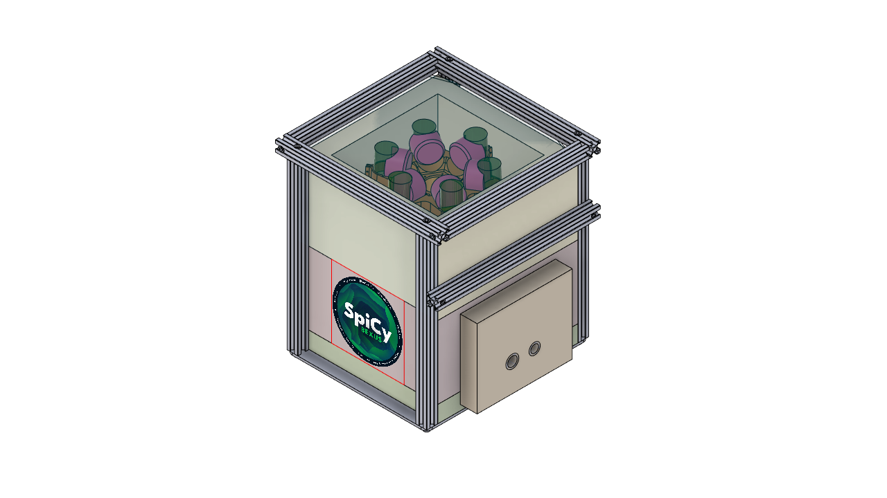

Fig. 4.1-1: Demonstration of module design

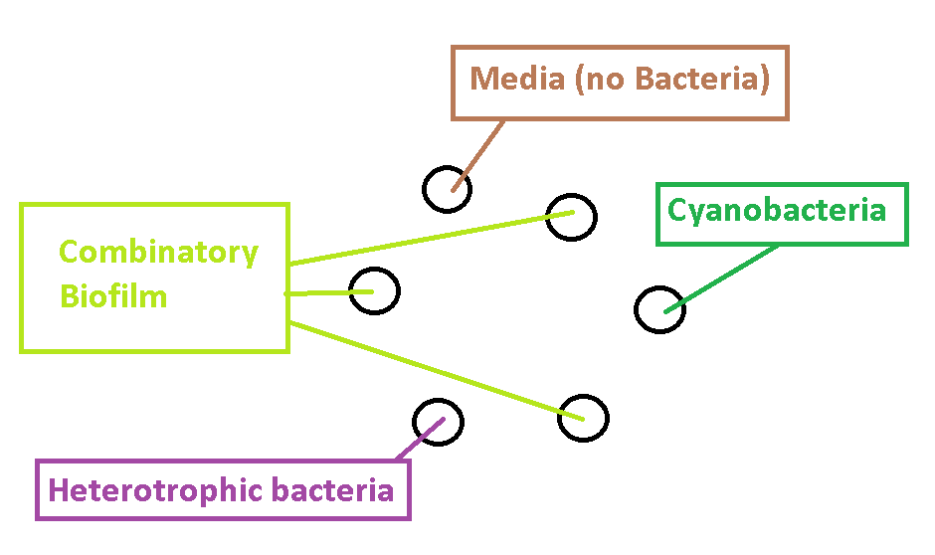

Fig. 4.1-2: Biological sample set-up

The tubes containing our experiment subjects, the combinatory biofilms, are placed in a circle alternating with the different control experimental approaches.

## Experiment Interfaces

The ethernet port will be used for down and uplink data.

### Mechanical

The mechanical interfaces will be the following:

* With the gondola: by the 4 aluminum profiles attached on the upper part, as shown in the CAD design, with 4 aluminium brackets of 20x20 to 45x45. The rest of the aluminum profiles (4) and two crossed steel hole stripes underneath fixated with 4 M5 bolts will act as a casing for the styrofoam box with the top glass lid stopping the vertical movement. The glass lid will be mounted under the aluminium profile frame on the top and glued together with the foam box below it as a damper.

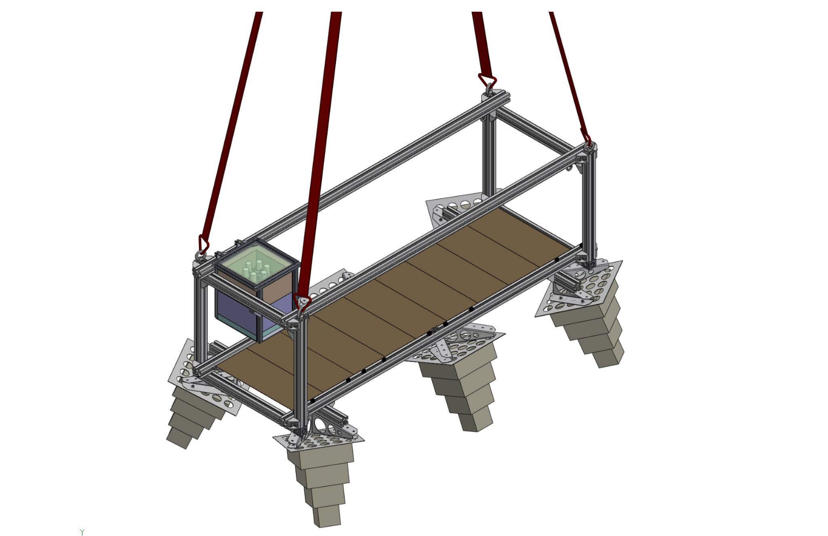

Fig. 4.2-1: Assembly of the module into the gondola

* With the environment: by the styrofoam box that is a porous material so the pressure in the inside and the outside is the same.
* With the styrofoam box: by the tubes and electronics compartment. Horizontally, it will be fixated by the aluminium profiles cage outside and high quality foam glue. Some pins go through the styrofoam box from sides and fix the position of the internal module vertically.
* With the electronics compartment and the glass tubes: by a styrofoam small compartment to allocate the electronics bay.
* With the inside of the module and the biofilms: by the glass tubes and the sealing around the oxygen and the temperature sensor.

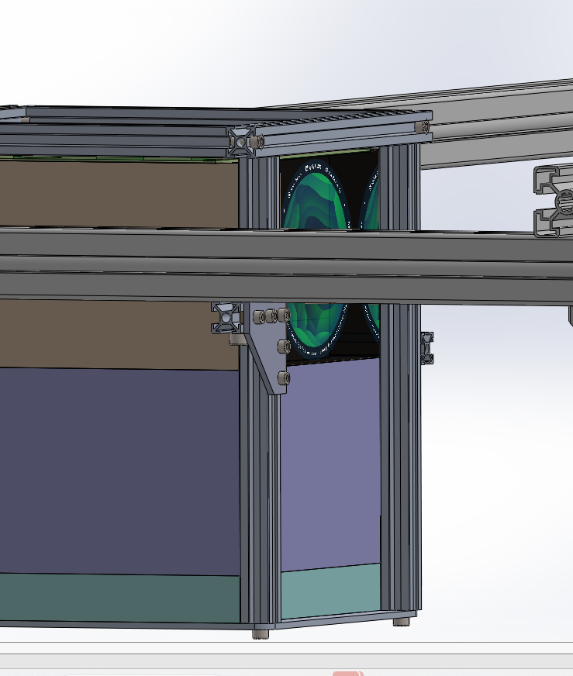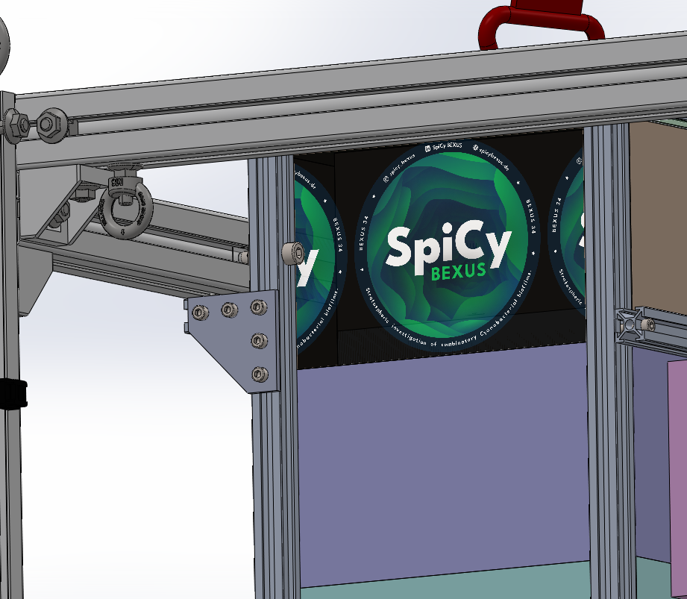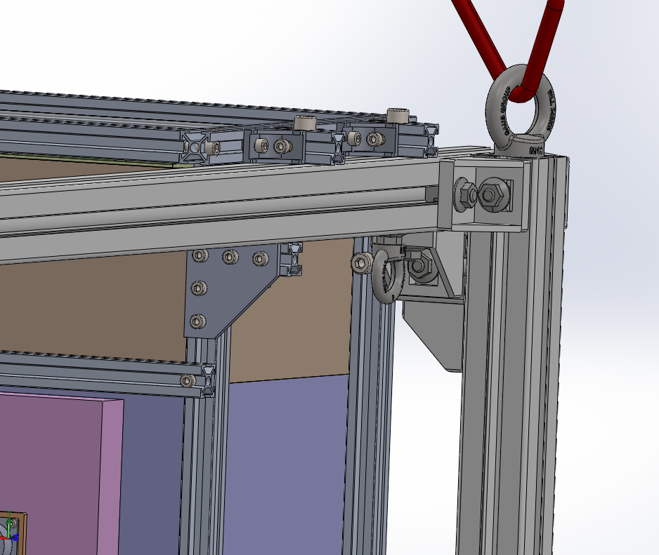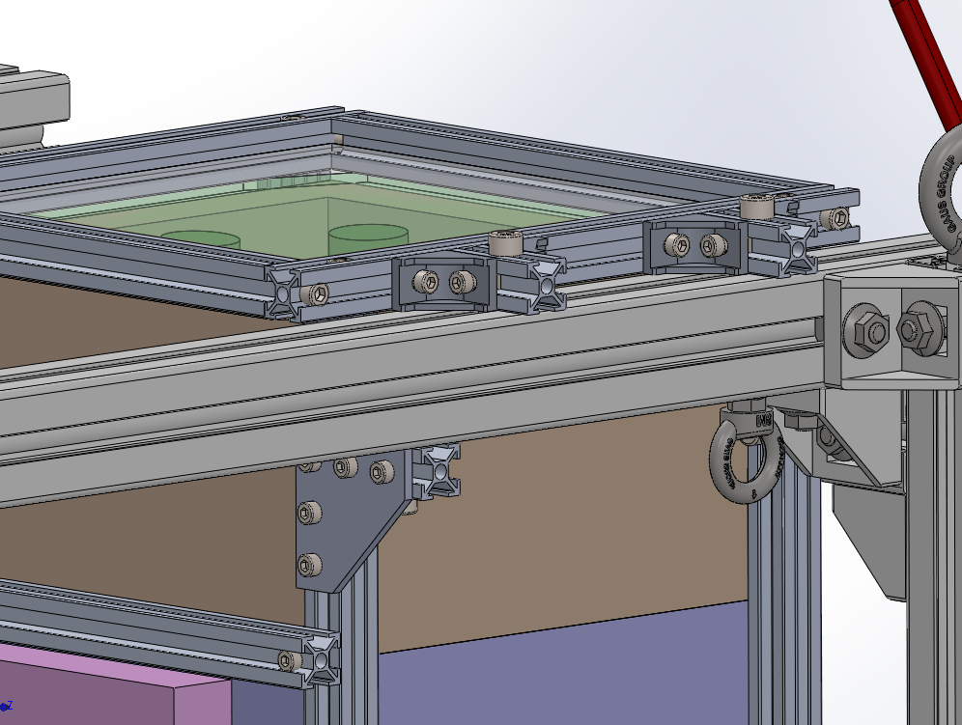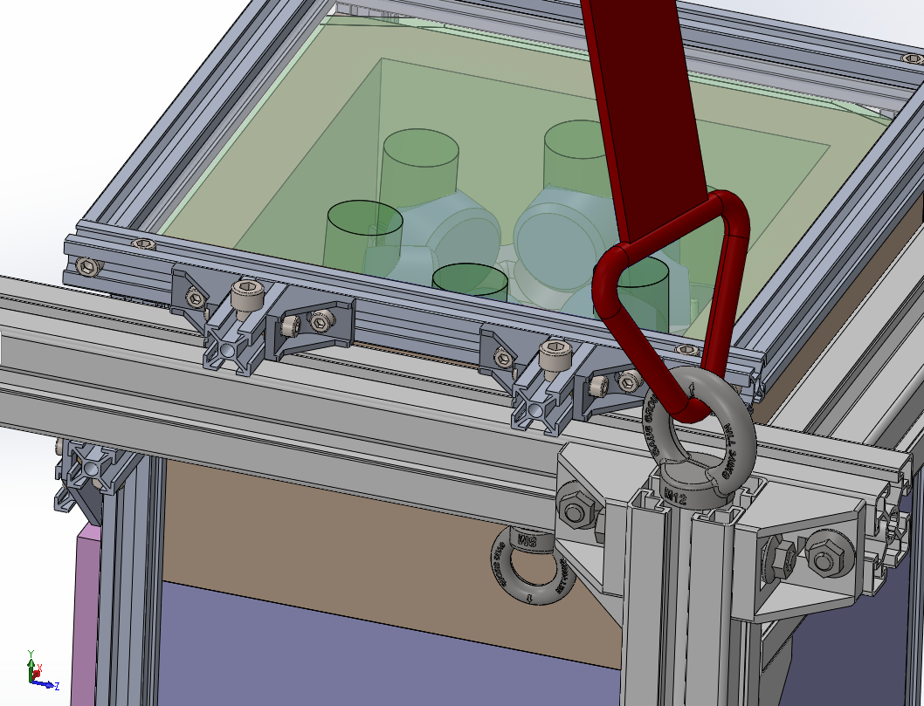 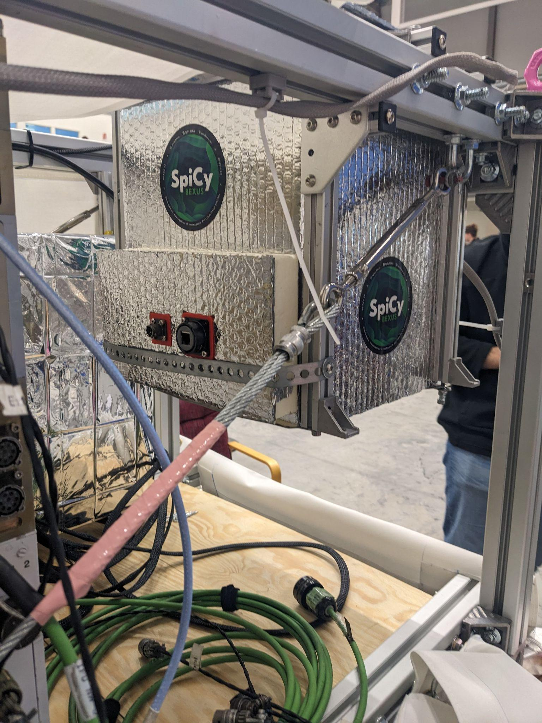

Fig. 4.2-2: Detailed illustration of the fixation on gondola.

In the upcoming Fig. 4.4-1, it can be seen how these interfaces are working in the assembly process.

### Electrical

The electrical interfaces will be the following:

* Usb C for reprogramming and debugging
* Battery Connection
* Ethernet Port

### Thermal

The thermal interfaces are the following:

* UV transparent Quartz glass upper boundary: radiation and conduction are the effective ways of heat exchange.
* UV transparent Quartz glass test tubes: radiation (upper part) and conduction (Kapton heater surface) are the effective ways of heat exchange.
* Styrofoam structure: conduction are the effective way of heat exchange and the interface with the outside of the experiment.

## Experiment Components

**Table 4-1: Experiment components**

| **#** | **Component** | **Number of items** | **Cost in EUR** | **Sponsor** | **Status** |
| --- | --- | --- | --- | --- | --- |
| 1 | NTC Thermistor | 6 | 10 | DLR via ZARM | Delivered |
| 2 | Oxygen Sensor | 6 | Ca. 6000 | DLR via ZARM/LMU | Delivered |
| 3 | Quartz Glass Vials | 6 | TBD | DLR via ZARM | Delivered |
| 4 | Kapton Heater | 6 | - | DLR via ZARM | Delivered |
| 5 | PIR Foam Box | 1 | 100 | DLR via ZARM | Delivered |
| 6 | RTV Glue | 1 | 12 | DLR via ZARM | Delivered |
| 7 | Motherboard | 1 | 300 | DLR via ZARM | Delivered |
| 8 | Light Sensor | 2 | 30 | DLR via ZARM | Delivered |
| 9 | Buck Convertor | 2 |  | DLR via ZARM | Delivered |

**Table 4-1*: Components specification**

| **#** | **Component** | **Specification** |
| --- | --- | --- |
| 1 | NTC Thermistor | A thermistor whose resistance changes with temperature. It is used to monitor, control and record the temperature in the tube during the flight. |
| 2 | Oxygen Sensor | FD-OEM oxygen sensor is characterized by small size and low power requirement. It is an optic-based sensor causing minimal disturbance of the tube environment. |
| 3 | Quartz Glass Vial | Quartz glass has a wide transparency range, which can extend from ultraviolet into near-mid infrared, which make it an optimal material for the study of the spatial radiant influence on bacteria. |
| 4 | Kapton heater | Kapton heaters are thin flexible metal foils that can be easily glued to curved surfaces. The tube temperature will be controlled by the heater at around 25°C. |
| 5 | PIR foam box | PIR (Polyisocyanurate) is a thermoset plastic typically produced as a foam and used as thermal insulation. PIR panels are usually laminated with aluminum foil and contain fire retardants. |
| 6 | RTV Glue | RTV stands for Room Temperature vulcanizing. It is used for the sealing of the tube to withstand the pressure difference. |
| 7 | Motherboard | Motherboard is the brain of the device. It monitors and controls all the parameters of the tubes such as temperature and oxygen density. It also powers the electronic devices and records the data for post flight analysis. |
| 8 | Light Sensor | Light sensor, which is capable of measuring both ambient and UV light, is to study the influence of the spatial radiant on the production of oxygen. |
| 9 | Buck Convertor | The motherboard requires two buck converters for power supply. One to power all LDOs which provide stable 3.3V to things like the microcontroller and SD card, the other powers the heating elements. |

**Table 4-2: Experiment summary table**

| Experiment mass (in kg): | 3.86 kg |
| --- | --- |
| Experiment dimensions (for BEXUS) or module size (for REXUS) (in m): | 290 x 290 x 319 mm (Incl. Aluprofiles) |
| Experiment expected COG (center of gravity) position: | 145 x 145 x 200 mm |

**Table 4-3: Mass summary table**

| Rack (3D printed) | 182 g |
| --- | --- |
| 6 tubes with medium | 108 g x 6 = 648 g |
| 1 Quartz Glass lid | 610 g |
| Aluminum Cage with fixation for the gondola | 1640 g |
| IPR Foam Box | 676 g |
| Cabling | 100 g |
| **Total experiment mass (in kg):** | **3856 g** |

## Mechanical Design

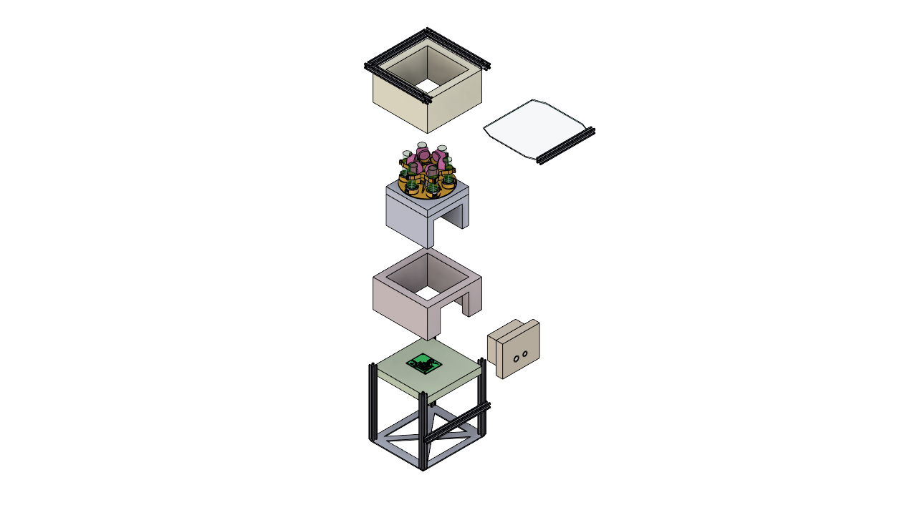

Fig. 4.4-1: Assembly view of the module design.

The mechanical part consists of 5 main components:

1. Bio experimental setup
2. Thermal control system
3. Quartz Glass Cover
4. Electronics
5. PIR Box with aluminum profile cage

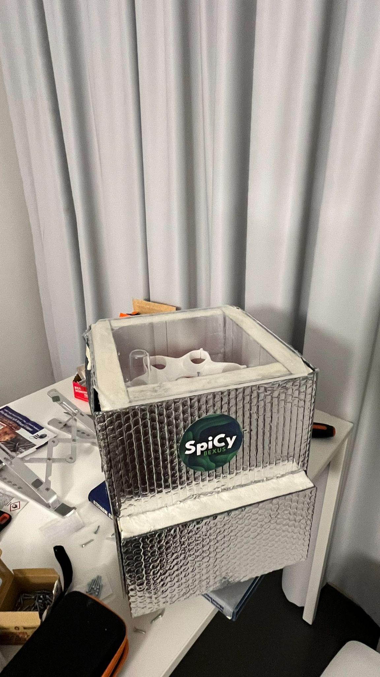 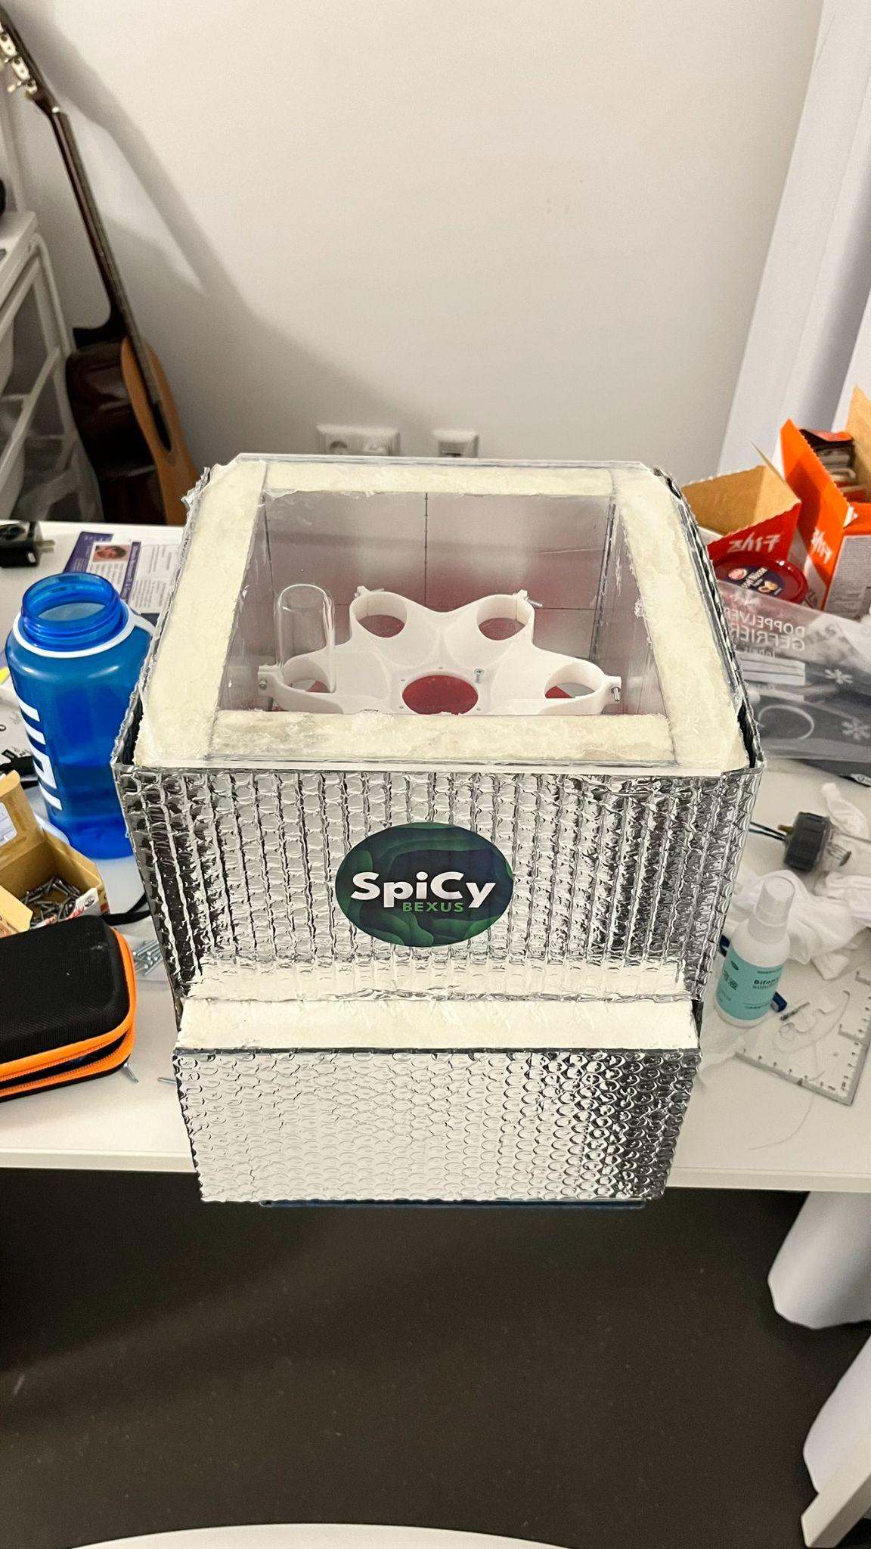

Fig. 4.4-2: The assembled module design without aluminum cage.

The detailed explanation of the mechanical design is as follows:

1. Experimental setup (Biofilm Tubes Housing):

A small styrofoam container with precise dimensions securely houses biofilm tubes, each slot tailored to accommodate their diameter and length. The styrofoam's insulation properties maintain stable temperature, preventing movement and potential damage conditions for the tubes. The tubes are tilted lightly into the center to avoid the formation of big bubbles at the tube bottom which could impact the oxygen measurement accuracy.

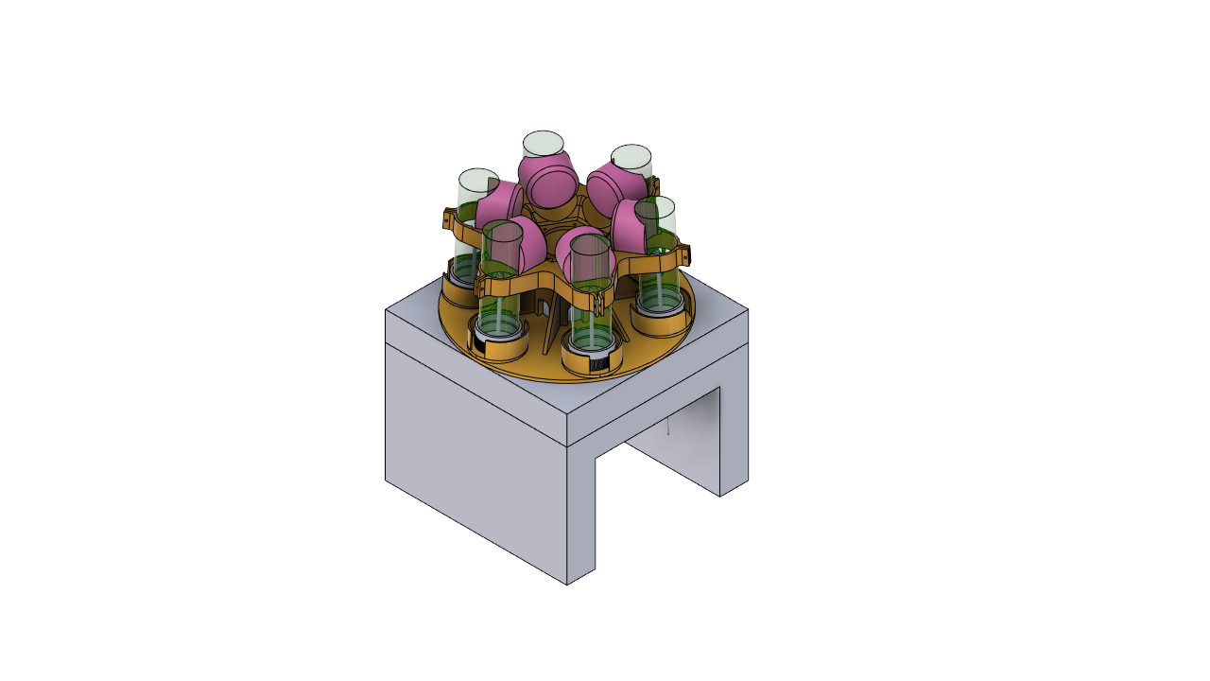 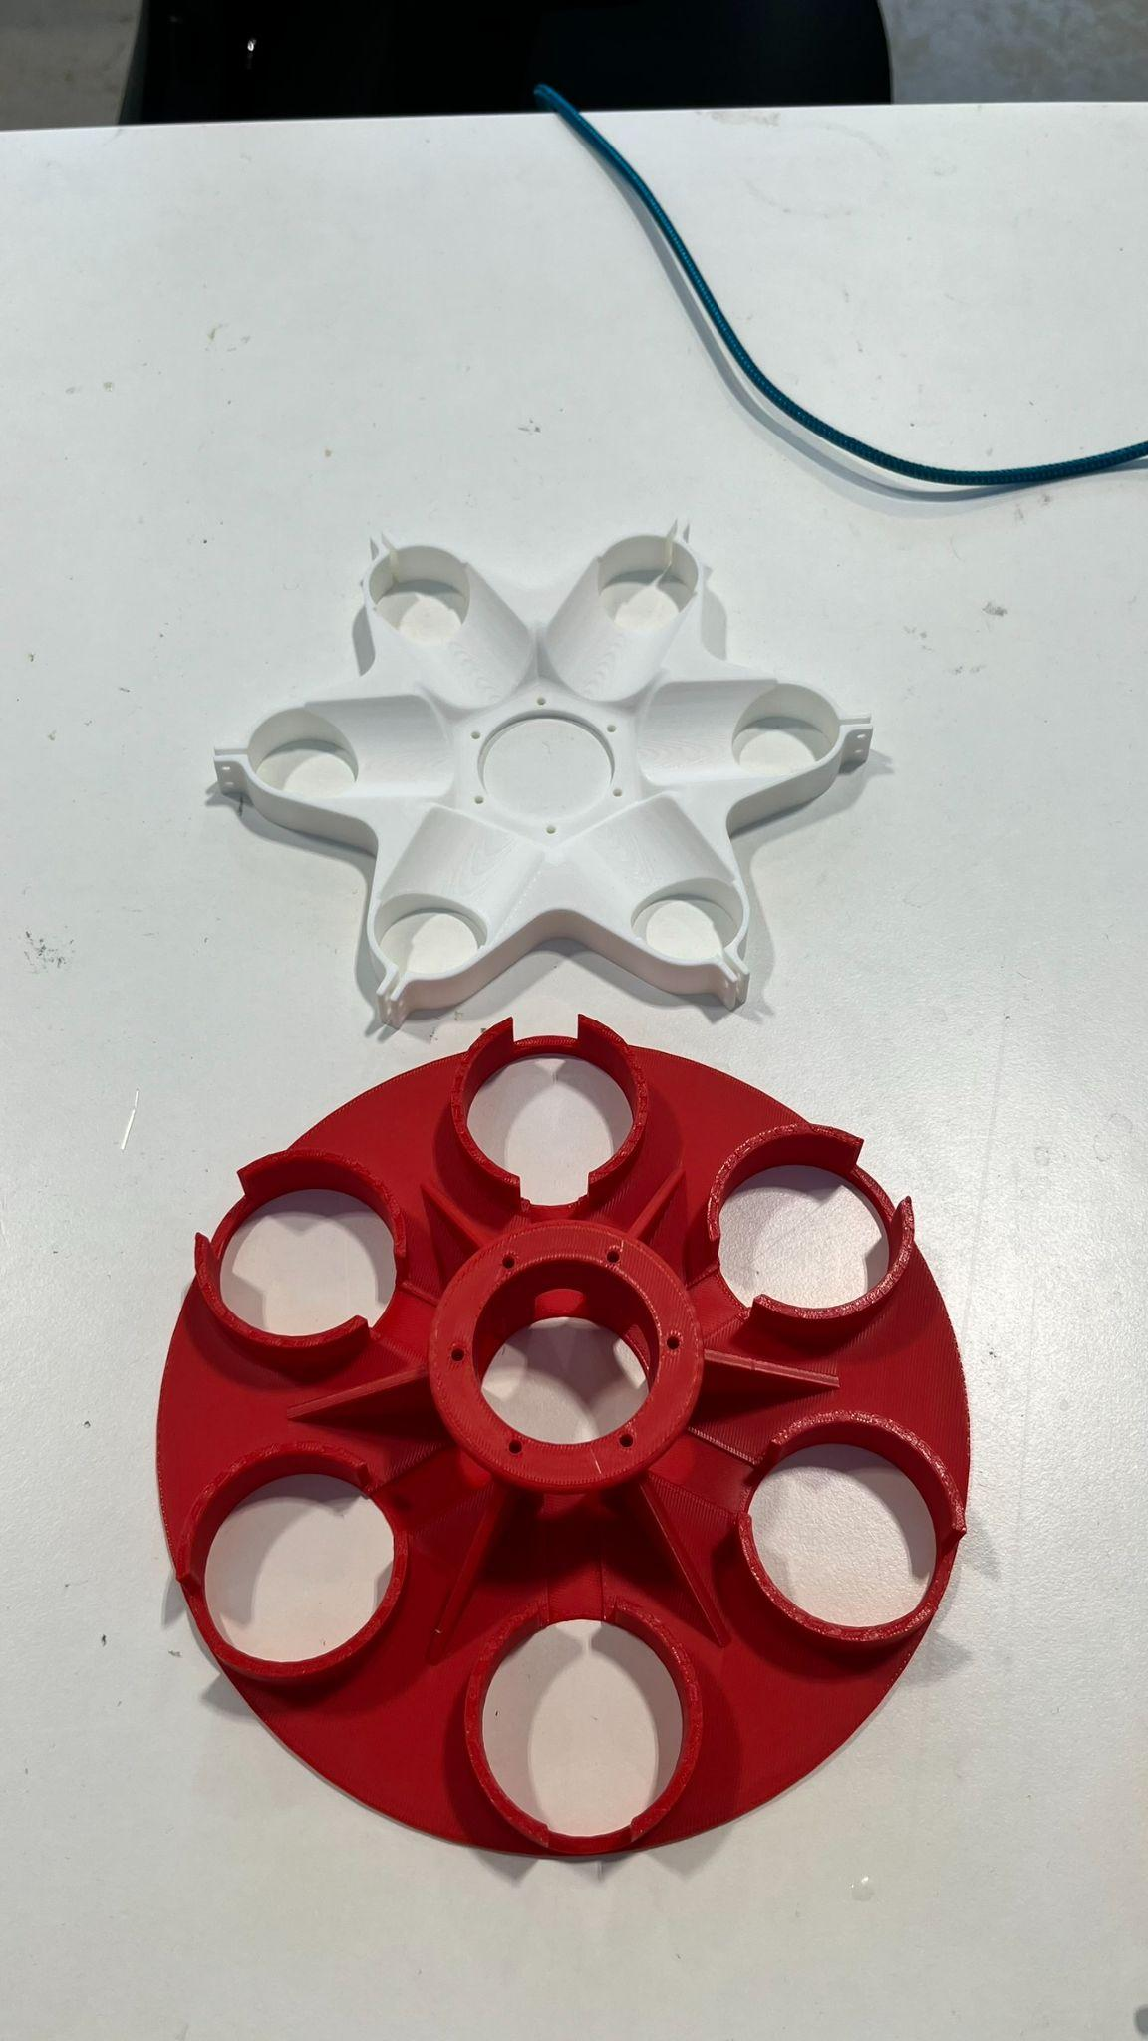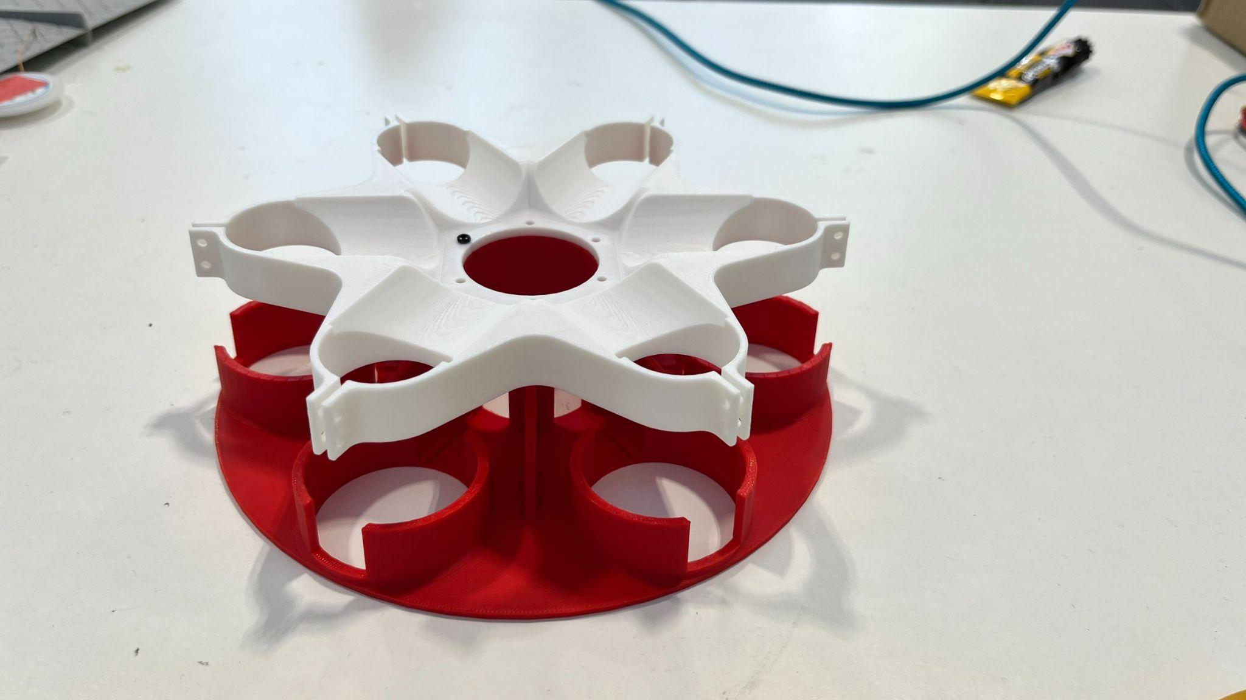 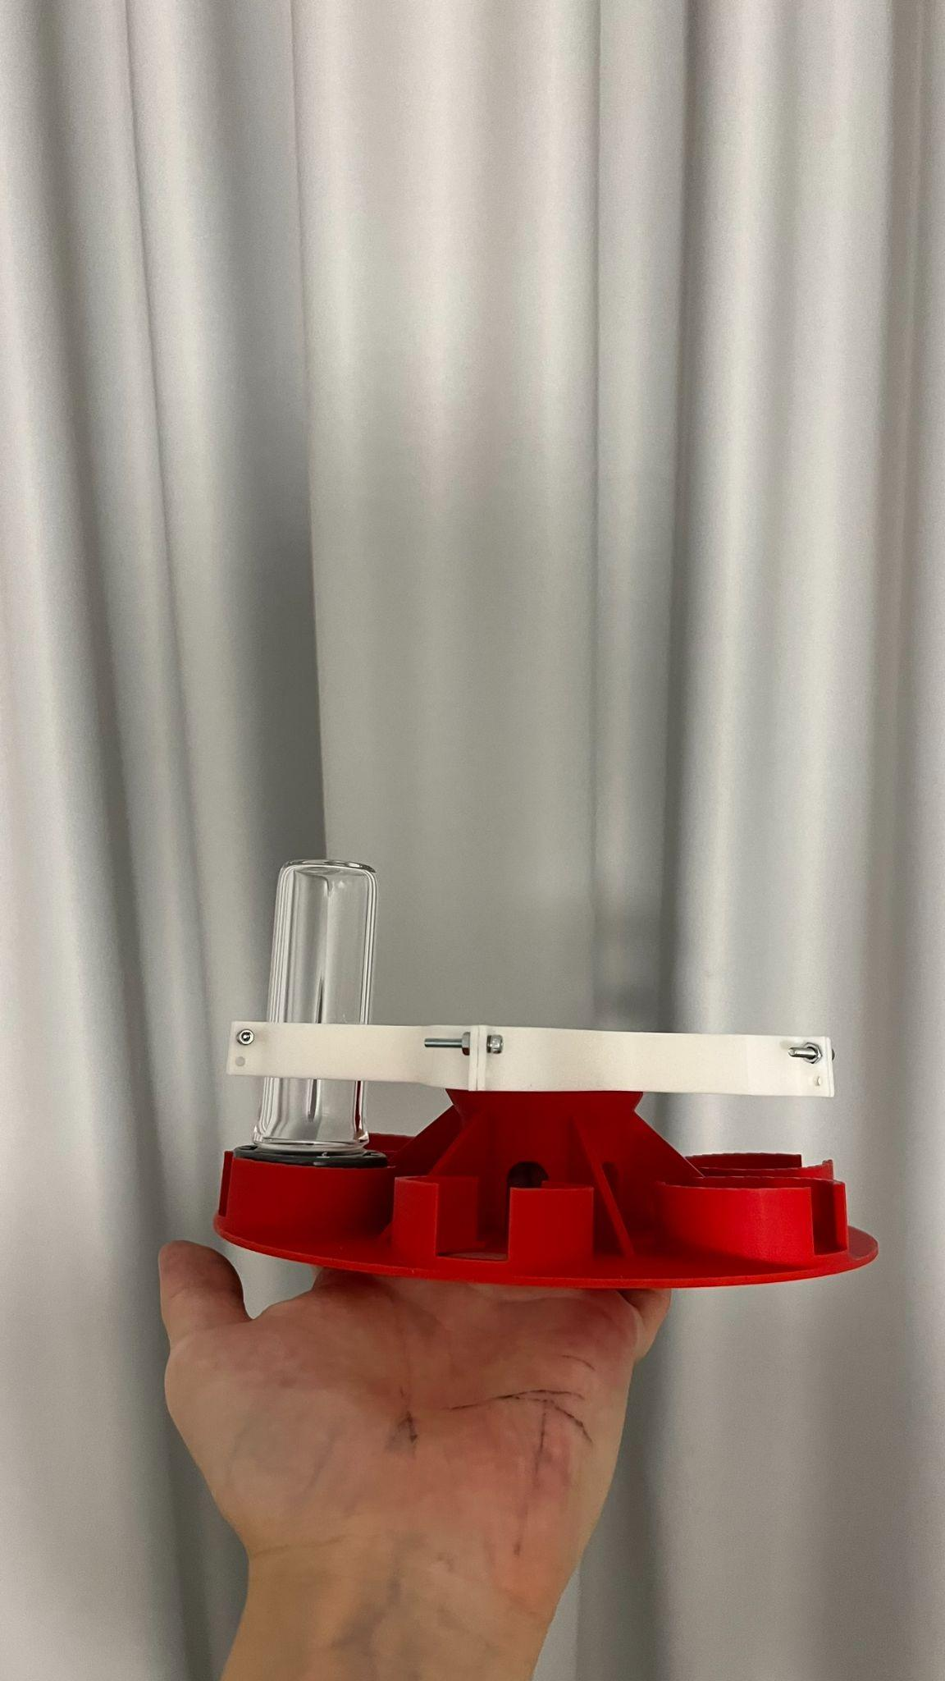

Fig. 4.4-3: Experimental setup design.

1. Thermal Control System:

The design integrates an active environmental control system (Kapton heater as heating element) to maintain suitable thermal conditions for biofilm, featuring temperature regulation for stable growth. Strategically placed sensors monitor environmental factors, providing real-time feedback to the control system (PI controller) for automatic adjustments based on the measurements from temperature probes on the inside of the tubes.

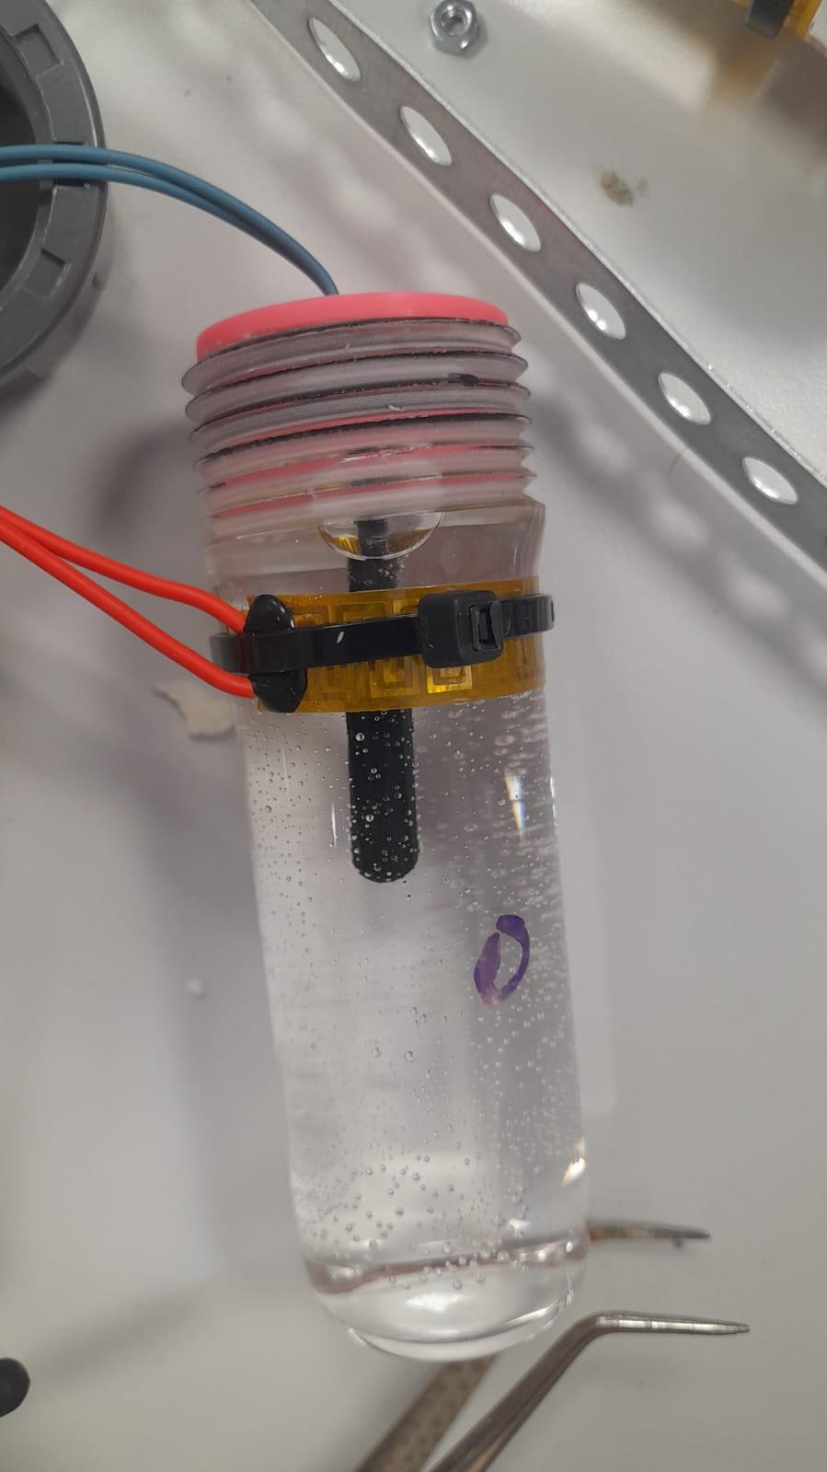

Fig. 4.4-4: Tube assembly with Kapton heater wrapped around.

1. Quartz Glass Cover:

A custom-cut Quartz Glass lid serves as a transparent protective cover for the styrofoam container, allowing sunlight penetration and visual inspection of biofilm tubes. Securely attached, it maintains a sealed, contamination-free environment. The Quartz Glass cover will be installed under the aluminum profiles and pressed and bonded together with the foam box under it. Silicone and rubber material will be used between the glass and the aluminium interface as damper and sealant.

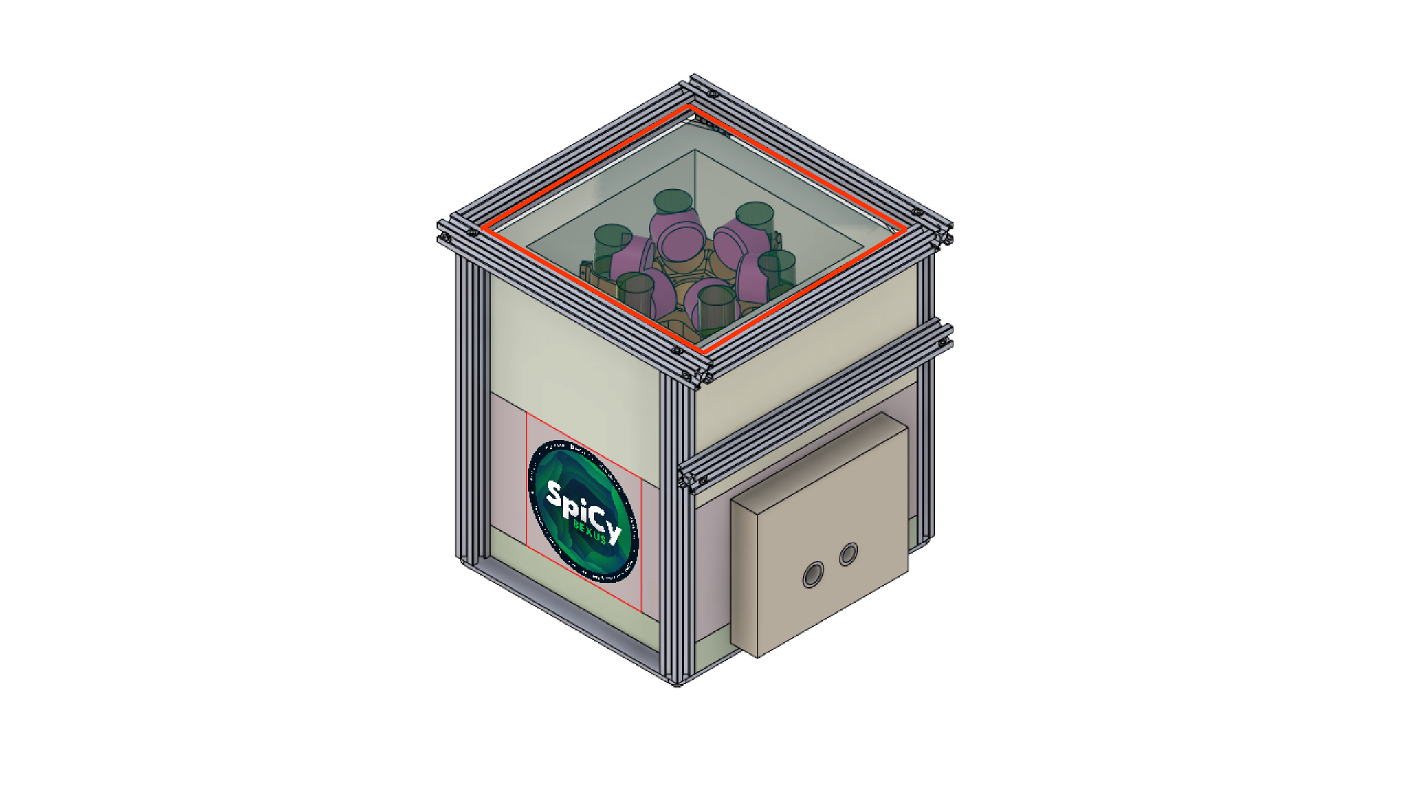 

Fig. 4.4-5: Quartz glass cover (in red box).

1. Electronics Compartment:

The electronics compartment, constructed from durable materials like rigid plexiglass, surrounds the styrofoam biofilm tube housing, providing structural integrity and protection for internal electronics. Its organized interior features specific sections for different electronic components, minimizing clutter and ensuring efficient organization. An extra door was made for convenient access to the electronics compartment. The door position is fixed by one piece of steel hole stripe mounted on the side of the aluminum cage. Furthermore, the connectors for power and ethernet from the gondola are integrated on the door.

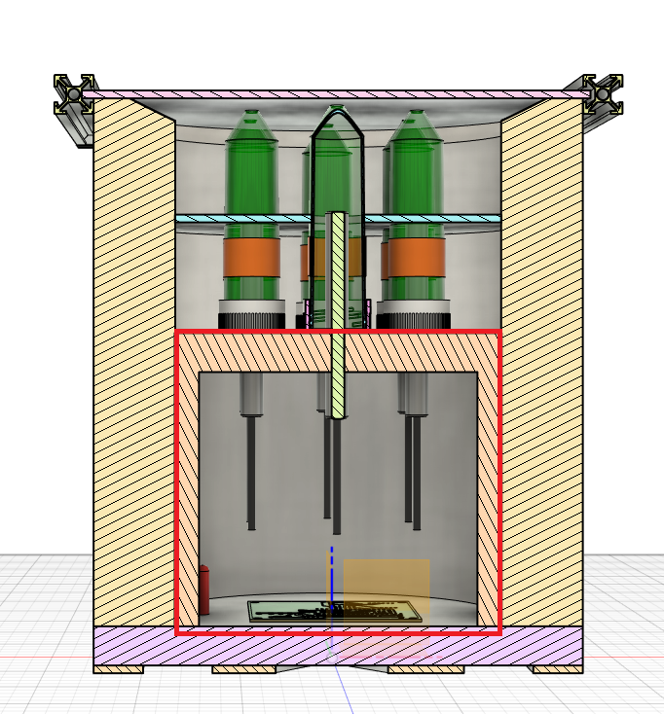

Fig. 4.4-6: Electronics compartment design (in red box).

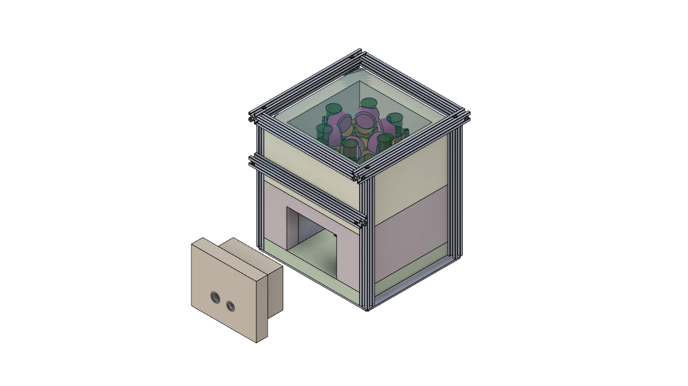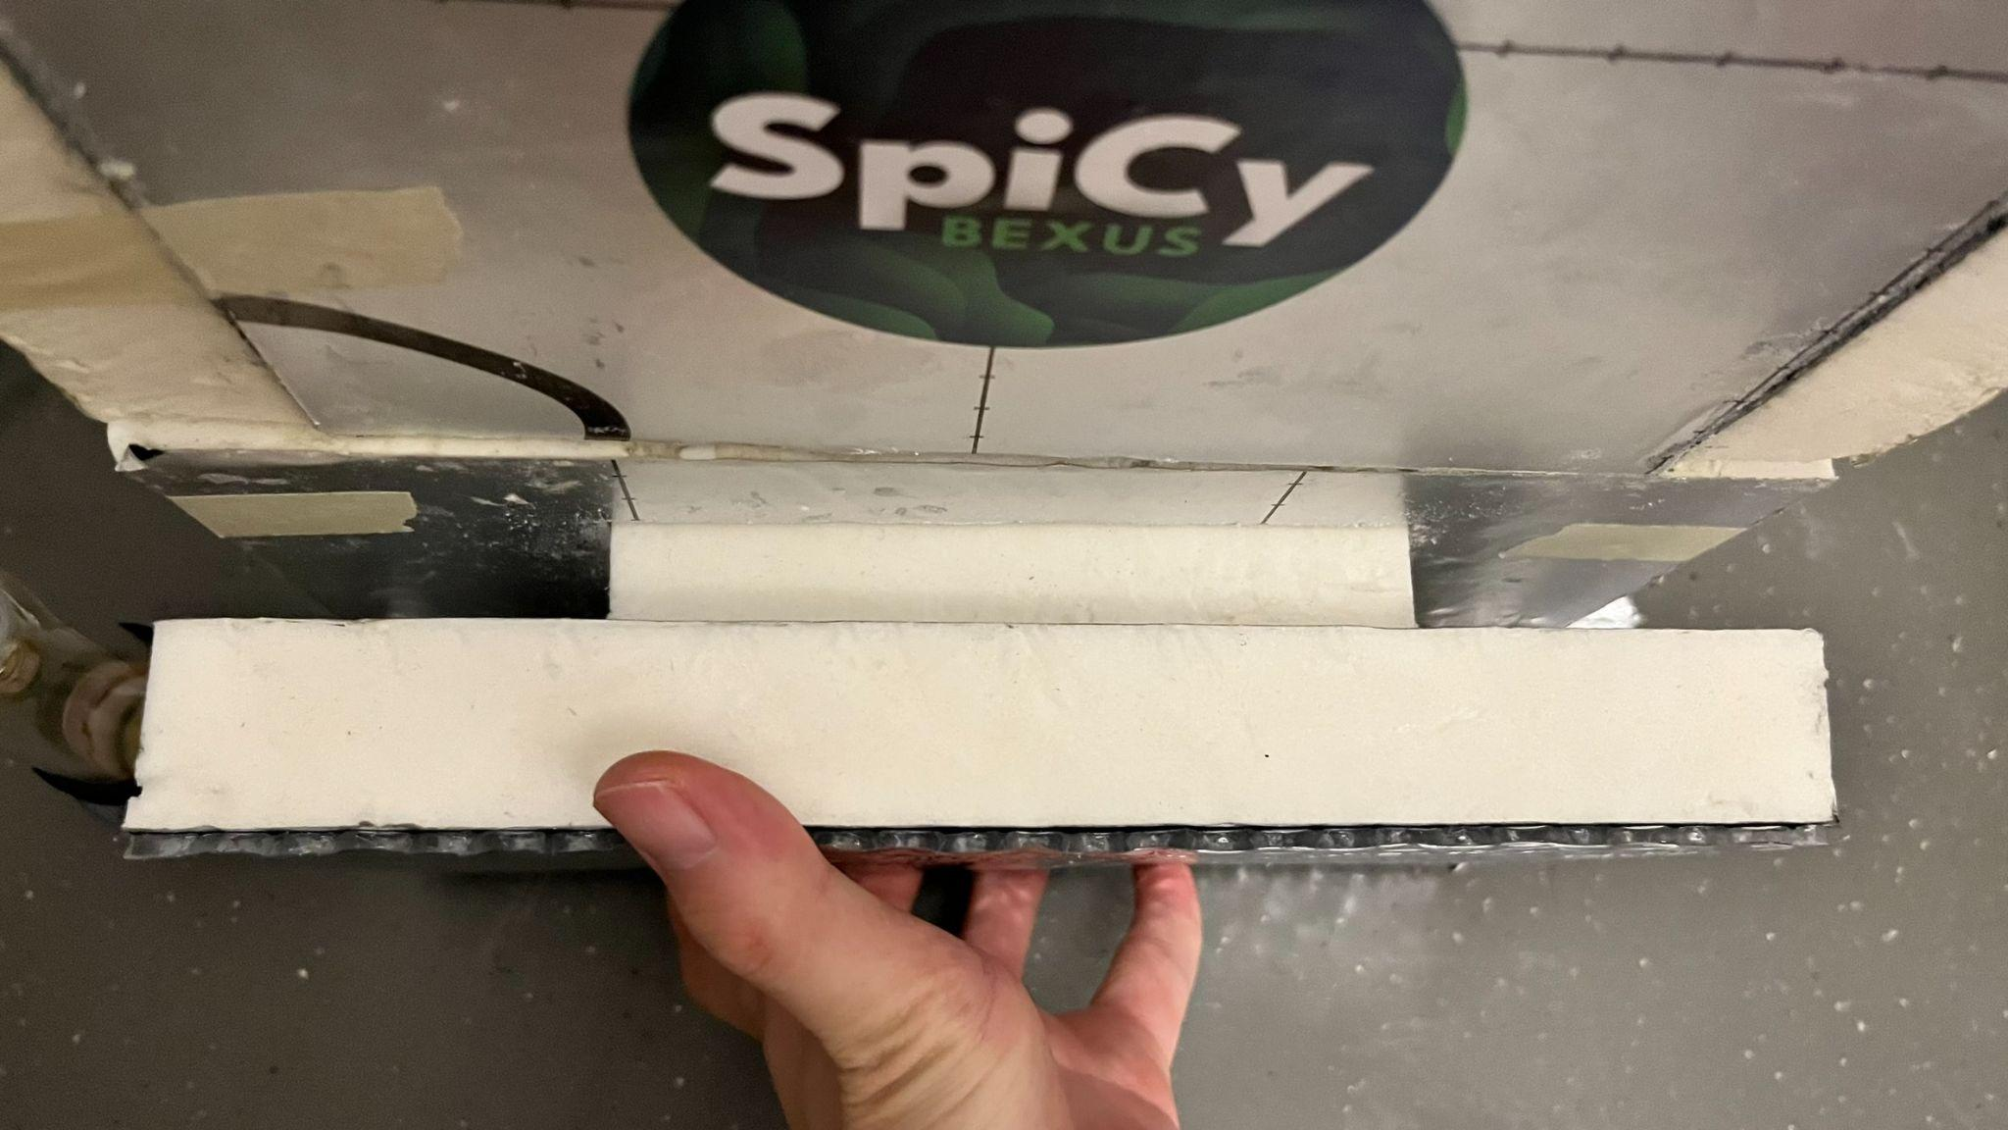

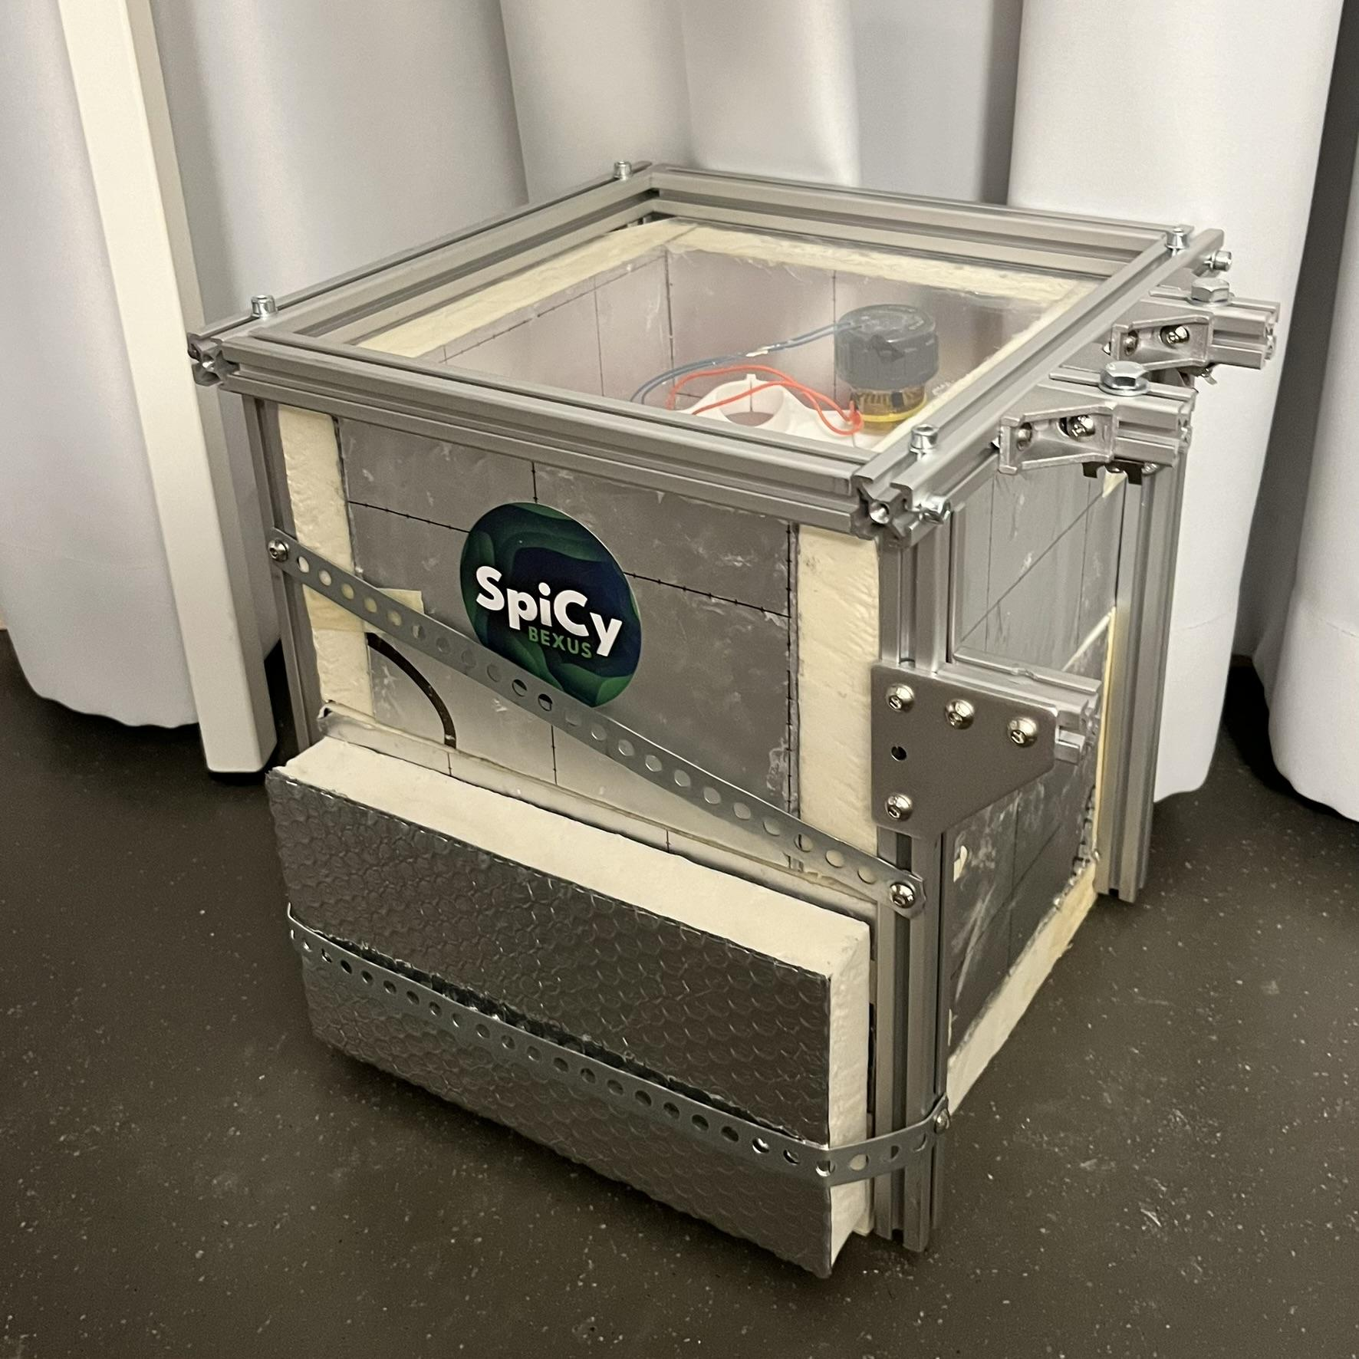 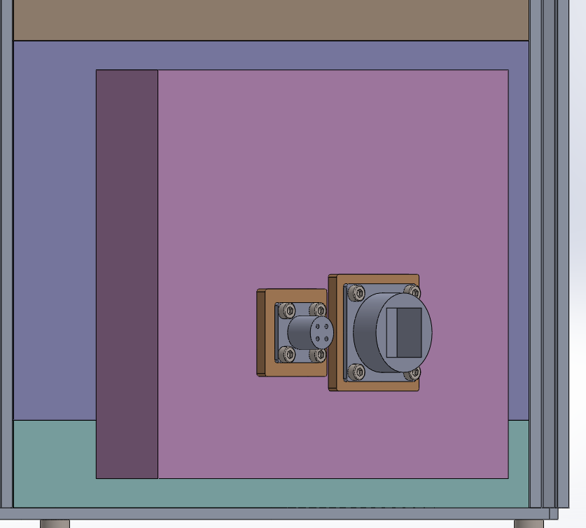

Fig. 4.4-7: Access door to the electronics compartment (top) and the steel hole stripe to fix the door position (bottom left). Power & Ethernet connectors (bottom right). The holes for the connectors are still missing in the module.

1. Box with aluminum profile cage:

An aluminum profile cage reinforces the outer box, enhancing structural integrity and providing resistance to external forces and impacts. This protective shell ensures the internal components remain secure during transportation or handling, while the compartmentalized interior organizes and stabilizes the biofilm tubes.

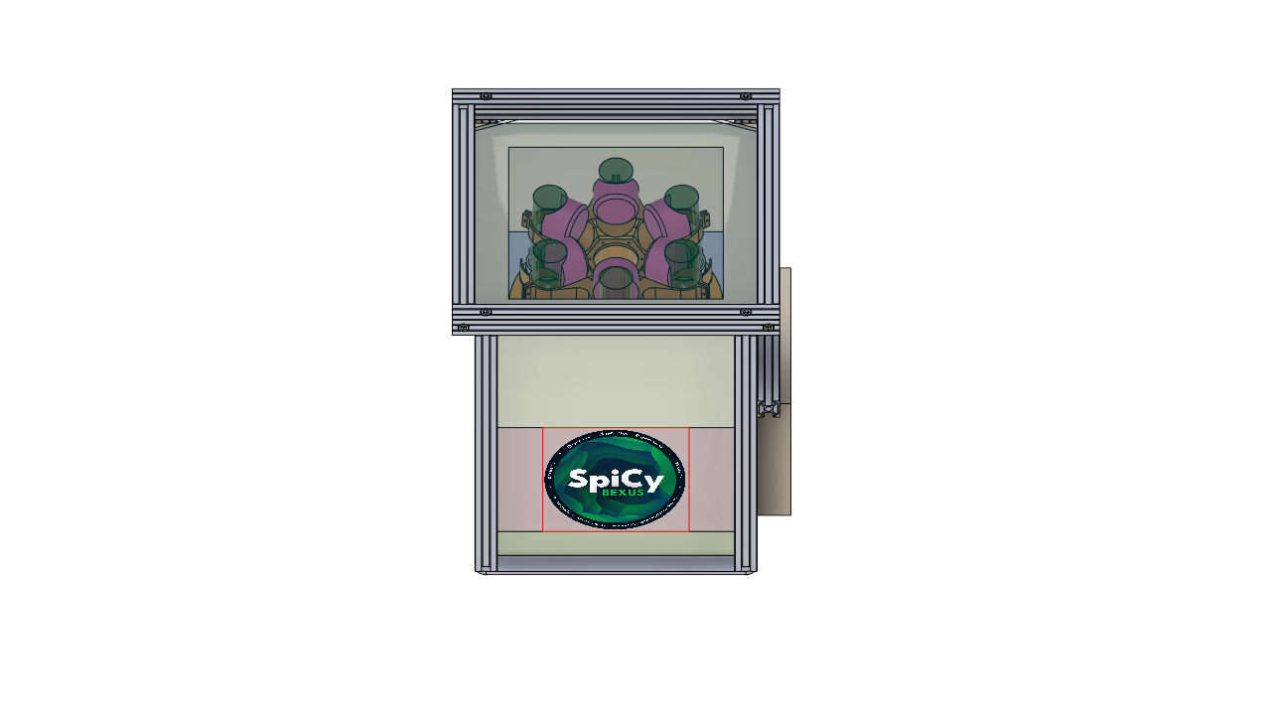 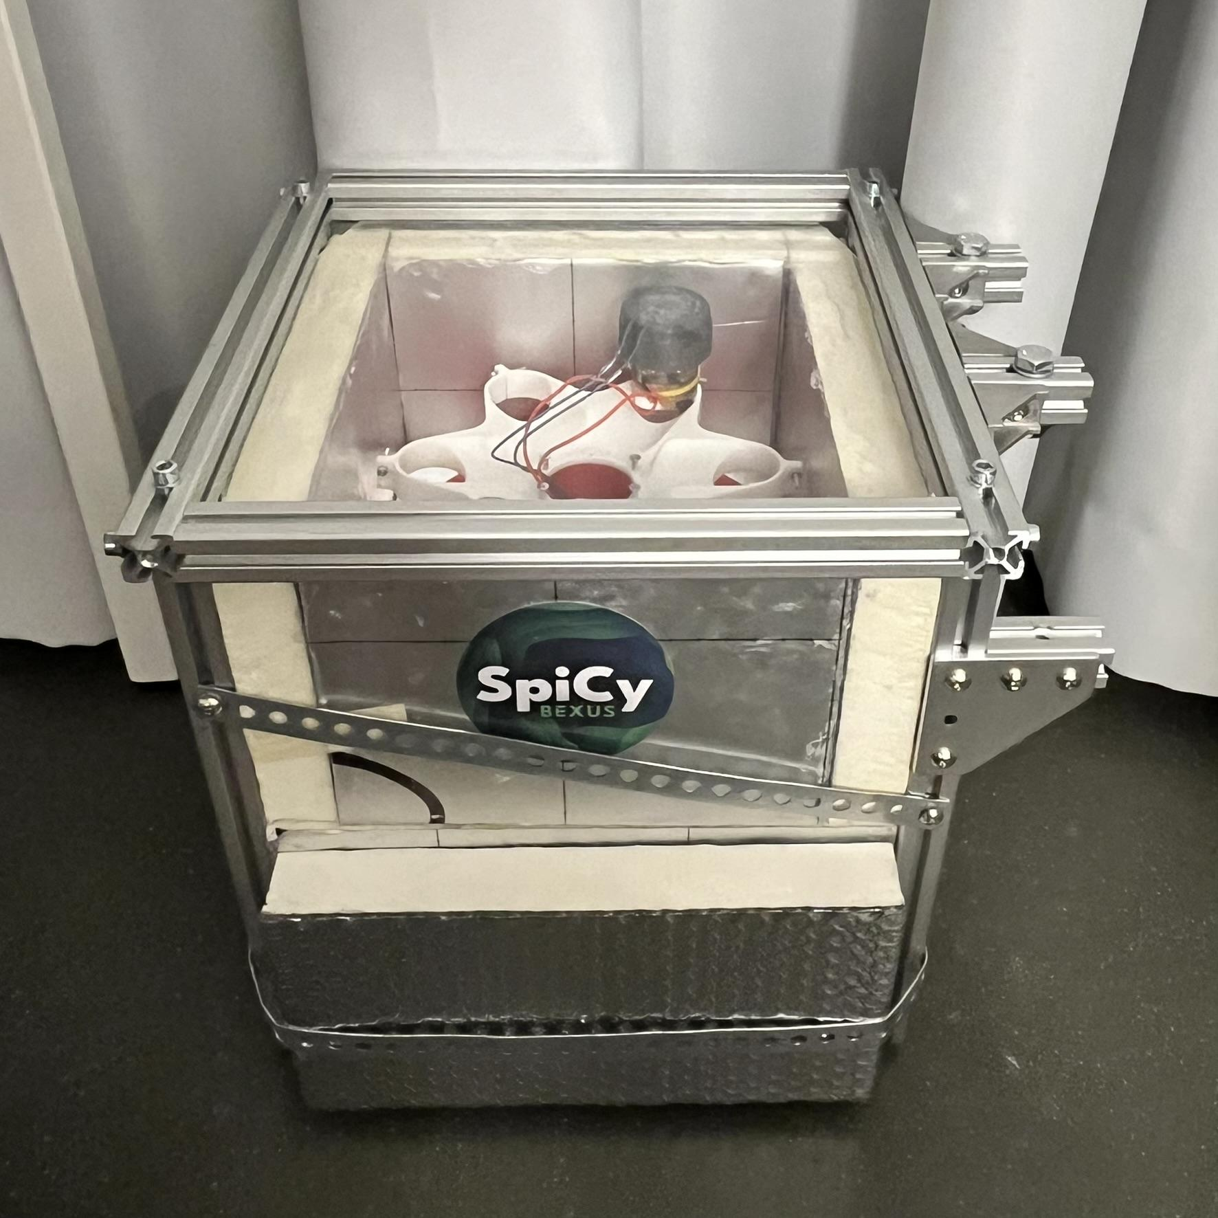 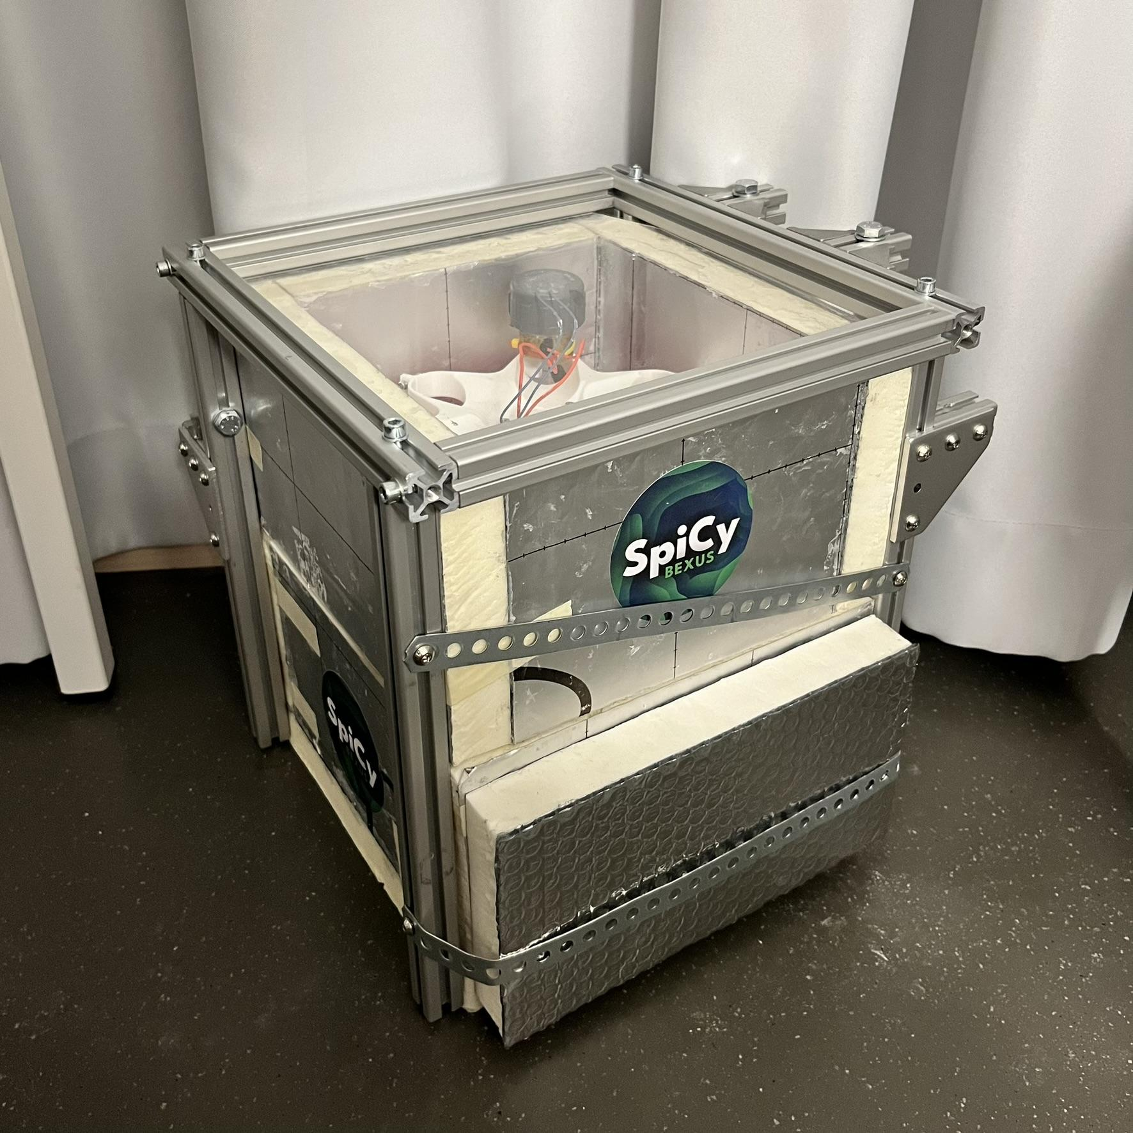 

Fig. 4.4-8: Box with aluminum profile cage design.

1. Sealing mechanism of the tube

For the tube sealing design, a 3D-printed plug is utilized to effectively seal a glass tube, ensuring water-tightness through optimized printing settings that enhance the material’s impermeability. Two rubber O-rings are strategically placed on the nuts of the plug, providing a robust sealing interface to prevent any medium leakage under pressure. The plug is securely held in place by the cap, which ensures that it remains within the tube even when subjected to internal pressure variations. The hole on the plug for the temperature sensor cables will be filled by silicone material.

This sealing mechanism is critical for preventing leakage and avoiding potential contamination within the bio module, thus maintaining the integrity of the biological environment and ensuring reliable experimental outcomes. Proven by the pressure test in a vacuum chamber, this sealing mechanism is able to seal the tube for at least 5 hours under 1 bar pressure difference.

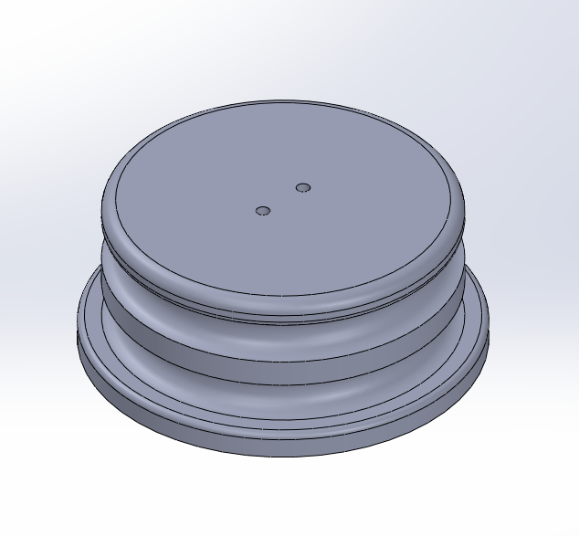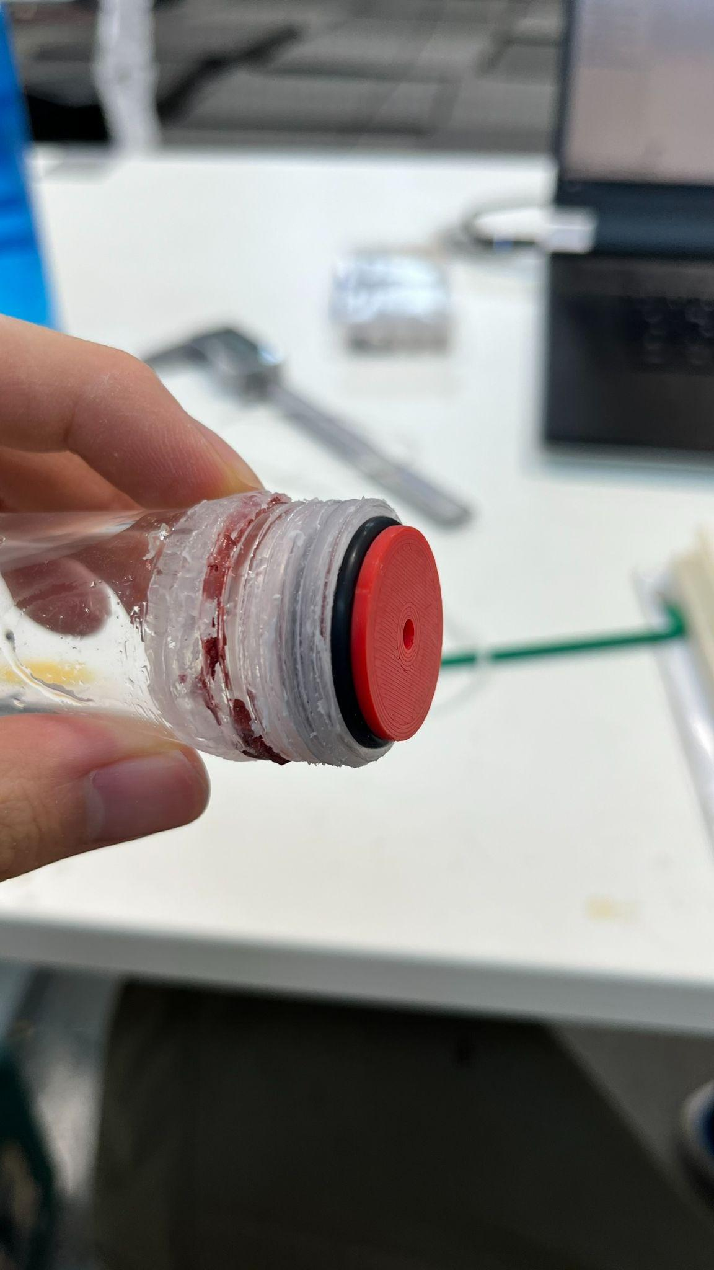

Fig. 4.4-9: Plug with O-Rings in the tube.

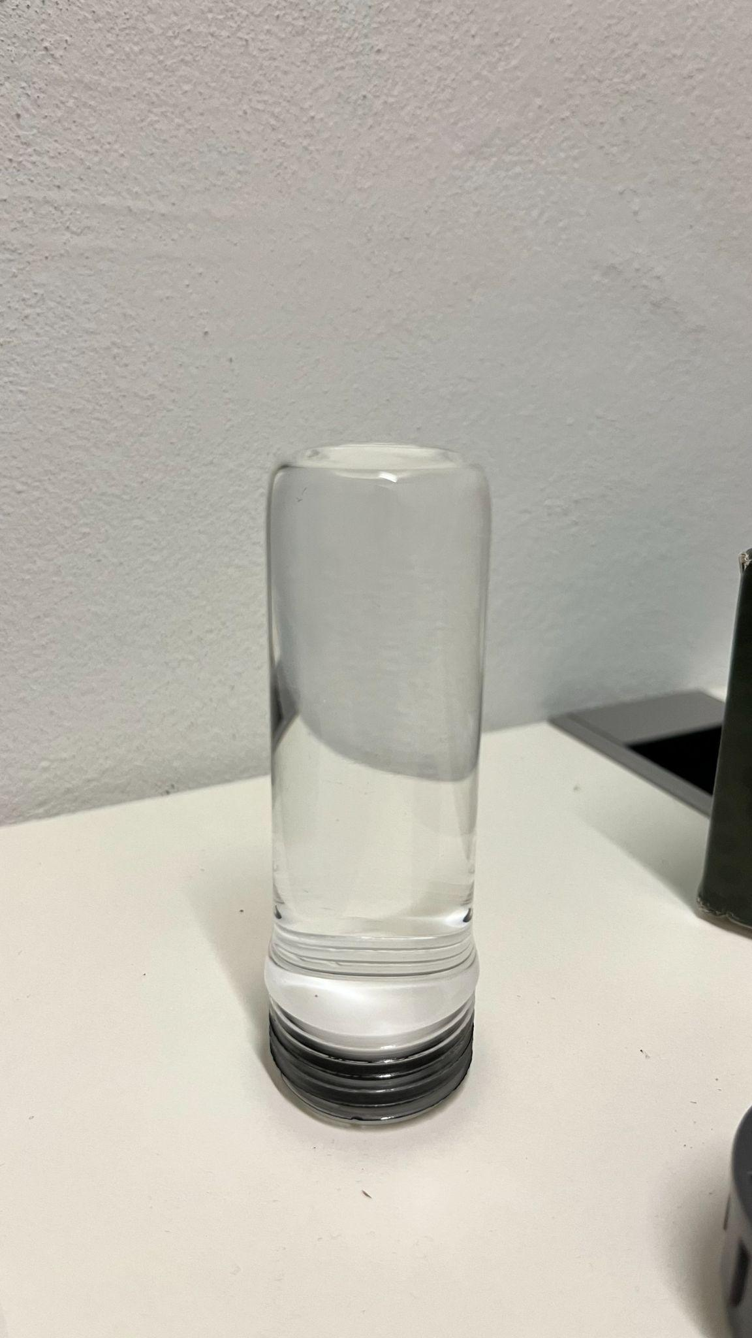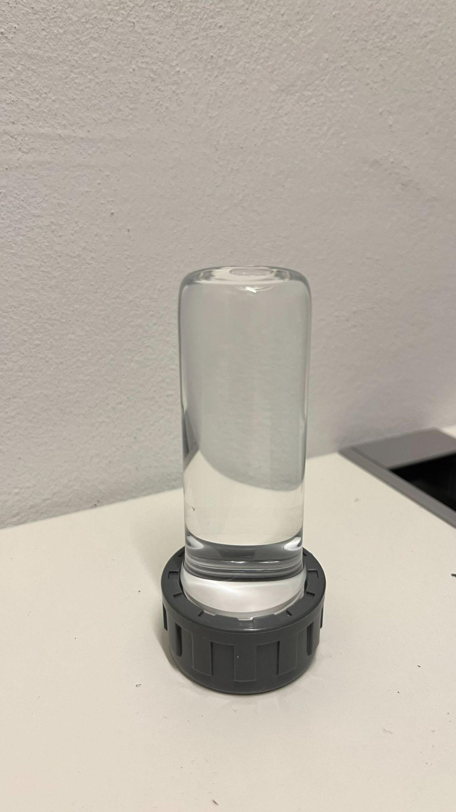

Fig. 4.4-10: Water filled tube without the cap (left) and with the cap (right).

1. Integration of Components:

The 3d printed biofilm tube housing and Quartz Glass lid are seamlessly integrated, using secure fasteners or adhesive bonding for robust attachment. The electronics compartment is designed to be located directly below the biofilm tube housing, ensuring the integrity of the design and ease of operation.

1. Material Considerations:

Firstly, IPR Insulation foam is selected for its light weight and outstanding insulating properties, ideal for maintaining a controlled environment for the biofilm tubes.

Secondly, Quartz Glass is chosen for its high UV allowance and transparency, allowing for a clear view of the biofilm tubes.

Finally, Aluminium profiles are ideal for constructing a robust and durable framework due to their lightweight and high strength. Their lightweight nature reduces the overall structure's weight, making it easier to handle and transport. Their strength ensures the framework can support biofilm tubes and other components, withstanding environmental stresses without deformation. Aluminium's corrosion resistance enhances longevity in high humidity or chemically exposed environments. Additionally, their versatility allows for flexible design options to accommodate various experimental setups.

## 

## Electronics Design

* + 1. **Hardware**

### Hardware **Versions**

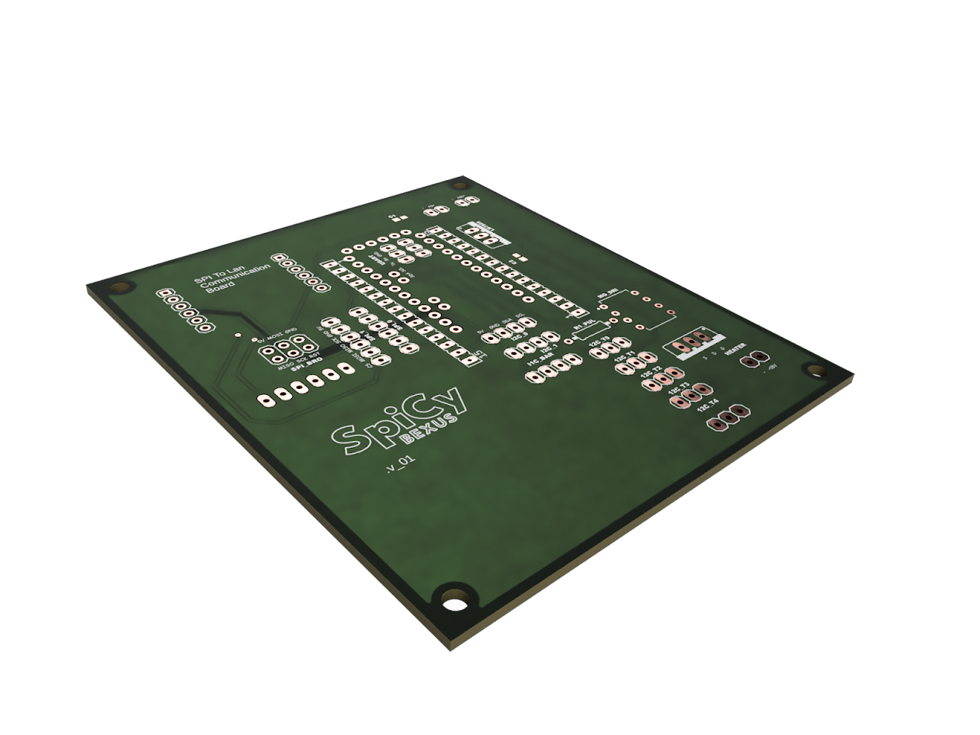

The version V1 was just a debug board for an arduino and a few sensors. This proved as not sufficient, mainly because of the limited capabilities of the arduino uno as well as space restrictions and reliability.

Fig. 4.5-1: SpiCy PCB V1

Second version (no picture) implemented a better Microchip AVR processor on a custom pcb, but got replaced by V3 as the RP2040 was a clear upgrade. Also a lot of sensors had changed so it made sense to start from scratch.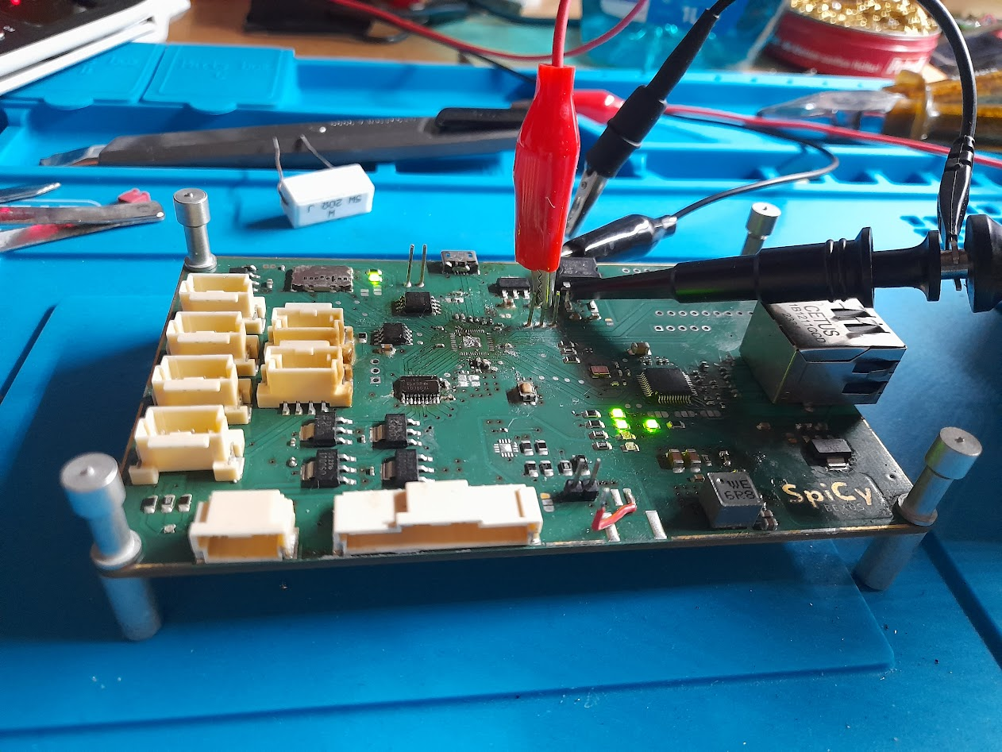

V3 was the first board with the RP2040, but due to a lack of soldering skills critical traces were destroyed and rendered it useless.

Fig. 4.5-2: SpiCy PCB V3

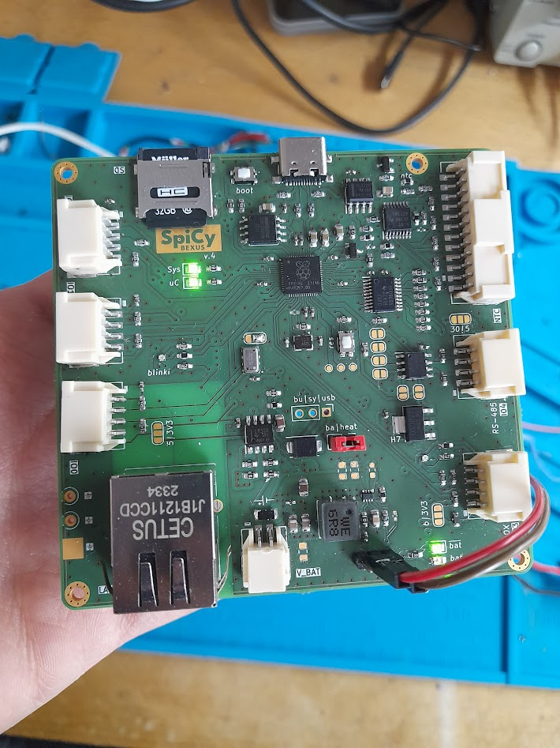

V4.0 was the first flightready hardware. It got some minor changes from V3, like different connectors for power and SD. This almost halved it´s footprint.

The heating elements also switched from [*PROFET*](https://www.infineon.com/cms/de/product/power/smart-power-switches/high-side-switches/profet-plus-12v-automotive-smart-high-side-switch/)s to normal Mosfets, as [*PROFET*](https://www.infineon.com/cms/de/product/power/smart-power-switches/high-side-switches/profet-plus-12v-automotive-smart-high-side-switch/)s don't work at low voltage.

The USB was changed from MicroUsb to Usb C.

Fig. 4.5-3: SpiCy PCB V4.0

V4.1 is the latest iteration of this project. The oxygen sensors changed and weren’t I2C compatible anymore. Instead, 6x UART were required. This added a multiplexer.

Also every heating element as well as thermistor got its own connector, in V4.0 they were bundled together.

### 

Fig. 4.5-4: Assembled Motherboard 4.1

### 

### 

### 

### 

### 

### 

### 

### 

### 

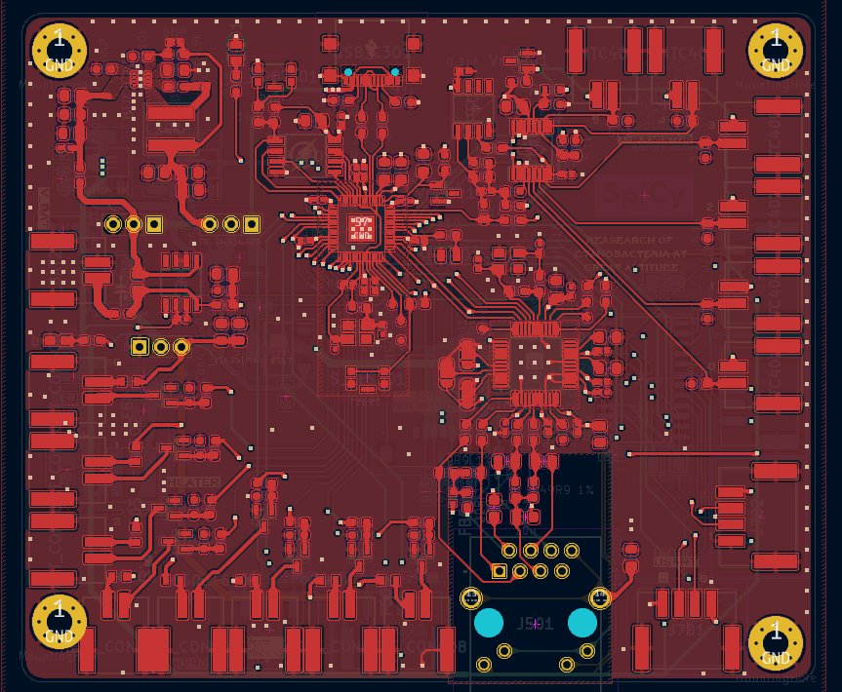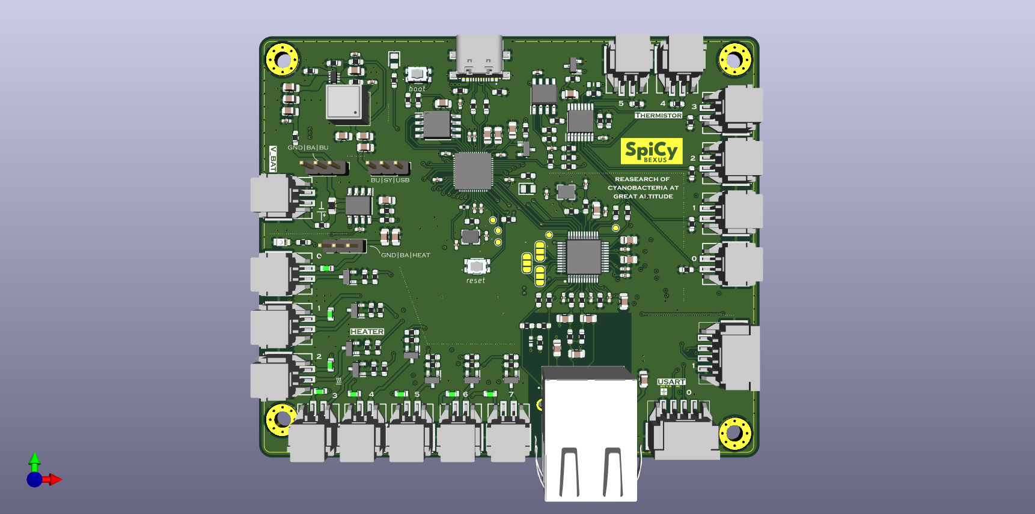

Fig. 4.5-5: V4.1 of the motherboard: [left] 3D rendering top view, [right] signal routing top layer

### Processor

RP2040 is a 32-bit dual ARM Cortex-M0+ microcontroller by Raspberry Pi Ltd. It's mostly known as the processor of the Raspberry Pi Pico.

It was chosen mainly because of the dual core, the ability to multiplex the IO buses like I2C and its easy integration with the Arduino Ide.

### Uplink/Downlink

A W5500 Ethernet chip manages the LAN link to the ground station. It's a Hardwired TCP/IP + MAC + PHY High Speed SPI Interface.

### Heating

As the probes require active temperature control, kapton heaters are used to keep the temperature constant. They get their power from a buck converter. Battery voltage can´t be connected directly, as there's a high current whenever all heaters are turned on. Initially the plan was to compromise this issue with a high resistance heating element, but they are hard to find in the small size required. The final design settled on a buck converter to lower the voltage therefore decreasing inrush current. Looking back it would probably have been fine with a big capacitor bank.

The switching elements were Mosfets with low enough Vth to be switched via GPIOs directly.

For short safety, a PTC fuse is used for each heating element.

### Temperature Probes

NTC probes are used, and with a multiplexer, it's possible to read up to six probes using just one ADC connection. The Multiplexer is connected between the NTC voltage divider and a high impedance amplifier, so it doesn't interfere with the NTC measurement. The amplifier scales the voltage drop across the voltage divider to 3.3V to optimally use the ADC range.

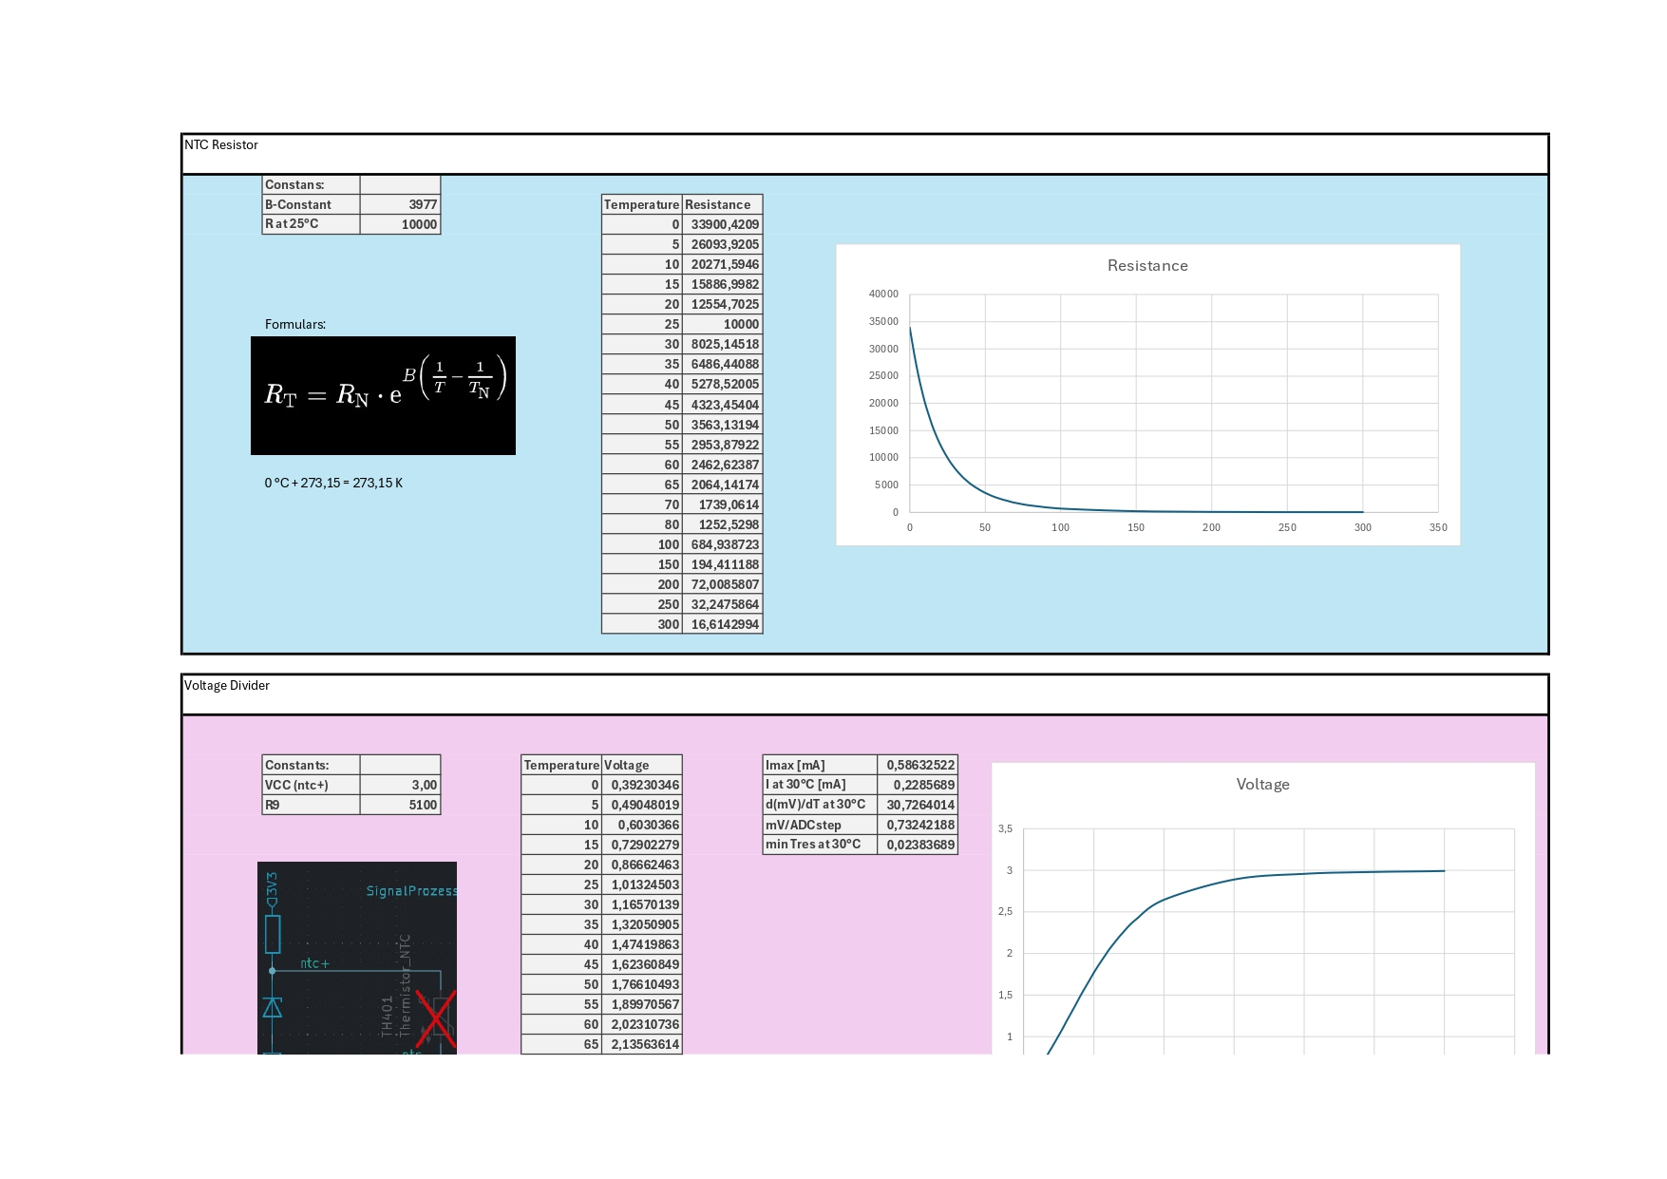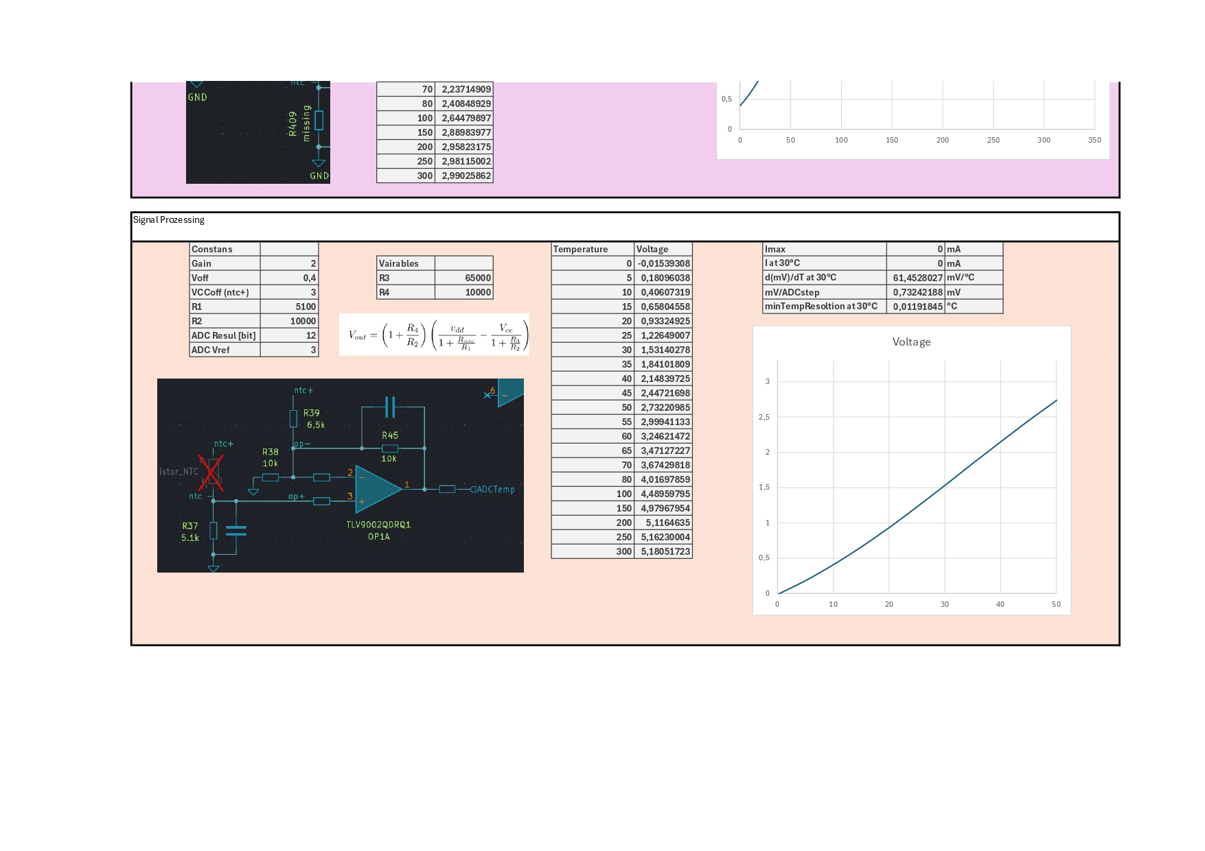

### 

### 

### 

### 

### 

### 

### Oxygen Probes

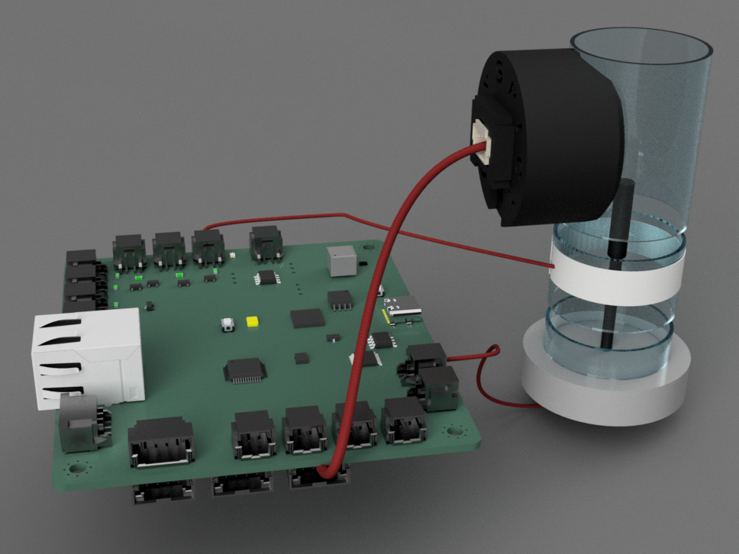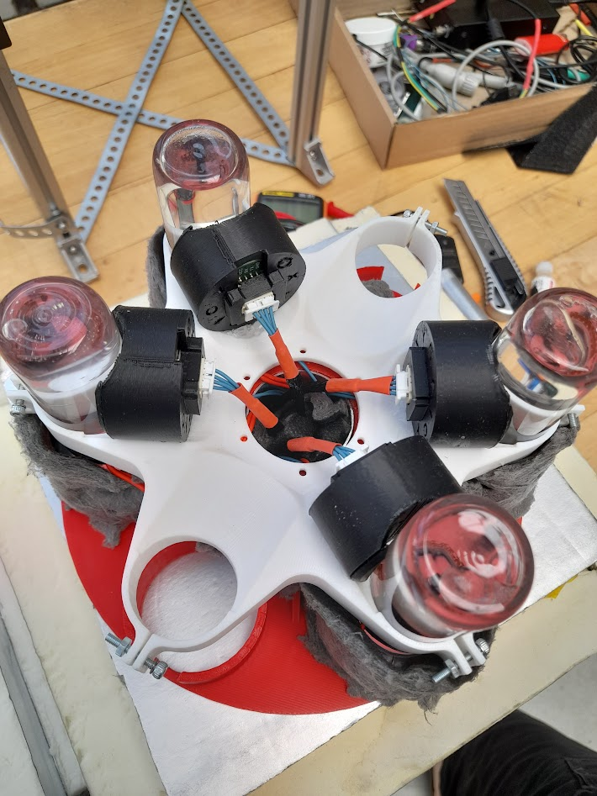

[left] Fig. 4.5-6: Rendering of single tube set-up. [right] Fig. 4.5-7: actual setup with 4 tubes installed

We are using 6 FD-OEM Modules from PyroSience. Links to them are found in the Appendix. They work via a spot glued inside of the container of your oxygen-containing medium. This spot is flashed with a UV light. The reflection of the light in the spot is measured and converted to an oxygen value.

They are easy to program via serial, offer for this project sufficient measurement ranges and accuracies and are equipped with an ambient temperature, humidity and barometer sensors each. As the used microcontroller doesn't have 6 serial IOs, an analog multiplexer is used to select the active sensor. To save on GPIO pins, the multiplexer of the NTCs is linked with the one of the oxygen probes, so if the oxygen probe 1 is selected, so is the NTC 1.

### 

### Light Sensors

The project uses the LTR-390UV light sensor board from Adafruit, which is capable of measuring both ambient and UV light.

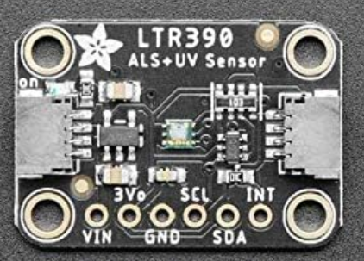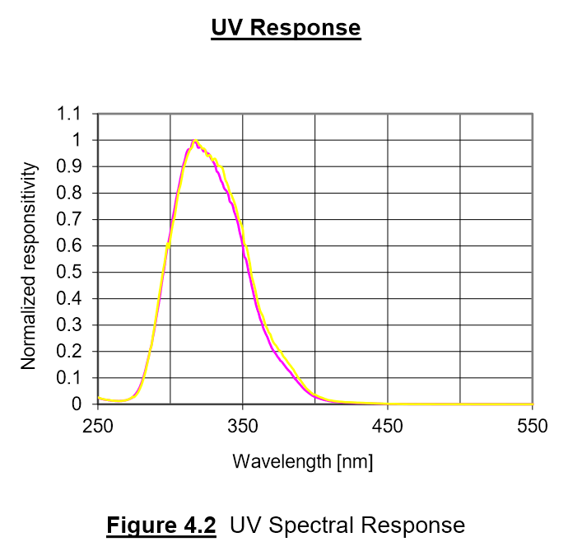

[left] Fig.: 4.5-8: UV Sensor LTR-390UV; [right] Fig. 4.5-9: Absorption spectrum of LTR-390UV

The sensor provides a raw value for each measurement, which can then be converted to LUX.

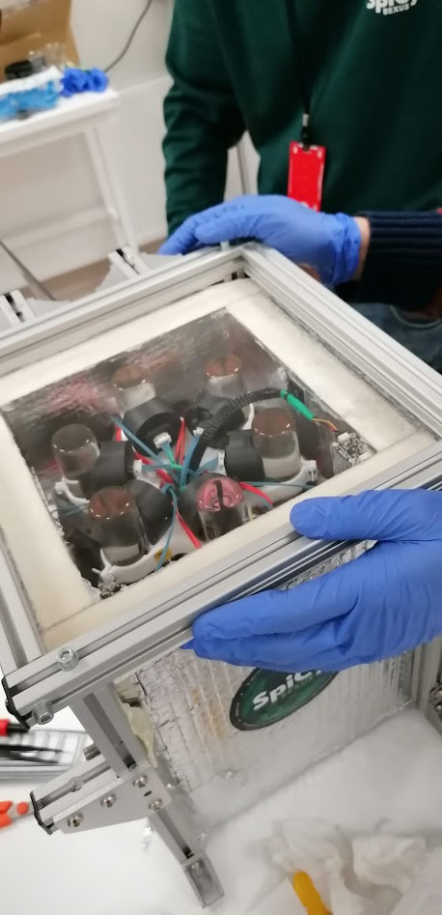

Fig. 4.5-9: Sensor placement in the module in the right corner

The oxygen sensors were also able to record ambient light.

### Circuit Diagrams

*Elements crossed out with a red X are not on the board and are included only for completeness and understanding.*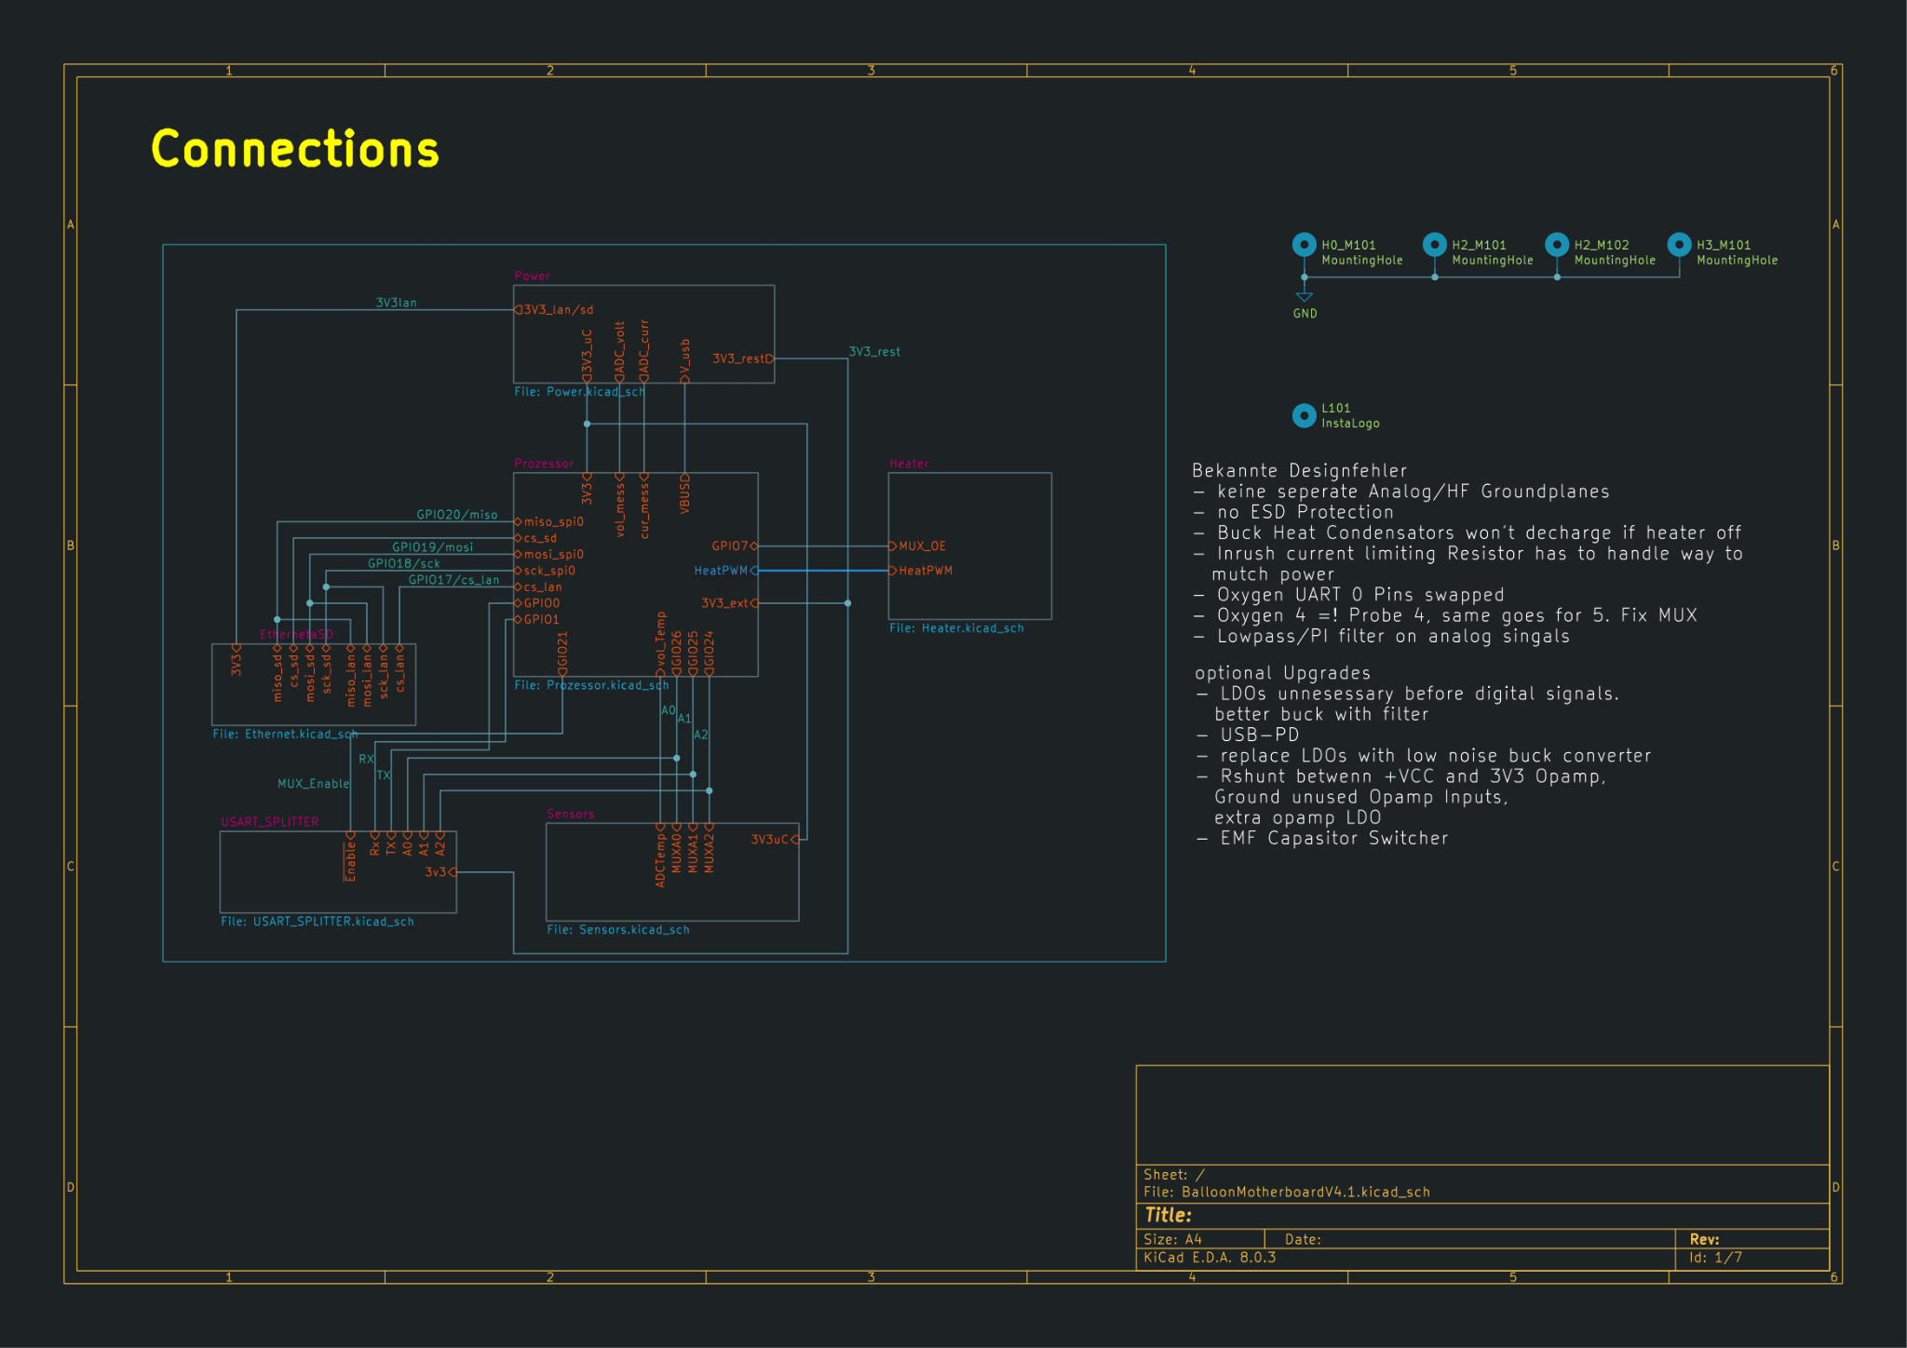

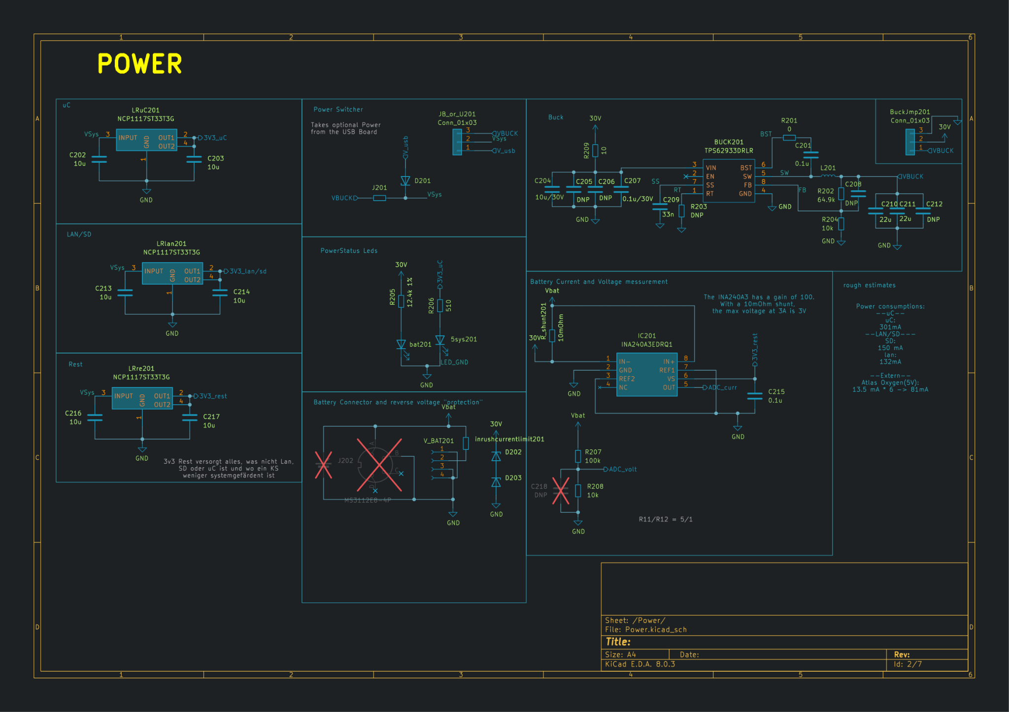

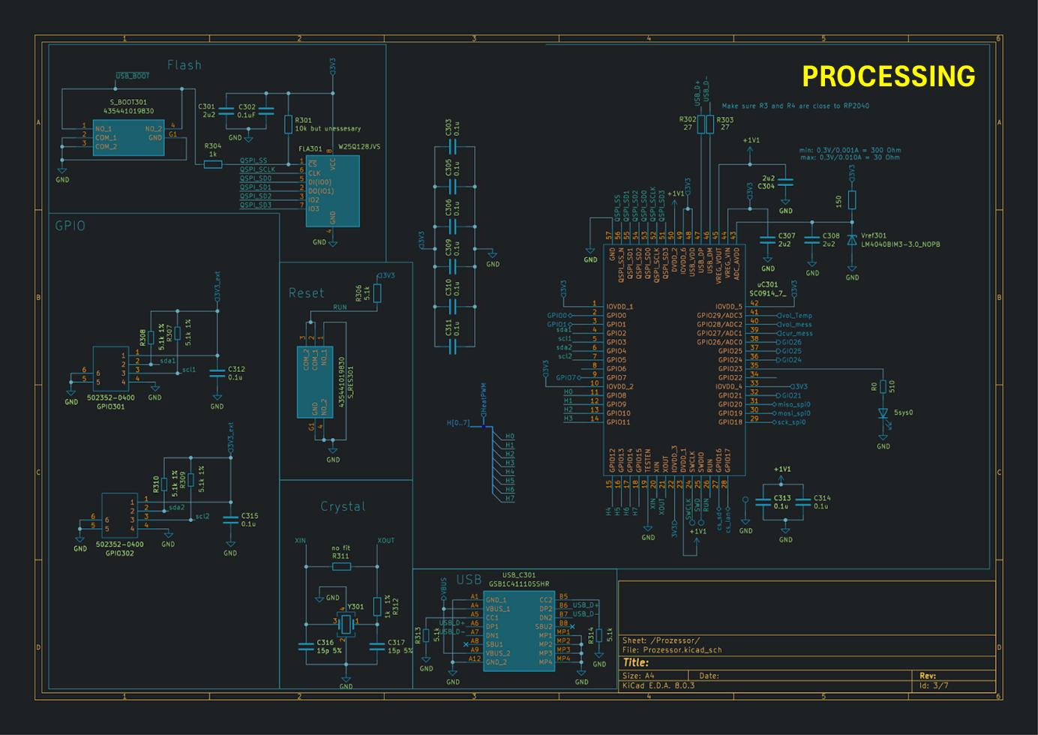

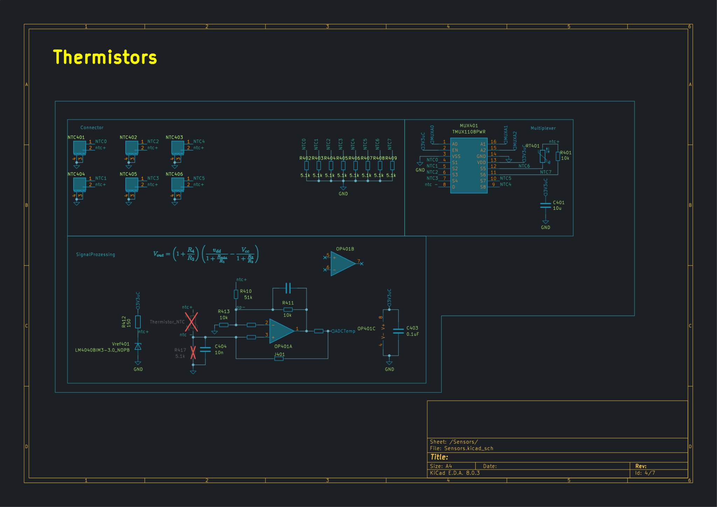

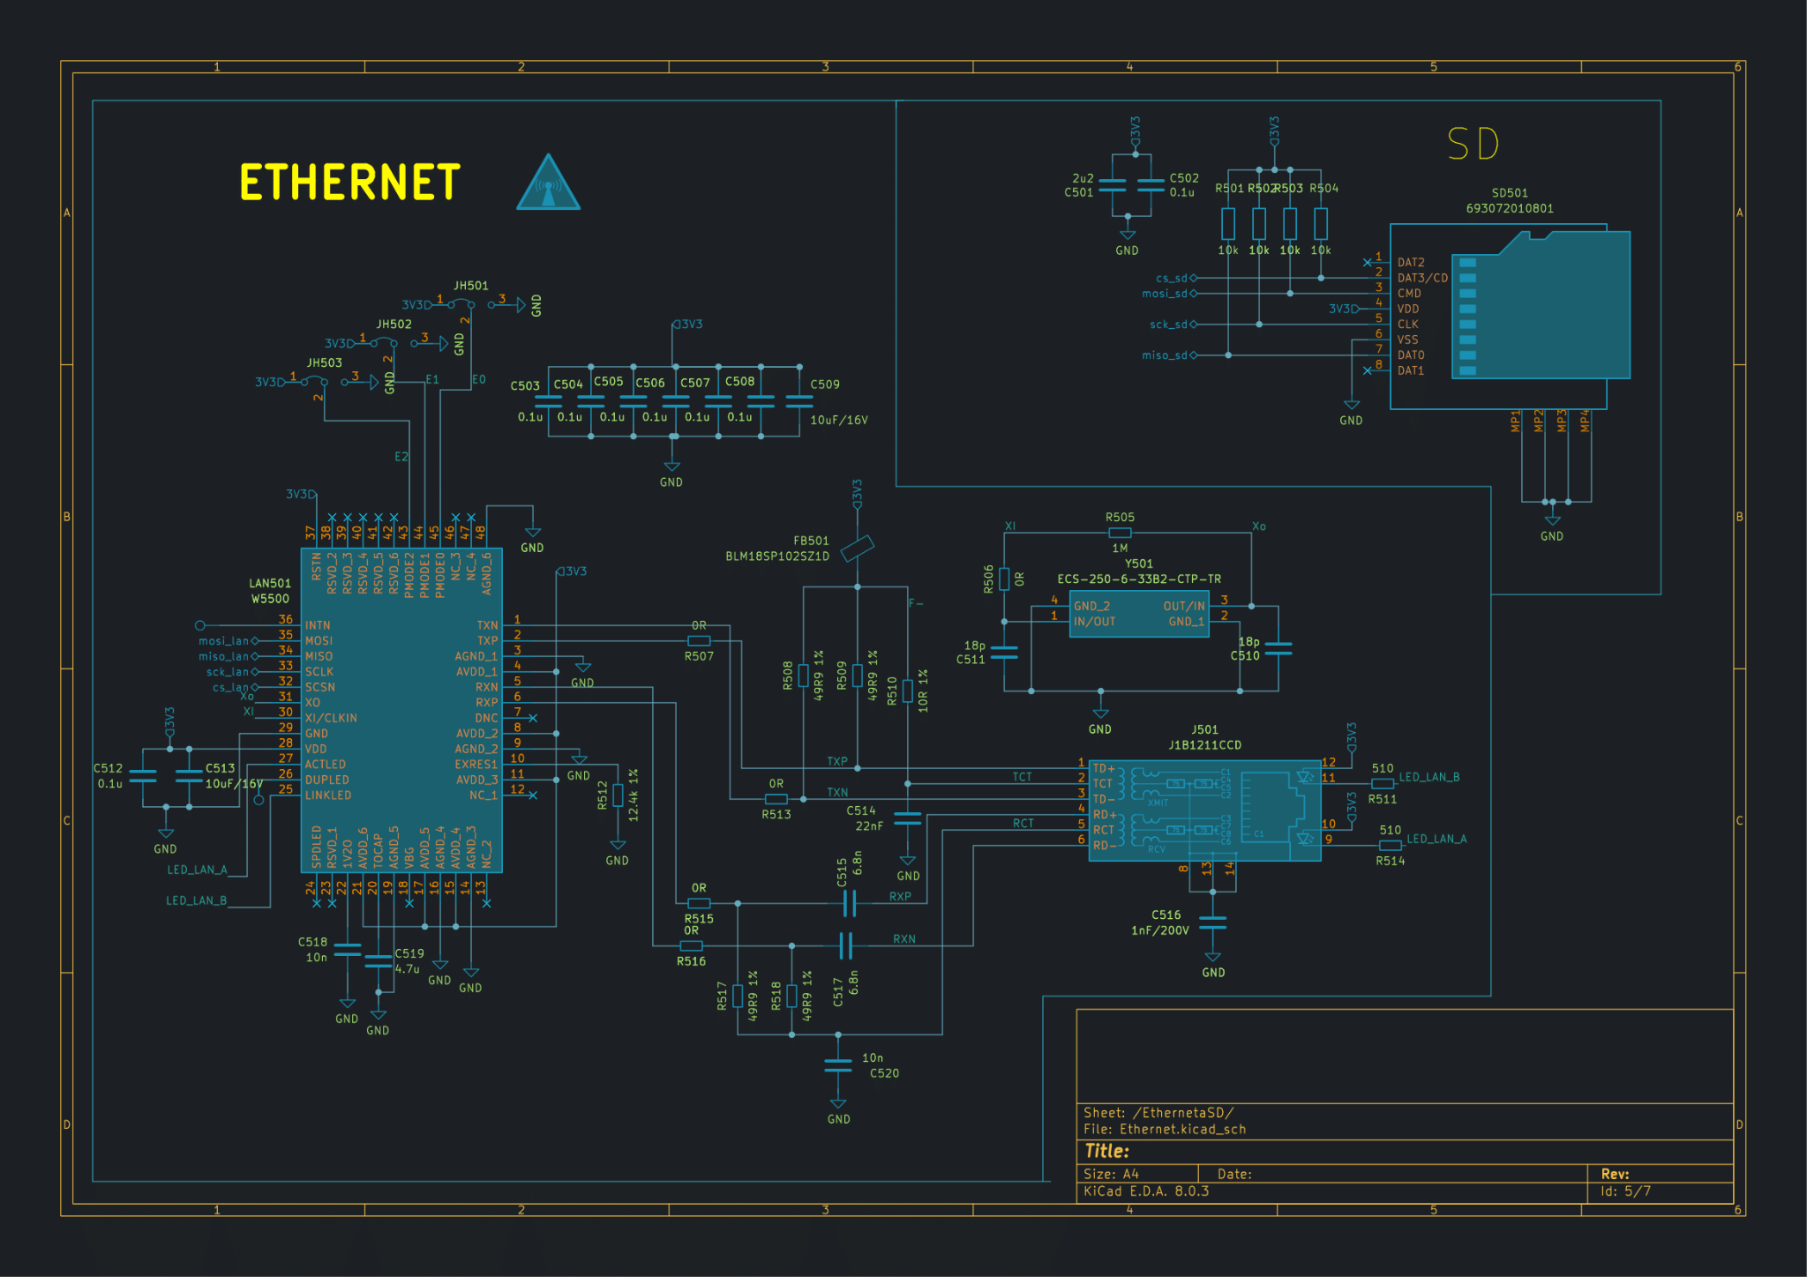

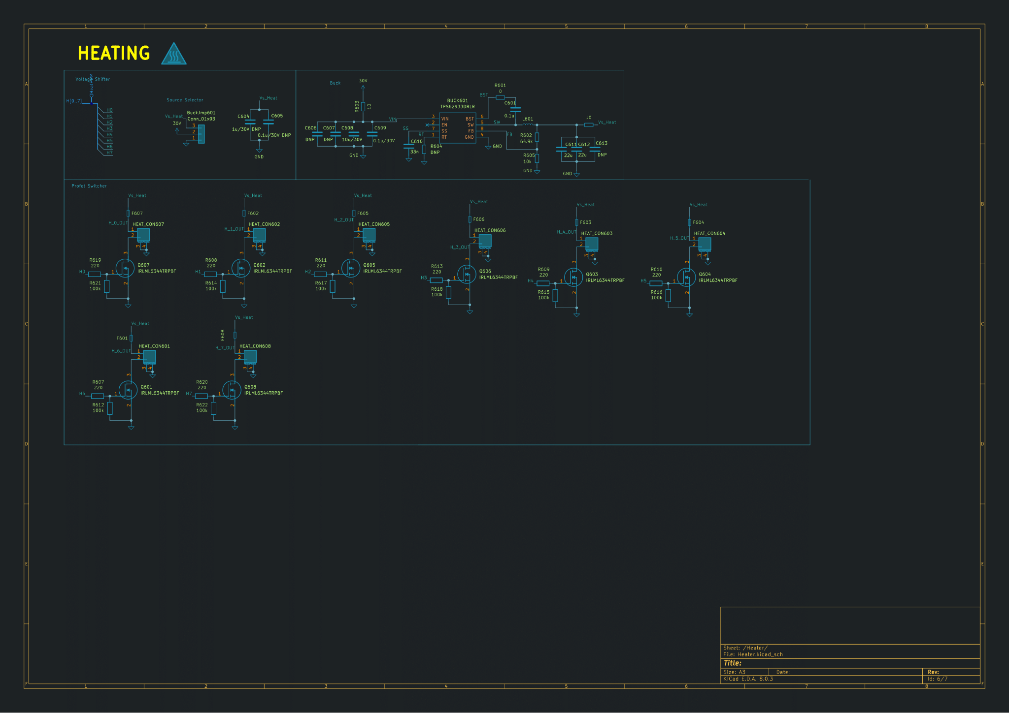

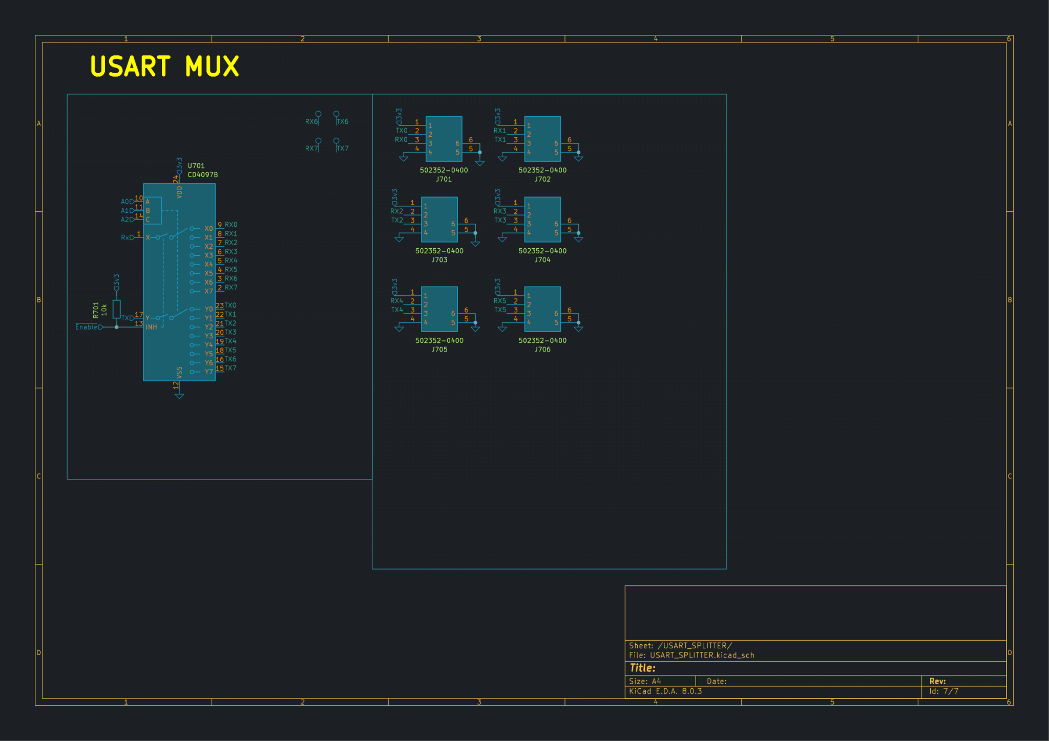

### Cable Harness

Fig. 4.5-10: PCB with indicated connector types (comp. Table. 4-4).

**Table 4-4: Cabling Scheme**

| **Connector on Motherboard** | **Cable type** | **Length** | **Extras** |
| --- | --- | --- | --- |
| Blue: 6x NTC/Thermistors | 2 x 24 AWG blue teflon wire with a duraclick connector. Blue tape at end | 30 cm | One cable side glued to cap of tube. |
| Green: 6x USART for the oxygen sensors. At USART0 the RX/TX line is switched. | 4 x 24 AWG blue teflon with two duraclick connectors.  Wire bundled and red tape on end. | 30 cm | USART0 cabling has green tape on the end and RX/TX switched. |
| Red: Heating elements | 2 x 24 AWG blue teflon wire with a duraclick connector. Blue tape at end | 30 cm | One cable side soldered to kapton heater. |
| Purple: Battery connector | 2 x 24 AWG blue teflon wire with a duraclick connector and the MIL – C-26482P soldered onto | 20 cm |  |
| Yellow: connections for external buck converter.  One for heating and one for the rest.. | 3 x 24 AWG blue teflon wire to one JST connector. The other side is soldered to the buck converter. | 20 cm | On the real pcb those are JST header and not pin header. |
| Ethernet | Lan cable to RJF21B | 20 cm | - |
| USB-C | USB C cable which can transfer data | - | Only used to flash firmware/debug |

### Inrush current limiter

*I decided against the use of such a limiter, as it seems not to be normally implemented on BEXUS missions. The battery fuse does trigger at 5A, but is expected to need continuous current and doesn't seem to be triggering at peaks. Regardless, here are my designs:*

As the input of the buck converter features quite large capacitors, there's a considerable current flowing whenever the motherboard is plugged in. And as the battery features a 5A fuse, a current limiter was planned. It would be implemented as a mosfet circuit.

## 

*Simulation without current protection. Ideal circuit-> in reality current limited by battery and wire resistance*

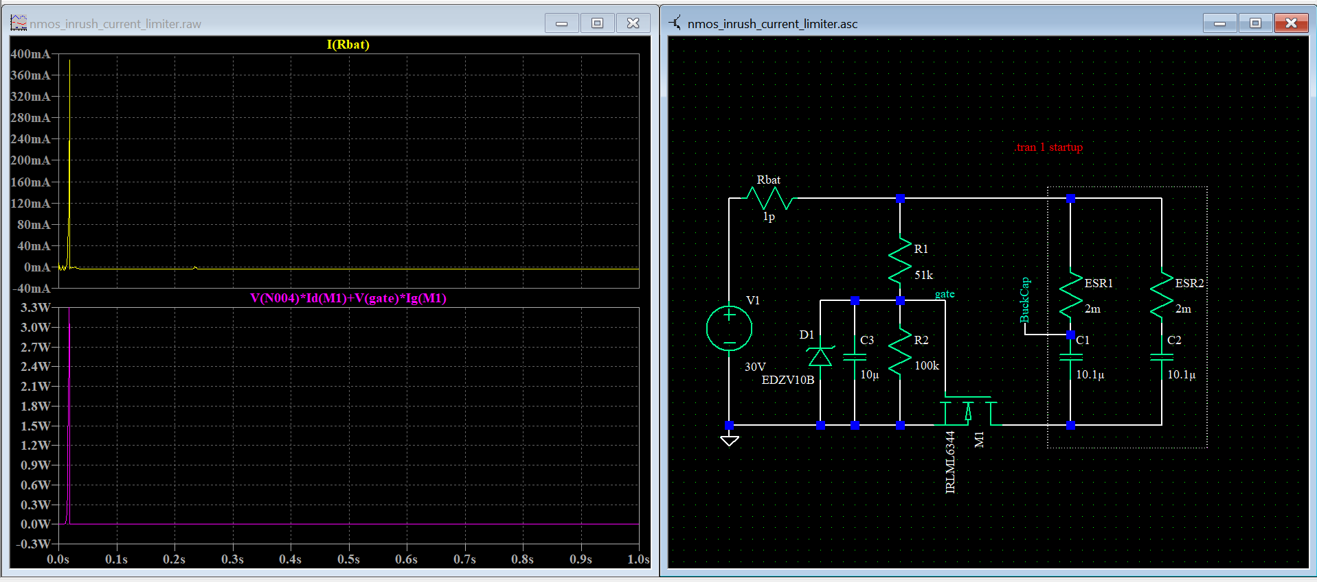

*Simulation with current protection. Capacitor limits rise of gate voltage, z-diode clamps gate voltage.*

It would be implemented as an extra protection circuit between the battery and the motherboard.

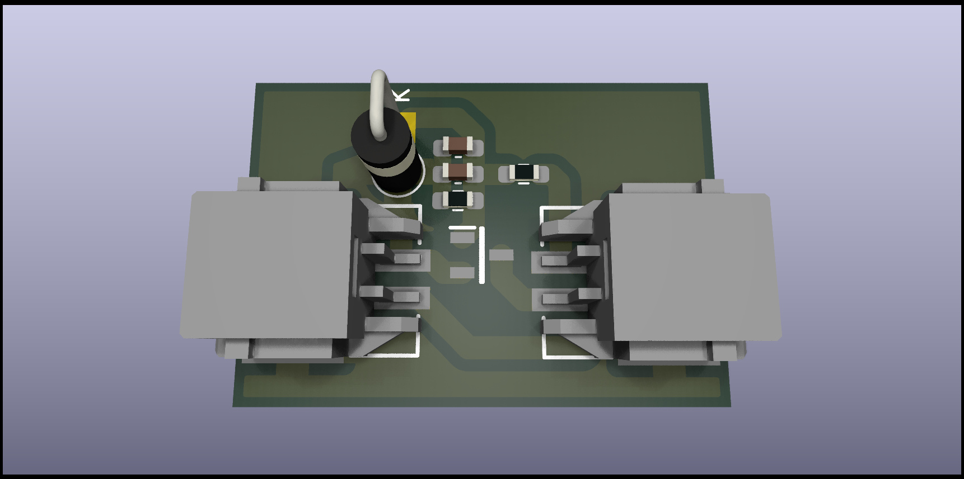

Fig. 4.5-11: Theoretical placement of inrush current limiter on PCB (not used in the end)

## Thermal Design

* + 1. **Goals**

The thermal design in this experiment has two primary objectives:

* Maintain the temperature of biological samples within their operating range of 25-30°C.
* Ensure that the temperature of the electronic components stays within the specified operating range for each component.

* + 1. **Boundary conditions**

The experiment operates in a low-pressure environment, approximately 1% of ground-level pressure.

Initially, convection is neglected due to the low density of the air.

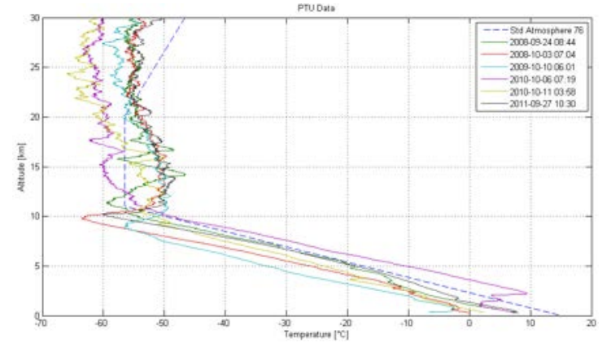

Fig. 4.6-1:Temperature of the Kiruna atmosphere on different days.

Fig. 4.6-1 illustrates the temperature profile of the Kiruna atmosphere on various days. The module must function in temperatures as low as -80°C, as stated in the BEXUS User Manual. Therefore, the cold case is defined at -80°C, and the hot case during the float phase is at -40°C.

* + 1. **Heat transfer model**

To determine the appropriate thermal control system and its design, the heat flow into and out of the module must be modeled and analyzed. A schematic representation is shown in Fig. 4.6-2.

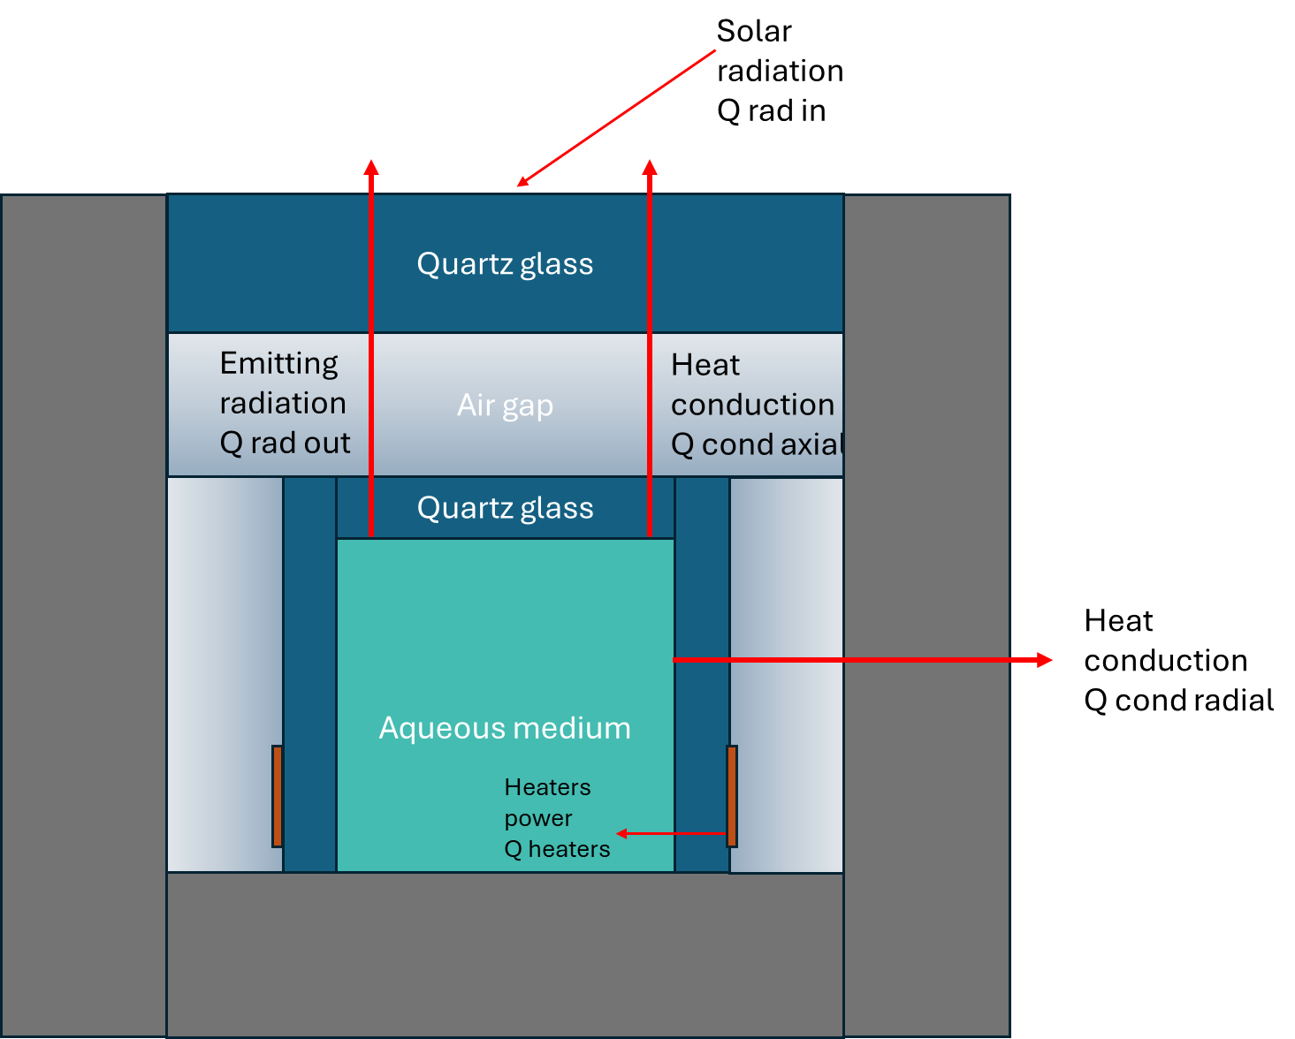

Fig. 4.6-2: Heat exchange model.

For the heat input (Qin,​), the following sources are considered:

* Solar radiation: Solar energy entering through the transparent glass layer and the module surface. Only the solar radiation through the top is considered, as the rest of the module is covered with a non-transparent fabric.
* Albedo: Reflected solar radiation from the Earth's surface is significant for satellites but is neglected here, as the gondola's lower part and sides are covered.
* Earth IR radiation: Similar to albedo, infrared radiation is neglected because the module is shielded by the gondola's bottom plate and fabric layer.
* Air friction: Heating due to air friction is considered only during the ascent phase due to higher velocities but is relatively minor compared to solar radiation.

In this case, only solar radiation through the glass layer is included in the model.

For Qout, the heat rates to be considered are the following:

* Convection of air outside the module: Heat losses due to the cooling effect of the surrounding cold air. During the float phase, low air density results in a less effective convection with a heat transfer coefficient (h) of 0.254 W/(m²·K). Fig. 4.6-3 shows the variation of this coefficient with temperature and pressure.

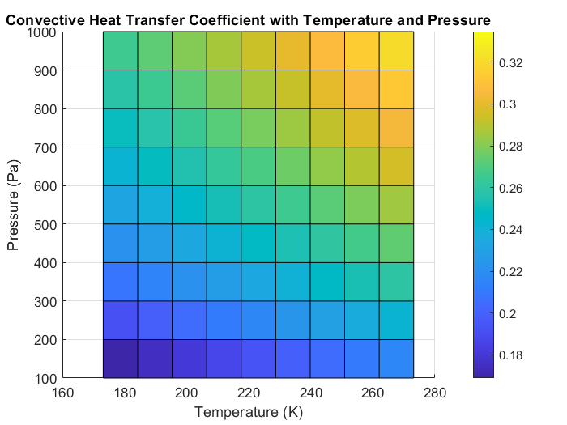

Fig. 4.6-3:Variation of the convective heat transfer coefficient with Temperature and Pressure.

In this context, convection is more relevant than for a satellite. Thus, the outer temperature of the module is assumed to equal the environmental temperature.

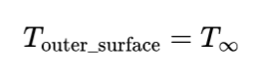

* Radiation through the glass layer: The biological samples, at 27.5°C, emit infrared radiation through the transparent glass layer. This requires the view factor between the glass layer and the tube's flat end.
* Radiation at the module surface: When the module's surface temperature differs from the environment and there is no convection, radiation occurs. Here, the outer temperature equals the environment temperature, so there is no radiation through the styrofoam box.
* Heat conduction through the glass plate (Axial): Heat loss through axial conduction from the aqueous medium to the outer environment across the glass layers is modeled using an electric circuit analogy to determine total resistance.

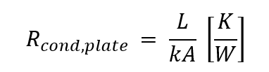

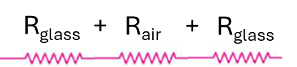

Fig. 4.6-4:Electric circuit analogy for heat conduction of flat plates.

* Heat conduction through the styrofoam box (Radial): Similar to glass conduction, but for cylindrical shells.

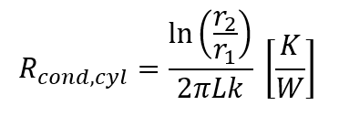

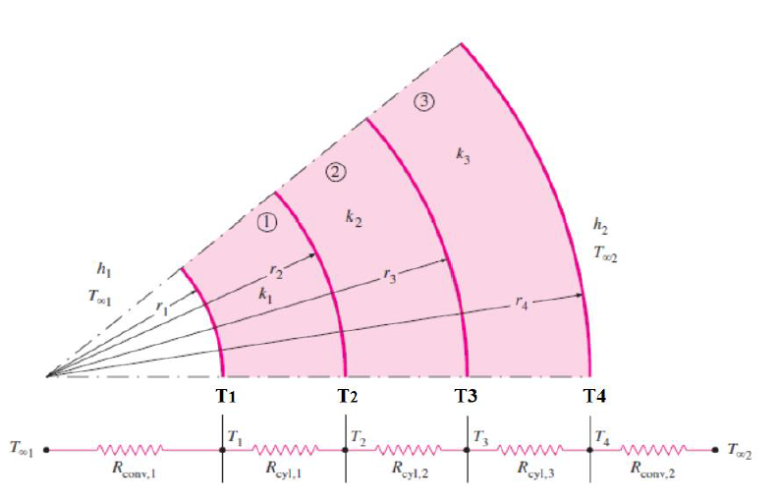

Fig. 4.6-5:Electric circuit analogy for heat conduction of cylindrical shells.

* + 1. **Equilibrium analysis**

The heat transfer rates are calculated using the following equilibrium formula:

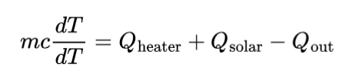

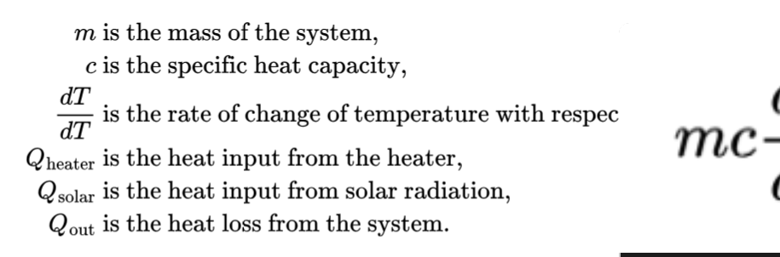

In the following Table 4-5, the results of the heat transfer model computed in MATLAB are displayed.

**Table 4-5: Heat rate distribution**

| **Qin** | **Qout** | |
| --- | --- | --- |
| **Solar radiation** | **Hot case (Tamb = - 40°C)** | **Cold case (Tamb = - 80°C)** |
| 0.18 W | 1.75 W | 2.54 W |

As it can be observed in the table, there is a deficit of power that must be provided in order to keep the temperature constant.

To maintain a constant temperature, an active thermal control system with Kapton heaters and a PI controller is recommended. The required power is 2.54 W per tube in the cold scenario.

Regarding the electronics, the different components have to operate in the range of temperatures specified for them. The most restrictive one is -25°C to 70°C. The approach to keep the temperature within the operating range is to cover the electronics box with insulating foam so the dissipated power remains inside the electronics box to keep it within the operating range.

**Table 4-6: Component Temperature Range**

| **Component Type** | **Typical Temperature Range (°C)** | **Component Name** |
| --- | --- | --- |
| Inductor | -40 to 125 | 74439346068 |
| SMD Resistor | -55 to 155 | 435441019830 |
| SD Card Socket | -25 to 85 | 693072010801 |
| Shunt Resistor | -55 to 125 | PA1206FRE7W0R001Z |
| Battery Connector | -40 to 105 | 502352-0200 |
| Right Angle Header | -40 to 105 | 502352-0400 |
| Micro SD Card Hinge | -40 to 70 | 502352-1210 |
| Crystal Oscillator | -40 to 85 | ABM8G-12.000MHZ-4Y-T3 |
| Chip LED | -40 to 85 | APTD2012LCGCK |
| Ferrite Bead | -55 to 125 | BLM18SP102SZ1D |
| Pin Header | -40 to 105 | Conn_01x03 |
| Crystal Oscillator | -40 to 85 | ECS-250-6-33B2-CTP-TR |
| USB Type-C Connector | -40 to 85 | GSB1C41110SSHR |
| Ethernet Connector | -40 to 70 | J1B1211CCD |
| Operational Amplifier | -40 to 125 | LM2904AVQDRQ1 |
| Voltage Reference | -40 to 85 | LM4040BIM3-3.0_NOPB |
| RS-485 Transceiver | -40 to 85 | MAX3485AEASA+T |
| Voltage Regulator | -40 to 125 | MCP1826S-5002E_DB |
| PPTC Fuse | -40 to 85 | MF-FSML100/8-2 |
| Voltage Regulator | -40 to 85 | NCP1117ST33T3G |
| NTC Thermistor | -40 to 125 | NTCGS163JF103FT8 |
| Rectifier Diode | -40 to 150 | RBR2LB60BTBR1 |
| Microcontroller | -40 to 85 | RP2040 |
| Status LED | -40 to 100 | LTRBR37G-4R4S-0125-0 |
| Analog Multiplexer | -40 to 125 | TMUX1108PWR |
| Buck Converter | -40 to 85 | TPS62933DRLR |
| Voltage Translator | -40 to 85 | TXS0108EQPWRQ1 |
| Flash Memory | -40 to 85 | W25Q128JVS |
| Network Controller | -40 to 85 | W5500 |
| Light Sensor | -40 to 85 | AS7262 |
| Light Sensor | -40 to 85 | AS72623 |

* + 1. **Mission envelope analysis**

To compare different operation points is relevant to analyze the mission envelope and what are the different heating needs of each. In this analysis, convection is included dynamically as at the beginning the pressure is significantly higher than the one over the float phase.

The assumptions made in this chapter are the following:

* Convection outside the module is included and it will have an effect on the heat transport.
* Convection in the air gap between the glass plate and the tube is included.
* The module is not airtight and the pressure on the inside of the module is the same as outside, modifying then the heat convection coefficient.

In light of these assumptions and the provided mission in the following graph, the power required can be derived.

The mission consists of a combination of pressure and temperature points that varies from 1013.15 Pa to 101315 Pa and from 20°C to -60°C. The temperature is depicted with the blue line and the pressure is depicted with the red line.

The power that is required in each of the operating points is depicted in the green line. It varies from 0.19 to 2.09 W per tube. The most demanding conditions occur during the float phase reaching the maximum power usage.

In addition, the dependency of the heat transfer by convection with respect to the air pressure is remarkable just at the beginning and at the end of the flight. Also the heat required is linear with respect to the difference in temperature between the desired and the outside temperature. This is the case for segments where there is no change in temperature. In case of pressure change, the variation between the heating power and temperature is no longer linear as the convection heat transfer coefficient is highly nonlinear with respect to the pressure.

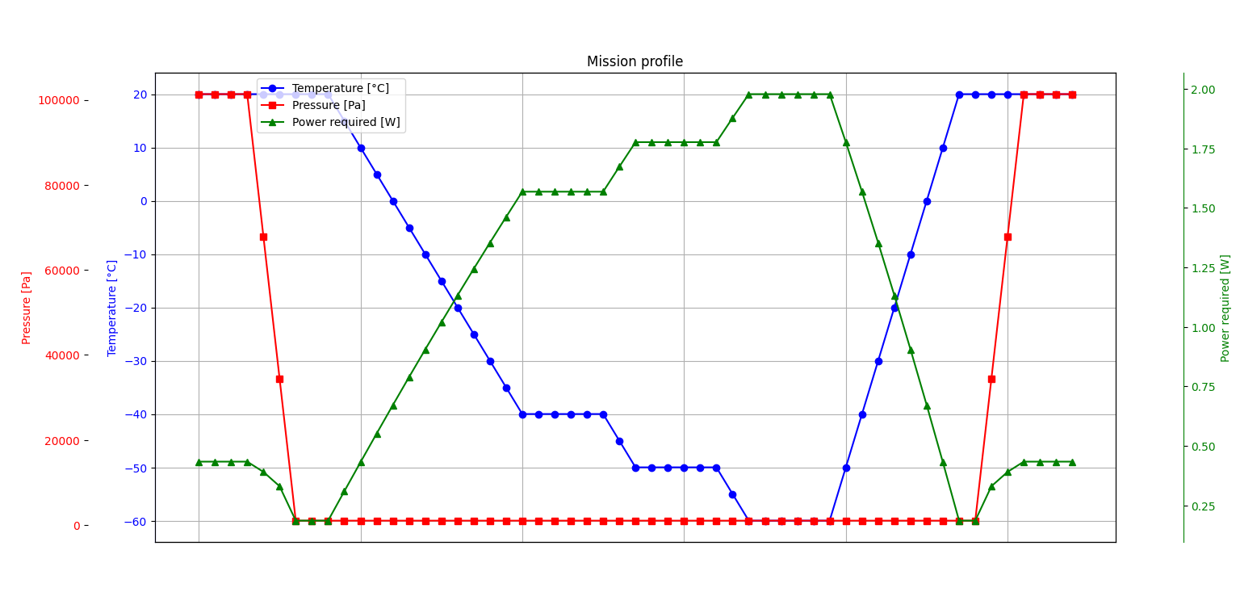

Fig. 4.6-6:Temperature distribution along the tube with the heaters around.

* + 1. **Dynamic analysis**

To study heat transfer dynamics, MATLAB simulations using a FEM solver show that heating the tube's center from 27.5°C to above 30°C takes approximately 2 minutes when the heater maintains 60°C at the water interface.

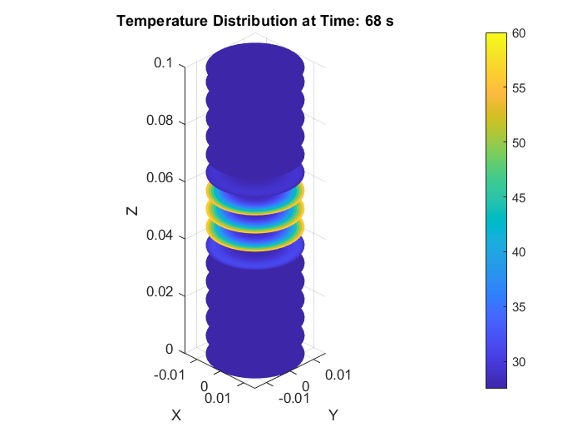

Fig. 4.6-7:Temperature distribution along the tube with the heaters around.

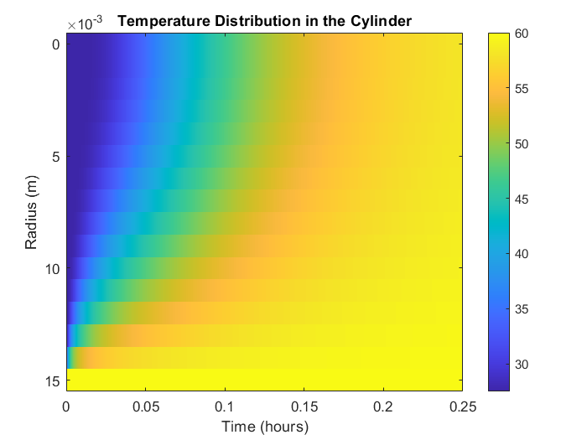

Fig. 4.6-8: Temperature radial distribution along the tube.

Moreover, to keep the temperature on the tube at a reasonable level and avoid exceeding the 30°C limit at the end of the tube, the conduction over the axial direction of the tube was computed.

In this graph it depicts the time that it takes to the end of the tube to reach 30°C while the heaters are turned on and their operating temperature is 60°C. It takes 278 seconds to reach 30°C so the heaters will operate less than this time to keep the temperature of the biological samples within the limits.

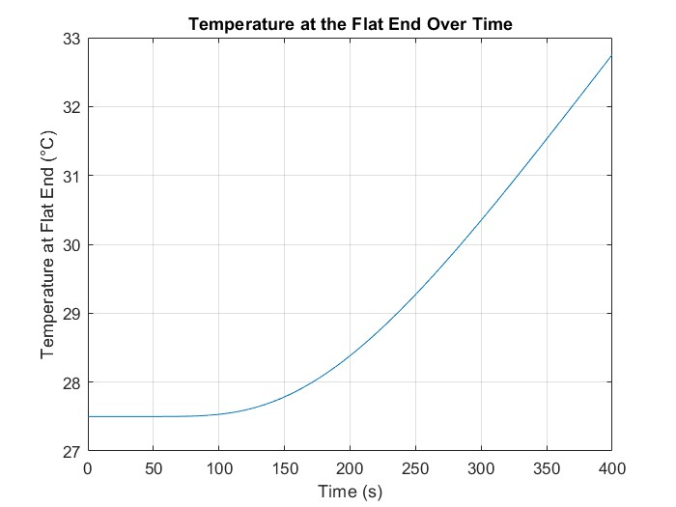

Fig. 4.6-9: Temperature axial distribution along the tube.

For convection and buoyancy analysis, the characteristic time that takes for water to travel half of the tube is computed as follows.

To analyze convection currents in water, we start with the essential properties of water: specific heat capacity (cp), thermal expansion coefficient (β), kinematic viscosity (ν), thermal diffusivity (α), and thermal conductivity (kwater).

* Rayleigh number (Ra)

The Rayleigh number is calculated using the formula:

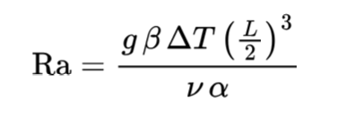

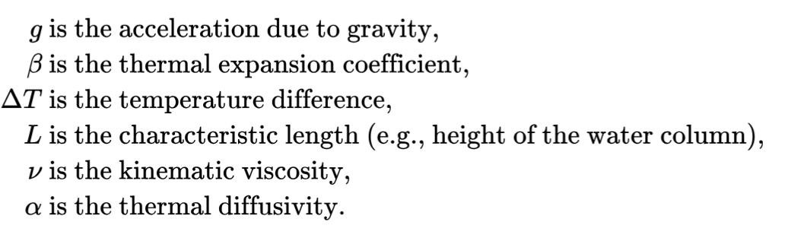

where g is the acceleration due to gravity, ΔT is the temperature difference, and L is the characteristic length (e.g., height of the water column). The Rayleigh number characterizes the flow regime in natural convection.

* Nusselt number (Nu)

The Nusselt number, representing the ratio of convective to conductive heat transfer, is given by:

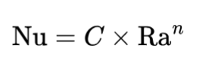

For a vertical tube, typical empirical constants are C = 0.1 and n = 1/3.

* Convective heat transfer coefficient of water (hwater)

The convective heat transfer coefficient of water can be determined using the Nusselt number:

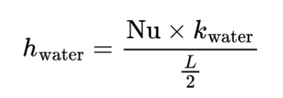

This coefficient represents the heat transfer per unit area per unit temperature difference.

* Velocity of convection currents (v)

The velocity of convection currents is calculated as:

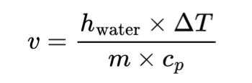

where m is the mass of water.

* Time delay (τ)

Finally, the time delay for convection currents to travel half the characteristic length L is given by:

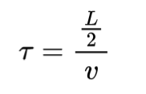

With this time delay, the convective effects and delays in heat diffusion are accounted for. The result for the tube used in the experiment is 0.0073 s. The time delay is very small but it is relevant due to the different position of the temperature sensor inside the tube and the heaters.

* + 1. **PI controller**

To maintain the temperature in the operational range, an active thermal control system is needed. The approach is to use a PI controller with saturation, because it reduces rise times and steady state errors, very suitable for thermal control on fluids.

In order to derive the controller, the plant, represented in the following figure as a transfer function, is needed to plot it in SIMULINK.

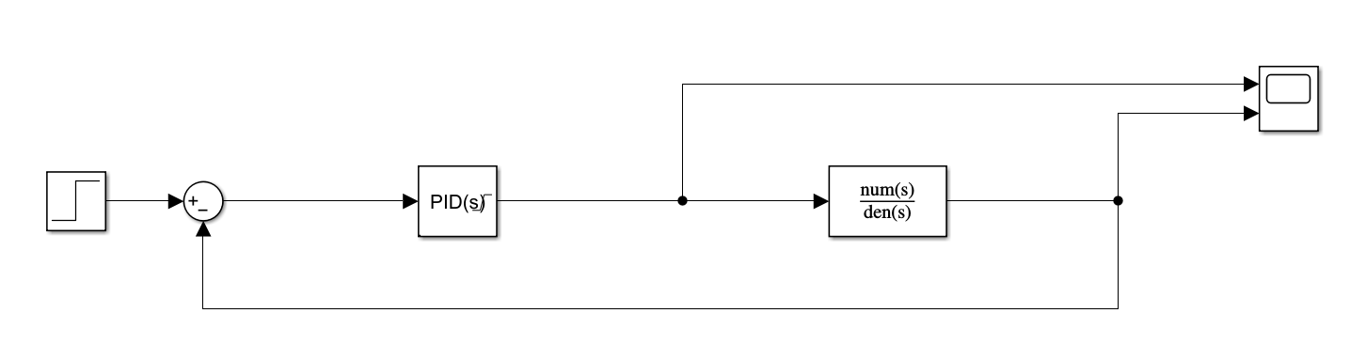

Fig. 4.6-10: Closed-loop thermal control system.

* **Transfer function:**

From the 1st law of Thermodynamics, the dynamics of heat transfer analyzed as follows:

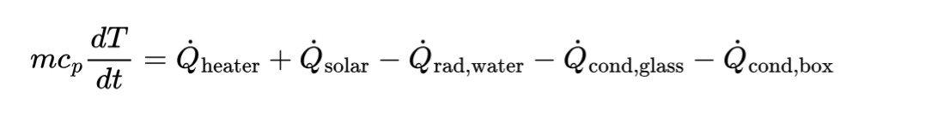

The power of the heater is the input and the water temperature is the output.

In line with that, the heat losses are written with the temperate explicitly:

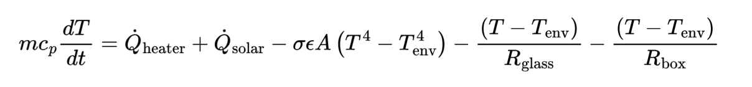

As the operating point is in a very narrow range of 5°C, it is reasonable to linearize the equation with respect to ∆T=T-Tnom. Tnom is the operating temperature of 27.5°C.

In addition lets linearize the the terms of fourth order like this:

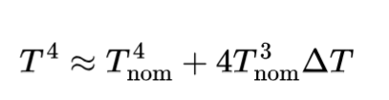

After that , the equation looks like this:



Simplifying more the equation:



Sorting by terms of ∆T, Qheater  and constant C, the result is the following:

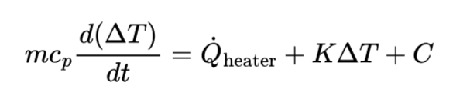

Where K and C are constants.

For the transfer function, the focus is on the relation between Qheater and ΔT, ignoring the offset C, as it doesn't affect the dynamics

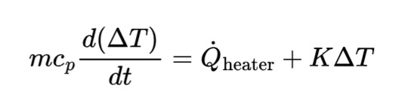

Taking Laplace function in both sides, the time domain change into the frequency domain:

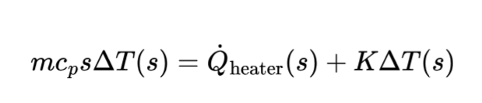

Rearranging the terms,

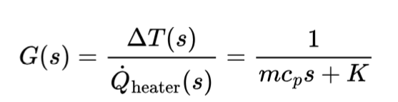

Including the time delay of the temperature sensor with respect to the heaters and the delay of the heat leaving the body of water, the transfer function is transformed by the Pade approximation:

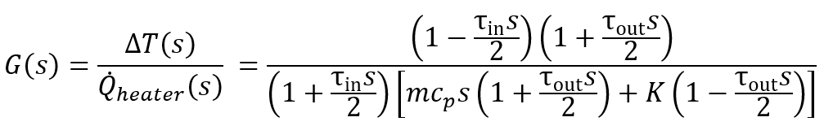

The open-loop step response of the system is depicted in the following graph with a final value around 11K which is the temperature increment if 1W is applied for a long time.

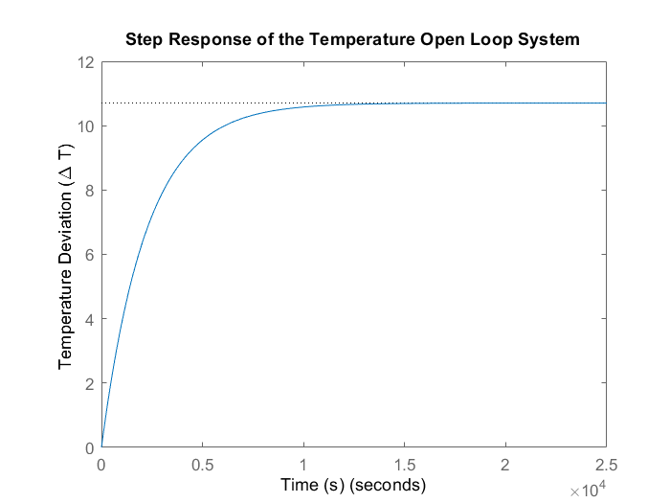

Fig. 4.6-11: Open-loop step response of the temperature control system with delay.

On the other hand, the closed-loop system has some overshoot as can be seen in Fig. 4.6-12. And it reaches the desired step response with a smaller settling time. The solution is very dependent on the values of Kp and Ki. In this case the values used are Kp = 8 and Ki = 0.0004.

Those can be derived depending on the characteristics of the system desired, the type of thermal damping or inertia in it. Also, the calibration of these parameters in TVAC is performed.

In order to have in place a functional controller the values must be realistic with the hardware used and that is the case of the simulation in Figure 4-25 and 4-26 where the power of the heaters is limited and the solution converges with the required heating and its profile.

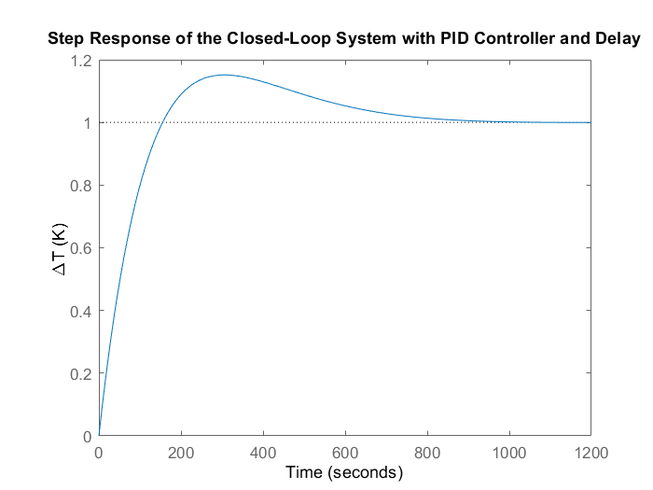

Fig. 4.6-12: Closed-loop step response of the temperature control system with delay.

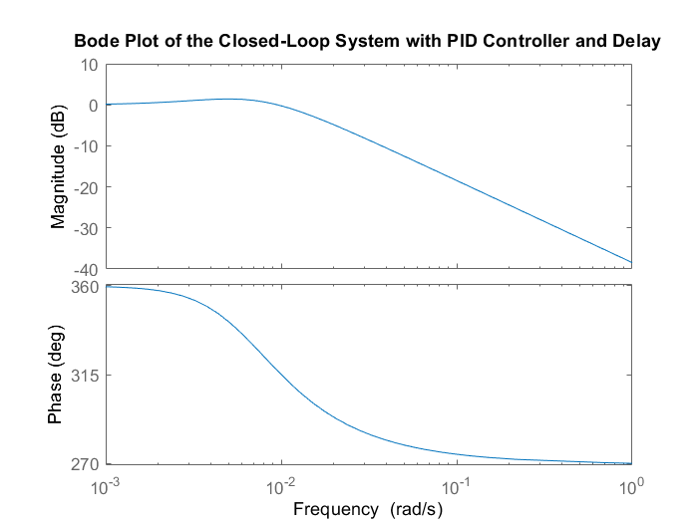

Fig. 4.6-13: Bode plot on the closed-loop system with PI controller and delay.

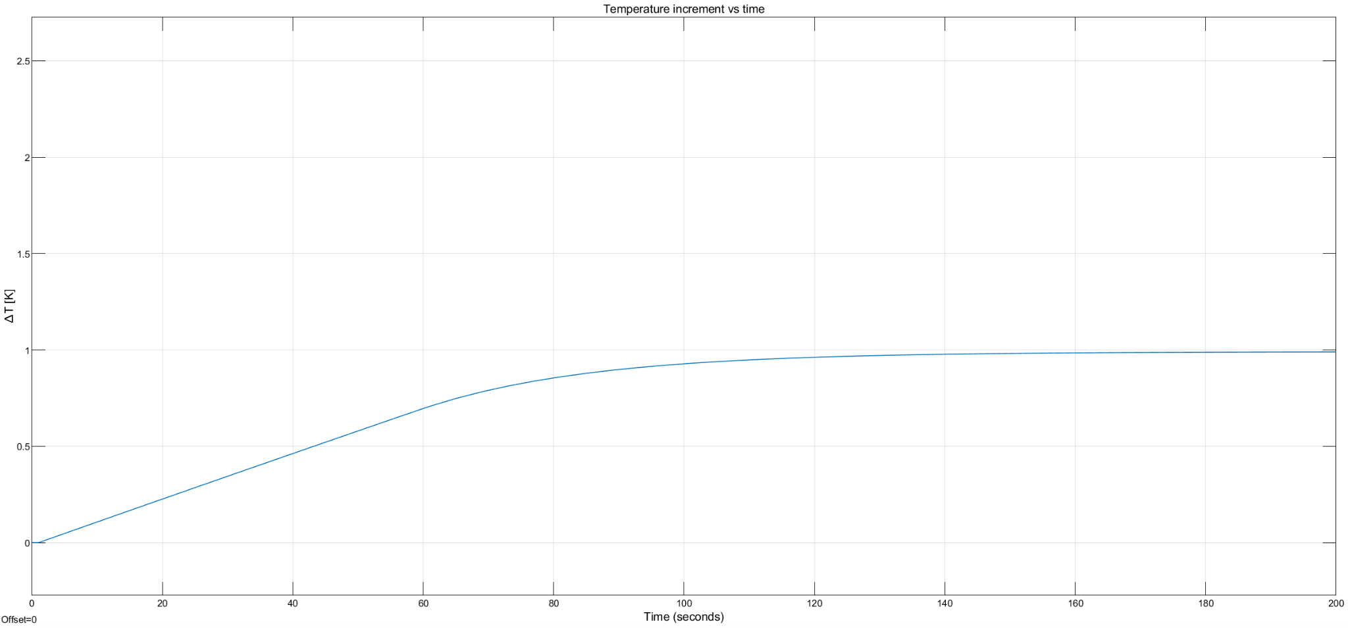

Fig. 4.6-14: Closed-loop step response of the temperature control system with delay and power limitation.

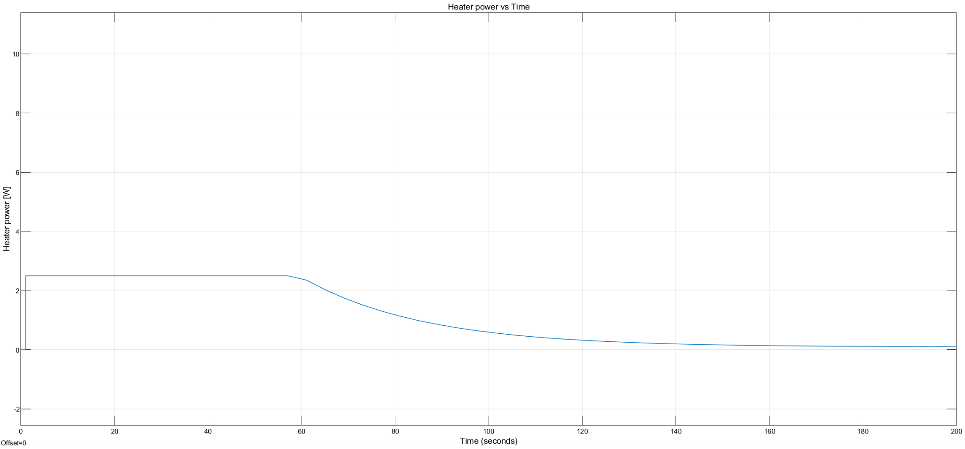

Fig. 4.6-15: Power consumption of heaters of a closed-loop system for active thermal control.

* + 1. **TVAC test**

During the TVAC test, the module is exposed to the combination of temperature and pressure represented in the graph below to replicate the conditions that the module is exposed to during the actual flight. In it the pressure was reduced up to 10 mbar and -60°C. The electronics and different tubes were tested to determine their readiness to fly on the gondola.

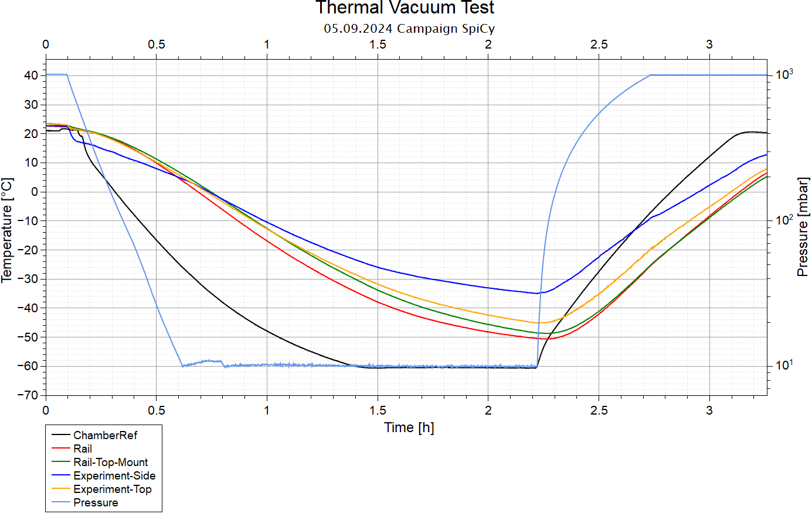

Fig. 4.6-16: TVAC testing temperature and pressure conditions.

Over the TVAC test, the temperature of the electronics compartment is displayed in the following graph and the temperature is between 25 to 40°C and falls in the required temperature range, granting an adequate operation of the module electronics.

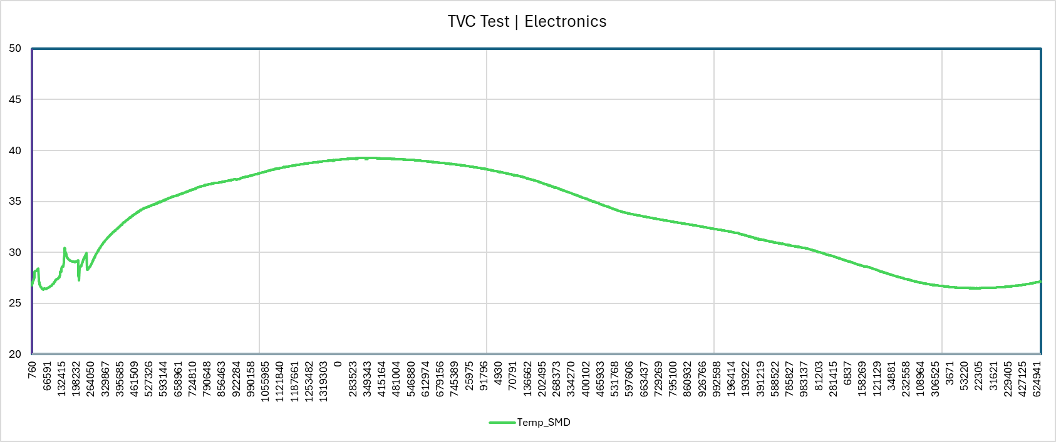

Fig. 4.6-17: Electronics temperature over TVAC test.

Regarding the glass tubes during the TVAC test, Fig. 4-42 and Fig. 4-43 display the temperature inside (blue) and the power consumption of the heater (orange). For both of them, the temperature is kept in the desired temperature range of 25° to 30°C with a power consumption similar to the one predicted for the mission envelope analysis but without the solar radiation contribution. The power required at -60°C is 2.23W. On the other hand, both glass tube graphs differ in their dynamic behaviour with broader fluctuations in the power provided to keep the temperature at 27.5°C. The PI controller has different Kp values which provides a stronger response in case of a higher Kp. Thanks to this variation of gains, the faster response is chosen to ensure the system’s stability

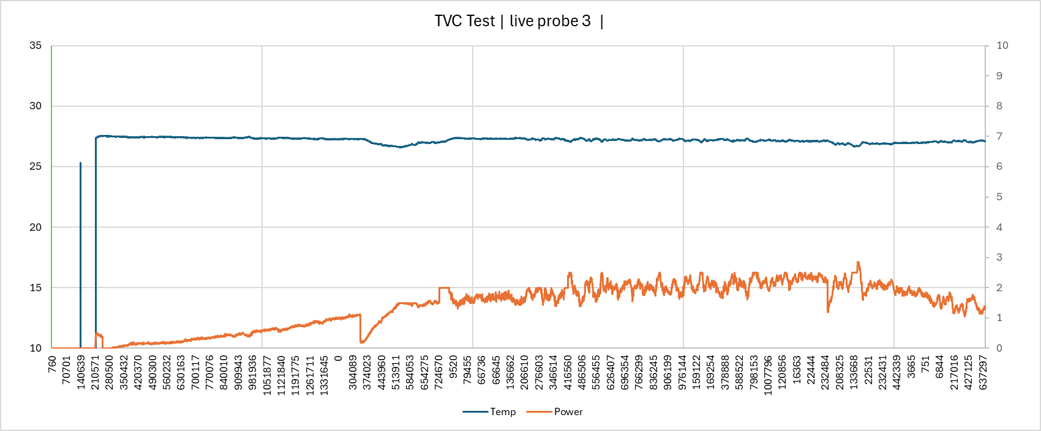

Fig. 4.6-18: Probe with Kp = 0.7047 and Ki = 0.0014 on TVAC test.

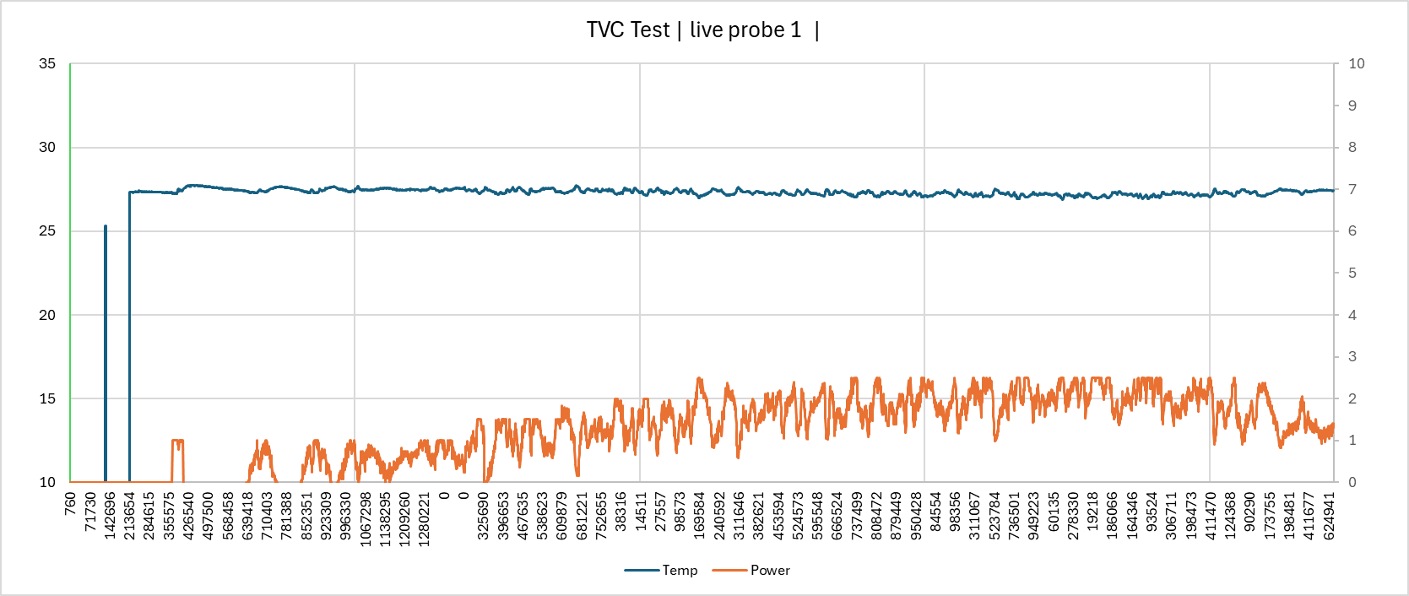

Fig. 4.6-19: Probe with Kp = 1.0011 and Ki = 0.0019 on TVAC test.

## Power System

### Overview

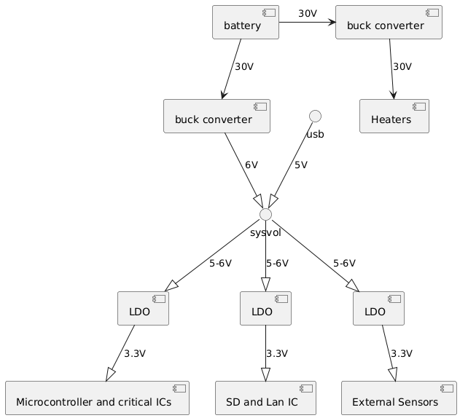

Fig. 4.7-1: Power System Flow Chart

The battery voltage is stepped down to 6V, to be linear regulated to 3.3V and 5V rails. The 3.3V rails are splitted in 3 to spread the heat (power losses) and provide redundancy. Therefore the uC can keep running even if all external sensors are shorted.

Through a shunt resistor power consumption is tracked, and the power available to the heating system will be adjusted to the power the BEXUS battery can provide minus the power consumption of the rest of the system.

Also it can detect a heater presence or failure via comparing the measured current with the expected one.

Also both buck converters are replaced with external ones to increase performance and reliability (more on that later).

### Detailed Power Plan

It is read from right to left, from consumer to stabilizer to converter to provider. The power values at the consumer states how much power is used. The power values of the stabilizer/converter/provider states how much power this component draws with all following components connected and active.

All efficiency values are already implemented in the power calculations. So for example the Microcontroller consumes 0.0924W under load. But this power goes almost double into the calculation of the power the LDOuC draws, as the LEDOuC has a efficiency of 0.55 aka needs to draw almost double the power it provides.At the recommended max current draw of 1.8A from the battery, it provides ~30V * 1.8A = 54W.

Also one is able to read out the diagram, max power drawn from the battery at full load is around 35.3W. 32.6W of that power goes directly to the heaters, and will in praxis never be that high. As all testing till now was done with 15W of heating power 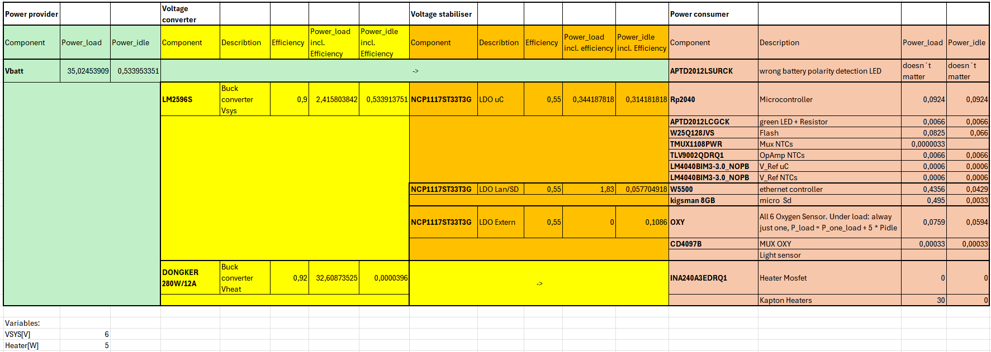and that should be enough already. Fig. 4.7-2: Detailed power plan

### 

### Buck converter

The motherboard itself needs 2 buck converters.

One converter (V_Sys) to power all LDOs, which provide stable 3.3V to things like the microcontroller and sd card.

The other one (V_Heat) provides power to the heating elements.

On the board these are both TPS62933DRLR buck converters, which are able to provide 3A. They were chosen because of the high output current and efficiency, but proved to be hard to solder and not reliable enough (2 shorted chips during testing).

So the jumpers connecting them to the corresponding voltages got removed and JST headers were used to connect external ones. This was anticipated and so this feature was implemented in the motherboard -> no PCB change needed.

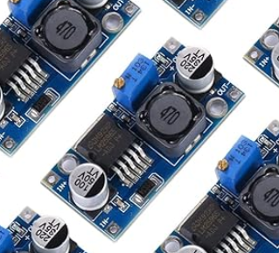

The V_Sys voltage is now provided by a LM2596S based [Buck converter module](https://www.amazon.de/Yizhet-Stromversorgung-Abw%C3%A4rtswandler-Einstellbares-Abw%C3%A4rtsmodul/dp/B0B5GQTS64/?_encoding=UTF8&pd_rd_w=b6YpW&content-id=amzn1.sym.16038c01-cfea-4f09-a119-c9f8c051c46c%3Aamzn1.symc.fc11ad14-99c1-406b-aa77-051d0ba1aade&pf_rd_p=16038c01-cfea-4f09-a119-c9f8c051c46c&pf_rd_r=ND3MVY809FZSHKWEXZMX&pd_rd_wg=tcFa1&pd_rd_r=dc2952d5-85f4-4599-b2a6-72839ca86887&ref_=pd_hp_d_atf_ci_mcx_mr_ca_hp_atf_d&th=1). It is a very commonly used board and features 1,25-35V input voltage as well as theoretical 3A output. It will at peak load need to provide around 3W at 3.3V -> around 0,9A, but realistically more like 1W -> 0,3A continuous current, as peak load can't happen.

Fig. 4.7-3: LM2596S based Buck converter module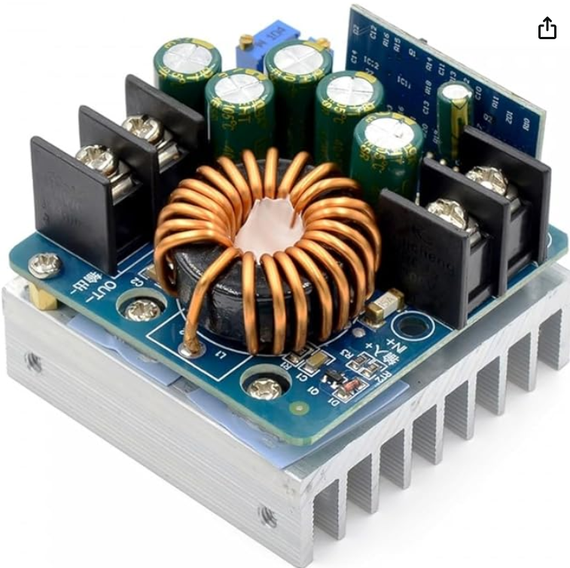

The V_Heat voltage is provided by a [DONGKER SZ-BK0612 buck converter](https://www.amazon.de/Converter-5V-60V-Adjustable-Supply-Regulator/dp/B0BLG7TN1C/?_encoding=UTF8&pd_rd_w=b6YpW&content-id=amzn1.sym.16038c01-cfea-4f09-a119-c9f8c051c46c%3Aamzn1.symc.fc11ad14-99c1-406b-aa77-051d0ba1aade&pf_rd_p=16038c01-cfea-4f09-a119-c9f8c051c46c&pf_rd_r=ND3MVY809FZSHKWEXZMX&pd_rd_wg=tcFa1&pd_rd_r=dc2952d5-85f4-4599-b2a6-72839ca86887&ref_=pd_hp_d_atf_ci_mcx_mr_ca_hp_atf_d). It has a 10,5V-60V supply voltage range and can deliver up to theoretical 15A of output current. Not reachable without increasing cooling, realistically more like 12A (dependent on ambient temperature).

This is still way more power than we need for heating, which is 30W on 6x12 Ohm Kapton heaters -> 5V and ~3.8A in total. And this is the theoretical maximum to allow for some unforeseen heat spikes. In reality, heating should´t consume more power peak than 6W -> ~1.73A (1W per probe). This is still peak power consumption during ascent, the average is way lower.

Fig. 4.7-4: DONGKER SZ-BK0612 buck converter

## Software Designuml missing

### 

### Overview

The embedded software architecture is implemented on the microcontroller in C++, covering essential functionalities like thermal control, sensor data acquisition and uplink/downlink communication processes. The thermal control is implemented as a PI controller, which controls the heating via PWM.

For ground station operations, the system will utilize a tech stack consisting of a Node.js backend communicating with a MongoDB database, complemented by a Web-based Localhost Application frontend.

### Embedded Software

You can find all the embedded source code [here](https://github.com/EggiEl/SpiCy-BEXUS/tree/main/motherboard/Software/V4%20_1_Motherboard_Firmware_BEXUS_SPICY/src).

It´s 1163 lines of comments on 3288 lines of code.

**IDE/Language**

All code running on the Microcontroller is written in C/C++. We are using the arduino ide with heavy dependence on the [earlphilhower](https://github.com/earlephilhower/arduino-pico) open source arduino core/framework for the rp2040.

Fig. 4.8-1: UML diagramm [Version of 25.3.24]

### Multithreading

The rp2040 has 2 cores.

First one handles all the sensor/data traffic as a state machine. It creates a packet, that's a container for data, and fills it with mostly temperature, oxygen and light sensor data. More details to the packet in the chapter Up/Downlink.

Second one is running exclusively the PI controller.

As the thermistor multiplexer is connected with the multiplexer of the oxygen sensors, the second core is paused whenever the oxygen sensors are accessed by the first core..

*On the left is a simplified state machine of the first core.* Of course there is also an Error state.

Also, after each state change, the controller is checking whether there are new commands available via serial or tcp.

### Memory Safety

As with every C based code, memory safety must be provided.

These steps are taken to make this happen:

* Before memory is freed, the corresponding pointer is checked if it's NULL. That's because after freeing of memory the pointer is set to NULL. Prevents double freeing.
* All code is checked by [cppcheck](https://cppcheck.sourceforge.io/)
* If possible, method parameters are const, especially strings
* For string operations, only methods with buffer_length parameters are used
* All buffer sizes are calculated by the compiler or provided by #define

### Fig. 4.8-2: State machine

### Up/Downlink

The link is provided via BEXUS. Our project is using the payload as a client and the groundstation as a server. The client stays connected and will periodically send data down or receive commands from the ground station. All data from the payload will be saved in a struct named packet. It ist 472 bytes long and will be sent down every second. With additional head room of string based debug messages, the downlink rate is <5KB/s. Uploads are just the commands of 11B and if necessary a firmware file of 162KB, which needs to be uploaded in at least 6 seconds (watchdog). -> 11B/s for normal operation, 162KB/s if a firmware update should be necessary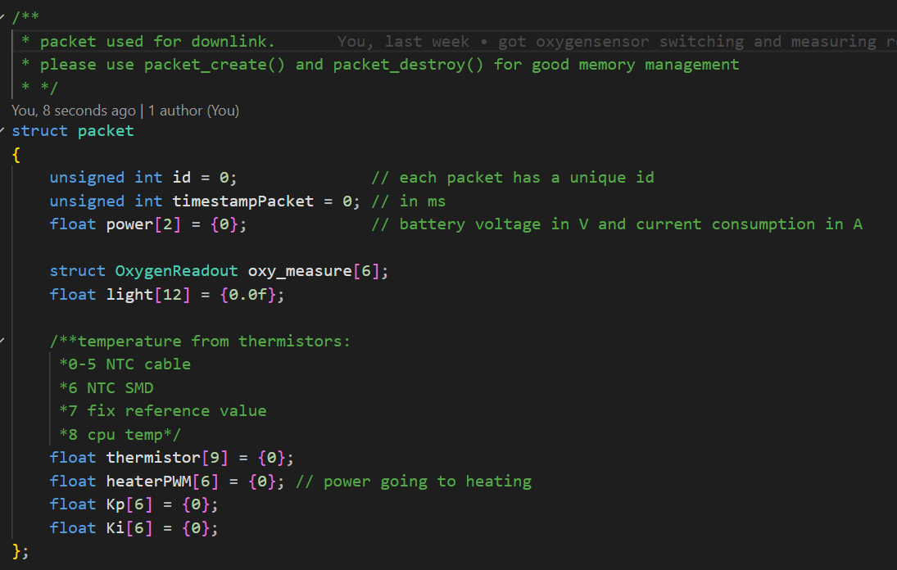

Every packet has an individual ID and timestamp. These are followed by sensor data. Power is the voltage and current of the battery.

#### 

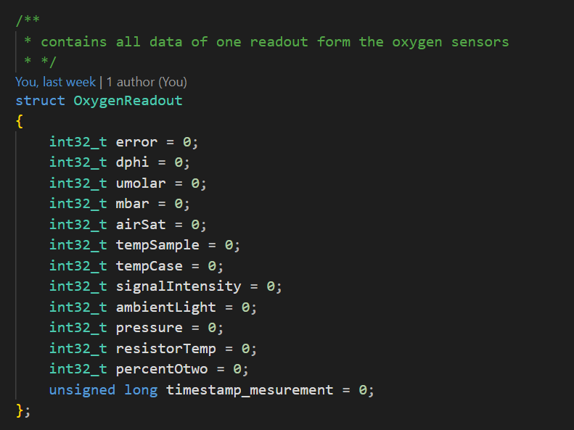

*The struct OxygenReadout on the right is an extra container just for the measurements of the oxygen probes. It is included once per probe within the main packet.*

### Debug Console

There is a simple debug console implemented on the microcontroller to make prototyping easier and to have a chance to fix things during flight.

It can be accessed via USB or Ethernet. When accessed via USB, all messages (Infos up to errors) have different colors and are human readable to provide a pleasant debug experience. When used via Ethernet, every error debug message is just an error code, which needs to be looked up. Here the list of available error codes:

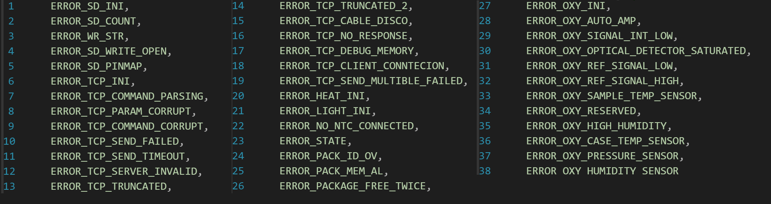

Each command to the console consists of a [char]command and 4 [float] parameters. Not every command uses all parameters, but they are limited to 4 to make data recovery and integrity easier.

Here a list of currently implemented commands: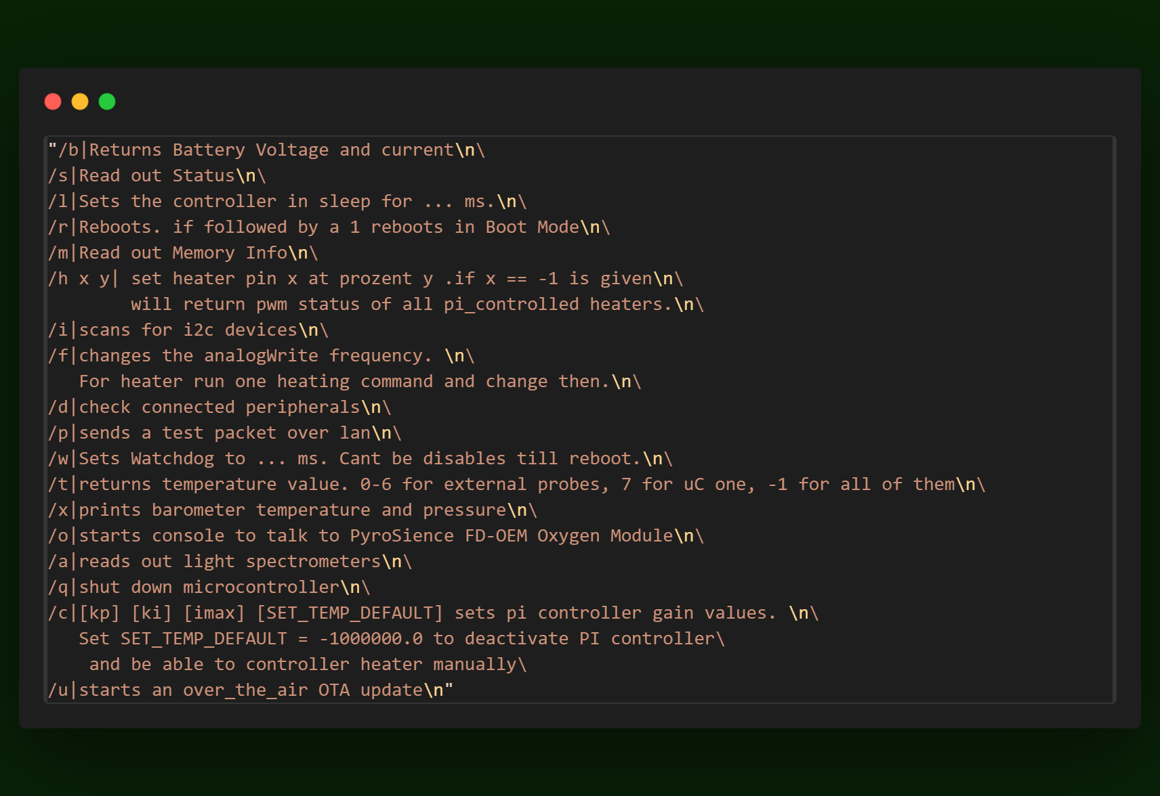

Also, if using TCP, the command is sent three times to make sure the data is valid. Each parameter is sent twice, as they are less important than the command.

As one might notice, there is a command for the oxygen sensors. This opens another console, which is primarily for calibrating and testing of these sensors and will not be used in flight.

**Uplink during Launch**

COM tests at the Launch revealed the TCP overhead was missing in the calculations above. Also string based debugging proved to be quite huge. Especially as colour strings got sent with them. There was a parameter to disable the color, but after the FRR no firmware updates were allowed.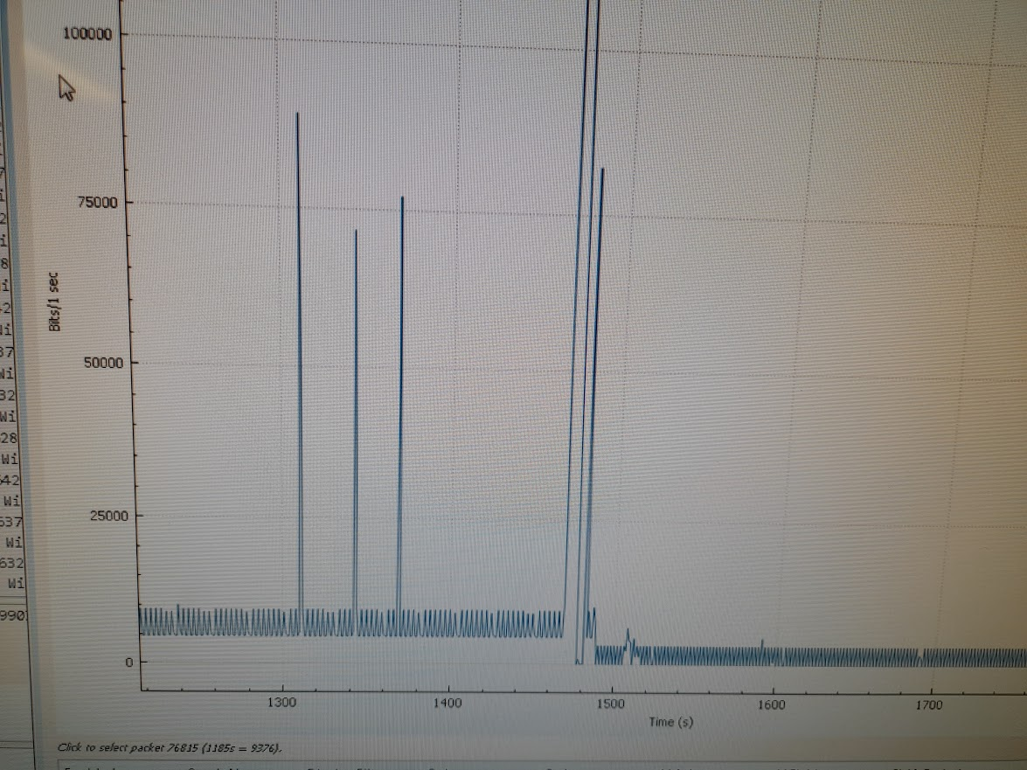

[left] Fig. 4.8-3: Here you can see the data traffic. The peaks are whenever /? got used for an overview of available commands -> this is a huge sting.

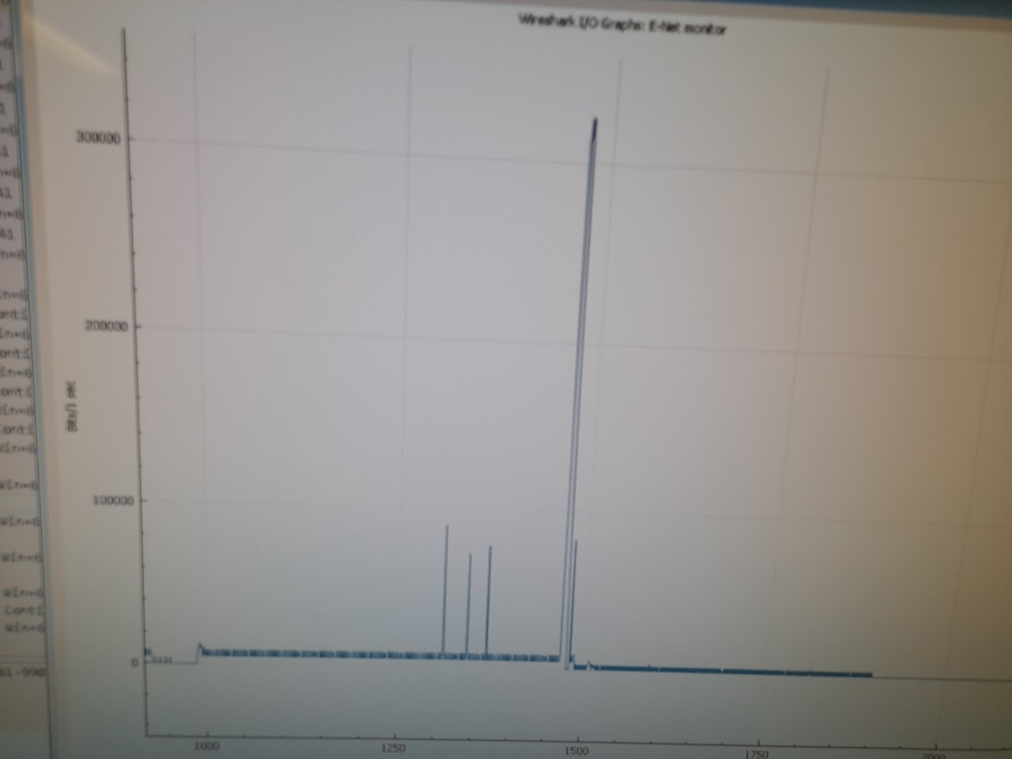

[right] Fig. 4.8-4: Peak was a firmware

update.

### NTC thermistor readout

This method reads out a NTC thermistor, with some advanced features.

It detects if there's no NTC connected and returns then -1000000.

It takes a predefined amount of ADC measurements and averages them out. Then it loops over the array of measurements and replaces every value which dividates strongly from average with the average. This removes any spikes in the measurement, like from EMI or noisy power supply. Then the average from the now spike free array is used in the calculation of the temperature.

This calculation is done via the [Steinhart-Hart equation](https://www.wikiwand.com/de/Steinhart-Hart-Gleichung).

Also there is a fixed voltage option as “ntc input”, which can provide feedback whether the amplifier is working correctly and the temperature data is valid.

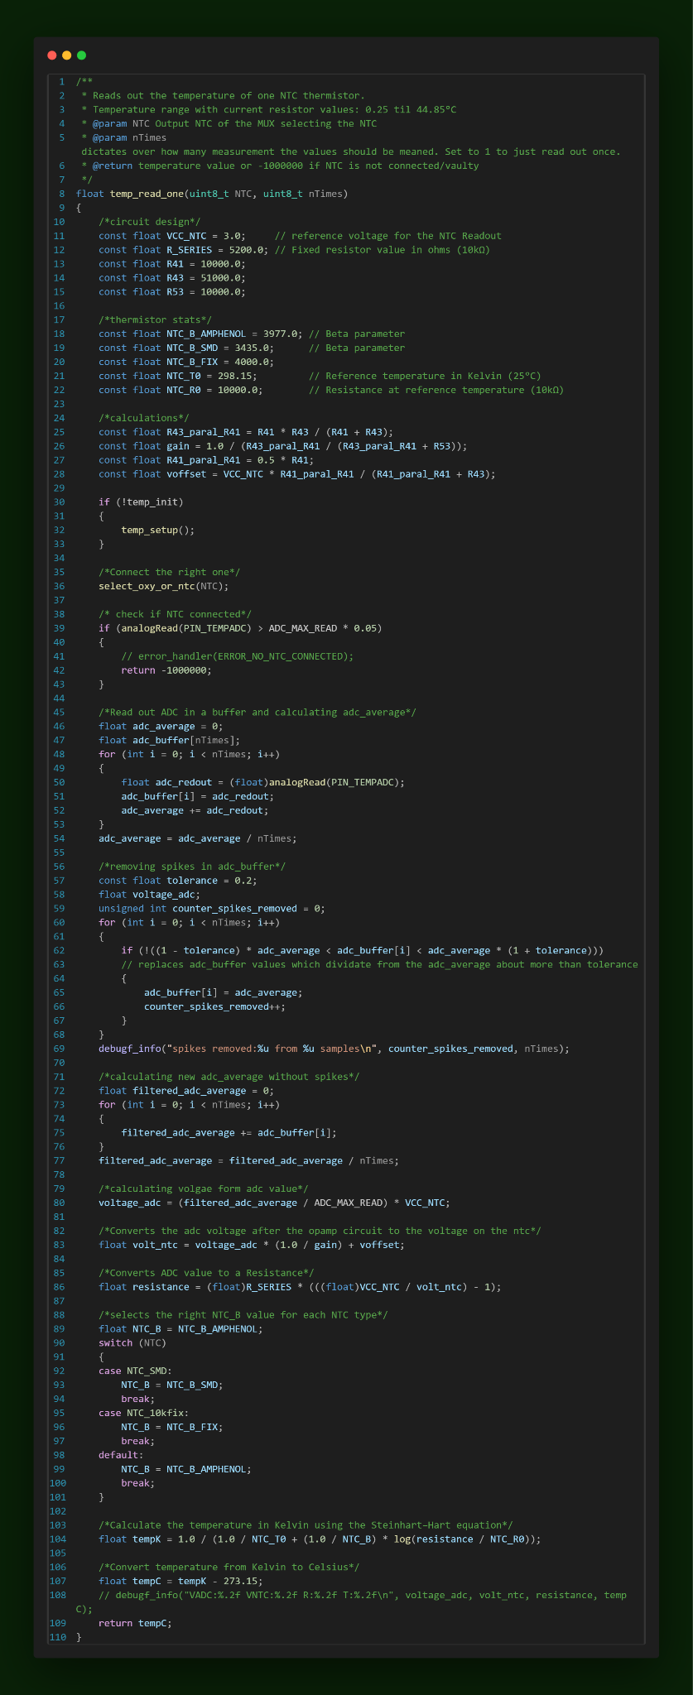



### PI Controller

Implementation of a discrete PI controller with anti windup integral part and cap on integral as well as the power level. It’s struct based and nonblocking.

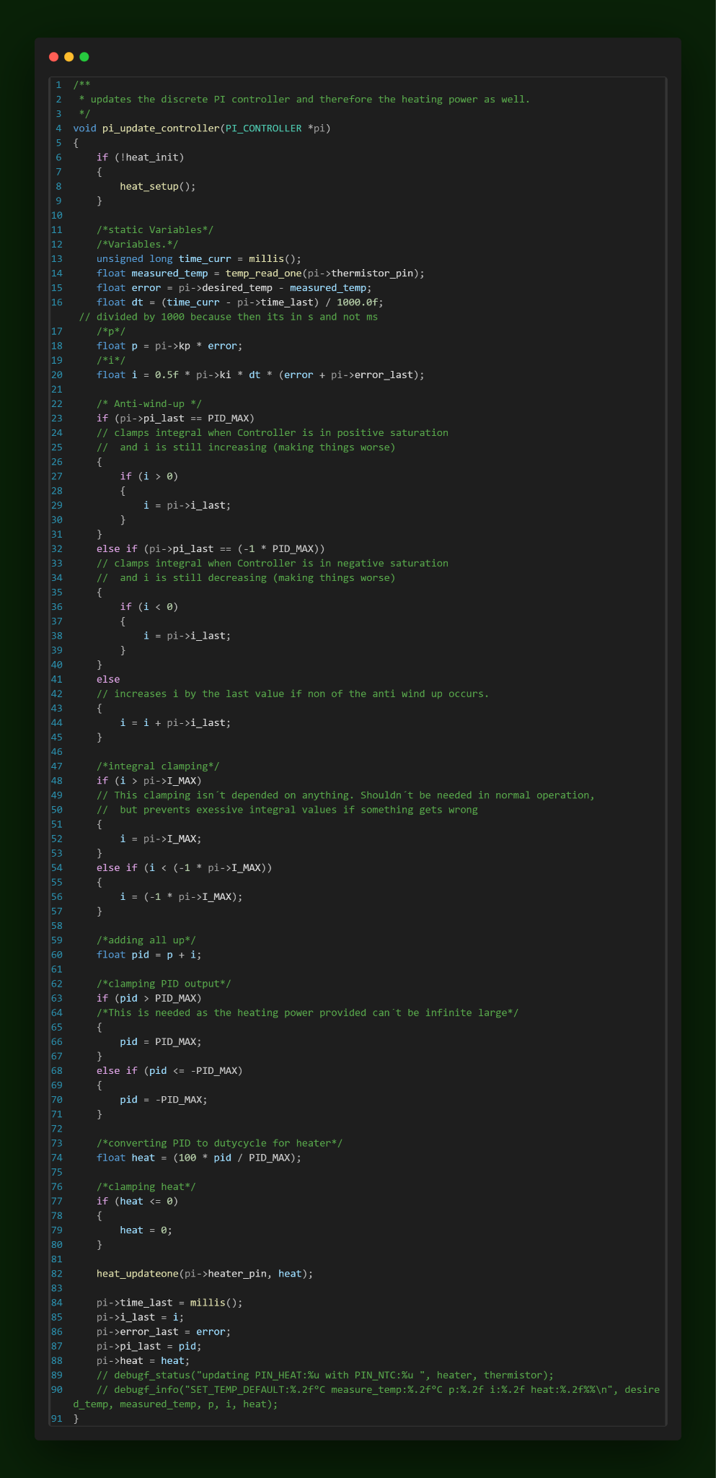



This pi controller will run with a frequency of 1Hz, as the temperature of the water takes at least a minute to change by a reasonable amount.

### 

### 

### 

### 

### 

### 

### Thermal Testing

#### Getting a numerical approximation for the system response function

As described in the function documentation, this function waits till the probe cools down to a set temperature and then will set the heater to 100% for a preprogrammed time. It’s non blocking and will record results as step response on the sd card.

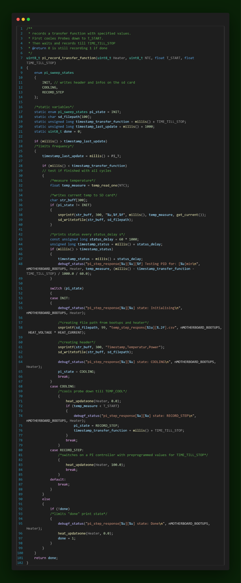



The step response function can now be numerically approximated. This is done by this python script.

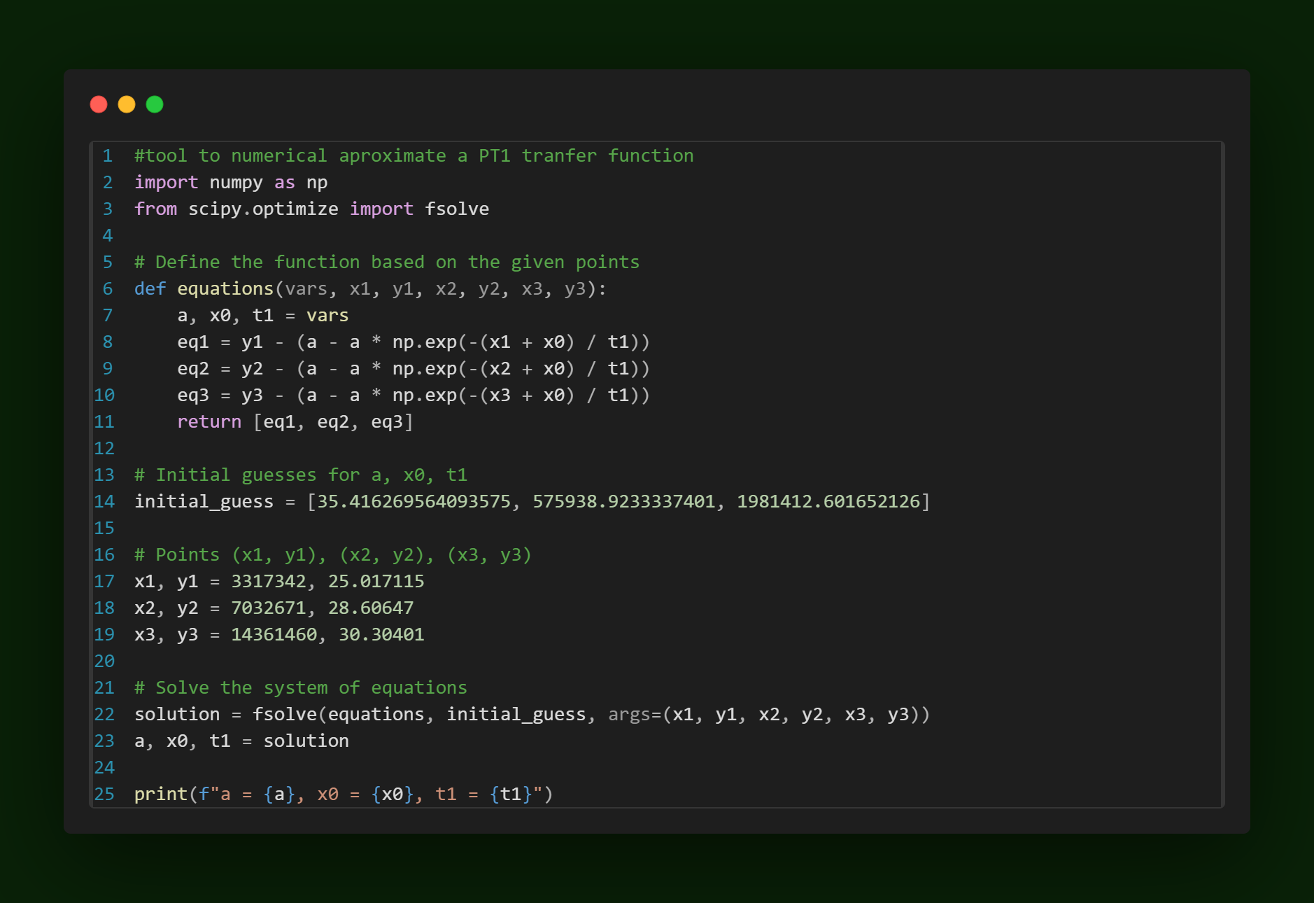

*The estimated values are based on guesses with help of online plotting tools (mainly GeoGebra).*

Figure below is an example graph with the numerical approximation in red and the real recording in blue:

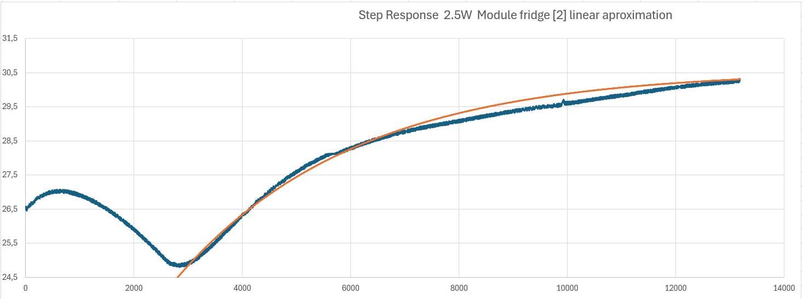

Fig. 4.8-5: Example of step response

If you now divide the numerical approximation of the step function by 3, you get the transfer function of the system.

#### 

#### PI_controller_sweep

This function records the performance of a few PI controllers with preprogrammed gains for a set time. It is useful to finetune controller values.

Also with Kp=1 and Ki = 0, it's able to record a step function.

It's struct based and non-blocking. For more details take a look at the code [here](https://github.com/EggiEl/SpiCy-BEXUS/blob/main/motherboard/Software/V4%20_1_Motherboard_Firmware_BEXUS_SPICY/src/Thermals/pi_controller.cpp).

This is the cycle it goes through:

* cools down to specified temperature
* engages a pi controller with programmed values
* when temp hits a specified temperature, it waits for a specified duration
* cooling down again

It then repeats this cycle for nCycles with different PI gain values

In praxis, the temperature curves it produces looks like this:

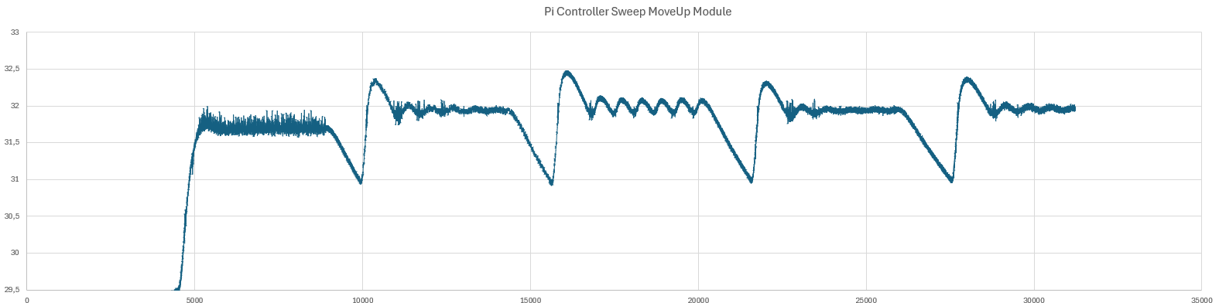

Fig. 4.8-6: Example of PID cycle

### OTA updates

Over-the-air updates through an Ethernet connection are implemented in this system. Here's how the process works:

1. **Firmware Compilation**: The firmware is first compiled on a local machine (ground station).
2. **Mainboard waiting**: The mainboard receives a command through the tcp server, so it's waiting to receive the new firmware.
3. **Firmware Transmission**: The compiled firmware is then transmitted to the mainboard via the TCP server.
4. **Saving the Firmware**: Once received, the firmware is saved as a LittleFS file on the mainboard.
5. **Comparing sizes:** With the waiting command the mainboard received the filesize of the firmware. This is now compared to the filesize of the uploaded one. This ensures data integrity at a basic level.
6. **Loading into Arduino OTA Buffer**: The saved firmware file is then loaded into the Arduino OTA buffer.
7. **System Reset and Boot**: Finally, the microcontroller needs to be reseted, and it boots up with the newly updated firmware. If no reset occurs, it can be reflashed to replace the previous version

## Groundstation

### 

### TCP Server (Python Groundstation)

You can find the code [here](https://github.com/EggiEl/SpiCy-BEXUS/blob/main/groundstation/src/Serverv8.py).

A video of it running [here](https://github.com/EggiEl/SpiCy-BEXUS/blob/main/documentation/Demo_console.mp4).

This server handles the communication to the motherboard. It's written in python and is based on the library socket. Also the final version is compiled in a .exe.

It has a console with the following features:

* Displaying network infos
* Displaying infos about running threads
* Starting Server
* Closing Server
* Displaying status updates, like what is running, if data is received and when what kind (packet, error or debug message
* Sending commands

The Server itself connects a socket and a client and receives data from the client.

If that data is a packet it gets saved to a binary file and sent to MongoDB. If it's an error or debug message it gets printed on the console as text

Fig. 4.8-7: UML diagram of the TCP_Server

### Data Storage & Plotting

1. **Purpose:**

The ground station's purpose is to visualize incoming sensor data and assist in evaluating experiment results.

1. **Design:**

The design will be structured around a REST-based application system, with separate handling of data and plotting responsibilities allocated to the frontend and backend, respectively (Figure 4.8 - 1).

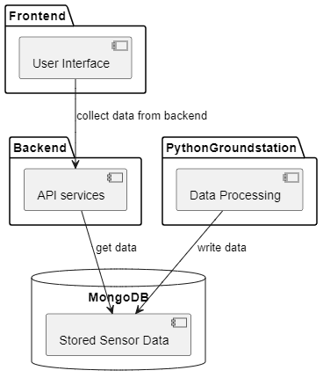

Fig. 4.8-8: Groundstation Software Design

Backend Functions and Design:

The backend consists of two main functions. One of them is to provide the frontend with all measured data existing in the database (Figure 4.8-2), while the other is to retrieve the new data of one sensor since the last call (Figure 4.8-3).

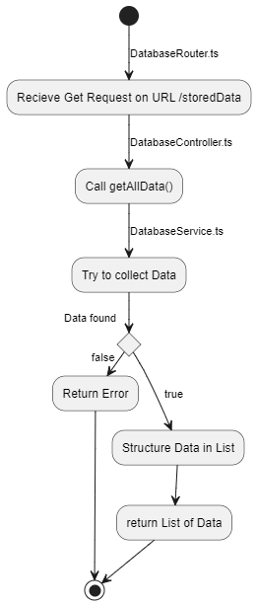

Fig. 4.8-9: Endpoint GET /storedData_latest/:sensorname/:id

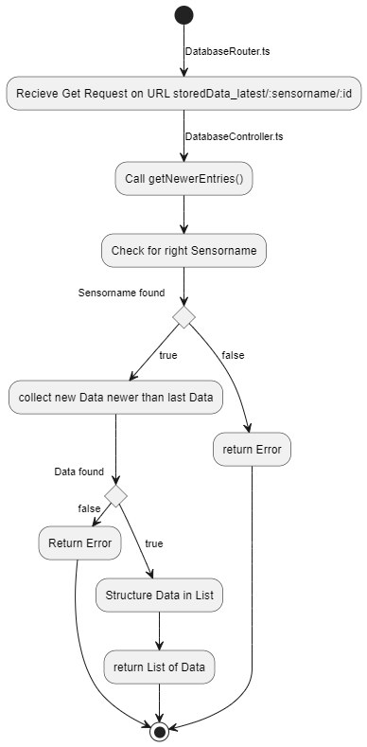

Fig. 4.8-10: GET /storedData_latest/Sensor1/6602a19c2d76cc5bcd9ede51

Frontend functions and design:

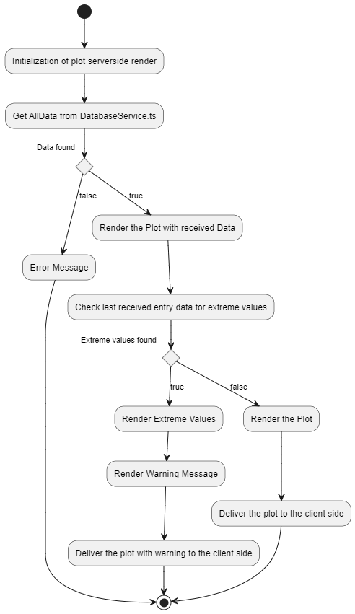

Fig. 4.8-11: Frontend Design

1. **Implementation:**

The software is stored and managed in a GitHub repository for development and documentation purposes. Development is conducted using the VSCode editor.  
https://github.com/EggiEl/SpiCy-BEXUS

## Biological Experiment Design

Biofilms composed of cyanobacteria and heterotrophic complements are cultivated and sealed in tubes with oxygen sensors. The test tubes are exposed to natural sunlight in the stratosphere to observe their behavior, especially UV-B radiation. Stressed cyanobacteria produce less oxygen as they have to halt their metabolism to avert radiation damages or die off quickly. We expect a positive impact of biofilm structures formed together with heterotrophic bacteria in this stress response, with higher oxygen production compared to a single species biofilm.

Cultivation and growth:

Cyanobacteria were grown in natural light conditions at room temperature for 2-3 weeks in BG11 medium or BG11+ medium (*C. cubana* +). Heterotrophic bacteria were incubated for 2 days at 30°C (*E. coli*) and 37°C (*B. subtilis*, *P. taiwanesis*) in M9 medium (see protocol and comparable commercial datasheet in appendix).

Cyanobacterial growth was monitored with photometric measurement of Chlorophyll A.

Cyanobacteria and heterotrophic complements were paired together in small well plates to observe their survival and biofilm formation qualities and cultivated for 3 weeks under natural light conditions at room temperature.

A detailed biological laboratory plan can be found in appendix C.

The following images were taken 3 weeks after joint cultivation with an inverted microscope (40x) to control cyanobacterial growth with different added heterotrophic complementary bacteria.

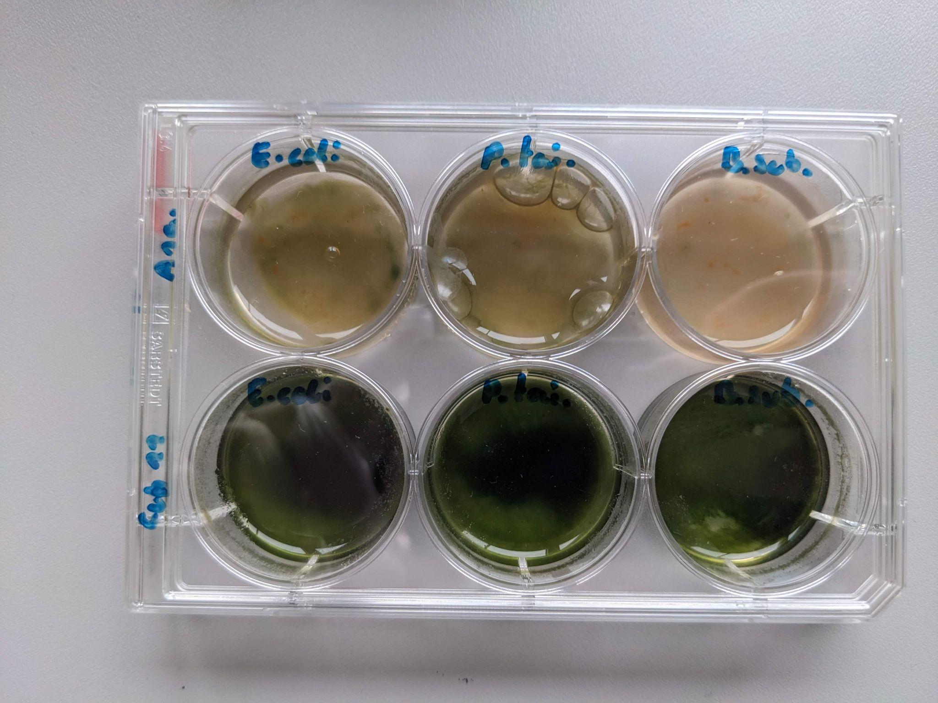

Fig. 4.9-1: Exemplary first cultivation of Biofilms. *Anabaena cylindrica* (top row) and *Chroococcidiopsis cubana* (bottom row) show varying response to co-cultivation (5ml volume) with heterotrophic bacteria regarding the chlorophyll buildup (green color), oxygen production (air bubbles) and general survivability.

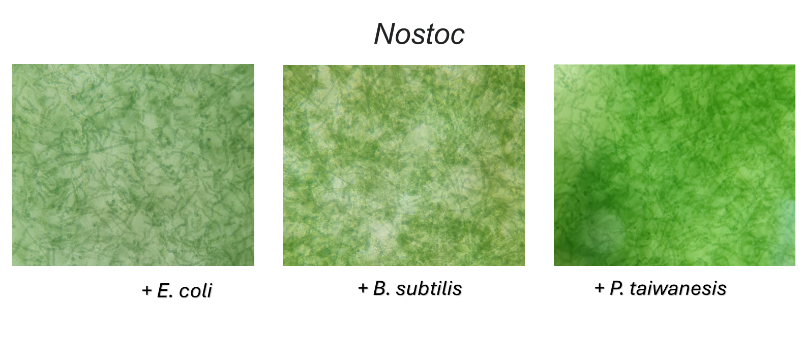Fig. 4.9-2: *Nostoc sp.* in liquid culture with different complementary heterotrophic bacteria

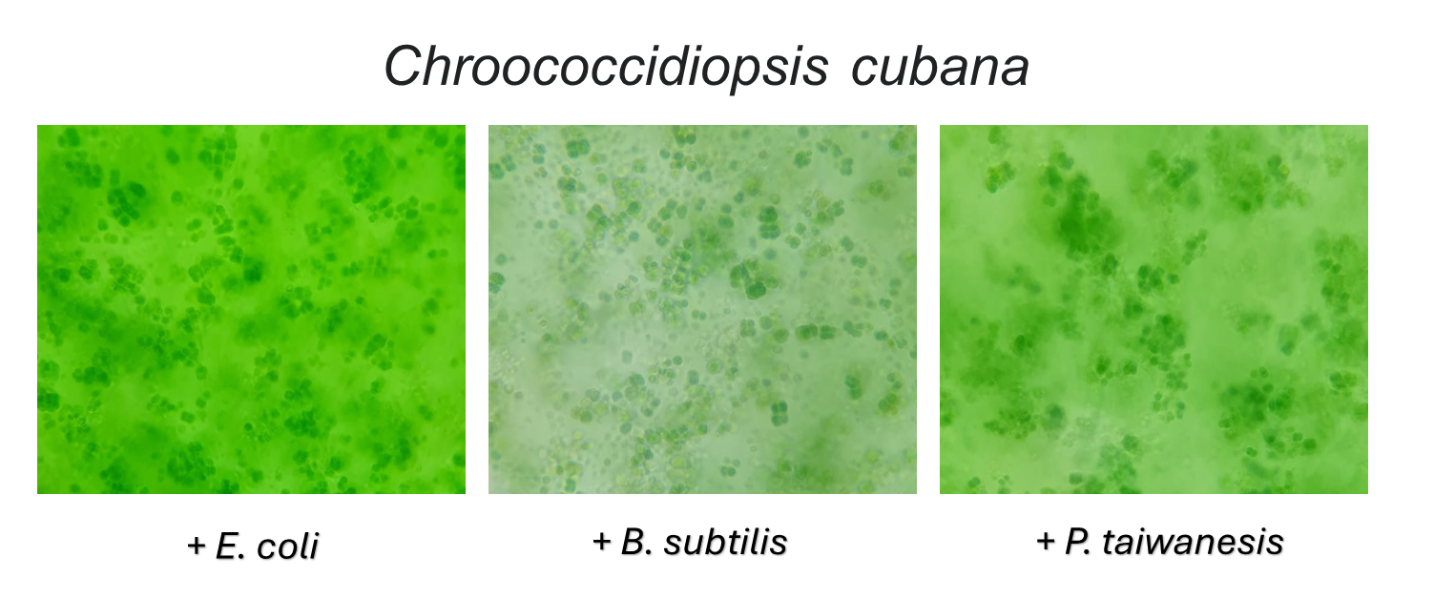

Fig. 4.9-3: *Chroococcidiopsis cubana* in liquid culture with different complementary heterotrophic bacteria

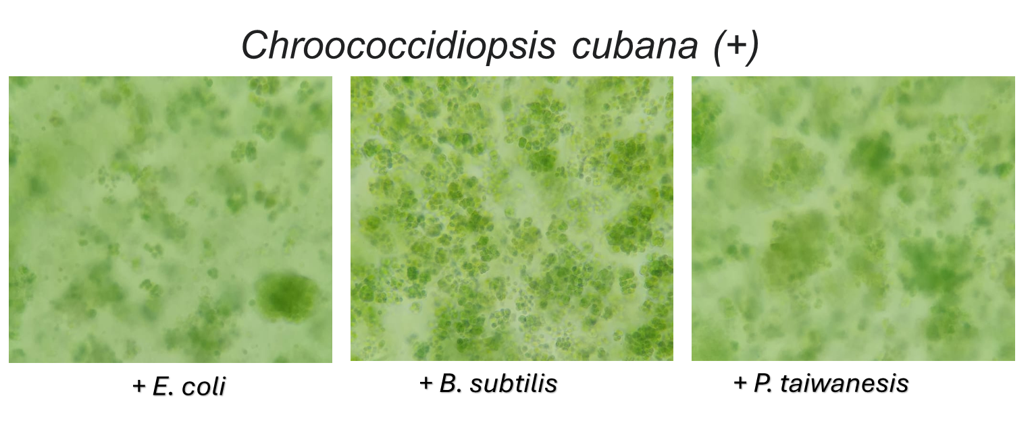

Fig. 4.9-4: *Chroococcidiopsis cubana* in liquid culture in BG11+ medium with different complementary heterotrophic bacteria

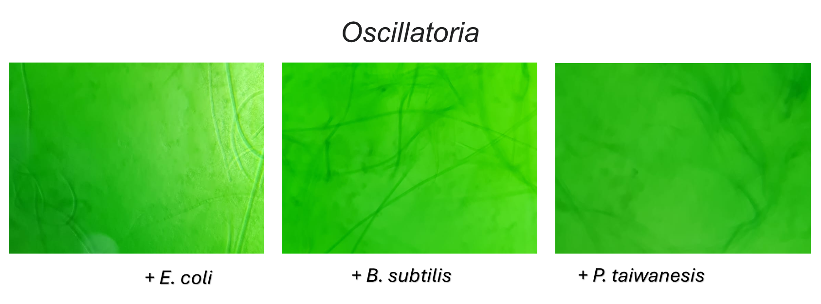

Fig. 4.9-5: *Oscillatoria sp.* in liquid culture with different complementary heterotrophic bacteria

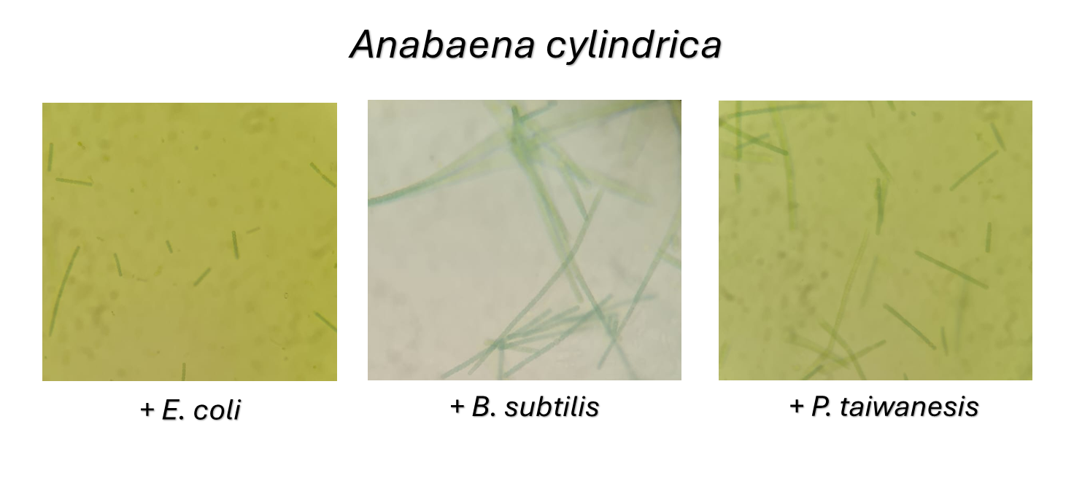

Fig. 4.9-6.: *Anabaena cylindrica* in liquid culture with different complementary heterotrophic bacteria

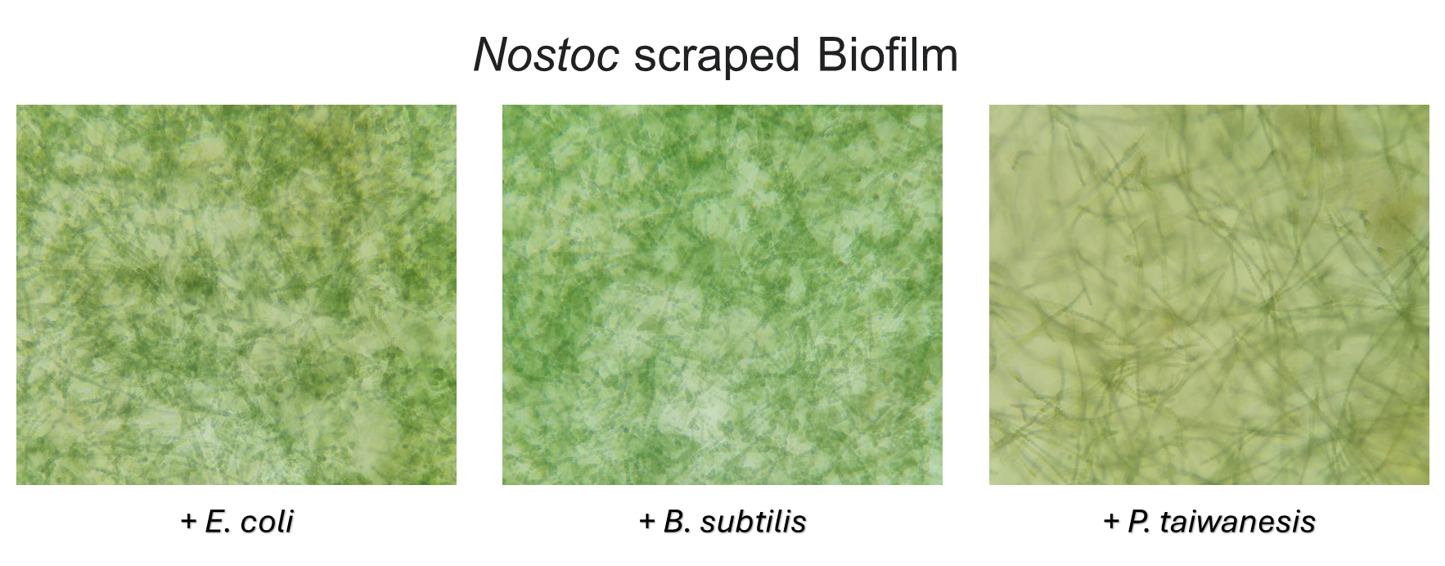

Fig. 4.9-7: *Nostoc sp.* biofilms in liquid culture with different complementary heterotrophic bacteria

Sample Selection:

*Nostoc sp.* was chosen as the prime flight candidate as it proved to be the most resilient sample in the stated ground setup conditions with a stable biofilm formation time of 3-4 weeks. They were able to sustain changes in daily light periods, direct sunlight and continuous Chlorophyll buildup with all tested heterotrophic complements.

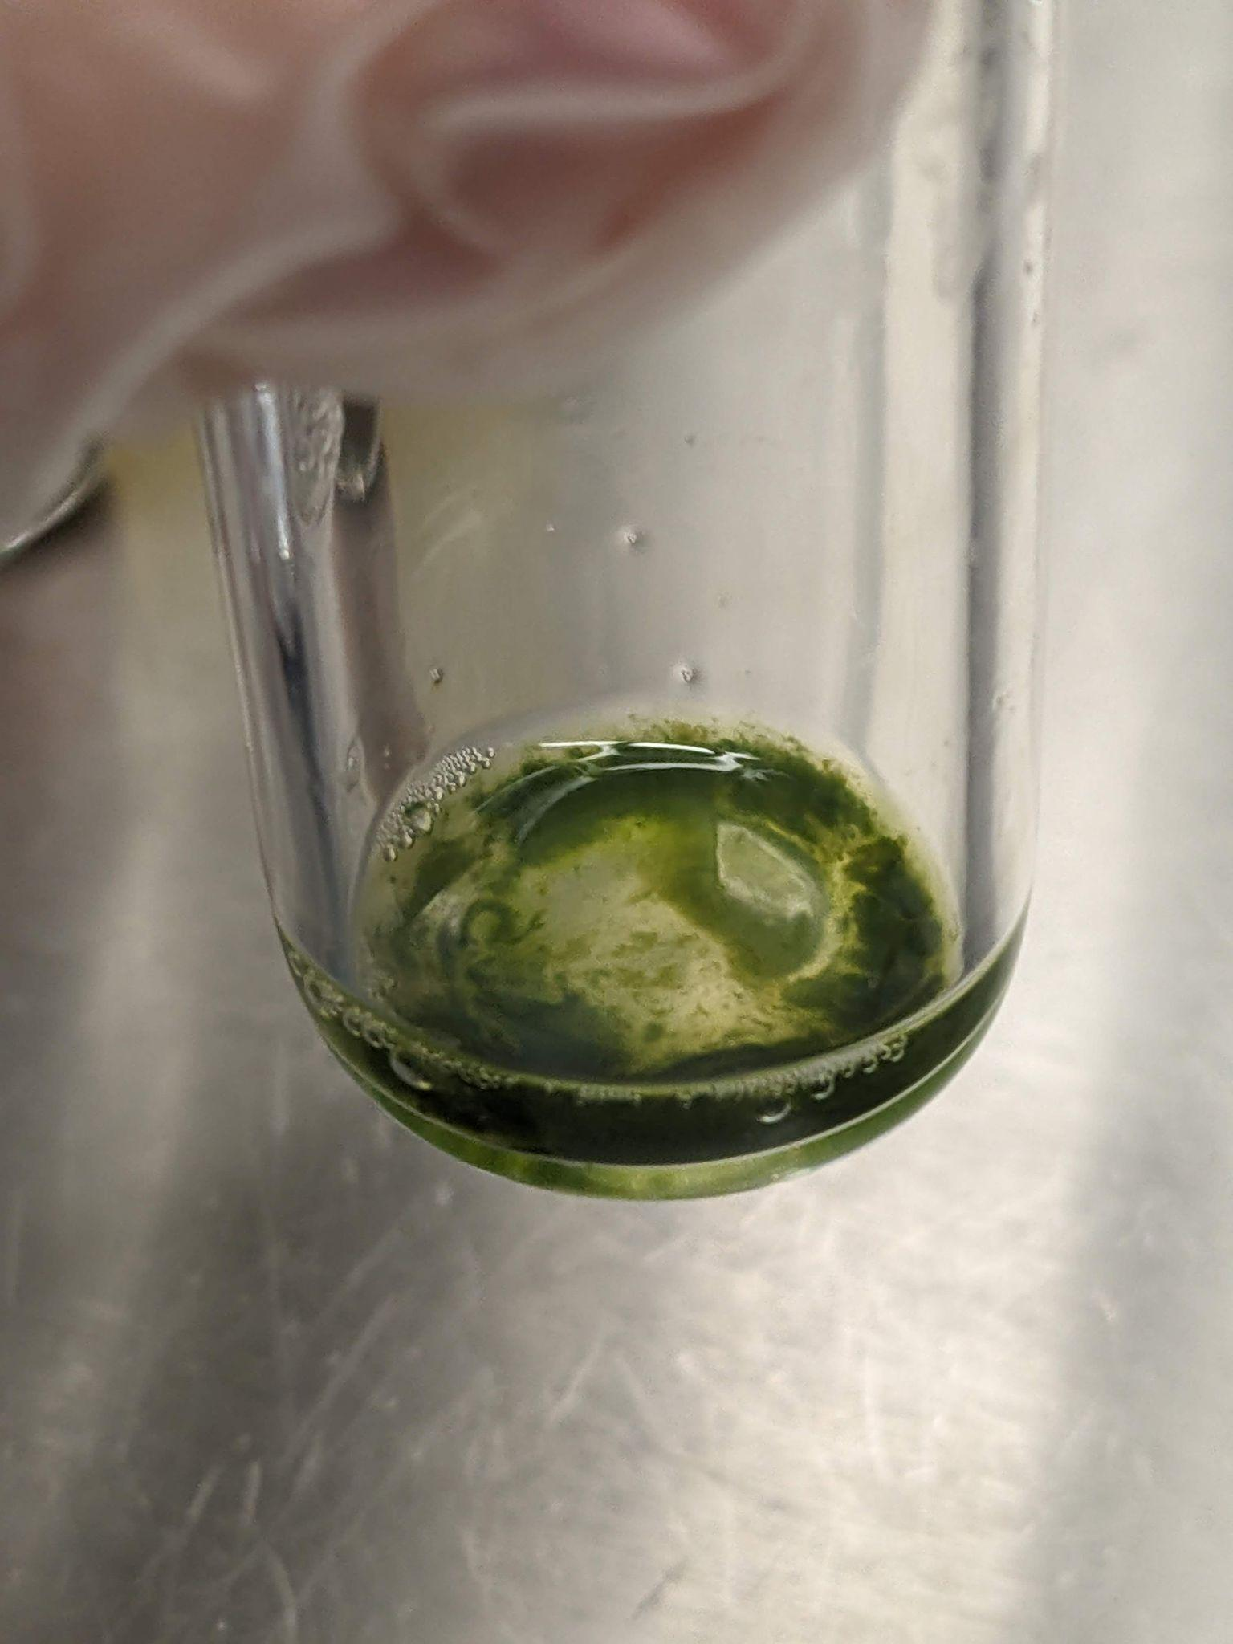

Fig. 4.9-8: *Nostoc sp.* Biofilm selected for flight. The biofilm shows good adhesion to the glass wall, dense biomass, sustained oxygen production (air bubbles) and deep green color indicating sufficient chlorophyll buildup.

Preparation of flight samples:

The following samples were cultivated in 15ml BG11 medium in the experiment glass tubes for 3-4 weeks pre-flight:

1. *Nostoc sp.* with *B. subtilis*
2. *Nostoc sp.* with *P. taiwanesis*
3. *Nostoc sp.* with *E. coli*
4. Pure culture *Nostoc sp.*
5. *Nostoc sp.* with *B. subtilis* from a previous cultivation batch (scraped)
6. *Nostoc sp.* with *P. taiwanesis* from a previous cultivation batch (scraped)
7. *Nostoc sp.* with *E. coli* from a previous cultivation batch (scraped)

One glass tube with BG11 medium and without bacteria is prepared right before launch as a medium control sample.

Samples are reversibly sealed and transported to the facilities in a closed container without access to sunlight to avoid any variability in growth conditions.

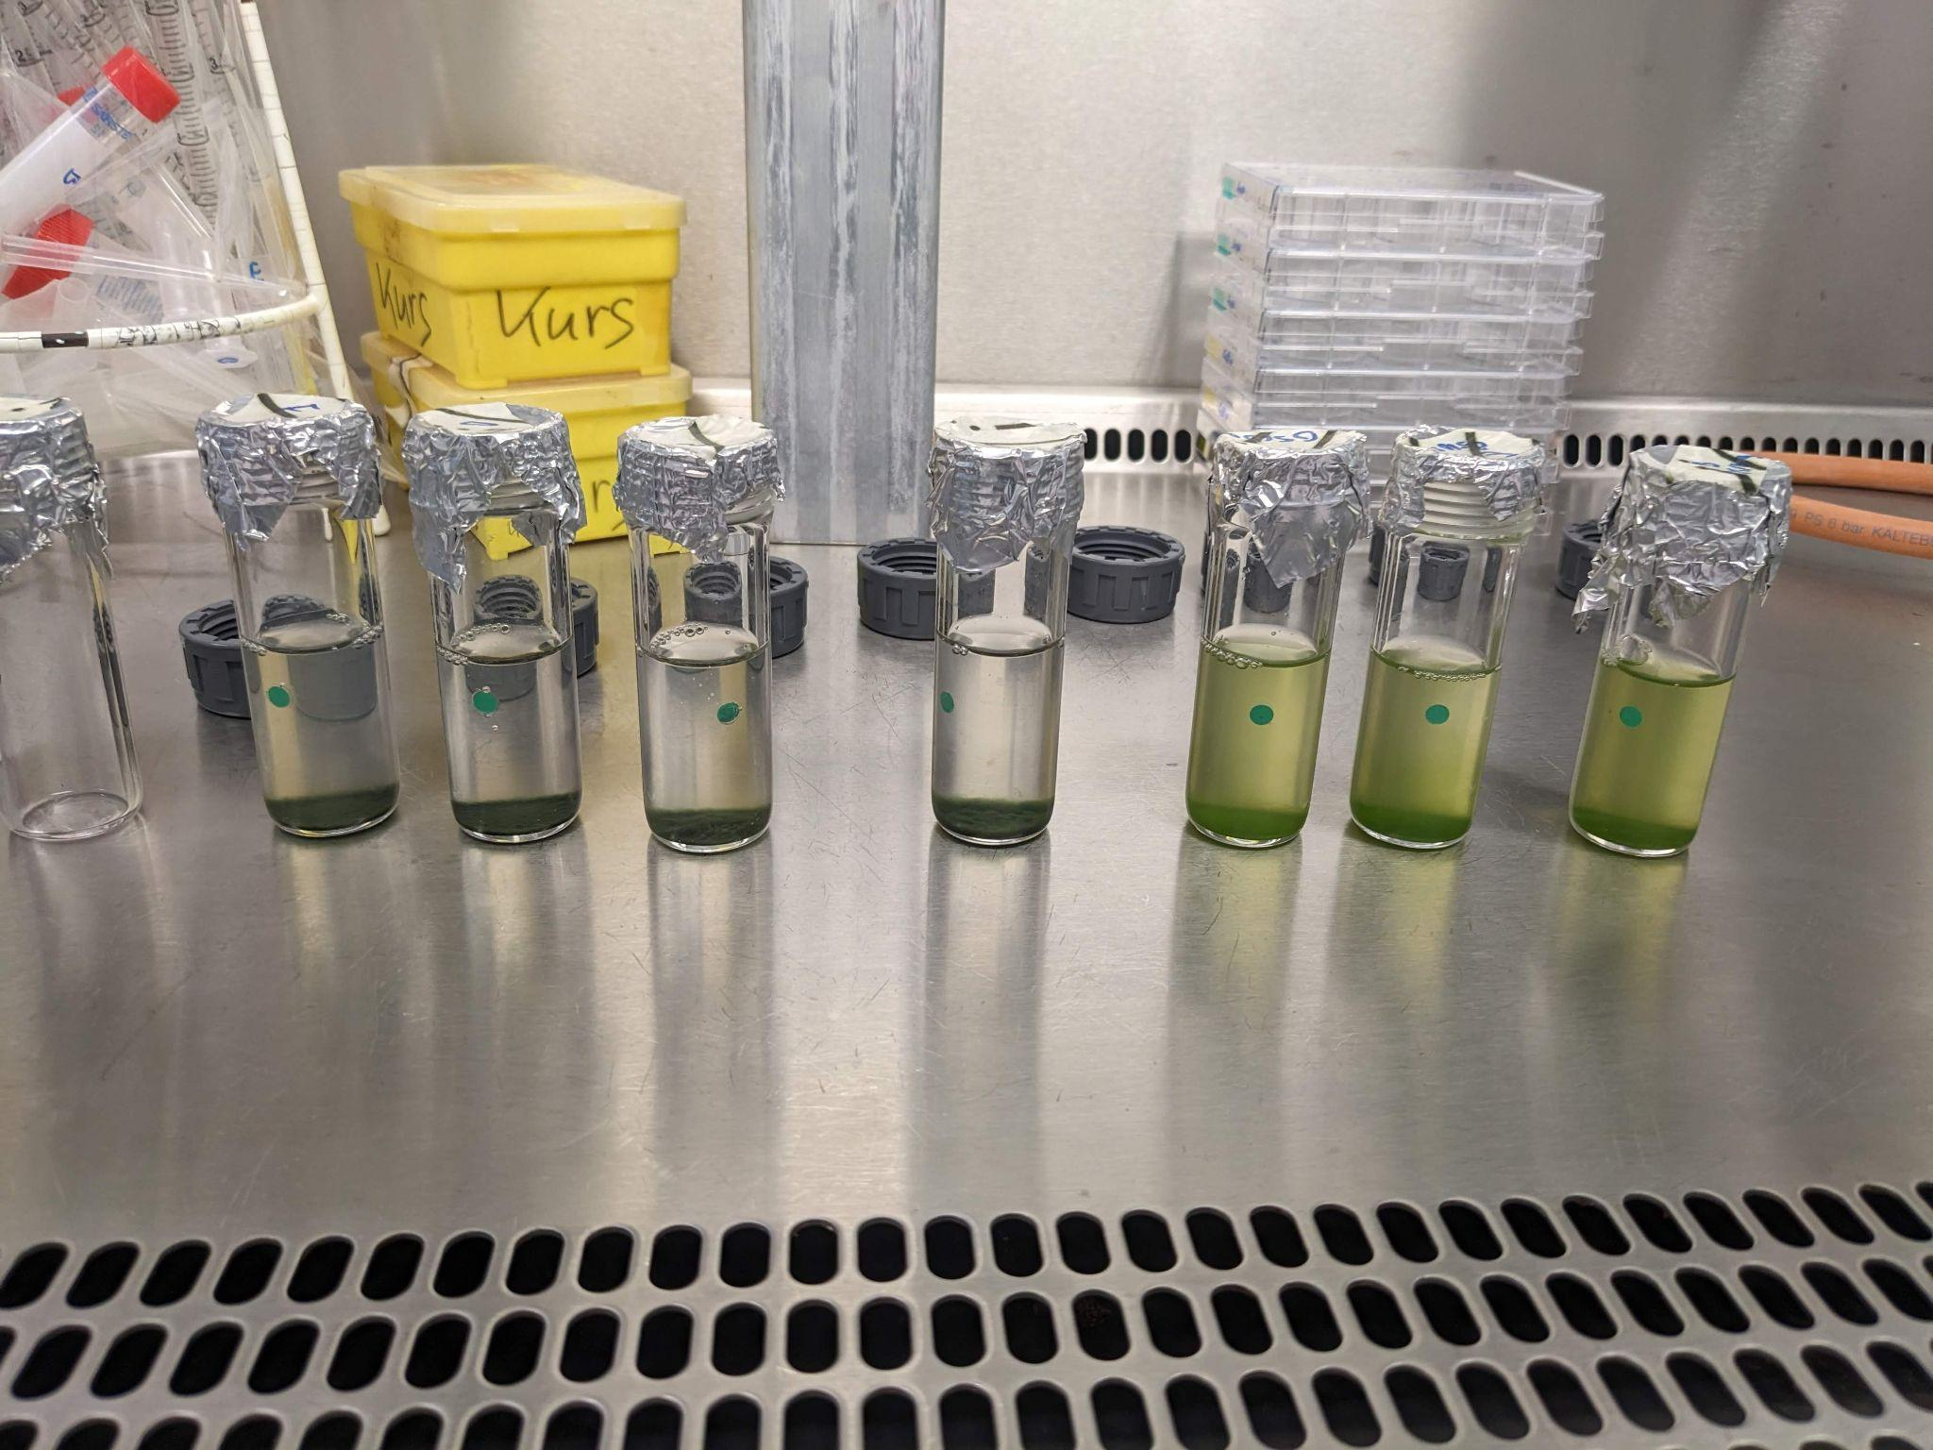

Fig. 4.9-9: *Nostoc sp.* samples in 35ml BG11 medium right before pre-sealing them for transport. The biofilm containing glass tubes are ordered as stated above from left to right.

## Ground Support Equipment

A Laptop with an ethernet port is needed to house the backend and the frontend.

The programming languages used for plotting the data on the ground station will be integrated following the specifications outlined in section 4.8.

## Changes from Former Flight (for Re-Flights only)

SpiCy is not based on former REXUS/BEXUS flight experiments.

# Experiment Verification and Testing

## Verification Matrix

**Table 5-1: Verification table**

| **ID** | **Requirement text** | **Methods** | **Ref.** | **Status** | **Verification Result** |
| --- | --- | --- | --- | --- | --- |
| F.1 | The biofilms shall be exposed to natural sunlight. | I, T, R | Test 14 | I - done  R - done  T - done | Verified |
| F.2 | The experiment shall measure the dissolved oxygen levels in the medium | A, T | Test 1 | A - done  T - done | Verified |
| F3 | The experiment shall measure the temperature inside the tubes. | A, T | Test 1 | A - done  T - done | Verified |
| F.4 | The experiment shall measure the temperature outside of the tubes. | A, T | Test 1 | A - done  T - done | Verified |
| F.5 | The experiment shall measure the temperature of the PCB in the electronic compartment. | A, T | Test 1 | A - done  T - done | Verified |
| F.6 | The experiment shall measure the UV light entering the module. | A, T | Test 1 &14 | A - done  T - done | Verified |
| F.7 | The experiment shall save the recorded data of diluted oxygen. | A, T | Test 1 | A - done  T - done | Verified |
| F.8 | The experiment shall save the recorded temperature data. | A, T | Test 1 | A - done  T - done | Verified |
| F.9 | The experiment shall save the light transmission data. | A, T | Test 1 | A - done  T - done | Verified |
| P.1 | The Oxygen sensors shall operate with an accuracy of 0.4 mg/l ± 0.009 | R, T | Test 1 | R - done  T - done | Verified |
| P.2 | The module shall be working within the range of -20 to 50°C. | A, T | Test 1 & 2 | A - done  T - done | Verified |
| P.3 | The thermal sensors shall operate with an accuracy of <=1°C. | R, T | Test 1 | R - done  T - done | Verified |
| P.4 | The thermal sensors shall operate with a response time of <=1 seconds | R, T | Test 1 | R - done  T - done | Verified |
| P.5 | The UV sensor shall measure the incoming UV light with an accuracy of ± 20nm. | R, T | Test 1 | R - done  T - done | Verified |
| P.6 | The Oxygen sensors shall operate with a sampling rate of <3 seconds. | A, R, T | Test 1 | A - done  R - done  T - done | Verified |
| D.1 | The top side of the module shall allow UV light to pass through. | R, T | Test 14 | R - done  T - done | Verified |
| D.2 | The tubes shall be hermetically sealed to prevent leakage. | R, T | Test 3 | R - done  T - done | Verified |
| D.3 | The electronics bay shall be accessible externally. | I, R | - | I - done  R - done | Verified |
| D.4 | The tubes inside the module shall have an exposure to natural sunlight for an elevation angle larger than 0 degrees. | A | - | A - done | Verified |
| D.5 | The biofilms shall cover the flat surface of the tubes. | I, R | - | I - done  R - done | Verified |
| D.6 | The temperature of the biofilm medium shall be maintained at 25-30°C. | A, T | Test 2 & 6 | A - done  T - done | Verified |
| D.7 | The temperature of the electronic compartment shall be maintained within the operational temperature range of the hardware components. | A, T | Test 2 & 6 | A - done  T - done | Verified |
| D.8 | The biological samples shall be S1. | R | - | R - done | Verified |
| D.9 | The experiment shall not interfere with other BEXUS experiments. | A, R | - | A - done R - done | Verified |
| D.10 | The experiment shall withstand the loads during the flight. | A, I, R, T | Test 4 | A - done  I - done  R - done  T - done | Verified |
| D.11 | The experiment shall withstand pressure differences during flight as defined in the BEXUS manual. | R, T | Test 2 | R - done  T - done | Verified |
| D.12 | The experiment shall withstand temperature differences during flight as defined in the BEXUS manual. | R, T | Test 2 & 6 | R - done  T - done | Verified |
| D.13 | The experiment shall withstand the loads during the landing. | A, I, R, T | Test 4 | A - done  I - done  R - done  T - done | Verified |
| D.14 | The experiment shall be compatible with the BEXUS vehicle. | I, R | - | I - done  R - done | Verified |
| D.15 | The experiment shall provide an interface for power and LAN. | I, R, T | Test 5 | I - done  R - done  T - done | Verified |
| D.16 | The experiment shall be grounded with the power connector | R, T | Test 5 | R - done  T - done | Verified |
| D.17 | The experiment shall work within the ambient temperature range of -60 to +30°C. | R, T | Test 2  Test 6 | R - done  T - done | Verified |
| D.18 | The experiment shall stay within the mass budget of 8kg. | T | Test 7 | T - done | Verified |
| D.19 | The experiment dimensions shall not exceed 340x340x300mm. | I, T | Test 7 | I - done  T - done | Verified |
| D.20 | The electronic system power consumption shall operate within the BEXUS power supply range. | A, R, T | Test 1 | A - done  R - done  T - done | Verified |
| D.21 | The experiment shall operate within the BEXUS voltage supply range. | A, R, T | Test 1 | A - done  R - done  T - done | Verified |
| D.22 | The data rate shall be lower than 50 kb/s. | A, T | Test 8 | A - done  T - done | Verified |
| D.23 | The electronics compartment shall be accessible independently from the biological experiment. | I, R | - | I - done  R - done | Verified |
| D.24 | The sensor data shall be sent to the ground station in accordance to the data rate specified in D.22. | A, T | Test 8 | A - done  T - done | Verified |
| D.25 | The frontend shall provide a function to evaluate the collected data in the oxygen plot. | A,T | Test 9 | A - done  T - done | Verified |
| D.26 | The frontend shall provide a function to help evaluate the collected data in the temperature plot. | A, T | Test 9 | A - done  T - done | Verified |
| D.27 | The system shall store raw data in a database. | A, T | Test 1 | A - done  T - done | Verified |
| D.28 | The incoming data shall be live plotted on the ground station. | A, T | Test 10 | A - done  T - done | Verified |
| D.29 | The plot shall check for new data at least every 3 seconds. | A, T | Test 10 | A - done  T - done | Verified |
| D.30 | The software interface shall visualize the temperature data on the ground station. | A, T | Test 10 | A - done  T - done | Verified |
| D.31 | The software interface shall visualize the oxygen data on the ground station. | A,T | Test 10 | A - done  T - done | Verified |
| D.32 | The software of the ground station shall be structured in frontend, backend and database. | R | - | R - done | Verified |
| O.1 | The biosafety protocols for handling the selected biofilms before and after flight shall be followed. | I,R | - | I - done  R - done | Verified |
| O.2 | The biofilms shall be cultivated inside of the Esrange laboratory. | I, R | - | I - done  R - done | The cultivation was done before the travel - **Verified** |
| O.3 | The biofilms shall be transferred inside of the Esrange laboratory. | I, R | - | I - done  R - done | Verified |
| O.4 | The experiment shall operate autonomously, without human intervention | T | Test 1 | T - done | Verified |
| O.4.1 | The system shall instantly start running and continue to function when connected to power supply | T | Test 1 | T - done | Verified |
| O.4.2 | The system shall instantly shut down when disconnected from power supply on retrieval | T | Test 1 | T - done | Verified |
| O.5 | The tube's temperature measurements shall be shared via Downlink with the Ground Station. | A, T | Test 10 | A - done  T - done | Verified |
| O.6 | The handling of bacteria shall comply with the safety regulations of the facilities they are handled in. | I, R | - | I - done  R - done | Verified |
| O.7 | The handling of bacteria shall comply with the rules for international exports posed by the German war weapons control act. | I, R | - | R - done | Verified |
| O.8 | The backend shall ensure continuous data processing and management in the event of receiving invalid requests. | A, T | Test 11 | A - done  T - done | Verified |
| O.9 | Operational documentation detailing the backend functionality shall be maintained and made available for user reference and system explanation. | R | - | R - done | Verified |
| O.10 | The plot interface shall alert if the temperature data are exceeding the tolerance range according to D.14, D.15. | A, T | Test 12 | A - done  T - done | Verified |
| O.11 | The software system shall feature a fault detection system. | A, T | Test 13 | A - done  T - done | Verified |
| O.12 | The system shall support retrieval and export of plotted data for further analysis and reporting. | A, T | Test 1 | A - done  T - done | Verified |

## 

## Verification Plan

| **Test number** | **Test 1** |
| --- | --- |
| Test type | a. To verify that all the electronic subsystems are functional  b. Verify data handling, storage, retrieval and exporting  c. Power consumption measurement  d. Overall functioning of the system; from start to shut down |
| Test facility | University lab |
| Tested item | *the motherboard, oxygen sensors, thermistors, light sensors and kapton heaters* |
| Model | Engineering Model (a)  Protoflight Model (b,c,d) |
| Procedure, Test level and duration | a. Making sure all power electronics are working even under load. Test each individual sensor by checking their functionality and performance specifications in varying conditions. Checking stability problems via an oscilloscope.  b. Connect all electronic components to sample one tube prototype in required configuration and with the power source, and start measurement and sending of data via the motherboard. Verify if the download container (package) is intact and properly filled with the right data. Additionally, check if the data is stored on the SD card by running it on a computer.  c. Measuring the power consumption of the subsystems and comparing it with the expected current draw. Measuring the power consumption of the complete motherboard under various operating conditions to ensure compliance with the BEXUS power supply.  d. The system should start as soon as connected to the power supply, and instantly stop when disconnected. Also should restart in case of power failure or data corruption.  Qualification test; few hours |
| Test campaign duration | 1-2 days |
| Test campaign date | June - August 2024 |
| Test completed | YES |
| Requirements verified | F.2, F.3, F.4, F.5, F.6, F.7, F.8, F.9  P.1, P.3, P.4, P.5, P.6  D.20,D.27  O.4, O.4.1, O.4.2, O.12 |

| **Test number** | **Test 2** |
| --- | --- |
| Test type | Temperature stability in a thermal controlled vacuum (Thermal Vacuum) |
| Test facility | Thermal vacuum chamber in a lab (ZARM) |
| Tested item | The entire experiment model |
| Model | Flight Model |
| Procedure, Test level and duration | Continuous monitoring of temperature within specified range over a period of couple of hours (exceeding the expected flight duration);  Acceptance and Performance test |
| Test campaign duration | 1-2 days |
| Test campaign date | First week of September with ZARM |
| Test completed | Yes |
| Requirements verified | Req ID #P.2: YES  Req ID #D.6: YES  Req ID #D.11: YES  Req ID #D.12: YES  Req ID #D.17: YES |

| **Test number** | **Test 3** |
| --- | --- |
| Test type | Tube sealing integrity/Pressure Testing |
| Test facility | Vacuum chamber in a lab |
| Tested item | Sealed tubes |
| Model | Prototype Model |
| Procedure, Test level and duration | Subjecting sealed tubes to pressure differential and leakage testing to ensure hermetic sealing for around 5 hours. The tube was subjected to an inside pressure of 0.1 bar, and therefore was tested against an atmospheric pressure of 1bar, and place inside a container of water to check for bubbles (indicative of pressure leakage);  Acceptance and Reliability test |
| Test campaign duration | 1 day |
| Test campaign date | Mid-August. 2024 |
| Test completed | Yes |
| Requirements verified | Req ID #D.2: YES |

| **Test number** | **Test 4** |
| --- | --- |
| Test type | Static Load Test for structural integrity and gondola fixation |
| Test facility | Kiruna Dome |
| Tested item | Final module structure |
| Model | Flight Model |
| Procedure, Test level and duration | 1. Apply 10 G (10x the mass of the module) to the top of the isolated module 2. Load test on gondola fixture: Apply 10G to top of module fixated to gondola. 3. Load test on bottom of module: Apply 10G on bottom of module while fixated to gondola to simulate force applied by experiment core. |
| Test campaign duration | 1 h |
| Test campaign date | 27th September 2024 (during launch lampaign) |
| Test completed | Yes |
| Requirements verified | Req ID #D.10: YES  Req ID #D.13: YES |

| **Test number** | **Test 5** |
| --- | --- |
| Test type | Interface/grounding functionality |
| Test facility | University Lab |
| Tested item | *Electronic interface of the module with power connector (Power and LAN connection)* |
| Model | Prototype Model |
| Procedure, Test level and duration | Testing the functionality of power and LAN interfaces, including connection and communication;  Acceptance test; 30 mins |
| Test campaign duration | Few hours |
| Test campaign date | June. 2024 |
| Test completed | Yes |
| Requirements verified | Req ID #D.15: YES  Req ID #D.16: YES |

| **Test number** | **Test 6** |
| --- | --- |
| Test type | Low Fidelity Thermal testing (system operation under cold and hot case) |
| Test facility | Hot case: Outside in the sun  Cold case: in a freezer/refrigerator |
| Tested item | Final module structure |
| Model | Qualification Model |
| Procedure, Test level and duration | Subjecting the entire experiment setup for the duration of the flight under the sun and in the freezer/refrigerator to simulate the cold and hot conditions and verify hardware functionality under these conditions. System further verified through Test 2 to achieve Flight Readiness Level;  Acceptance and Environment test; 4-5 hours each |
| Test campaign duration | 2 days |
| Test campaign date | Mid-August 2024 |
| Test completed | [detailed test results](https://github.com/EggiEl/SpiCy-BEXUS/blob/main/motherboard/Software/Thermal%20Simulations/Testing/thermal%20test%20result%2018.8.pdf)  **Hot case:**  Not an issue.  **Cold case:**  Heating is proven to be sufficient at around 15°C for the module in a fridge. This shows the step impulse function in the appended document. We will improve at the isolation by adding more isolation material around the tubes and outside of the module. Moreover, the gaps between the foam structure will be filled with isolation material and taped tightly. Regarding the heating system, we are also able to increase the heating capability significantly by adding an external buck converter.  Also: as the drop of temperature of the module is accompanied with a drop of pressure, the lack of air will isolate our module as well, reducing heating requirements significantly. See Fig 4-17  **Update:**  ZARM tvac test proved our heating system to be sufficient. |
| Requirements verified | Req ID #D.6: YES  Req ID #D.7: YES  Req ID #D.17: YES |

| **Test number** | **Test 7** |
| --- | --- |
| Test type | Weight and dimensions |
| Test facility | Electronic scale and measuring tape |
| Tested item | Final module assembly |
| Model | Flight Model |
| Procedure, Test level and duration | Weighing experiment assembly to ensure compliance with mass budget and also measuring the external dimensions of the module to stay within the allotted volume for the experiment on the gondola;  Qualification test; 2-5 mins |
| Test campaign duration | 30 mins |
| Test campaign date | Last week of August. 2024 |
| Test completed | Yes (Table 4.2) |
| Requirements verified | Req ID #D.18: YES  Req ID #D.19: YES |

| **Test number** | **Test 8** |
| --- | --- |
| Test type | Downlink testing. Interrupt stability, data rate and storage |
| Test facility | Laboratory setup with data transmission system |
| Tested item | Data transmission system |
| Model | Proto flight Model |
| Procedure, Test level and duration | Measuring the data transmission rate of the experiment system to ensure it is sent to the ground station at lower than 50 kb/s;  Acceptance and Performance test; a few hours |
| Test campaign duration | A week |
| Test campaign date | July 2024 |
| Test completed | Yes |
| Requirements verified | Req ID #D.22: YES  Req ID #D.24: YES |

| **Test number** | **Test 9** |
| --- | --- |
| Test type | Frontend functionality testing |
| Test facility | Laboratory setup with software and data visualization tools |
| Tested item | Frontend software |
| Model | Qualification Model |
| Procedure, Test level and duration | Testing the frontend software to ensure it provides functionality to evaluate collected data in oxygen and temperature plot;  Qualification and System test; 1-2 hours  Use the slider to zoom in on specific data points in the oxygen plot.    Verify the zoom functionality and confirm that only the last 10 points are visible when the slider is deactivated.    Tooltip Verification  Hover over data points to check that tooltips display accurate data.    Measurement Tool Test  Use the measurement tool to calculate and verify the time between two plotted points. |
| Test campaign duration | A week |
| Test campaign date | July 2024 |
| Test completed | YES (with dummy/simulated data) |
| Requirements verified | Req ID #D.25: VERIFIED  Req ID #D.26: PARTIALLY |

| **Test number** | **Test 10** |
| --- | --- |
| Test type | Data downlink, update and visualization testing |
| Test facility | Laboratory setup with ground station simulation equipment |
| Tested item | Data visualization system |
| Model | Qualification/Proto flight Model |
| Procedure, Test level and duration | Testing the system to ensure it checks for new data every 3 seconds and that incoming data is live plotted on the ground station as required;  Enable console logging to capture data checks.  4356  Verify that the system checks for new data every 3 seconds.  Calculate time intervals between server responses to confirm compliance.  Ensure incoming temperature and oxygen data are accurately visualized in real-time.  Cross-check logged data with the data shown in the plots.    Acceptance test; few hours |
| Test campaign duration | A week |
| Test campaign date | July. 2024 |
| Test completed | YES (with dummy/simulated data) |
| Requirements verified | Req ID #D.28: PARTIALLY  Req ID #D.29: PARTIALLY  Req ID #D.30: PARTIALLY  Req ID #D.31: PARTIALLY  Req ID #O.5: PARTIALLY |

| **Test number** | **Test 11** |
| --- | --- |
| Test type | Backend functionality testing |
| Test facility | Laboratory setup with backend software and simulated invalid requests |
| Tested item | Backend software |
| Model | Proto flight Model |
| Procedure, Test level and duration | Testing the backend software to ensure continuous data processing and management, including handling of invalid requests;  Ensure the backend is running normally.  Use Postman to send invalid requests (e.g., incorrect data or endpoints).  Confirm the backend continues to process valid data without interruption.  Check logs for error handling.  Record observations to verify backend stability and data integrity.    Acceptance test; 1-2 hours |
| Test campaign duration | A week |
| Test campaign date | End of July. 2024 |
| Test completed | Yes |
| Requirements verified | Req ID #O.8: YES |

| **Test number** | **Test 12** |
| --- | --- |
| Test type | Alert functionality testing |
| Test facility | Laboratory setup with plot interface software and simulated temperature data; |
| Tested item | Plot interface software |
| Model | Proto flight Model |
| Procedure, Test level and duration | Testing the plot interface to verify alert functionality for temperature data exceeding tolerance range;  Load Out-of-Range Data  Input temperature data into the plot, ensuring some values exceed the tolerance limits.  Check Alert Response  Verify that the plot turns red if the last data point exceeds the upper limit.    Verify that the plot turns green if the last data point is in between the limits    Verify that the plot turns blue if the last data point falls below the lower limit.    Acceptance and System test; 1-2 hours |
| Test campaign duration | Few days |
| Test campaign date | End of July. 2024 |
| Test completed | YES Partially in Oxygen Plot |
| Requirements verified | Req ID #O.10: YES |

| **Test number** | **Test 13** |
| --- | --- |
| Test type | Fault detection testing |
| Test facility | Laboratory setup with software fault simulation tools |
| Tested item | Software system |
| Model | Qualification Model |
| Procedure, Test level and duration | Testing the software system to verify the functionality of the fault detection system;  Acceptance and System test; few hours |
| Test campaign duration | A week |
| Test campaign date | Start of August. 2024 |
| Test completed | Yes |
| Requirements verified | Req ID #O.11: YES  In case of any small fault, a debug message gets downlinked. Can be fixed with firmware update.  For big faults the watchdog is used to reset the electronics. |

| **Test number** | **Test 14** |
| --- | --- |
| Test type | Exposure to natural sunlight |
| Test facility | Outdoor test site with access to direct sunlight |
| Tested item | The glass to be placed on top of module with UV sensor underneath |
| Model | Engineering Model |
| Procedure, Test level and duration | Position the glass under direct sunlight with a UV sensor underneath to measure the sunlight that passes through as a qualification test and one of the necessary conditions for the experiment's success.  Qualification test; 30 mins |
| Test campaign duration | A few hours |
| Test campaign date | Second week of August 2024 |
| Test completed | Yes |
| Requirements verified | Req ID #F.1: YES  Req ID #F.6: YES  Req ID #D1: YES |

## Verification Results

| **Verification number** | *Test 1 (a, b, c, d)* |
| --- | --- |
| **Type of test** | *a.To verify that all the electronic components are functional*  *b.Verify data storage, retrieval and exporting*  *c.Power consumption measurement*  *d.Overall functioning of the system; from start to shut down* |
| **Facility** | *University Lab* |
| **Verified item** | *the motherboard, oxygen sensors, thermistors, light sensors and kapton heaters* |
| **Verification description** | *a.*  *-For the power electronics put a resistor for max current draw across the output and see if the voltage is still stable.*  *-For the oxygen sensors test them with a 0% oxygen solution and then with as many other sources of know oxygen levels as can be found in the lab.*  *-For the thermistors put Ice in a glass to warm up and measure temperature with the thermistors of the motherboard and also with some calibrated ones. Then compare. (Temperature sweep)*  *-The light sensors can be only tested by shining a UV and the sunlight on it and seeing if the data seems to be alright, as we do not have access to an optical lab. They are factory calibrated.*  *- Testing if the heaters are working.*  *b.*  *Running all data acquiring methods in loops and tests with a signal analyser and oscilloscope for data corruption. Writing dummy data in the sd card and seeing if there's any conversion/corruption problem.*  *c. disabling all subsystems except one and measuring the power consumption. If disabling is impossible, subtract the known from the unknown.*  *D. running the whole experiment and ensure it still work, if:*  *-> power gets recycled*  *->loses Ethernet link*  *-> sd card goes missing*  *-> one or more oxygen sensors are missing*  *-> one or more thermistors are missing*  *-> one or more light sensors are missing*  *-> one or more heaters are missing* |
| **Expected results** | *a. no significant deviation from the calculated accuracy values for the sensors and no great dividation from the in the data sheets stated values for the power electronics*  *b.no data corruption and a healthy sd card*  *c.no significant division to the power levels stated in the SED*  *d.no complete failure (aka. Blackout or infinite reboot in watchdog) regarding what cable/component gets removed.* |
| **Obtained Results** | *Matched expected results. Conversions or corruptions were not recorded.* |
| **Conclusions** | The data acquiring systems reliably generates and saves data in a worst-case scenario and thus can be integrated. |

For the following tests, as well as those discussed in Section 5.3, the verification results were obtained at the system level rather than for individual subsystems. Some visuals have already been presented in Section 5.2, while the rest were verified during the comprehensive testing of all module systems, including TVAC (Thermal Vacuum) testing and final flight evaluations.The obtained results were as expected and according to the procedures detailed earlier.

| **Verification number** | *Test 4* |
| --- | --- |
| **Type of test** | *Static Load Test* |
| **Facility** | *Esrange Dome* |
| **Verified item** | *Integrity of module structure and faction to gondola* |
| **Verification description** | Loadtest on Experiment structure: Experiment mass: 3,86kg  Mass of reference man: 70kg   Loadtest on Gondola fixture: Experiment mass: 3,86kg  Mass of weights: 40kg     1. Loadtest on bottom of module:   Mass inside experiment (foam box, no aluminium rails): 2.1kg  Pulling force: 30.9kg |
| **Expected results** | *We expect that the experiment module and the fixation to the gondola withstands the static load applied.* |
| **Obtained Results** | *The tests were successful. The integrity of the module was retained during the static loads applied* |
| **Conclusions** | The cables and connectors can be integrated. |

| **Verification number** | *Test 5* |
| --- | --- |
| **Type of test** | *Interface/grounding functionality* |
| **Facility** | *University Lab* |
| **Verified item** | *Electronic interface of the module with power connector (Power and LAN connection)* |
| **Verification description** | *Testing if every cable fits and is easy to connect.* |
| **Expected results** | *All is working as expected.* |
| **Obtained Results** | *Same as expected results.* |
| **Conclusions** | The cables and connectors can be integrated. |

| **Verification number** | *Test 8* |
| --- | --- |
| **Type of test** | *Motherboard and tcp server running on a laptop with lan port* |
| **Facility** | *University Lab* |
| **Verified item** | *Setting up the tcp Server and connecting the motherboard via LAN.*  *Testing up downlink via sending of commands/dummy packets. Testing for data corruption and interruptions.* |
| **Verification description** | Measuring the data transmission rate of the experiment system to ensure it is sent to the ground station at lower than 50 kb/s |
| **Expected results** | *The data is sent to the ground station at lower than 50 kb/s.* |
| **Obtained Results** | *Same as expected results.* |
| **Conclusions** | The data transmission rate is acceptable. |

| **Verification number** | *Test 9* |
| --- | --- |
| **Type of test** | *Frontend functionality testing* |
| **Facility** | *Laboratory setup with software and data visualization tools* |
| **Verified item** | *Frontend software* |
| **Verification description** | ***Frontend Data Retrieval:***   * *Trigger the frontend application to retrieve the newly added dummy data from the database.* * *Use console logs to track the data retrieval process. Verify that the console logs indicate successful data fetch without errors.*   ***Data Plotting:***   * *Implement the logic to plot the retrieved data on the frontend.* * *Use console logs to capture the plotting process. Ensure that each data point from the dummy data set is accounted for and correctly mapped onto the plot.*   ***Verification of Plot Accuracy:***   * *Manually inspect the plotted data on the frontend interface to ensure it matches the dummy data.*   ***Console Log Verification:***   * *Review the console logs to confirm that:* * *Data retrieval from the database was successful and complete.* |
| **Expected results** | *The database contains the complete and correct set of dummy data.*  *The frontend retrieves all the dummy data without any issues.*  *The data is accurately plotted on the frontend interface, reflecting the expected visual representation.*  *Console logs confirm the successful completion of each step without errors.* |
| **Obtained Results** | *The dummy data is plotted completely.*        *There are no duplicate data points.*  *The plot accurately represents the dummy data.* |
| **Conclusions** | *Upon successful completion of the above verification steps, it can be concluded that the system correctly handles dummy data from database storage to frontend visualization.* |

| **Verification number** | *Test 10* |
| --- | --- |
| **Type of test** | *Data downlink, update and visualization testing* |
| **Facility** | *Laboratory setup with ground station simulation equipment* |
| **Verified item** | *Data visualization system* |
| **Verification description** | *Dummy data is sent to the visualization system.* |
| **Expected results** | *The dummy data is visualized correctly* |
| **Obtained Results** | *Same as expected results.* |
| **Conclusions** | The software reliably sends, receives and visualizes the measured data. |

# Launch Campaign Preparation

## Input for the Campaign / Flight Requirement Plans

### Dimensions and Mass

**Table 6-1: Experiment Mass and Volume**

| Experiment mass (in kg): | 3.86 kg |
| --- | --- |
| Experiment dimensions (for BEXUS) or module size (for REXUS) (in m): | 290 x 290 x 306 mm |
| Experiment expected COG (center of gravity) position: | 145 x 145 x 200 mm |

### Ground and Flight Safety Risks

**Table 6-2: Ground and flight safety risks**

| **Risk** | **Key Characteristics** | **Mitigation** |
| --- | --- | --- |
| Glass tubes filled with bacteria and bacterial medium at ground pressure might leak. | Content: Cyanobacterial Biofilms within liquid bacterial medium | Neither bacteria nor medium pose a hazard to human health. Handling of the contents is safe.  Tubes are sealed to be leak proof and withstand pressure gradient. |
| Glass tubing or upper ceiling might break due to impact during landing. | Sharp glass shards | Selection of quartz glass with high stability.  If the recovery team detects shattered glass, please proceed with caution. Wear gloves. |

### Electrical Interfaces

**Table 6-3: Electrical interfaces applicable to BEXUS**

| **BEXUS Electrical Interfaces** | | |
| --- | --- | --- |
| E-Link Interface: E-Link required? Yes | | |
|  | Number of E-Link interfaces: | 1 |
|  | Number of required IP addresses: | TCP_SERVER_IP(169,254,218,4);  PAYLOAD_IP(169,254,218,100);  *They can be edited in code.* |
|  | Data rate – downlink (max. and average): | 472B/s on average, 5KB/s max |
|  | Data rate – uplink (max. and average): | 11B/s on average, 162KB/s max (but only if a firmware update should be necessary. This should not be the case) |
|  | Interface type (RS-232, Ethernet): | Ethernet |
| Power system: Gondola power required? Yes | | |
|  | Peak power and current consumption: | 35.025 W and ~1,2A |
|  | Average power and current consumption: | 4W (averaged over the whole flight, current consumption will be way higher at liftoff) per tube |
|  | Total power and current consumption after lift-off | 40Wh |
| Power system: Experiment includes batteries? No | | |

### 

### Launch Site Requirements

**Table 6-4: Launch Site Requirements**

| **Category** | **Item** | **Amount** | **Provided by** |
| --- | --- | --- | --- |
| Microbiology laboratory | Sterile flow hood | 1 | SSC |
| Serological pipettes 5 mL (sterile) | 5 | SSC |
| Serological pipettes 10 mL (sterile) | 5 | SSC |
| Serological pipettes 25 mL (sterile) | 5 | SSC |
| Window (ideally south/south-west facing) | 1 | SSC |
| Shaker incubator | 1 | SSC |
| Table centrifuge (for Eppendorf tubes) | 1 | SSC |
| Centrifuge for 50 mL vessels | 1 | SSC |
| Photometer | 1 | SSC |
| Pipetting aid (for serological pipettes) | 1 | SSC |
| µL pipettes (10 µL, 50µL, 100µL, 1 mL) | 1 of each | SSC |
| Workstation | Table | 1 | BEXUS |
| Chair | 7 | BEXUS |
| Access to a Lab Power Supply, 0 – 30V | 1 | BEXUS |
| Power extension cord | 2 | BEXUS |
| Whiteboard | 1 | BEXUS |
| Whiteboard marker (multiple colors) | 2 | BEXUS |
| Access to a SMD hot air soldering station | 1 | BEXUS |

### Flight Requirements

**Table 6-5: Flight Requirements applicable to BEXUS**

| **Optimal altitude** | **As high as possible** |
| --- | --- |
| **Preferred path** | **/** |
| **Minimum float time** | **1 h** |
| **Ground track length** | **/** |
| **Light/dark condition** | **Natural sunlight** |

To maximize the sunlight elevation angle, the desired flight time is close to noon, which in Kiruna on the 1st of October is at 12:28. Ideally, the window for the flight should be distributed evenly with the noon in between, e.g. 2 hours flight → Launch - 11:28 and Landing - 13:28T. If this is not entirely possible, a launch time after sunrise (06:53 on 1. October) shall be chosen, preferably as close to noon as possible.

UV-A irradiance increases ca. 9 % and UV-B irradiance ca. 18 % per 1000 m altitude under clear skies (Blumthaler, Ambach and Ellinger, 1997; Schmucki and Philipona, 2002). This results in the altitude requirement of “as high as possible”. The higher the UV irradiance the higher the significance of the results of SpiCy.

### Accommodation Requirements

Our experiment design shall be mounted on the top of the gondola ensuring that the top part is not covered by any other experiment. Ideally, our experiment is placed away from other experiments that produce outward thermal energy to avoid overheating of our module.

## Preparation and Test Activities at Esrange

**Table 6-6: List of planned activities**

| **Time/Day** | **Main Task** | **Description** | **Responsible** | **Duration [h:m]** |
| --- | --- | --- | --- | --- |
| 3 days before launch | Static load test for the module | Apply static load of at least 10g on the module structure | Tian | 1h |
| 2 days before launch | Measure oxygen production of biofilms | Measure oxygen production of biofilms. Confirm expected results. | Ilana, Alex, Fynn | 1h |
| 1 day before Launch | Measure oxygen production of biofilms | Measure oxygen production of biofilms. Confirm expected results. | Ilana, Alex, Fynn | 1h |
| up/downlink | Testing ip allocation and up/downlink communication | Fynn, Elias | Depends on success. 5min to 2h |
| Hardware Preparation | Arrive at the launch site and set up equipment and workspace. | All team members | 1h |
| Launch day | Prepare the bio module | Ensure proper sealing of all tubes and insert into rack. | Alex, Tian | 1h |
| Prepare mechanical module | Prepare the mechanical module, ensuring all connections and attachments are secure. | Tian, Pablo, Fynn | 2h |
| T-5H | Transport the bio module | Transport the bio module to Dome (room temperature). | Ilana, Alex | 10 min |
|
| Integrate bio module | Integrate the bio module with the mechanical module and perform a final inspection to verify proper assembly. Verify electronics. | All team members | 30 min |
|
| Mount whole box on the gondola | Mount the assembled modules onto the gondola of the sounding balloon and secure them in place. | Tian, Fynn, Alex | 10 min |
| T-4H00 |
| Covering | Cover glass plate of bio module with cling film. | Tian, Ilana | 10 min |
|
| T-3H30 | Comm’ check | Communications checked | Fynn, Elias | 30 min |
| Tests outside Dome | Testing | Tian, Fynn, Alex, Elias, Pablo, Ilana | 1h |
| T-2H00 | Nominal functions check | Confirm hat expected sensor data is received | Elias, Ilana, Alex | 10 min |
| T-1H00 | Late Access: Remove Covering | Remove covering from module. | Ilana, Tian | 2 min |
| Nominal functions check | Confirm that expected sensor data is received. | Elias, Ilana, Alex | 10 min |
| Confirmation | Report ready for inflation. | Ilana |  |
| 0 | Balloon Release | Launch the sounding balloon with the SpiCy experiment onboard. | BEXUS team |  |

# 

## Timeline for Countdown and Flight

We have no specific timeline for our payload, as it is an uninterrupted continuous experiment. The moment it receives power all measurements / heaters are starting and the moment the battery runs dry it stops.

## Post-Flight Activities

Recovery Instructions:

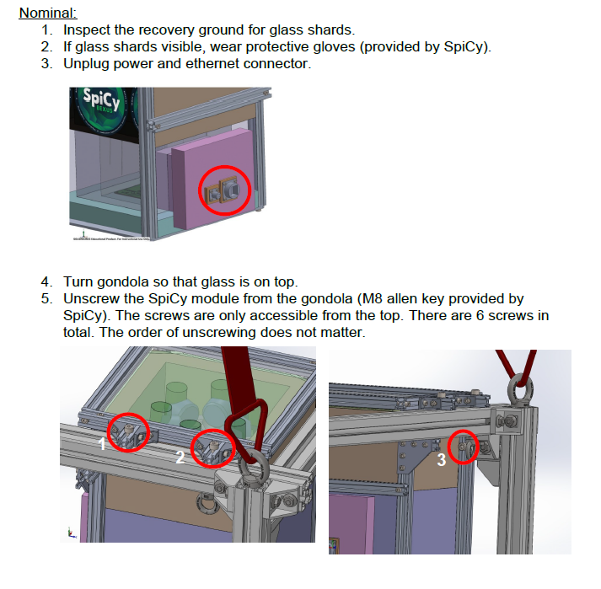

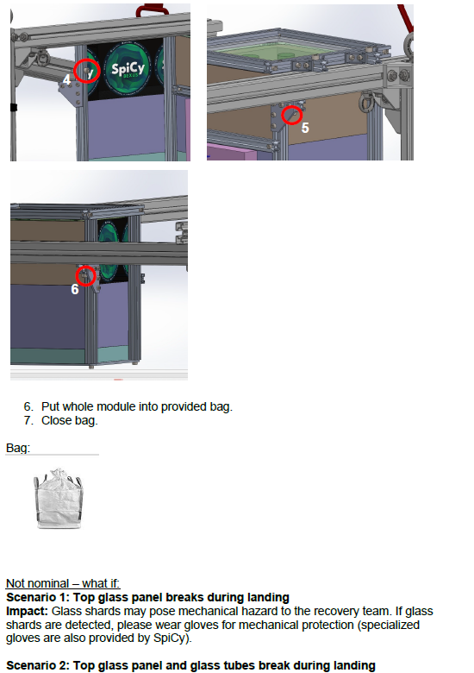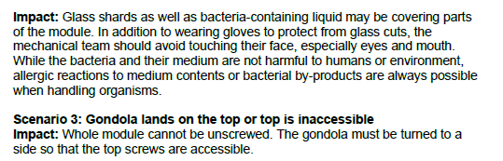

## Data Analysis And Results

## Data Analysis Plan

**Pre-Experiments on Ground:**

The first step is the cultivation of our cyanobacteria with different media. The Chroococcidiopsis cubana are grown in BG11+ and BG11 media to find the best growth conditions. The strains Nostoc and Oscillatoria are kept in BG11 media. The growth rate is determined via microscopy and visual indicators such as the color of the culture and the density.

We subsequently cultivate Pseudomonas taiwanensis, E.coli, Bacillus subtilis, Lactobacillus plantarum and Lactobacillus fermentum in their respective media and the minimal medium M9.

The next step is to optimize the combination of cyanobacteria and heterotrophic bacteria. Various combinations and concentrations are evaluated by measuring both oxygen production and biomass growth. The aim is to identify the most effective biofilm composition in regards to their relative oxygen output.

To gain insight into the biofilm composition and especially the matrix composition DNA, RNA and proteins are extracted using the AllPrep DNA/RNA/Protein Mini Kit by QIAGEN. The samples are then stored for a possible later analysis. A western blot analysis is used on the isolated proteins to document the matrix proteins for comparison with the samples extracted after the BEXUS experiment.

**Experiment on BEXUS:**

The main interrogative is the comparison of oxygen production between the controls, the selected best biofilm candidate and the data already collected in the pre-experiments. The growth rate on BEXUS is compared to the ground data from the pre-experiments.

After the landing, the biofilms are frozen as soon as possible so that DNA, RNA and proteins can be isolated in the lab. A Western blot is performed on the protein samples to compare the matrix composition to the ground experiment.

**Final Report:**

All the collected data will be integrated into a comprehensive statistical analysis. The parameters will be growth rates, biomass production, oxygen production and matrix composition.

After the final analysis predictions on whether biofilms of cyanobacteria and heterotrophic bacteria are a possibility for oxygen production in space travel will be made.

## Launch Campaign

**7.2.1 Flight Preparation Activities**

1. Arrival of biological samples in the laboratory. Further cultivation with full spectrum lamp (36W) during module setup. Preparation of biological samples as described in Appendix E one day before first launch.
2. Disassembly of biomodule and placement back into the laboratory setup after first and second unsuccessful launch attempt. This delay altered our experimental setup conditions by transporting the bacteria back and forth from laboratory to Dome multiple times with varying light and temperature conditions.

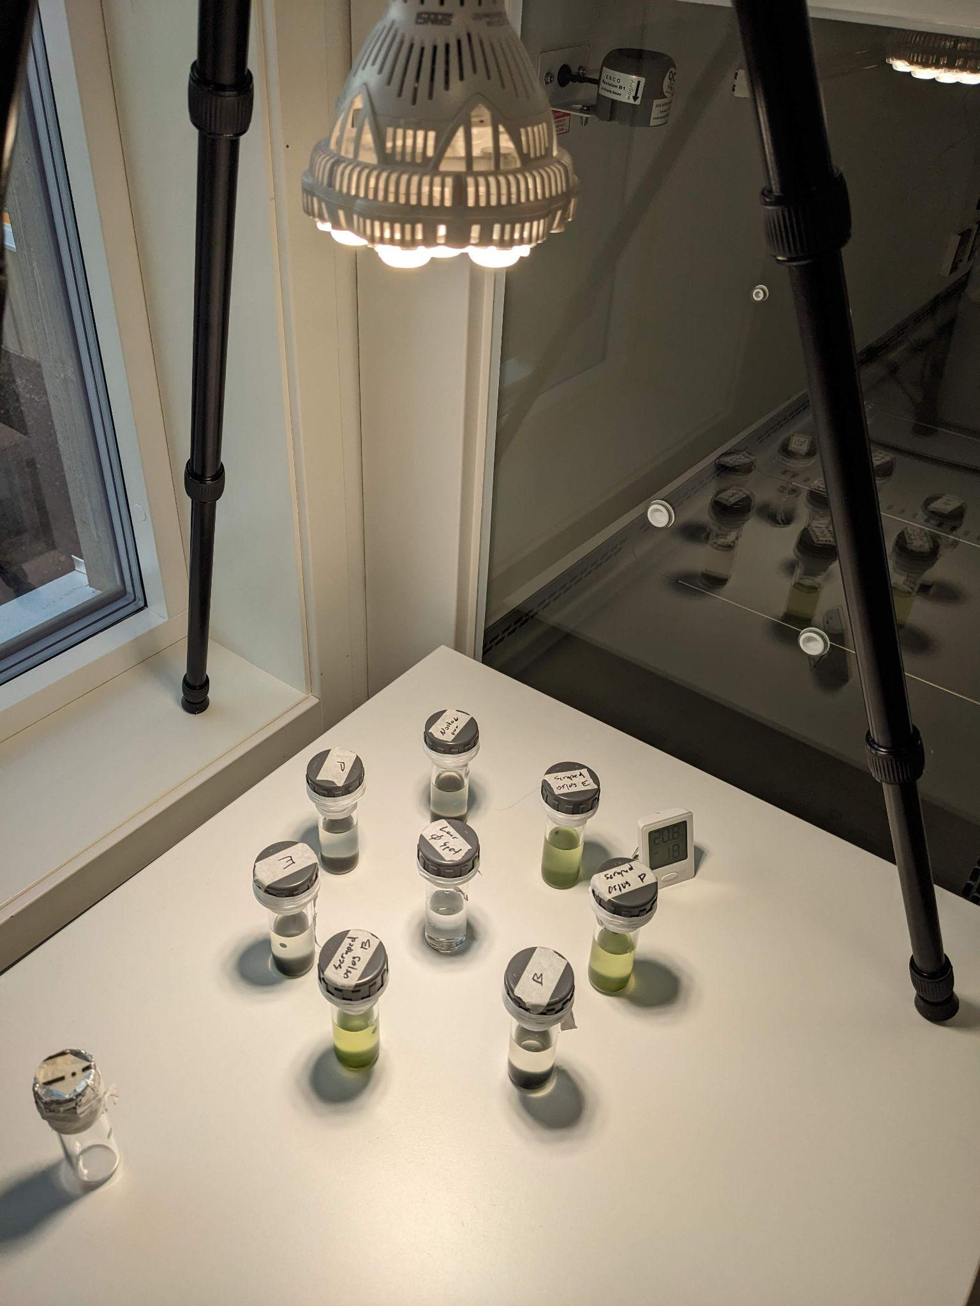

Fig. 7.2-1: Laboratory setup of biological samples. Due to lack of sunlight in the facilities a 36W full spectrum lamp was employed in ~30cm distance to the circular arranged tubes.

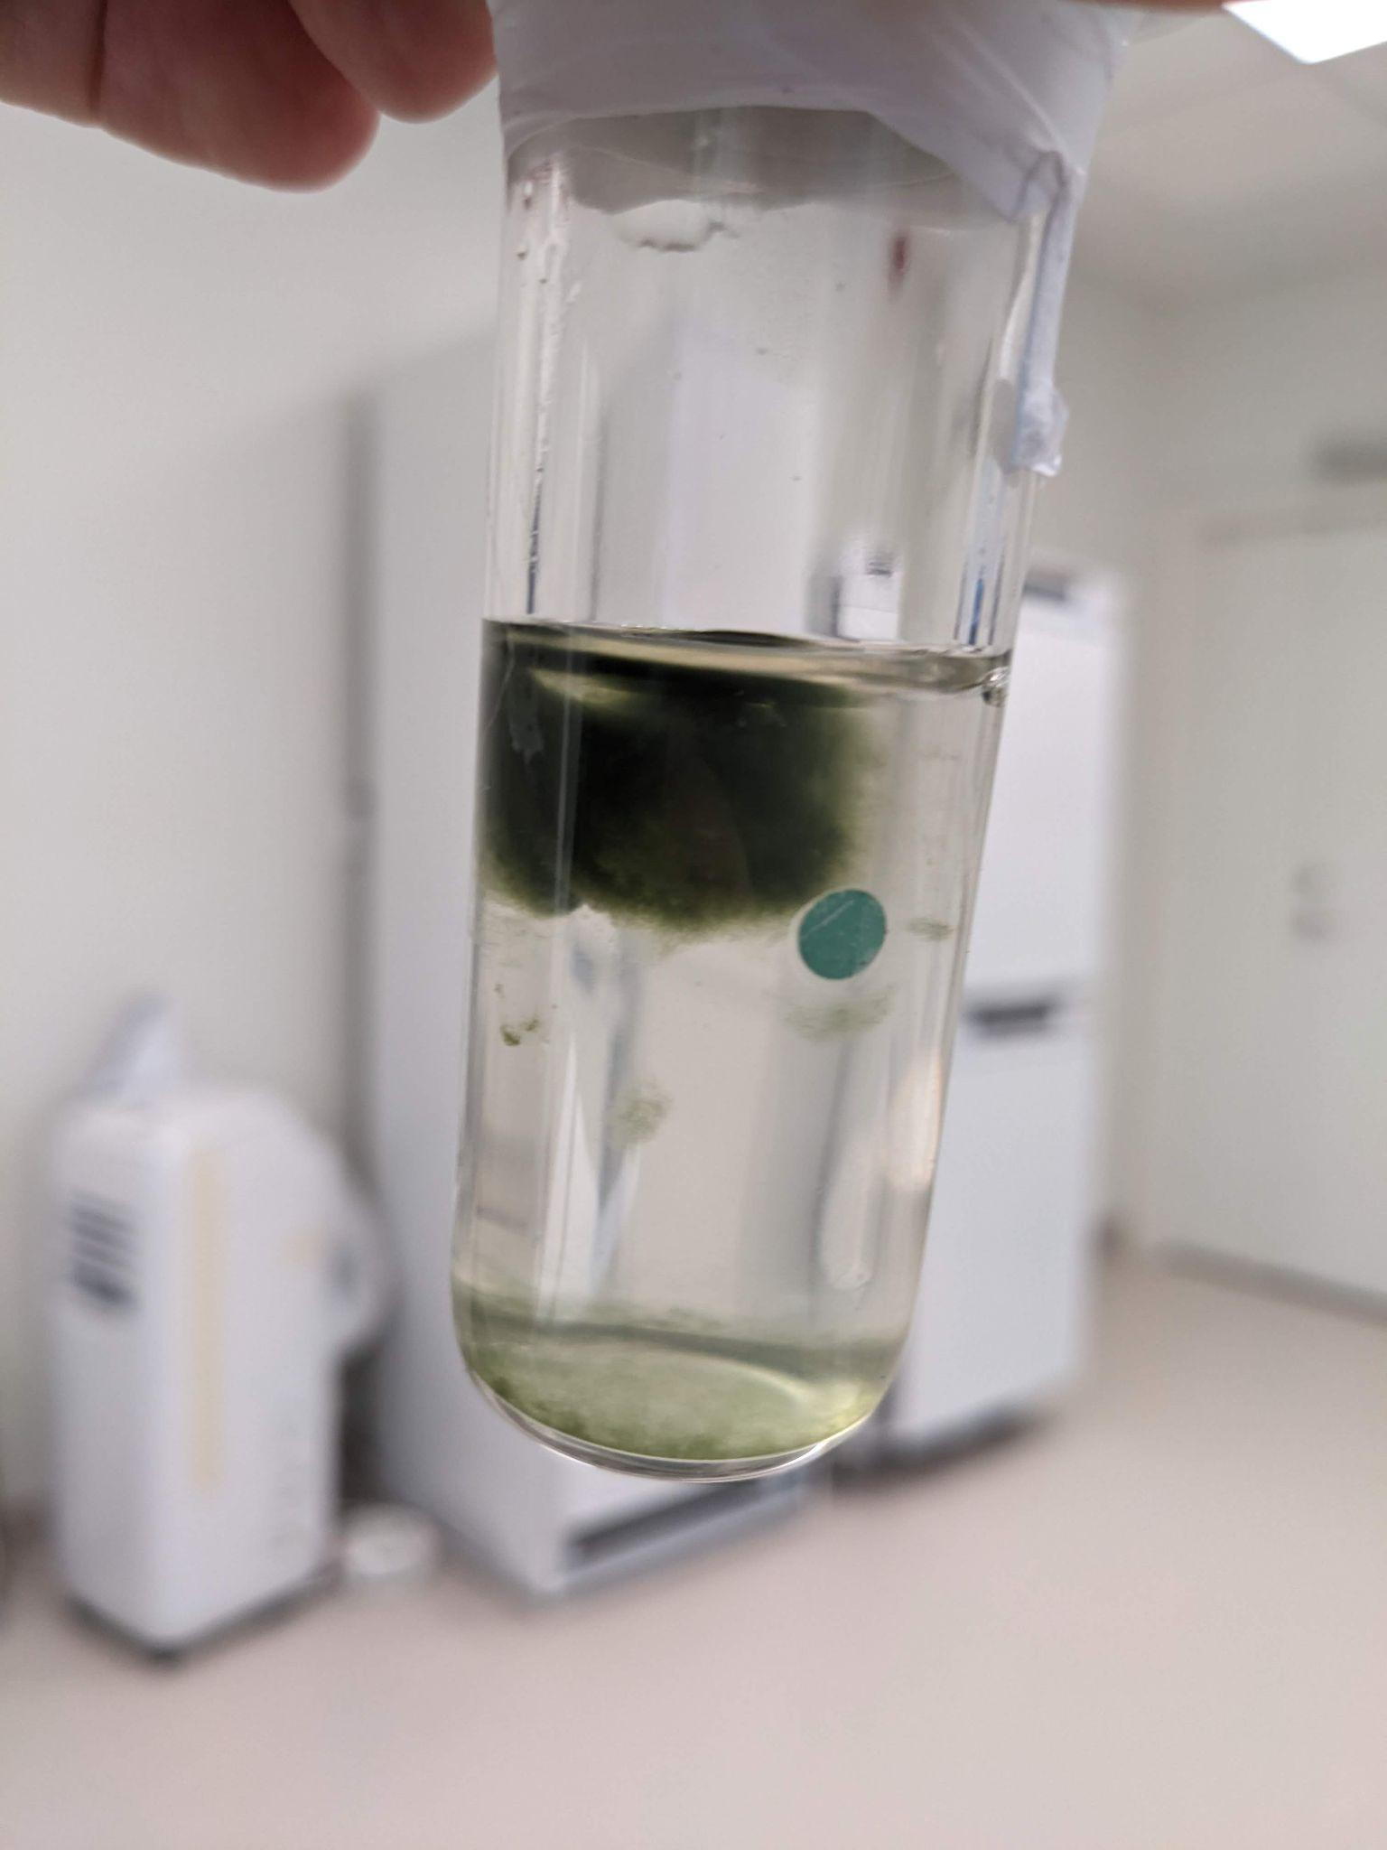

Fig. 7.2-2: Liftup of microbial biofilm mat. Shortly after arrival, some samples show detachment of the biofilm from the bottom of the glass tube and rise up to the top.

After slightly shaking the tubes, the biofilms sank down again, but remained detached from the glass bottom. This effect may be explained by the strong formation of an EPS matrix during biofilm formation with oxygen bubbles trapped inside the microbial mat. After transport in dark for a prolonged period and exposure to the grow lamp, the motile cyanobacterial mat gained buoyancy and moved toward the stronger light source as the indirect sunlight in the laboratory was not sufficient enough.

**7.2.2 Flight Performance**

**Launch Attempts**

There were 2 unsuccessful launch attempts until Thursday, 03.2024.

03.10.2024:

After an unsuccessful launch we collected some ground data to analyze. The bacteria were under an aluminum padded foil lid for the whole duration of the measurement.

04.10.2024

Attempted launch at 15:15. Sun light requirement shortened to minimum 30 min. Sun light at float phase due to wind gusts towards the wests and too high.

Forecast: massive drop of wind between 14:00 and 15:00. Launch might have been possible.

According to the predicted launch time the angle of light is below 8°C during float phase. Prediction is that the angle is too low for direct UV radiation onto samples. Possibility that aluminum reflective material might refract UV light onto the samples.

Launch was not performed on this day.

**Failure Analysis**

1. Corrupted data points

We observed a small number of corrupted oxygen sensor data points (less than 1%), which was expected due to the use of non-shielded, multiplexed serial communication. This had no impact on our data analysis, as oxygen levels change too gradually for the loss of a few points to make a noticeable difference.

The appended plot shows that data derived from the oxygen sensors, such as pressure and temp_sample_oxy, contained some corrupted values. However, data from other sources, such as Temp_CPU, remained unaffected by the same issue.

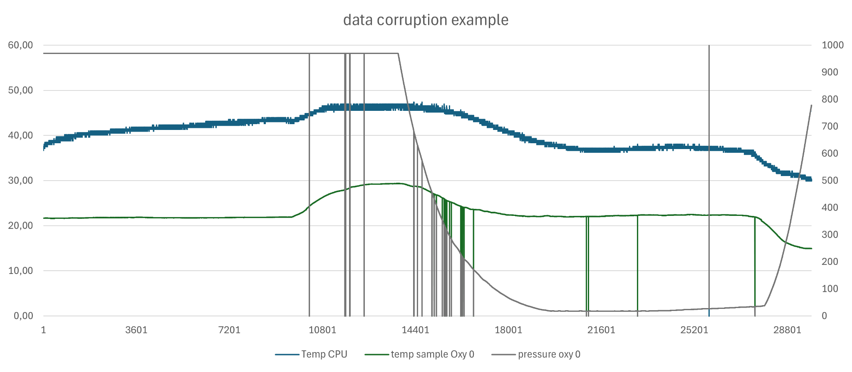

Fig. 7.2-3: Example of data corruption.

1. Temperature and power consumption

During the flight, the temperature inside each tube and power consumption were recorded to study the accuracy of the simulations previously performed. The maximum altitude of the float phase was 27 km with a temperature of -48°C.

In Fig. 7.2-4, the temperature inside the tubes is displayed. The probes were kept at 20°C before the flight and prior to the launch it was raised up to 27.5°C so the biofilms were at an optimal point for oxygen production.

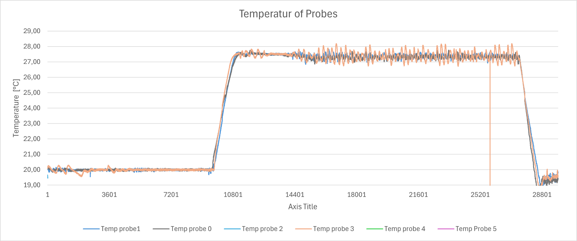

Fig. 7.2-4: Probe temperatures along the flight.

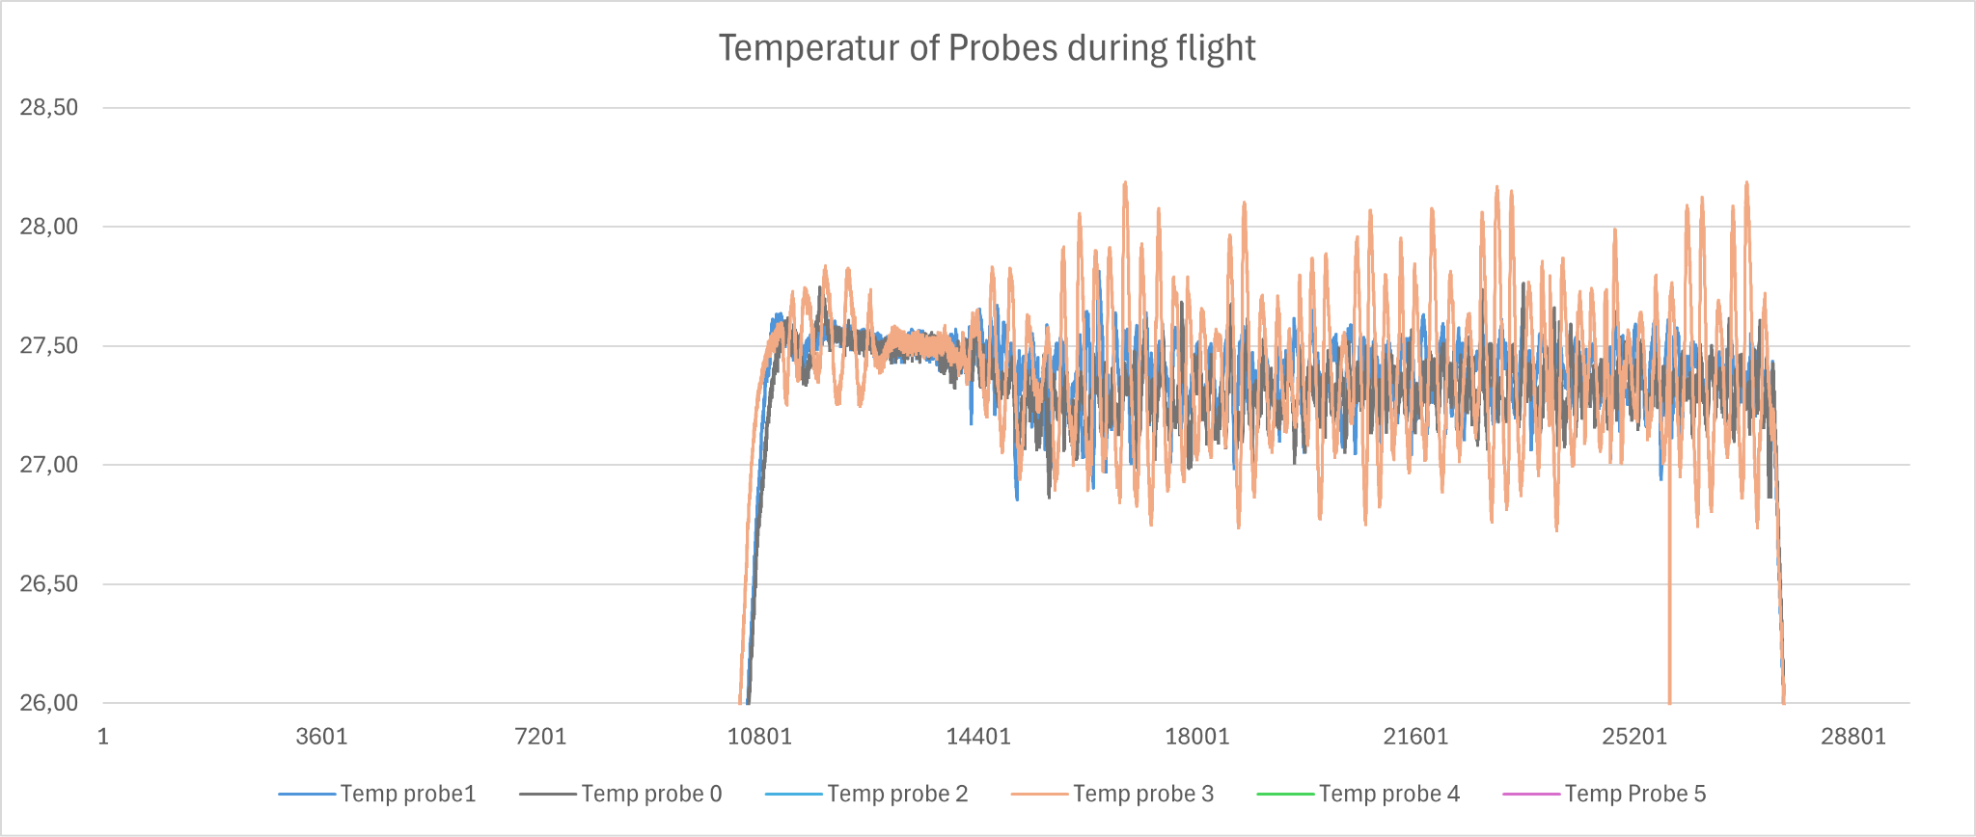

Fig. 7.2-5: Zoom-in of probe temperatures along the flight.

The temperature inside the tubes was kept between 27 and 28°C narrowing down the required range of 5°C to just 1°C.

All the heaters exhibited some oscillation, as it was intentionally programmed to have a faster response than necessary. This was done to ensure the system's stability, even in the event of communication loss or a temperature drop. However, the temperature of probe 3 oscillated more noticeably than the others. While still within the temperature range, this behavior was unexpected given the symmetrical geometry and identical electronics of the tubes.

Attempts to adjust the controller yielded minimal improvement, but no significant changes were made since it was well in the temperature range all the time.

Regarding the power consumption, this experiment used an average of 10.77W and 80.76Wh in total during the ~7.5h from launchpad to cut off. Fig 4-33 illustrates the probe heating power along the flight. Before launch, the power was fixed to 2W per tube for a short period of time to heat them up to 27.5°C. The heating power oscillates significantly with temperature but never reaches the maximum limit of 5W. The average heating power of all the probes is around 2W per tube for the float phase which is similar to the value proposed in the initial analysis. This indicates that the power budget was adequate.

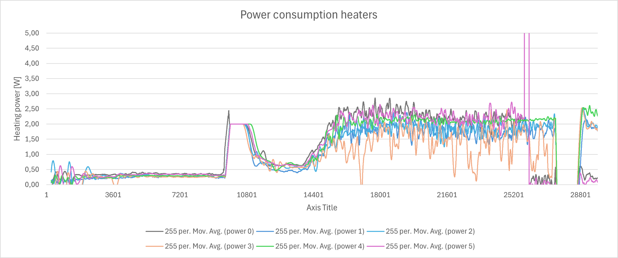

Fig. 7.2-6: Power consumption of heaters along the flight.

The oscillations in heating power might have different reasons:

* Wind over the module surface: the forced convection over the glass surface can have an oscillating effect due to its turbulent behaviour. This turbulent behaviour can increase the heat evacuation in parts of the surface where the speed is higher but it is very difficult to predict with enough accuracy as the movement of the gondola is not prescribed.
* Situation of the probes: although the distribution of the glass tubes is symmetrical, there are two sides on the external side of the gondola and two on the inside. The probes that are placed on the outside are likely to have wider oscillations as there is no dumping effect of the other tubes and the rest of the gondola.
* Cloth over the tubes base: the cloth protecting the electronics from liquid spillage were included in the lower part of the tubes and it is likely that these parts could have modified the dynamic behaviour studied initially.



Fig. 7.2-7: Probe temperatures in relation to heating power.

The graph Fig. 7.2-7 illustrates the probe temperatures in relation to the heating power (shown at the bottom). The heating power oscillates significantly with temperature but never reaches the maximum limit of 5W. This indicates that the power budget was adequate.

There was no overheating problem with any of our electronics.

Thermal power considerations which helped achieve our temperature requirements were mainly:

1. Casing (aluminum foil) for preflight activities, radiation is not relevant at this point and axial conduction includes it.
2. Gaps in the foam were sealed last minute before launch with aluminium tape. This decreased the heating power required dramatically, at least compared to the TVAC test. Especially as the launch had winds and TVAC did not.
3. Addition of absorbent material in electronics and around the cap of the tubes.
4. Light measurement

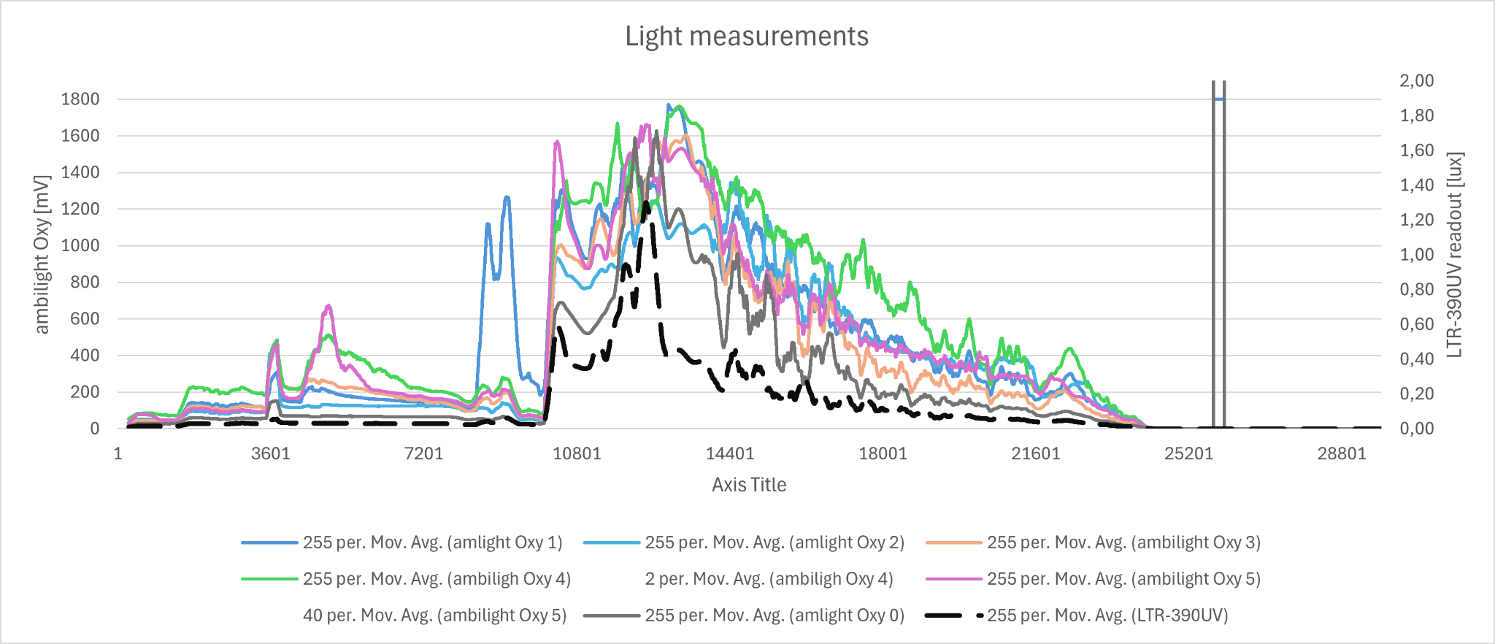

Fig. 7.2-8: Ambient UV light measurements

The ambient UV light measurements from the oxygen sensors showed amplitudes comparable to those of the LTR-390UV light sensor. This suggests that these measurements are at least relatively accurate in terms of their strength.

1. **Recovery**

The experiment module was not damaged during any time of the flight and recovery operations. The experiment could have flown directly again. Against everybody’s expectations even the quartz glass top panel stayed intact.

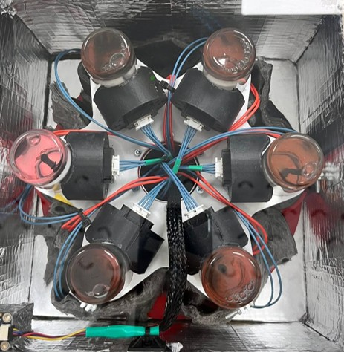

Fig. 7.2-9: Top view of retrieved assembled biomodule.

1. **Disassembly and transport to Munich**

Check-List before disassembly:

1. Double checking the assignment of every sensor to every probe by individual power on and visual inspection. This was done to make sure no sensor data got assigned to the wrong tube.
2. Readout of the SD card. All stored data there was valid.
3. Compiling the binary SD card data in a .csv file and plotting the data as graphs.

The glass tubes with bacterial probes were taken out of the module and transferred directly into the transport box. They were not opened and kept in the flight configuration since we planned to observe how long they would survive after the flight. The bacteria transport box was taken to Germany via plane with the bio team. In the LMU laboratory they were directly placed under the growth lamp.

The module was not disassembled further. It was placed in the padded and insulated module transport box and shipped to Munich. It arrived in Munich ca. 1 month after the Launch Campaign.

## Results

### Cyanobacteria oxygen data and interpretation

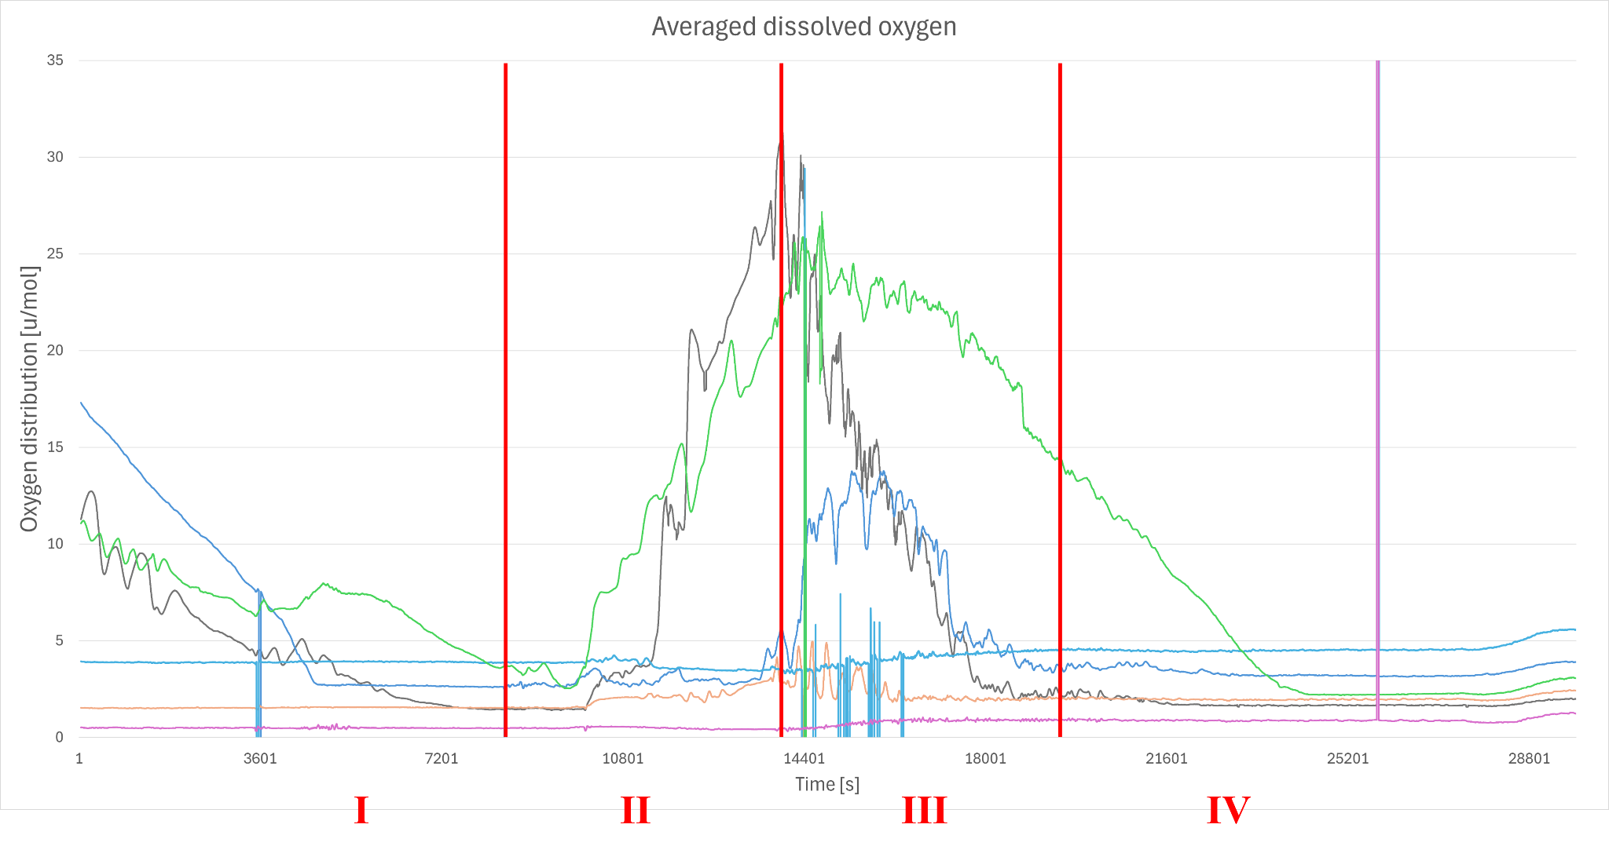

Fig. 7.3-1: Measurement of dissolved oxygen shows significant differences across the samples during flight. Oxygen trends were averaged over 40 time points to account for single corrupted data points.

Samples are indicated by color as follows:

Light Blue: *Nostoc sp.* with *B. subtilis*

Blue:  *Nostoc sp.* with *P. taiwanesis*

Green: *Nostoc sp.* with *E. coli*

Black: Pure culture *Nostoc sp.*

Orange: *Nostoc sp.* with *E. coli* from a previous cultivation batch (scraped)

Magenta: Medium control

Samples were not exposed to light during launch preparation (**I**) and continued to decline in oxygen production. This effect could also be caused by movement of the gondola on the transport vehicle and mounting to the balloon, as abrupt shaking could cause the dissolved oxygen to form bubbles, which the oxygen sensors can not measure.

At late access (**II**) the light cover was removed shortly before launch. Samples pure culture *Nostoc sp. (*Black*) and Nostoc sp.* with *E. coli (*Green*)* immediately resumed oxygen production as soon as light was detected (refer to ambient light measurement Fig. 7.2-8). The other samples did not display any significant change in oxygen production, which may indicate a resting state due to stress or the light not reaching the biofilms as they may have sunken down the glass.

Shortly after launch during ascent (**III**) pure culture *Nostoc sp. (*Black*)* immediately stopped oxygen production which rapidly declined. Surprisingly, *Nostoc sp.* with *P. taiwanesis (*Blue) showed increased dissolved oxygen levels right after launch. However, this could have been caused by light reaching the previously sunken biofilm or dissolving of the biofilm into medium and is not directly indicative of a biofilm-related effect.

Most excitingly, sample *Nostoc sp.* with *E. coli (*Green*)* displayed steady oxygen levels, which suggests a continuous production of oxygen despite the changes in altitude, mechanical stresses or increase in light variance during ascent. A slow decline during flight was to be expected, as living conditions are not optimal for any samples in the stratospheric environment and they shut down their metabolism in response.

Also *Nostoc sp.* with *E. coli (*Green*)* maintained steady oxygen production during float phase (**IV**), which can be observed in the delayed drop of oxygen.

The expected reduction of oxygen levels due to cellular respiration by the heterotrophic *E. coli* was not observed, although further research is needed to investigate the presence and function of heterotrophic bacteria in the final biofilms. As indicated in chapter 1.1, heterotrophic bacteria could be vital in sustaining the biofilm, enhancing its initial formation or pre-cultivating the surfaces to allow the cyanobacteria to attach.

As the Medium control sample *(*Magenta*)* did not show any changes in oxygen data throughout the preparation, flight and descent, the oxygen sensors were working properly and the used BG11 medium was not contaminated. The other samples *Nostoc sp.* with *B. subtilis* (Light Blue) and scraped *Nostoc sp.* with *E. coli* (Orange) did not show any change in oxygen data even before flight. This was further analyzed to be very low oxygen data points caused by a missing calibration error due to the multiple assembly/disassembly actions caused by the flight delays.

The biomodule itself and the glass tubes did not show any signs of leakage, contamination or other damages. All biological samples survived the flight and continued to survive back in the laboratory with the exception of the scraped *Nostoc sp.* with *E. coli* from a previous cultivation batch (Orange), which died off 2 weeks after flight.

In conclusion, pure culture *Nostoc sp.* oxygen production dropped immediately and significantly during flight in contrast to complementary cultured *Nostoc sp.* with *E. coli*. This is a first indication towards mediation of resilience in cocultivation and complementary formation of biofilms of cyanobacteria with heterotrophic bacteria.

### Future outlook

**Current Tests and Experiments**

As part of our ongoing research, we are conducting detailed sequencing of *Nostoc* sp. to determine the specific strain we are working with. This foundational step is crucial for understanding its characteristics and potential applications. Additionally, new biofilms are being cultivated under controlled conditions to facilitate accurate oxygen ground measurements. These experiments are essential for interpreting the data collected during the flight and for validating our findings.

To enhance our experimental capabilities, we have partnered with PHIO to utilize their innovative CellWatcher technology. This cutting-edge tool allows for real-time monitoring of *Nostoc* biofilm formation, providing dynamic insights into their development and generating valuable data for our ongoing studies.

**Future of SpiCy**

Looking ahead, plans are underway to engage students in SpiCy 2.0 and introduce them to the possibilities of conducting their own REXUS/BEXUS experiments. Through dedicated lectures, we aim to inspire the next generation of researchers and promote hands-on involvement in high-impact projects.

To ensure the continuity and growth of the SpiCy initiative, discussions are currently taking place with the dean of the LMU Faculty of Biology about integrating the project into his laboratory. This potential collaboration would provide the necessary infrastructure and support for further advancements.

Moreover, we are actively working on expanding our research with *Nostoc* biofilms to generate data for a comprehensive scientific paper. These additional tests and experiments will deepen our understanding of biofilm dynamics and contribute to broader scientific knowledge in this field.

## Input to Campaign Report

No input to the campaign report is required.

## Lessons Learned

As SpiCy is coming to an end, we would like to reflect on our experience with the program, the team and our environment during the duration of our involvement with REXUS/BEXUS. Apart from the academic, engineering and biological knowledge each of us has gained valuable life lessons and life-long friendships. We would like to thank all of those involved in creating a truly unforgettable experience.

Finding a lab space posed an unexpected challenge, as no professors initially had the resources to assist us. However, this issue is currently being resolved, and a lab space is now available for use. This was made possible after reaching out to the dean and establishing connections with other universities.

Coordinating among the various sub-teams proved to be challenging due to the diverse nature of the subjects involved. Learning to communicate effectively across different specialties was a valuable experience that required time and effort. This problem will also be minimized in the future by implementing the SCRUM methodology. Another reason for communication issues between the sub-teams were unclear requirements. With better requirements, agreed by everyone, it is much easier to work.

The lack of expert knowledge in conducting such projects became apparent during the experimental design phase. To address this, the team engaged in extensive collaboration and sought guidance from external experts, ultimately enhancing the project's design.

Securing grants and sponsors posed a significant hurdle, particularly in the project's early stages. However, the situation has improved, and it is no longer a major concern as the project has gained support from the LMU. As paying travel costs through tax money such as the LMU funds poses bureaucratic difficulties, we continue to look for sponsors in this regard.

Our team acquired proficiency in several novel techniques, including the soldering of QFN componentsand thecultivation of cyanobacteria. Challenges encountered during our exploration of these methodologies were effectively addressed through insightful conversations with experts. Additionally, we honed our skills by repeatedly practicing these methods.

The outreach team struggled with finding a balance between their own demands and needs, and having to pick the cheapest and quickest way of producing high-quality content. No matter how urgently a scientific project like ours is needed to be given a voice to reach out to the public and potential supporters, especially the financial means amongst our sponsors and ourselves are quite dim, when it comes to not essential experiment-related content. This way, we need to think outside the box of what we learned in sheltered university seminars and shift our design process towards a more flexible and less resource-heavy approach.

Finding a suitable temperature sensor proved challenging due to the varied options available. Testing different sensors is necessary to identify the one with optimal performance.

Defining the requirements for the project presented a challenge. A comprehensive understanding of all necessary components was crucial to ensure the design met expectations. As a team we think that we have now reached a quite clear understanding for the requirements a requirement has on the experimenter.

Simulating the unique experimental environment poses difficulties during the verification process. Overcoming these challenges requires out of the box approaches that we have been developing.

Thorough consideration before conducting experimental tests was essential. Planning and evaluating potential outcomes helped anticipate and address potential issues.

Mechanical design inherently involves multiple iterations to achieve the desired functionality. Each iteration provides valuable insights and opportunities for improvement.

Lessons learned at Launch Campaign:

Every part MUST be labeled and written down manually for everyone to see. This must be also visible without full disassembly of the module. The order of assembly is important.

Background: We did not write down anywhere except on the tubes themselves which sample is measured by every sensor and which tube is where in the module. The labeling of the tubes was not visible without assembly of the whole module. This posed major analysis issues before recovery of the module.

Connected to previous point: Oxygen sensors should also be labeled by sample in groundstation UI (instead of just numbered) so that no guesswork is necessary. Therefore, sensor attribution must be done beforehand.

**Summary of the Lessons Learned**

The project taught us several valuable lessons, beginning with the unexpected challenge of securing lab space. Initially, no professors had the resources to accommodate us, leaving us at an impasse. However, by reaching out to the dean and fostering connections with other universities, we successfully resolved this issue. Today, a dedicated lab space is available for our work, underscoring the importance of persistence and networking.

Coordinating across sub-teams proved to be another significant challenge, largely due to the diversity of expertise required by the project. Effective communication between specialties took time to develop, but it became a crucial skill for our team. To prevent such difficulties in the future, we have adopted the SCRUM methodology to streamline collaboration. We also realized that unclear requirements further exacerbated these communication issues. Establishing better-defined and mutually agreed-upon requirements not only improved coordination but also laid a stronger foundation for the project.

A gap in expert knowledge became apparent during the experimental design phase, highlighting the need for specialized guidance. By collaborating extensively within the team and consulting external experts, we were able to refine our experimental approach. This experience emphasized the value of seeking diverse perspectives when faced with complex challenges.

Securing funding and sponsorship presented another hurdle, particularly in the project's early stages. With time, support from LMU alleviated many of these concerns. Nevertheless, bureaucratic complications in using LMU funds for travel costs persist, prompting us to actively seek additional sponsors to cover these specific needs.

On a technical front, the team acquired new skills, including soldering QFN components and cultivating cyanobacteria. While mastering these techniques involved overcoming initial challenges, conversations with experts and consistent practice helped us refine our methods. These skills not only advanced the project but also enriched the team’s technical repertoire.

The outreach team grappled with balancing high-quality content production against the constraints of limited resources. Academic seminars had not prepared us for such practical limitations, so we adapted by developing flexible, cost-efficient approaches. This shift required creative problem-solving but proved essential for sustaining our public engagement efforts.

Sensor selection also brought its share of challenges, particularly in identifying the optimal temperature sensor from numerous options. Through rigorous testing, we addressed this issue. Furthermore, lessons learned during the launch campaign underscored the critical importance of thorough labeling and documentation. A lack of visible labeling for tubes and sensors created significant difficulties during analysis, a mistake we now recognize as preventable. Moving forward, we will ensure that all components are labeled clearly and visibly, both on the hardware and within the user interface of the ground station.

Defining project requirements was another area where clarity proved essential. A deeper understanding of the components and their interdependencies emerged as critical to achieving a design that met expectations. Through iterative refinement, we have gained confidence in establishing comprehensive requirements.

Simulating the unique experimental environment posed challenges during the verification process, requiring innovative and non-traditional approaches. By thinking creatively, we developed methods to address these difficulties effectively. Similarly, careful planning before conducting experimental tests helped anticipate potential issues, saving time and resources in the long run.

Mechanical design was another iterative process, where each cycle of refinement provided opportunities for improvement. This iterative approach, though time-intensive, proved indispensable in achieving the desired functionality.

In summary, the project taught us resilience, adaptability, and the importance of meticulous planning and collaboration. Every challenge we faced became an opportunity to learn, ultimately strengthening our team and the project as a whole.

# Abbreviations and References

## Abbreviations

Add abbreviations to the list below, as appropriate, and delete unused abbreviations.

AIT Assembly, Integration and Test

ASAP as soon as possible

CDR Critical Design Review

COG Centre of Gravity

CRP Campaign Requirement Plan

DLR Deutsches Zentrum für Luft- und Raumfahrt

EAT Experiment Acceptance Test

EAR Experiment Acceptance Review

ECTS European Credit Transfer System

EIT Electrical Interface Test

EPM Esrange Project Manager

ESA European Space Agency

Esrange Esrange Space Center

ESTEC European Space Research and Technology Centre, ESA (NL)

ESW Experiment Selection Workshop

FAR Flight Acceptance Review

Fig. Figure

FST Flight Simulation Test

FRP Flight Requirement Plan

FRR Flight Readiness Review

GSE Ground Support Equipment

HK Housekeeping

HM Hochschule München (University of Applied Sciences Munich)

H/W Hardware

ICD Interface Control Document

I/F Interface

IPR Integration Progress Review

LMU Ludwig Maximilians University Munich

LO Lift Off

LT Local Time

LOS Line of Sight

Mbps Mega Bits per second

MFH Mission Flight Handbook

MORABA Mobile Raketen Basis (DLR, EuroLaunch)

OP Oberpfaffenhofen, DLR Center

PCB Printed Circuit Board (electronic card)

PDR Preliminary Design Review

PI Proportional and Integral controller

PST Payload System Test

RBF Remove Before Flight

SED Student Experiment Documentation

SNSA Swedish National Space Agency

SODS Start Of Data Storage

SOE Start Of Experiment

SSC Swedish Space Corporation

STW Student Training Week

S/W Software

T Time before and after launch noted with + or -

TBC To be confirmed

TBD To be determined

TUM Technical University Munich

TVAC Thermal Vacuum Chamber

WBS Work Breakdown Structure

ZARM Zentrum für Angewandte Raumfahrttechnologie und Mikrogravitation

## References

The document should stick to a single referencing format, with IEEE being preferred.

It is recommended to use a dedicated referencing software or inbuilt tool/add-in to correctly reference material throughout the document.

[1] Y. A. Velez Justiniano *et al.*, "Mitigation and use of biofilms in space for the benefit of human space exploration," *Biofilm,* vol. 5, p. 100102, Dec 2023, doi: 10.1016/j.bioflm.2022.100102.

[2] J. Olejarz, Y. Iwasa, A. H. Knoll, and M. A. Nowak, "The Great Oxygenation Event as a consequence of ecological dynamics modulated by planetary change," *Nat Commun,* vol. 12, no. 1, p. 3985, Jun 28 2021, doi: 10.1038/s41467-021-23286-7.

[3] M. Mehdizadeh Allaf and H. Peerhossaini, "Cyanobacteria: Model Microorganisms and Beyond," *Microorganisms,* vol. 10, no. 4, Mar 24 2022, doi: 10.3390/microorganisms10040696.

[4] B. Wang, J. Wang, W. Zhang, and D. R. Meldrum, "Application of synthetic biology in cyanobacteria and algae," *Front Microbiol,* vol. 3, p. 344, 2012, doi: 10.3389/fmicb.2012.00344.

[5] A. Frenkel *et al.*, "Cell specialization in cyanobacterial biofilm development revealed by expression of a cell-surface and extracellular matrix protein," *NPJ Biofilms Microbiomes,* vol. 9, no. 1, p. 10, Mar 2 2023, doi: 10.1038/s41522-023-00376-6.

[6] F. Villa, B. Pitts, E. Lauchnor, F. Cappitelli, and P. S. Stewart, "Development of a Laboratory Model of a Phototroph-Heterotroph Mixed-Species Biofilm at the Stone/Air Interface," *Front Microbiol,* vol. 6, p. 1251, 2015, doi: 10.3389/fmicb.2015.01251.

[7] M. Bozan, A. Schmid, and K. Buhler, "Evaluation of self-sustaining cyanobacterial biofilms for technical applications," *Biofilm,* vol. 4, p. 100073, Dec 2022, doi: 10.1016/j.bioflm.2022.100073.

[8] G. Roeselers, M. C. van Loosdrecht, and G. Muyzer, "Heterotrophic pioneers facilitate phototrophic biofilm development," *Microb Ecol,* vol. 54, no. 3, pp. 578-85, Oct 2007, doi: 10.1007/s00248-007-9238-x.

[9] R. P. Rastogi *et al.*, "Ultraviolet radiation and cyanobacteria," *J Photochem Photobiol B,* vol. 141, pp. 154-69, Dec 2014, doi: 10.1016/j.jphotobiol.2014.09.020.

[10] J. Yu *et al.*, "Synechococcus elongatus UTEX 2973, a fast growing cyanobacterial chassis for biosynthesis using light and CO(2)," *Sci Rep,* vol. 5, p. 8132, Jan 30 2015, doi: 10.1038/srep08132.

[11] J. Masojidek, „Photosystem II Electron Transport Rates and Oxygen Production in Natural Waterblooms of Freshwater Cyanobacteria During a Diel Cycle“, *Journal of Plankton Research*, Bd. 23, Nr. 1, S. 57–66, Jan. 2001, doi: 10.1093/plankt/23.1.57.

| [12] | ECSS, “ECSS Standards,” [Online]. Available: https://ecss.nl/standards/. |
| --- | --- |
| [13] | ECSS, “ECSS-E-ST-10-06C – Technical requirements specification,” 6 March 2009. [Online]. Available: https://ecss.nl/standard/ecss-e-st-10-06c-technical-requirements-specification/. |
| [14] | ECSS, “ECSS-M-ST-10C Rev.1 – Project planning and implementation,” 6 March 2009. [Online]. Available: https://ecss.nl/standard/ecss-m-st-10c-rev-1-project-planning-and-implementation/. |
| [15] | Project Management Institute, Practice Standard for Work Breakdown Structures - Second Edition, Pennsylvania, USA, 2006. |
| [16] | ECSS, “ECSS-M-ST-80C – Risk management,” 31 July 2008. [Online]. Available: https://ecss.nl/standard/ecss-m-st-80c-risk-management/. |
| [17] | EuroLaunch, “BEXUS USER MANUAL V8,” 03 June 2021. [Online]. Available: https://rexusbexus.net/bexus/bexus-user-manual/. |
| [18] | EuroLaunch, “REXUS USER MANUAL V7-17,” 26 November 2021. [Online]. Available: https://rexusbexus.net/rexus/rexus-user-manual/. |
| [19] | ECSS, “ECSS-E-ST-10-02C Rev.1 – Verification,” 1 February 2018. [Online]. Available: https://ecss.nl/standard/ecss-e-st-10-02c-rev-1-verification-1-february-2018/. |
| [20] | SSC, “Esrange Safety Manual - SCIENCE-60-4208,” 12 June 2020. [Online]. Available: https://sscspace.com/wp-content/uploads/Esrange-Safety-Manual.pdf. |
| [21] | C. Olsson, ‘Sensitivity Analysis for Ascending Zero Pressure Balloons’, Dissertation, 2019. |
| [22] | K. Garg, ‘Autonomous Navigation System for High Altitude Balloons’, PhD dissertation, Luleå tekniska universitet, 2019. |
| [23] | R. Karam, *Satellite Thermal Control for Systems Engineers*. Reston, VA: AIAA, 1998. |
| [24] | D. P. Gilmore, *Satellite Thermal Control Handbook*. El Segundo, CA: The Aerospace Corporation Press, 2002. |
| [25] | D. Hastings and H. Garrett, *Spacecraft-Environment Interactions*. New York, NY: Cambridge University Press, 1996. |
|  |  |

## EXPERIMENT REVIEWS

**Preliminary Design Review – PDR**

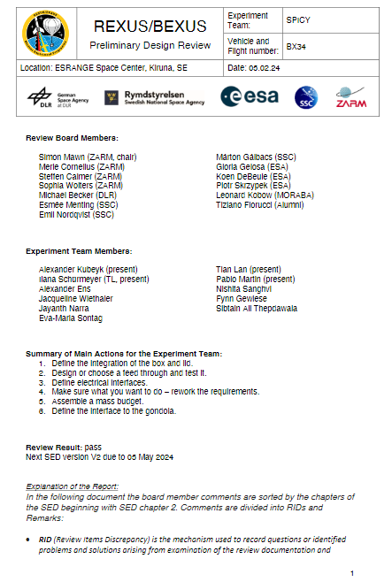

**Preliminary Design Review - PDR**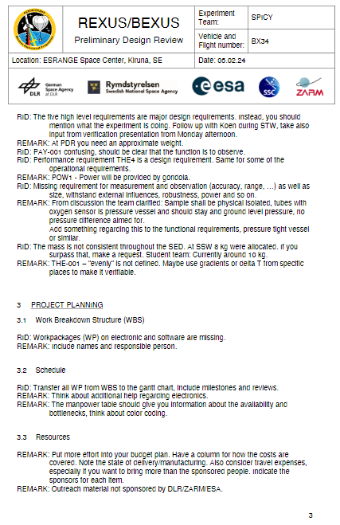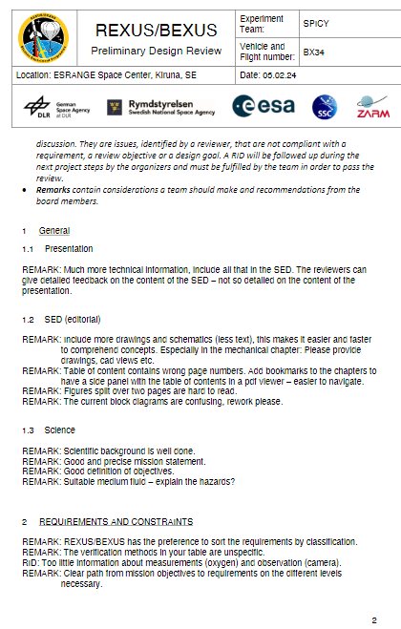

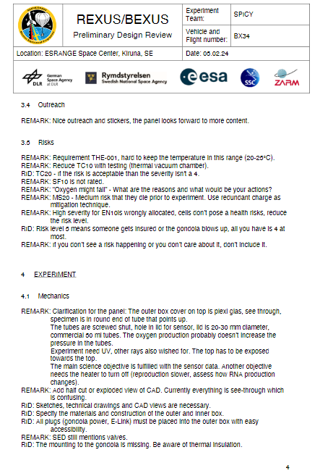

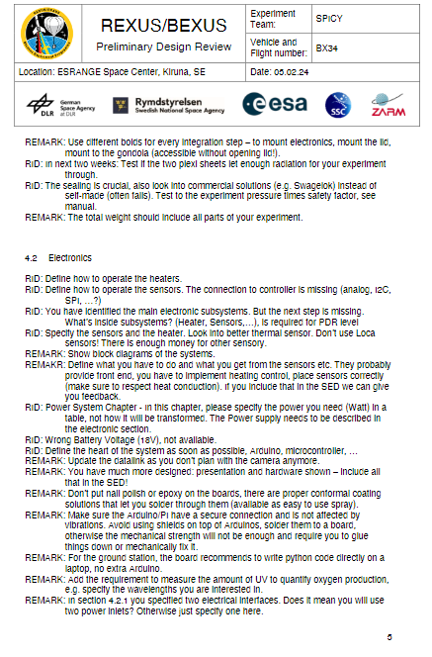

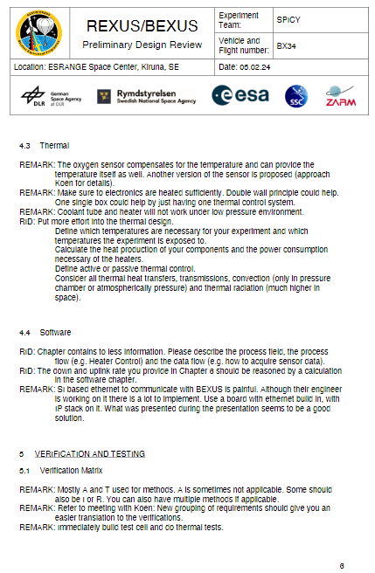

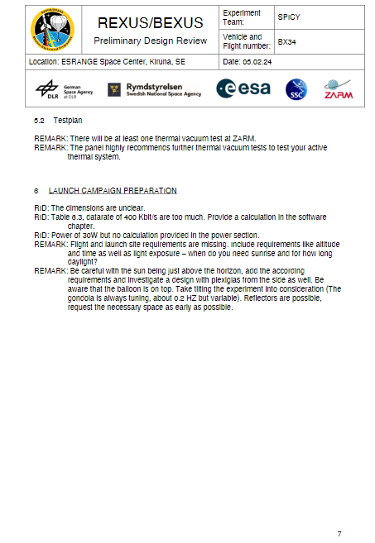

**Critical Design Review – CDR**

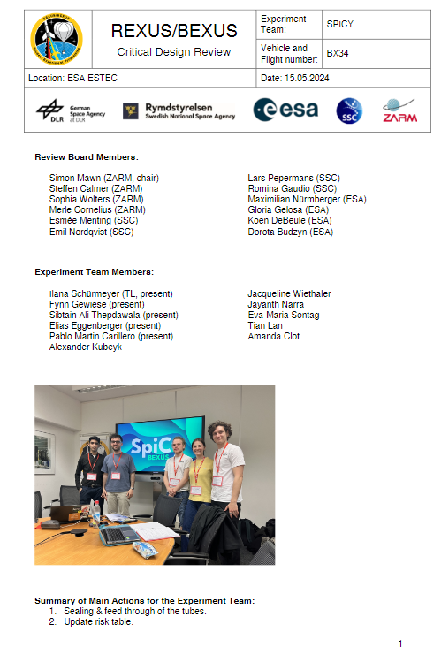

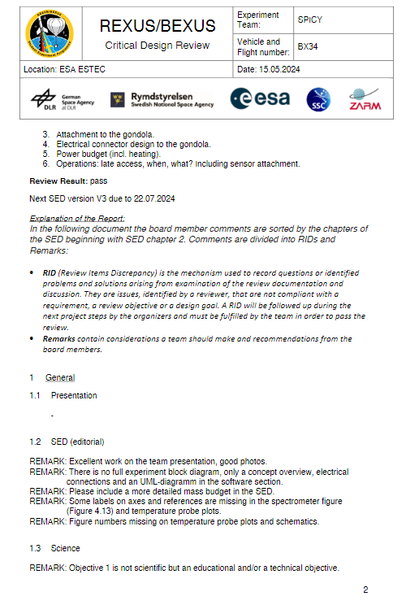

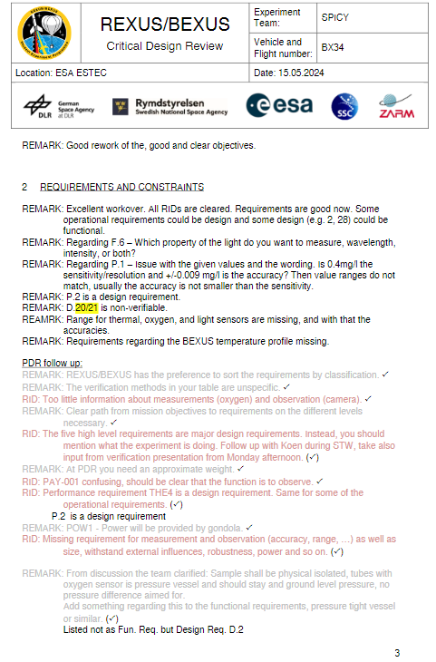

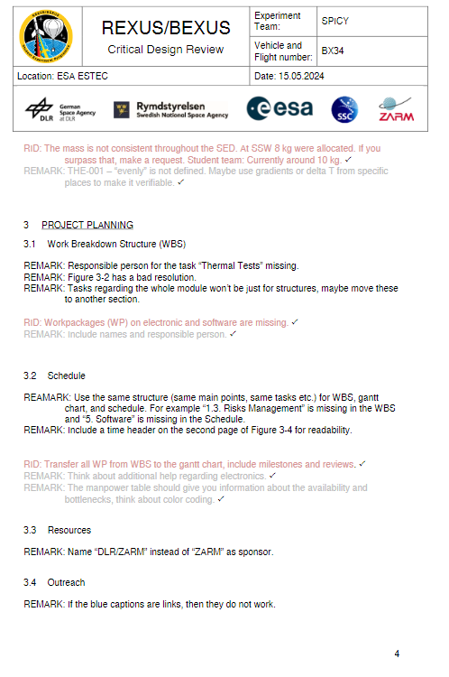

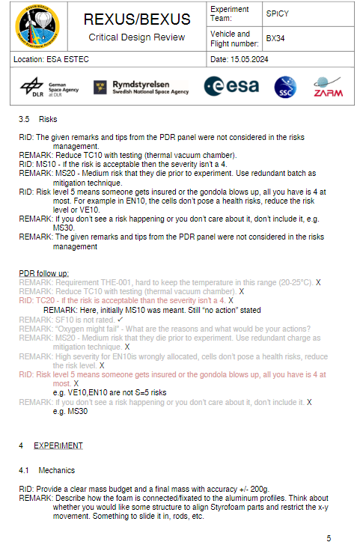

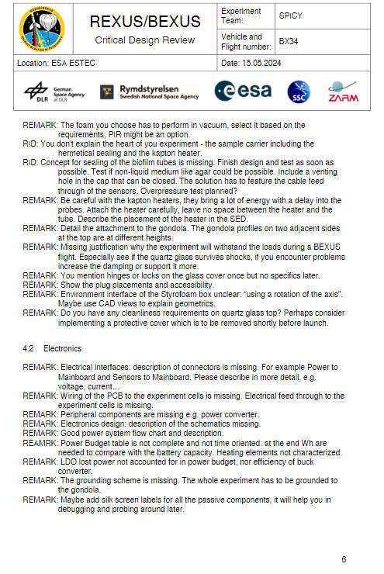

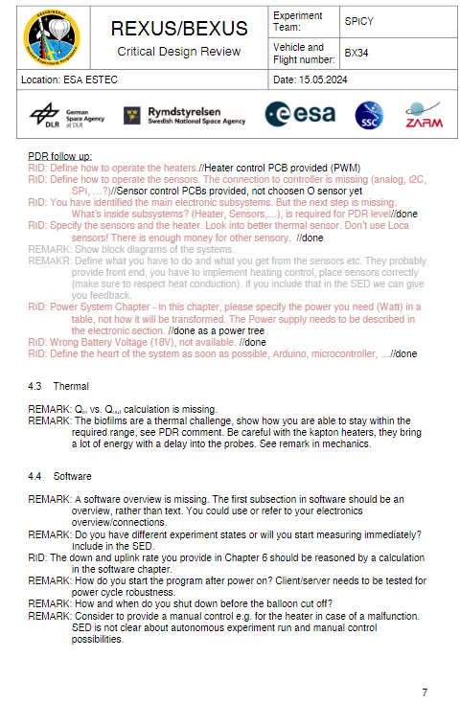

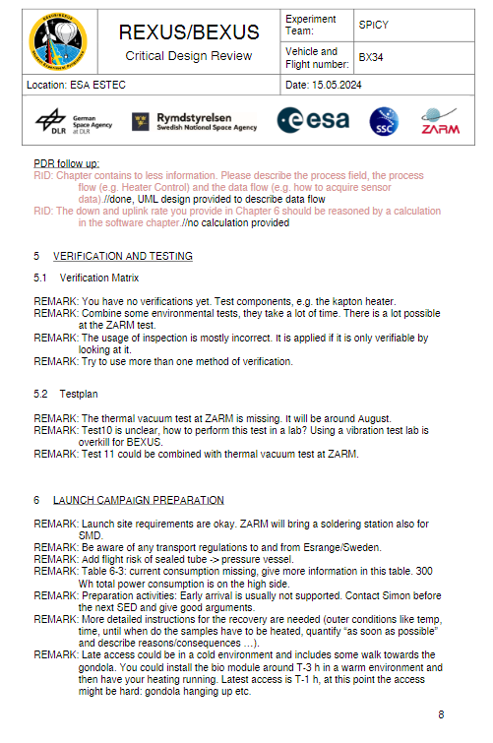

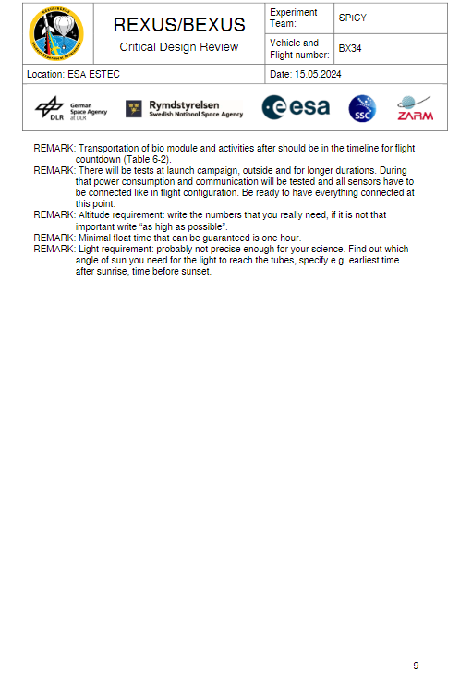

**Integration Progress Review – IPR**

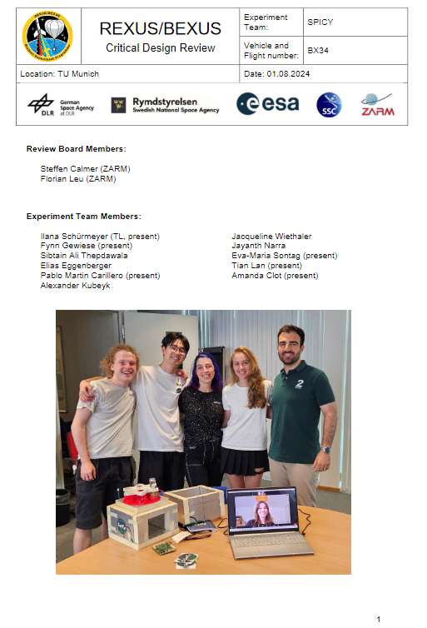

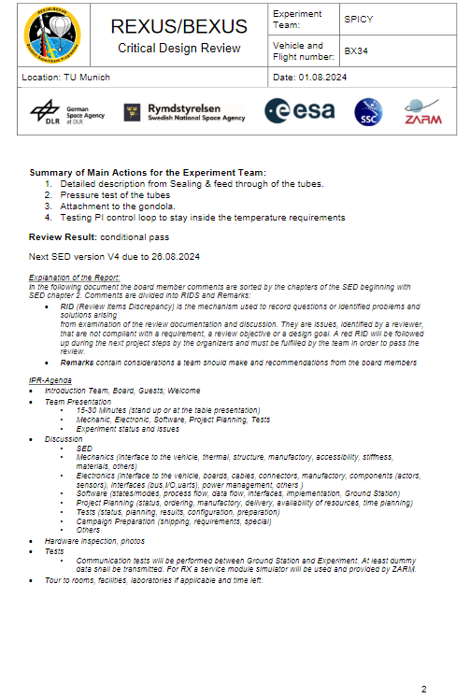

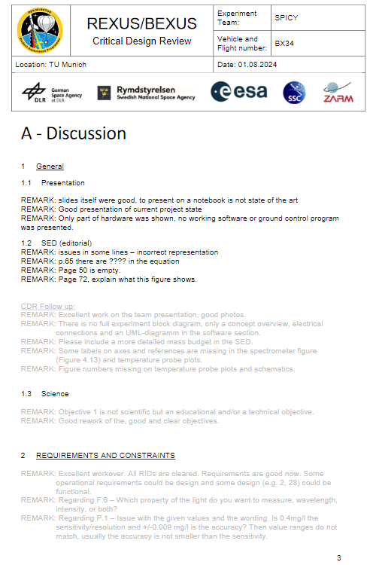

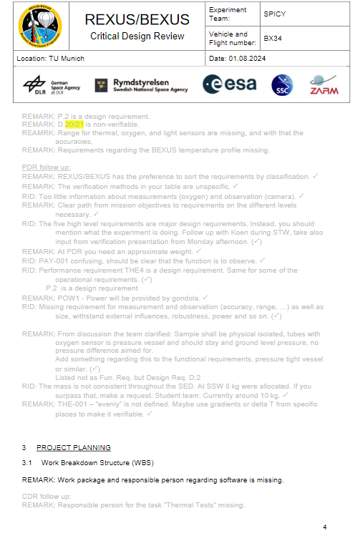

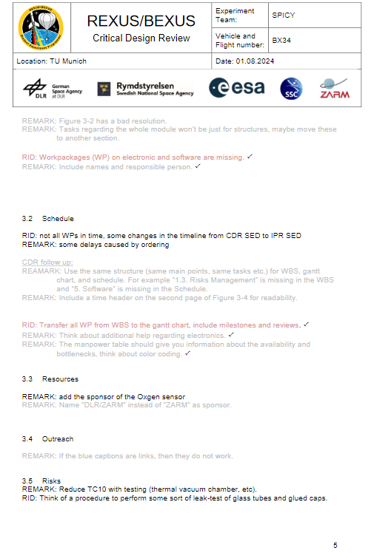

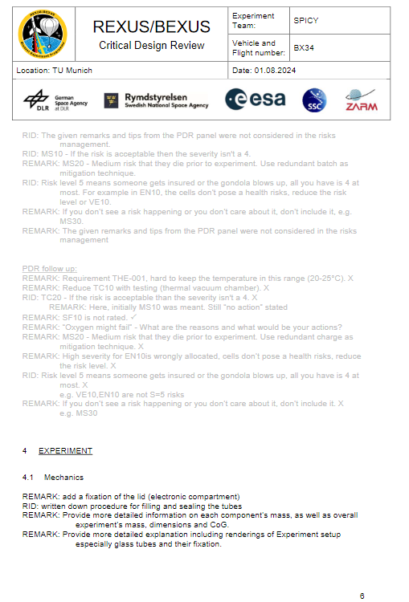

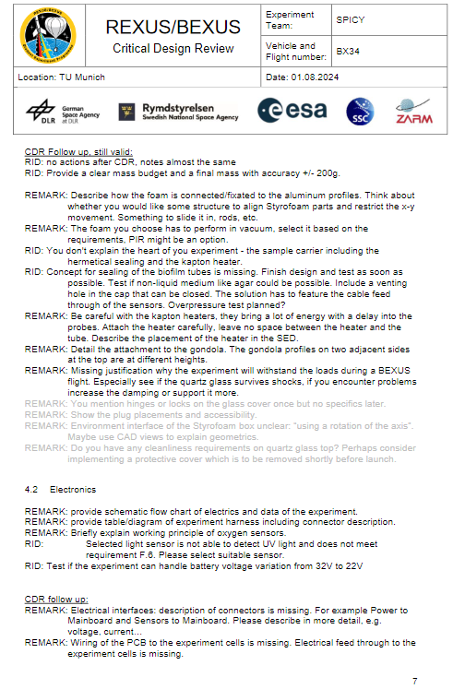

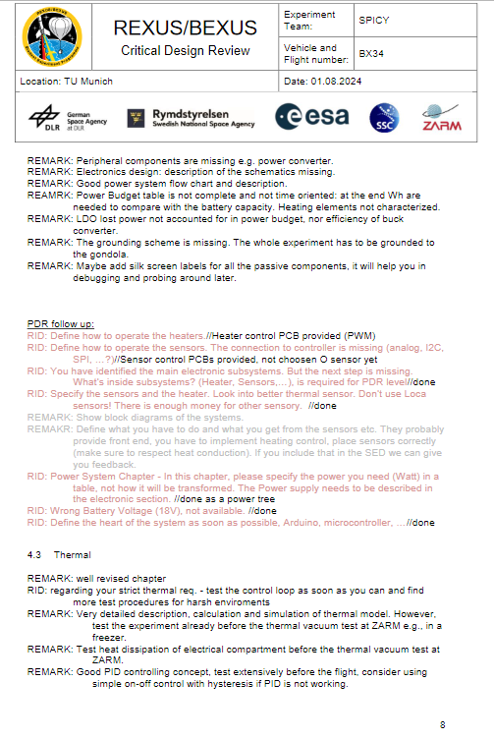

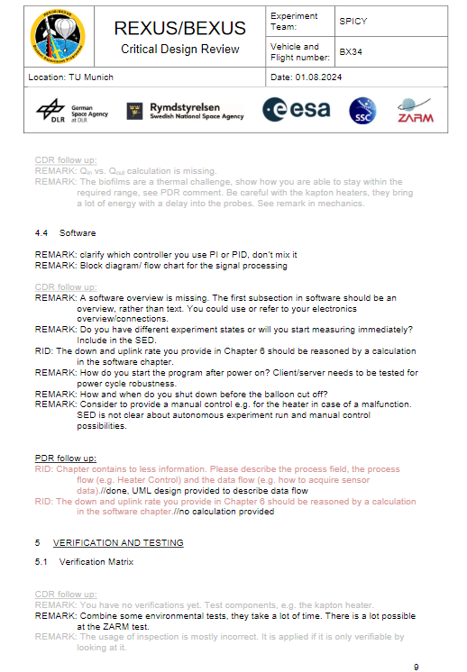

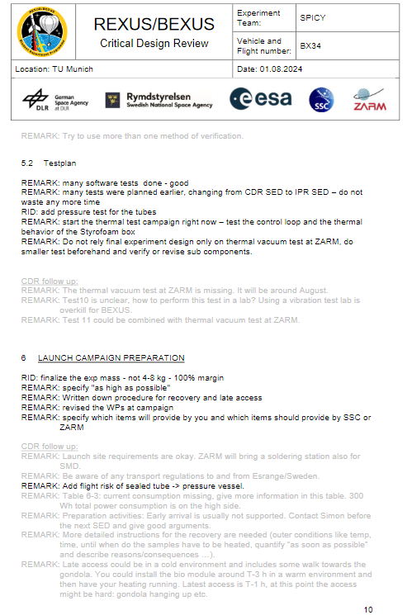

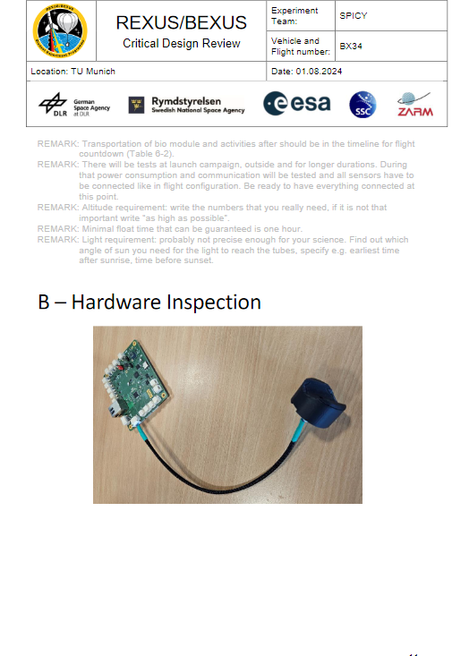

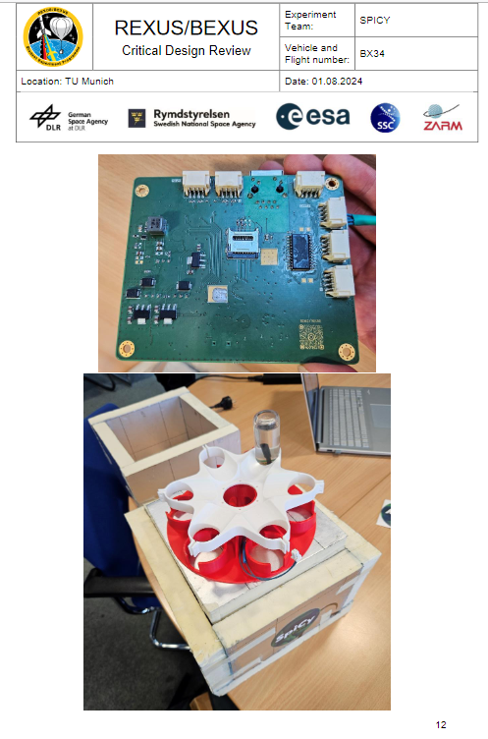

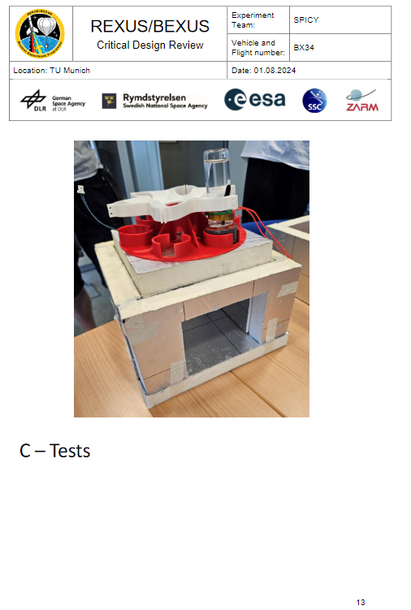

**– OUTREACH AND MEDIA COVERAGE**

**B.1 Visual Concept**

**B.1.1 Color Guide**

The following paragraph shall explain the use of colours for all outreach media. We aimed for a palette that enables our visual language and therefore fits both a looser but yet scientifically serious communication on e.g. social media and the means of communication on a more neutral, professional level.

Figure B.1.1: Colour Palette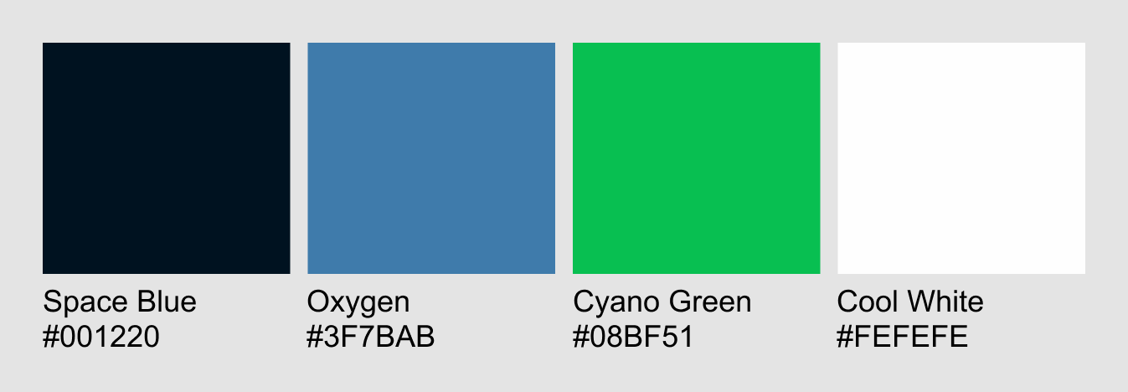

**Space Blue**: Primary colour. The dark blue gives the eye some rest. It feels mystic and undiscovered; it represents the view of the space towards which our balloon will fly and all the things being undiscovered for us so far; it is best used as a shadow colour, text colour or for great flats.

**Oxygen:** Secondary colour. The bright blue shall be used in alternative, brighter layouts if needed. It strongly performs in gradients with the Space blue or Cool White and can be used for decorative elements that are supposed to unobtrusively support the main content; it represents oxygen, air and the view of the sky from afar where our balloon will be in the end.

**Cyano Green**: Primary colour. This green is a great accent colour and shall also be used in gradients with Space Blue. It feels vivid, exciting and represents the cyanobacteria and life itself.

**Cool White:** Primary (Text) colour. The white feels neutral and clear and is great for emphasising this by using it in great flats or gradients with Oxygen. Most of all, this is our main text colour since backgrounds are mostly filled with Space Blue; it represents our scientifically and professional approach but shall be carefully used since too much white can cause discomfort amongst the consumer.

**B.1.2 Gradients**

A major part of the visual language is the use of gradients. They shall either be created within one hue just by raising/lowering brightness of the base colour (or by raising transparency) or be a combination of

1. **Space Blue and Cyano Green** (see Figure B.1-2)
2. **Space Blue and Oxygen** (see Figure B.1-3)

with a) being our predominantly used gradient.

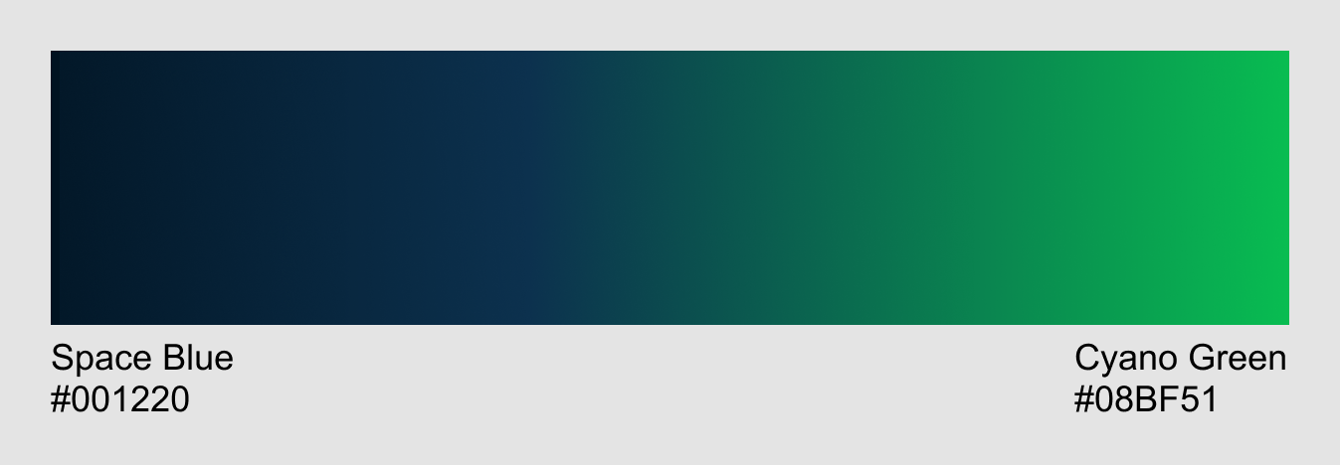

Figure B.1.2-1: Gradient a)

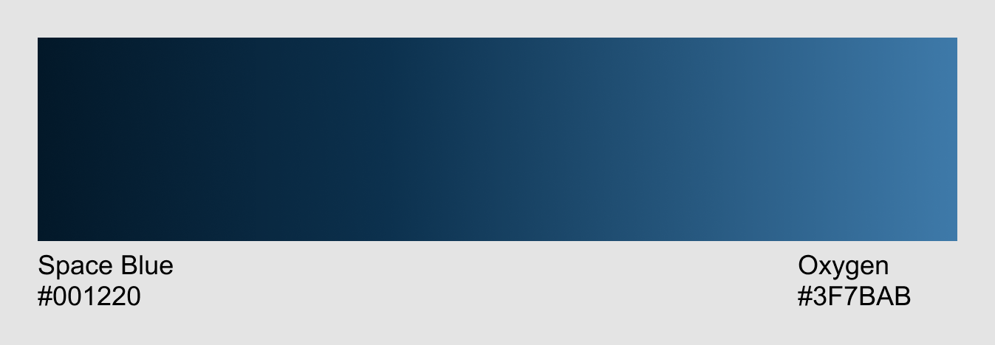

Figure B.1.2-2: Gradient b)

**B.1.3 Shapes**

To keep the continuity of our visual language and picking up the behaviour of oxygen, air and our project itself as a vividly moving and reshaping substance, we chose long and calming waves as a visual representation of this concept. The waves may vanish at one end, so they are not creating a stiff frame around content and shall be emphasised by a very blurred shade in either pure black (#000000) or whenever possible Space Blue (#001220)



Figure B.1.3-1:Basic shapes - polychrome

Figure B.1.3-2: Basic shapes - monochrome

**B.1.4 Typography**

We chose [***League Spartan***](https://fonts.google.com/specimen/League+Spartan/about) as our primary and [***Crimson Pro***](https://fonts.google.com/specimen/Crimson+Pro) as our secondary font. *League Spartan* is a typeface based on American geometric sans serif from the early 20th century. Its simple and yet very expressive style works both in headings as capitals and body text. *League Spartan* is mainly used in Extra Bold (in body and heading). Exception: For headings or big text you might reduce the weight to “light” at its lowest, if there is a need to highlight other text in the same size. *Crimson pro* is for body only and optional. The predominantly used font shall be *League Spartan*.

**B.2 Examples of Use**

The following examples are sorted by 1. platform and 2. time. This shall visualise the process of developing our language with time until our latest designs in use.

**B.2.1 Logo**

The SpiCy logo may be used in the following shapes with the circular one being the predominantly applied version:



Figure B.2.1-1: SpiCy logo in different shapes

However, if the logo is too distracting from other content, apply the word mark instead. Depending on the use case there will be many things to consider like contrast, pictures beneath, spacing, readability and context. Here are examples of possible scenarios and how to use and not to use our logo:



Figure B.2.1-2: The basic SpiCy wordmark logo on different backgrounds.

The basic SpiCy wordmark logo shall not be applied on a bright background. To raise lacking visual contrast, follow the next examples:



Figure B.2.1-3: Use of SpiCy wordmark logo in black

The SpiCy wordmark logo in black shall be applied on bright desaturated and bright coloured backgrounds. Do not use this on darker backgrounds as shown above.

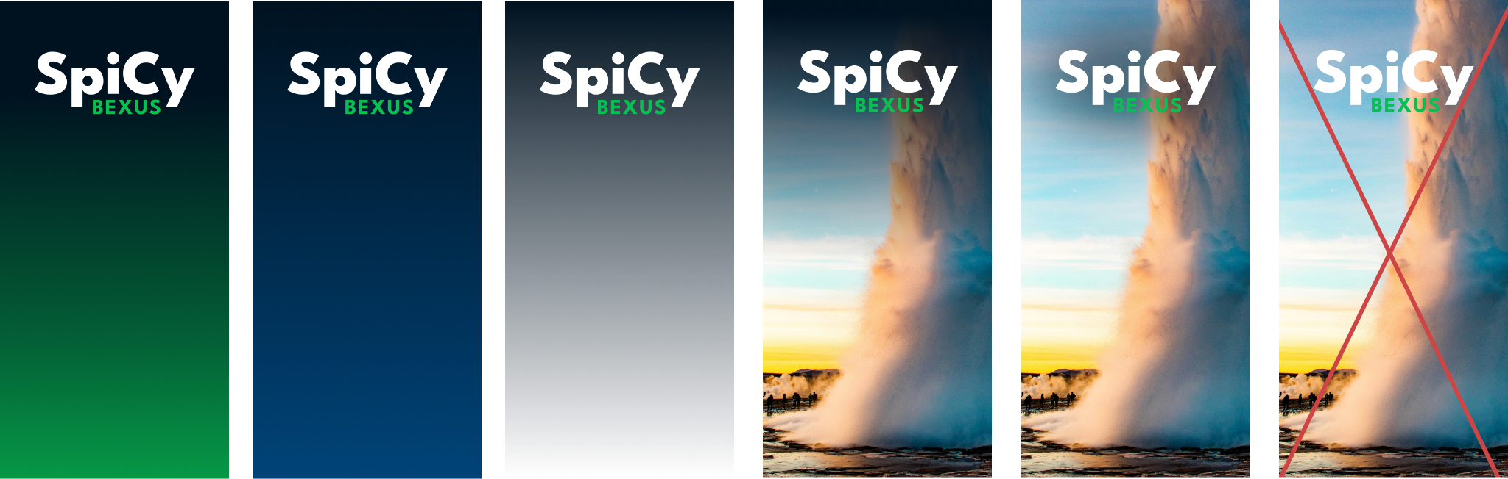

Figure B.2.1-4: Basic SpiCy wordmark logo on gradients and pictures

In case none of the variants shown above provide enough contrast, use a gradient with as mentioned in chapter “B.1.2 Gradients”. If the basic SpiCy wordmark logo is placed on bright pictures always apply a soft luminosity gradient behind the logo or if necessary, combine a very blurred shade together with a blurred ellipse both set to luminosity behind the logo. In case the wordmark logo shall be used on a gradient, the logo must be placed on the darker tone.

**B.2.2 LinkedIn**

LinkedIn is a secondary outreach platform for our team and was ultimately launched in February 2024. Nonetheless, we planned on implementing it at a later stage if we were in need for more sponsorships or for team members to publicly show engagement and provide the possibility of connecting for further business approaches.

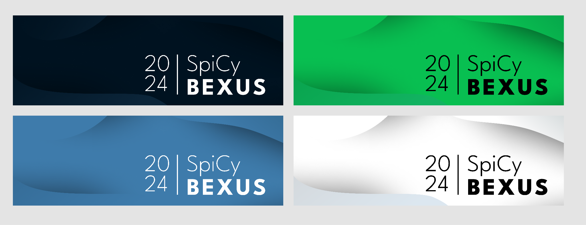

Figure B-2.2-1: Designs for LinkedIn Headers - OUTDATED

Learning: These designs don’t work for different reasons:

* The weight of the Font *League Spartan: ExtraLight* is too low
* The white and the green version are too high in contrast
* If used in a twitter or LinkedIn Header, the text is gratuitous

The old design was therefore reworked and applied to our LinkedIn page that has been launched in February 2024:



Figure B.2.2-2: LinkedIn Page Header

**B.2.3 Instagram**

Together with our Website, Instagram is the main platform of communication for us. Before launching the page, the visual concept was the following:

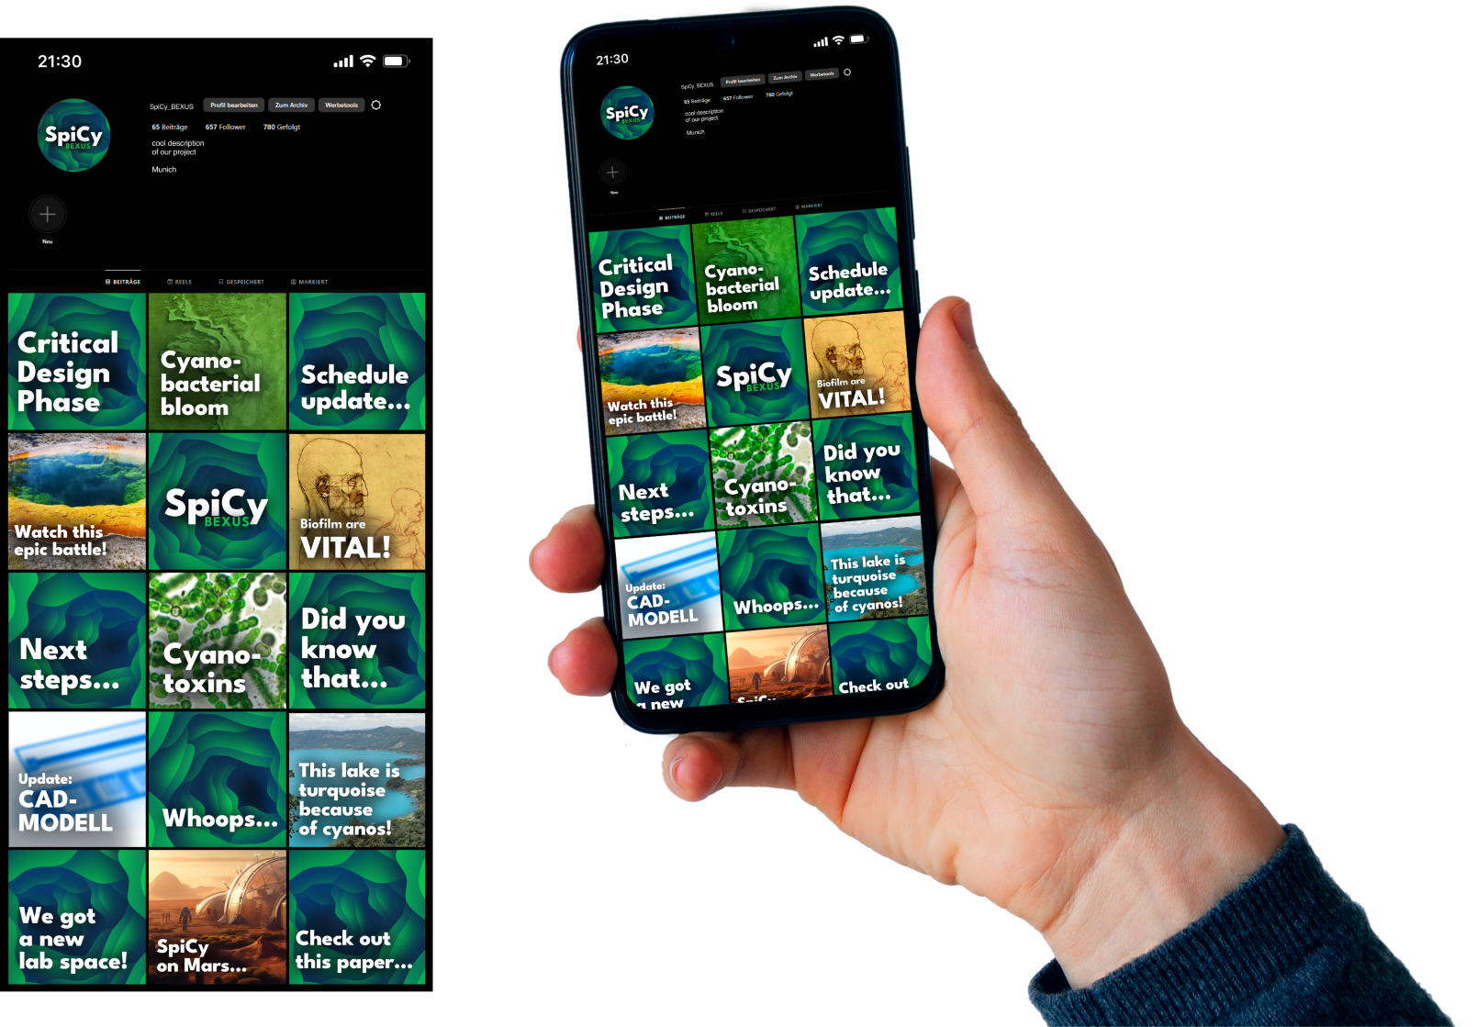

Figure B.2.3-1: SpiCy BEXUS instagram channel - MOCKUP

We started posting on November 27th 2023. For comparison, click [here](https://www.instagram.com/spicy_bexus/) to have a look at our instagram channel.

It is important to us to include as many people as possible and so we pay much attention on using barrier-free tools like alt-texts and screen reader friendly post texts.

SpiCy was given the opportunity to take part in the [LMU-Takeover](https://www.instagram.com/lmu.takeover/), an instagram channel hosted by the LMU that is temporarily open for invited groups. These groups are picked via an interview with the hosts and can then post about their projects and student life for about one week. The following picture shall give a quick overview about our takeover outline. For more details such as descriptions, comments, more pictures, videos and alt-texts, visit the LMU-Takeover or the SpiCy BEXUS channel.

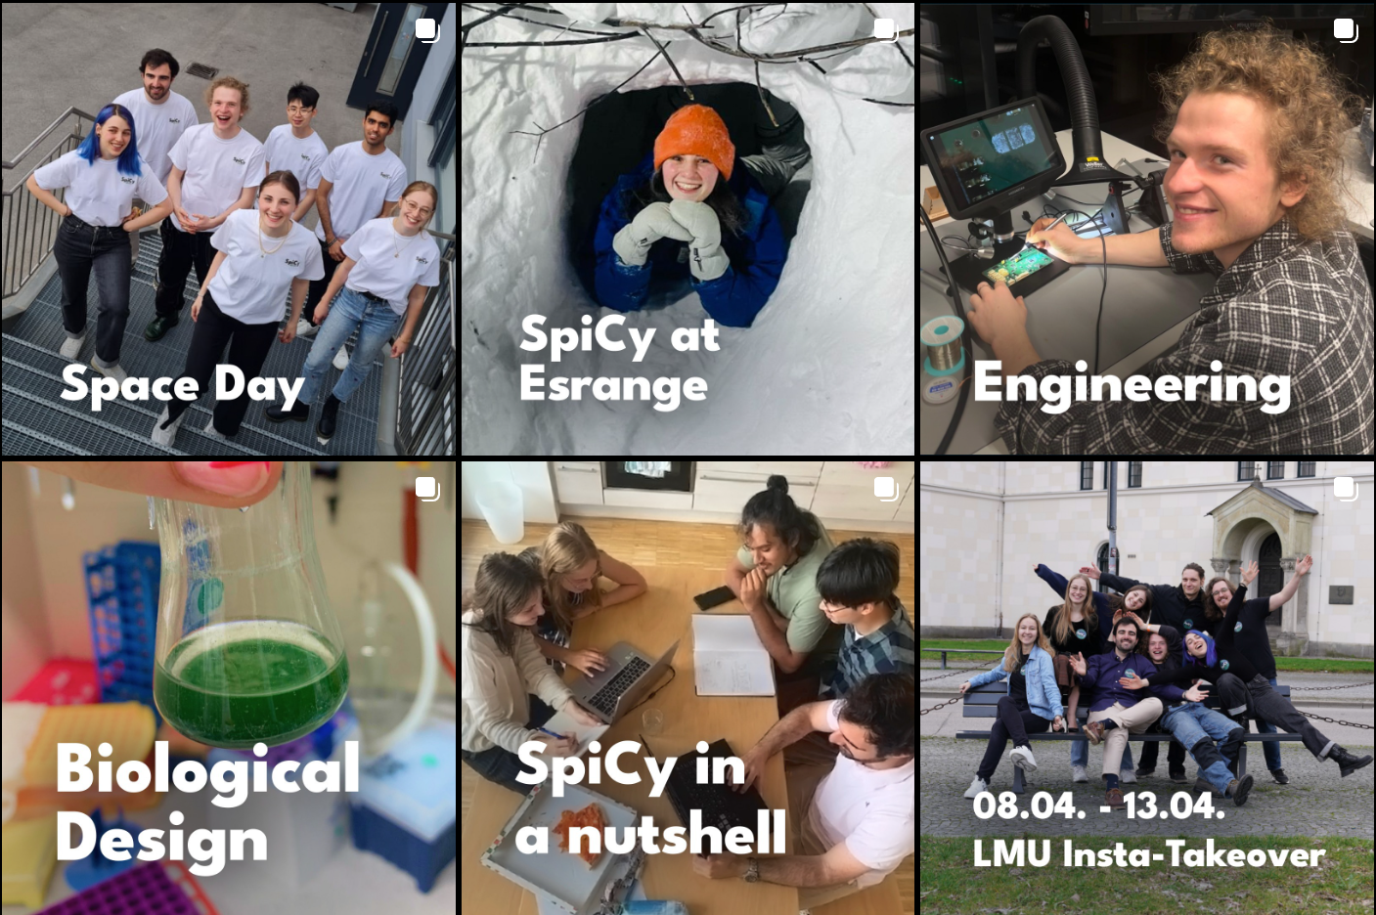

Figure B.2.3-2: SpiCy’s instagram feed after the LMU-Takeover

**B.2.4 Website**

See chapter 3.4 Outreach Approach

Our Website has the purpose of giving deeper insight into our project and providing information for the science community.



Figure B.2.4-1: Favicons for the Website

To combine easy editing for everyone on the team, even non programmers, and keep the advantages of adding self written code on the website we used “wordpress” as a CMS System. Wordpress is a PHP based Website framework that we host under our own domain: [www.spicybexus.de](http://www.spicybexus.de).

The blog entries provide updates, news and technical information about the project.

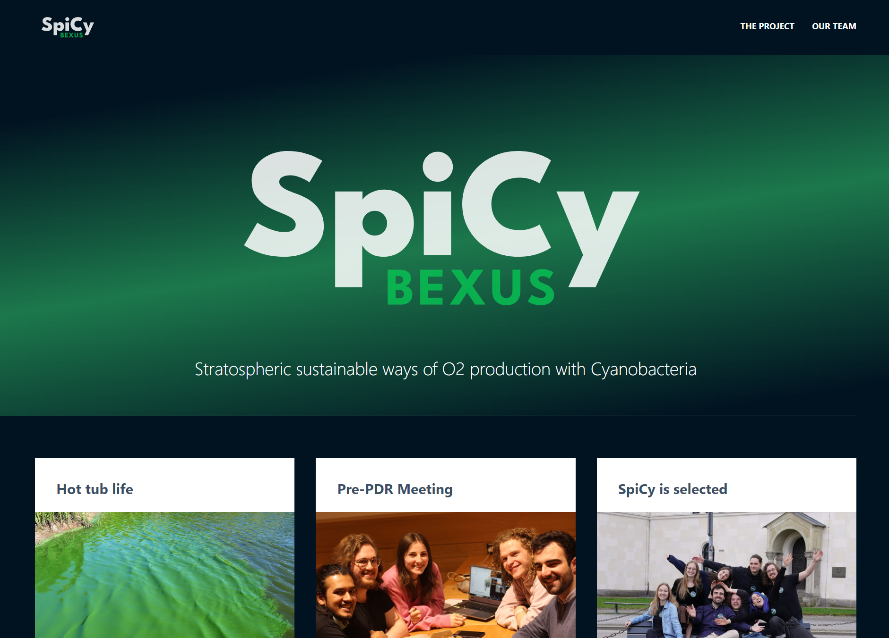

Figure B.2.4-2: SpiCy Website



Figure B.2.4-3: SpiCy Website Footer

Along with the website we also set up E-Mail addresses under our domain. For example: [info@spicybexus.de](mailto:info@spicybexus.de) or [admin@spicybexus.de](mailto:admin@spicybexus.de). The info@spicybexus.de will be used to give one universal Email address to contact our team.

**B.3 Analogue Media**

**B.3.1 Posters**

The posters were made for the TUM Spaceday, to give a brief introduction to our project and designed with a call to action, to follow us on social media.

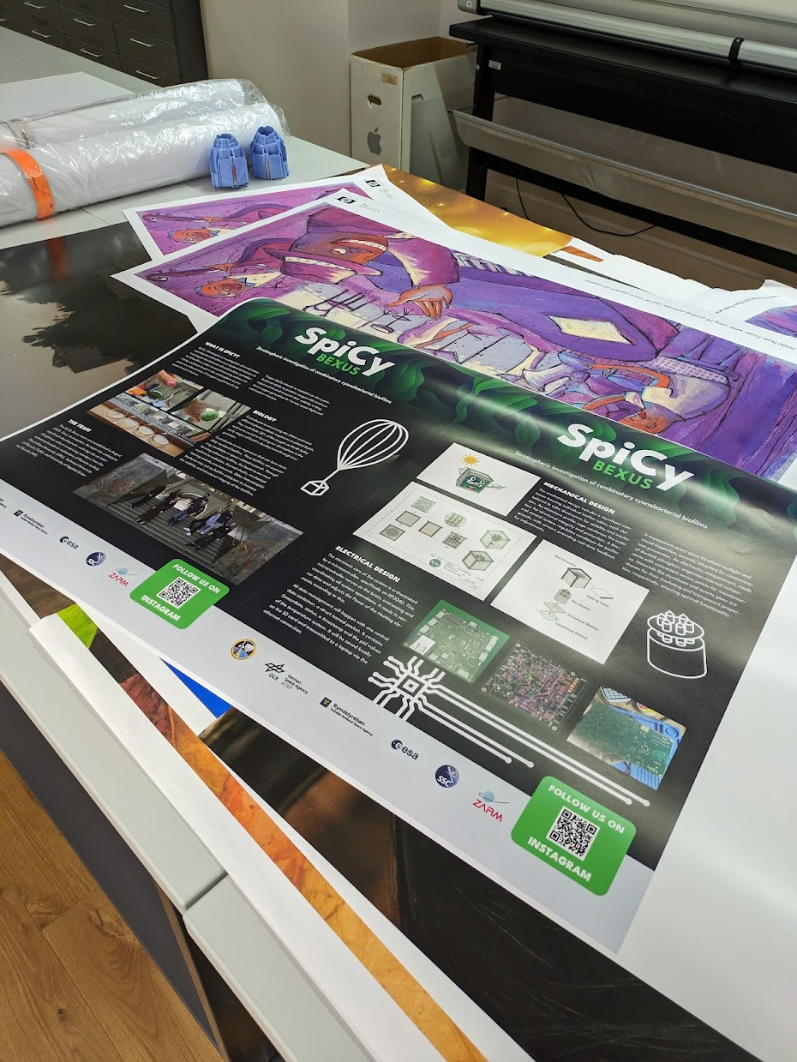

Figure B.3.1: Printed posters before cutting at HM digital printlab

**B.3.2 Stickers**

To [emphasize](https://dict.leo.org/englisch-deutsch/emphasise) associations with the REXUS/BEXUS programme and highlight our contact data, we implemented a new sticker design that approaches the current REXUS/BEXUS logo layout but at the same time implements our brands’ identificational character within this product.  
The following picture shows our current sticker version.  
  
Figure B.3.2: Sticker Layout

**B.3.3 Apparel**

We printed team t-shirts with our logo, some illustrations and a qr-code for our website. We used a digital textile printer due to the fast production and cost efficiency. The t-shirts were worn by our team members at the TUM spaceday.

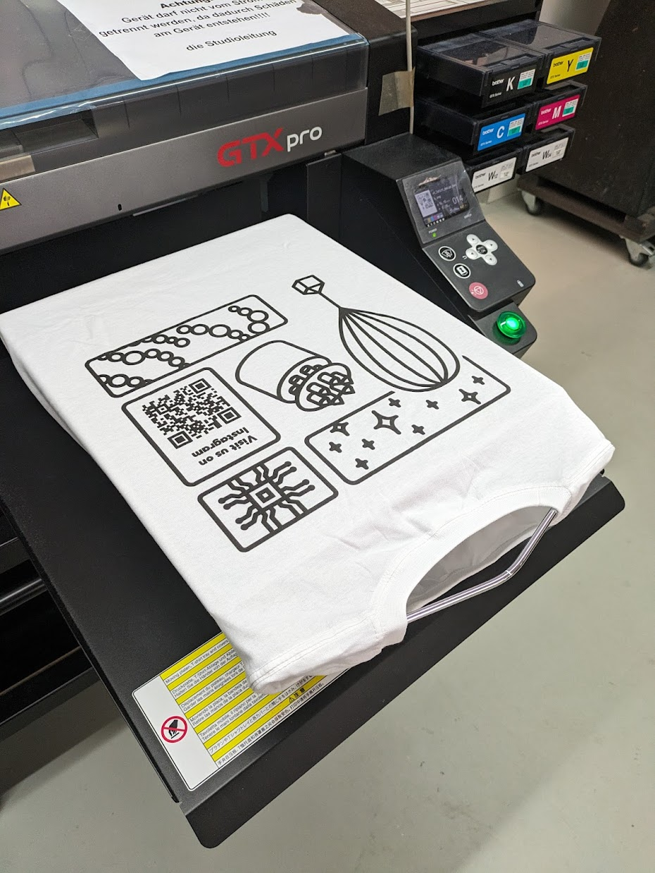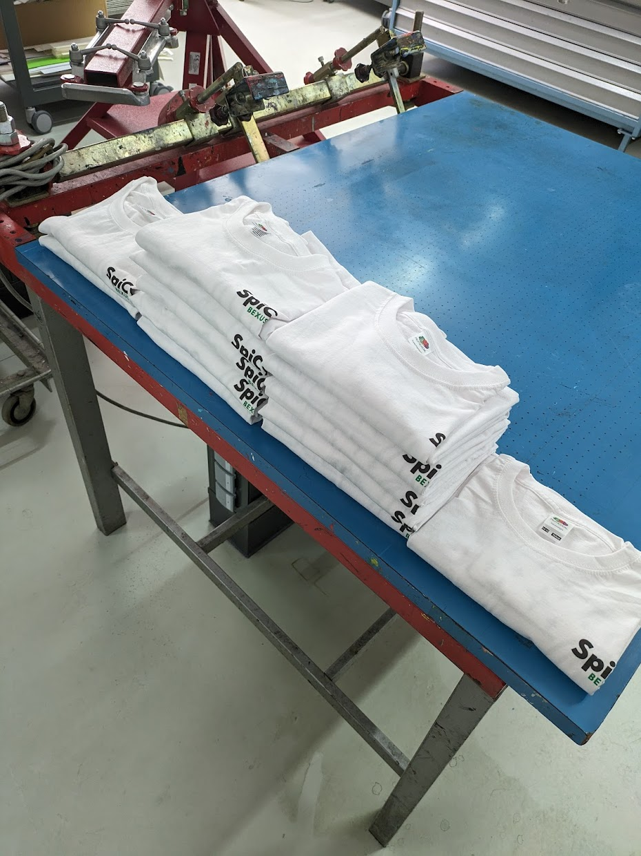

Figure B.3.3: T-Shirts in printing process at HM analoge printlab

**B.4. Special Events**

**B.4.1 Space Day**

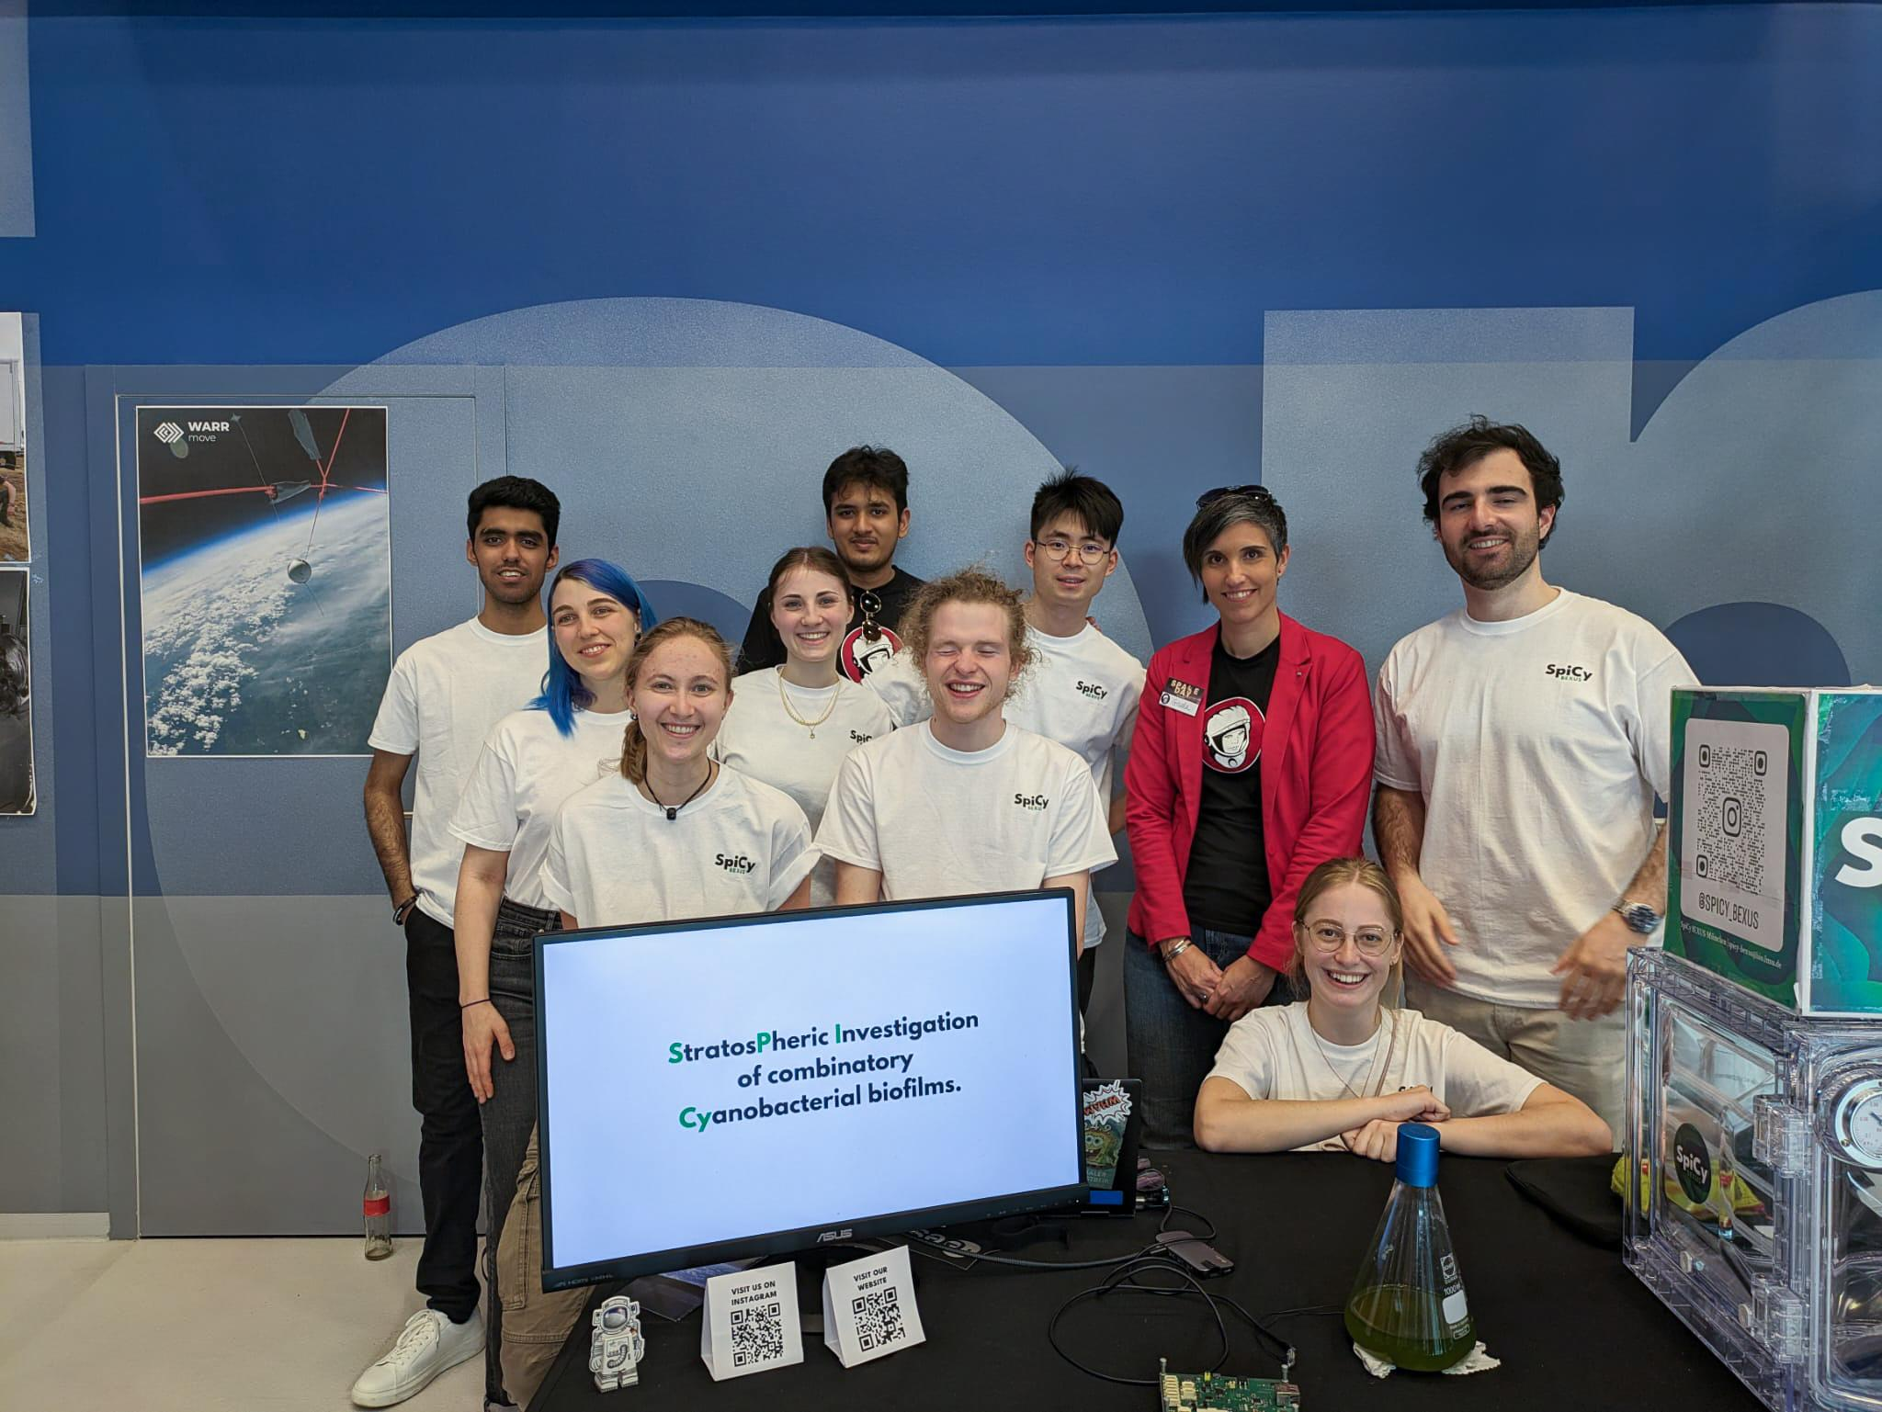

Figure B.4.1: Team SpiCy at the Space Day. In Red: Endorsing professor Dr. Gisela Detrell

**B.4.2 Open Day at LMU’s Bio Faculty**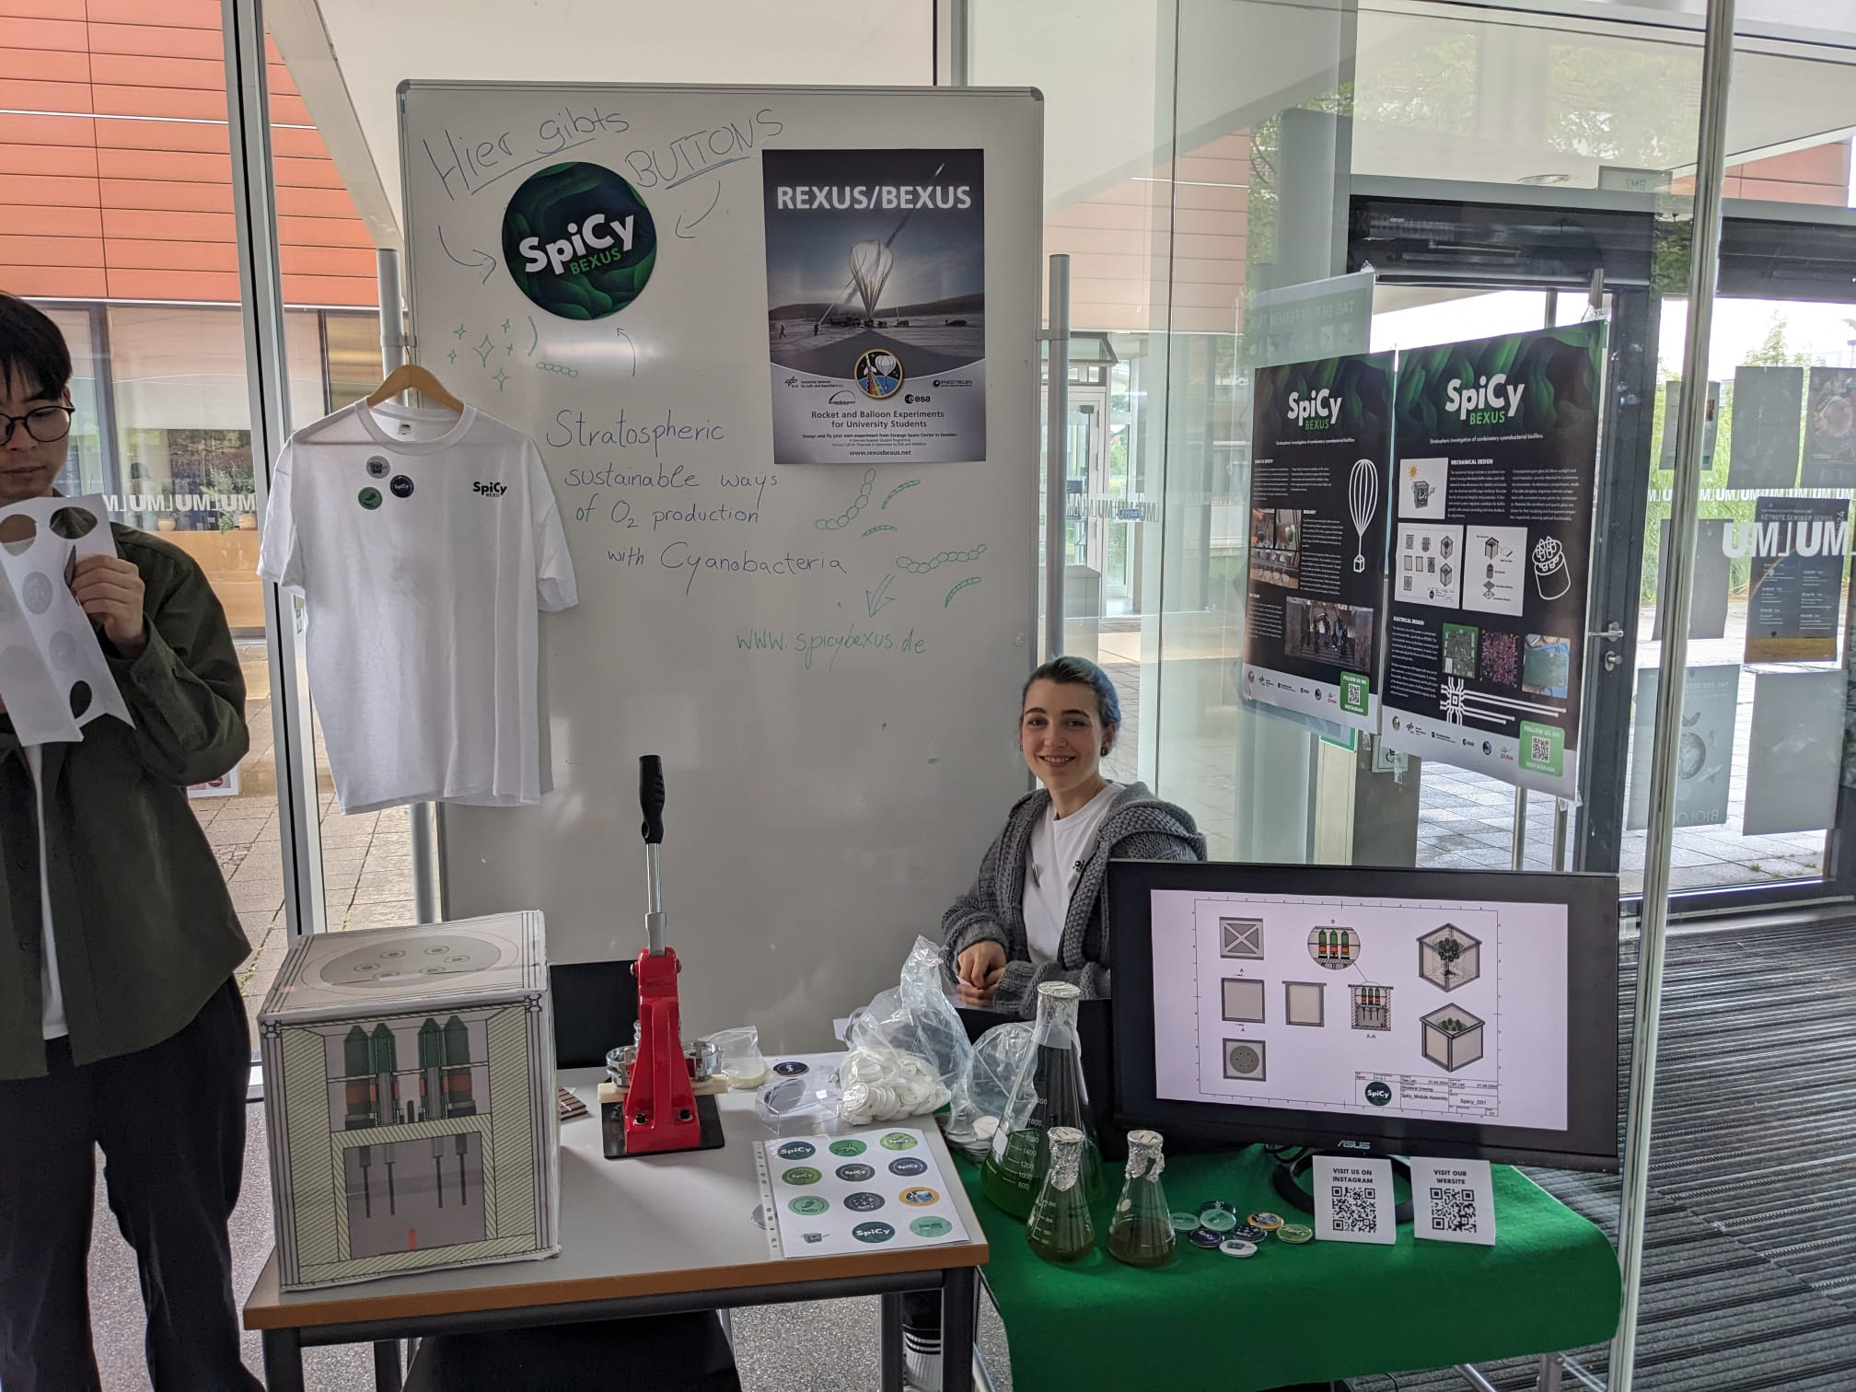

Figure B.4.2: Our booth at the Open Day

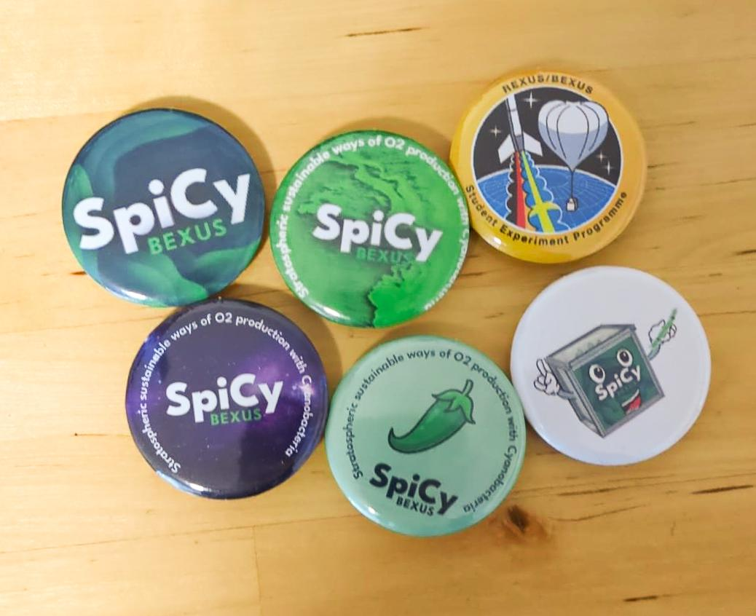

Figure B.4.3: Some of the button motives that we made

## ADDITIONAL TECHNICAL INFORMATION

### Pyrosience FD-OEM Oxygen Sensors

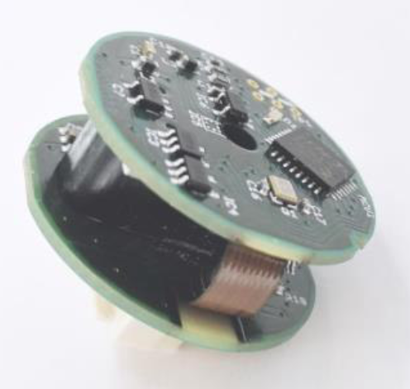

Fig. C-1: FD-OEM sensor

They are basically [this](https://www.pyroscience.com/en/products/all-meters/pico-o2) sensor just in a different packing.

**Biological Laboratory Plan**

May:

* 3rd week of May: Oxygen measurement of Cyanobacteria cultures (C. cubana in BG11 and BG11+, Nostoc sp., Oscillatoria sp., Anabaena cylindrica)
* 4th week of May: Ordering heterotrophic bacteria (P. taiwanesis, E. coli, Bacillus subtilis) and preparation of media (LB, M9)

June:

* 1st week of June: Cultivation of heterotrophic bacteria
* 2nd week of June: Combination of Cyanobacteria with heterotrophic bacteria in different ratios (1:1, 2:1, 4:1)
* 3rd week of June: Oxygen measurement of surviving combinations
* 4th week of June: Selection of top candidates and conducting tests (matrix analysis, photosynthesis rate, ...)

July:

* 1st week of July: Combination of Cyanobacteria with 2 heterotrophic bacteria strains
* 2nd week of July: Oxygen measurement of surviving combinations
* 3rd week of July: Selection of top candidates and conducting tests
* 4th week of July: Oxygen measurement of the top candidate in the module

**Biological Preparation at the LMU lab in Großhadern:**

**Tested bacterial strains:**

Cyanobacteria:

- *Anabaena cylindrica*

- *Oscillatoria sp.*

- *Nostoc sp.*

- *Chroococcidiopsis cubana*

The *Nostoc sp.* was the only strain that formed consistent biofilms with all three heterotrophic bacterial strains, so this species was selected to be the best candidate for the experiment.

Heterotrophic bacteria:

- *Pseudomonas taiwanesis*

- *Escherichia coli*

- *Bacillus subtilis*

All three strains formed biofilms with the *Nostoc sp.* so all three were selected for the experiment.

**Media:**

BG11 Media for *A. cylidrica, Oscillatoria sp. and Nostoc sp.:*

1. **200x-Stocksolutions**: autoclave separately

For 200 ml you need:

· 60 g NaNO3 [3.5 M]

· 1.6 g K2HPO4 x 3 H2O [0.035 M]

· 3 g MgSO4 x 7 H2O [0.06 M]

· 1.4 g CaCl2 x 2 H2O [0.05 M]

· 0.24 g Citric acid + 0.24 g Fe-Citrate

· 1.6 g NaCO3 [0.1 M]

1. **EDTA-Stocksolution:** 100 ml

· 3.72 g EDTA [0.1 M], adjust pH 8.0 with NaOH

1. **Trace elements solution A5+Co:** 100 ml

· H3BO3 286 mg

· MnCl2x4 H2O 181 mg

· ZnSO4 x 7 H2O 22.2 mg

· Na2MoO4 x 2 H2O 39 mg

· CuSO4 x 5 H2O 7.9 mg

· Co(NO3)2 x 6H2O 4.9 mg

1. **HEPES-Stocksolution:**

· 59 g / 250 ml è[1 M] pH 7.5 with NaOH

1. **NaHCO3-Stocksolution:** sterile filter it!

· 21 g /250 ml è[1 M]

1. **For 1 l of Cyanobacteria media you need:**

· 5 ml of every stocksolution

· 30 µl EDTA stock solution

· 10 ml HEPES

-> autoclave everything together

-> then add:

· 5 ml NaHCO3

· 1 ml Trace elements solution

BG11+ Media for *C. cubana*:

|  | | [g/L] | [mg/200mL]  [mL/200mL] | [ml/L] |  |
| --- | --- | --- | --- | --- | --- |
| **Trace metal  Mix** | H3BO3 | 2.9 | 580 | <- |  |
| MnCl2 *4H2O | 1.81 | 362 | <- |  |
| ZnSO4 *7H2O | 0.22 | 44 | <- |  |
| Na2MoO4 *2H2O | 0.39 | 78 | <- |  |
| CuSO4 *5H2O | -> | 2 mL | 10 ml | 0.8g/100ml Stock Sol. |
| Co(NO3)2 *6H2O | -> | 2 mL | 10 ml | 0.5g/100ml Stock Sol. |

| Minerals | Volume  [mL/L] | Stock Solutions  [g/L] | Stock Solution  [g/200mL] |  |
| --- | --- | --- | --- | --- |
| NaNO3 | 5.0 | 300 | 60 | Autoclave |
| MgSO4 *7H2O | 10 | 7.5 | 1,5 | Autoclave |
| CaCl2 *2H2O | 10 | 3.6 | 720 mg | Autoclave |
| Na3‐citrate *2H2O | 10 | 0.6 | 120 mg | Autoclave |
| Na2‐EDTA *2H2O | 10 | 0.1 | 20 mg | Sterile filtrate |
| K2HPO4 *3H2O | 2.0 | 20 | 4 | Autoclave |
| Na2CO3 | 2.0 | 10 | 2 | Autoclave |
| Fe‐NH4‐citrate | 2.0 | 3.0 | 600 mg | Autoclave |
| Trace metal mix | 1.0 | - |  | Sterile filtrate |

| Adjust to 1000mL with mQ water and autoclave. | | |  |
| --- | --- | --- | --- |
|  |  |  |  |
|  |  |  |  |
| After cooling, add the following filter components | | |  |
| Minerals | Volume  [mL/L] | Stock Solutions  [g/L] | Stock Solution  [mg/200mL] |
| Vitamin B12 | 1.0 | 0.02 | 4 |

M9 Minimalmedia for heterotrophic bacteria:

M9 Salts: for 500mL -> autoclave

- 30g Na2HPO4 x 2 H2O

- 15g KH2PO4

- 2.5g NaCl

Trace Elements: for 200mL

- 1g EDTA(Na)

- Dissolve in water

- pH 7.5

- 166mg FeCl3 x 6 H2O

- 16.8mg ZnCl2

- 2.6mg CuCl2 x 2 H2O

- 2mg CoCl2 x 2 H2O

- 2mg H3Bo3

- 0.32mg MnCl2 x 4 H2O

- Fill up to 200mL with water

- Sterile filtrate

Stock Solutions: for 200mL each

- 54.1g MgSO4 x H2O -> autoclave

- 5.9g CaCl2 x 2 H2O -> autoclave

- 67.5g Thiamine-HCl -> sterile filtrate, store in fridge

- 100g NH4Cl -> autoclave

- 1M Carbon source -> autoclave

M9 Media: for 500mL

- 50mL M9 Salts

- 500µL MgSO4 x H2O

- 1mL Thiamine-HCl

- 5mL NH4Cl

- 5mL Trace Elements

- 10mL Carbon Source

- 500µL CaCl2 x 2 H2O

- CaCl2 x 2 H2O has to be put in last

LB Media for *E. coli* and *B. subtilis*:

for 500mL:

5g Tryptone

2.5g Yeast extract

5g NaCl

-> pH 7

-> autoclave

Nutrient Broth for *P. taiwanesis*:

For 500mL:

4g Nutrient Broth (Roth)

-> pH 6.8

-> autoclave

**Methods:**

The cyanobacteria were first cultivated in their respective media in April 2024. In June 2024 we decided that the cyanobacteria cultures had a high enough biomass to start a cultivation with the heterotrophic bacteria.

Here we first measured the Chlorophyll a of the cyanobacteria with a photometer. 1mL of each culture was pelleted and resuspended in ice cold methanol. This was then incubated in the fridge for 1h. The solution was centrifuged, and the absorbance of the supernatant was measured at 665nm and 720nm. With these readings the amount of Chlorophyll a was calculated: 14.4892 * (A665 – A720) = Chl a [µM] (Bozan et. al. 2022).

Then the OD600 of the heterotrophic bacteria was measured. The bacteria had been cultivated for 24h in their normal media at their optimal growing temperatures:

*E. coli*: 37°C in LB Media

*P. taiwanesis*: 30°C in Nutrient Broth

*B. subtilis*: 30°C in LB Media

Then 1mL of culture was transferred into M9 Minimalmedia. Where they were cultivated for 48h at optimal growing temperatures.

To cultivate the combinatory biofilms 16µM of Cyanobacteria culture and an OD of 1.5 for the heterotrophic bacteria were used for each approach.

In July 2024 the *Nostoc sp.* was the only strain that formed stable biofilms with each of the heterotrophic bacteria. So, it was decided to send the *Nostoc sp.* with each one of the heterotrophic bacteria on the module. The final biofilms in the glass tubes were cultivated in August 2024. They did however not attach to the bottom of the tubes as we were hoping because the glass was to smooth. A short oxygen measurement was done in September 2024 to confirm that the system works.

**Material Safety Data Sheets (MSDS)**

**Biological Samples**

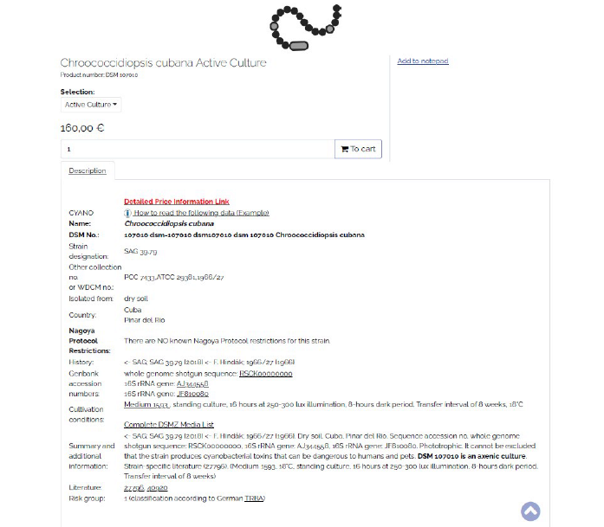

Fig. C-2: MSDS of Chroococcidiopsis cubana

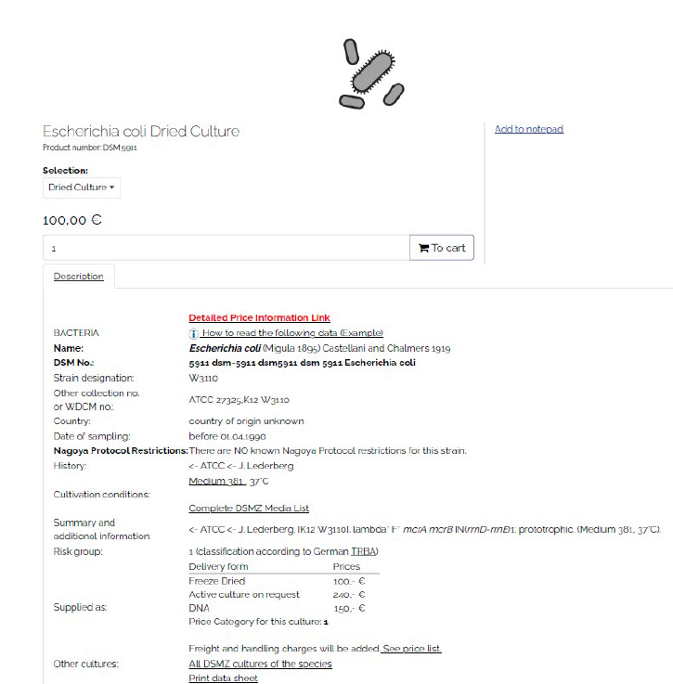

Fig. C-3: Fig. C-3: MSDS of Escherichia coli (Migula 1895) Castellani and Chalmers 1919

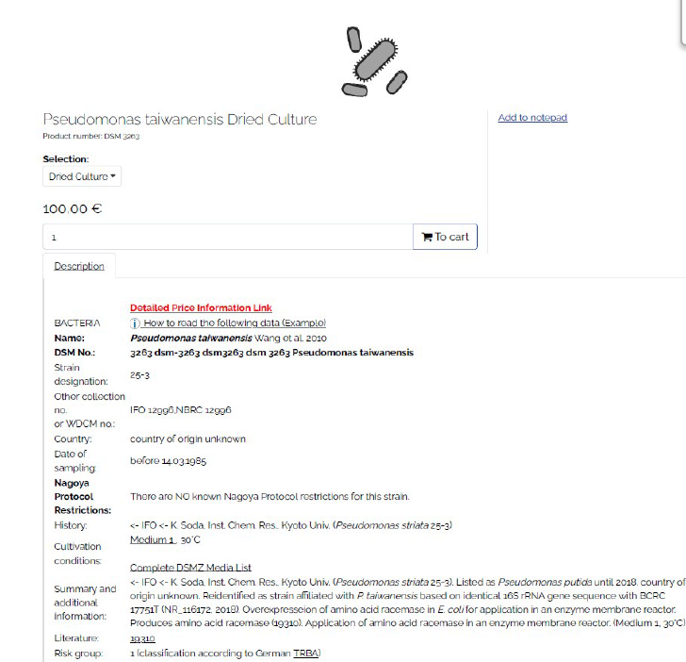

Fig. C-4: MSDS of Pseudomonas taiwanensis Wang et al. 2010

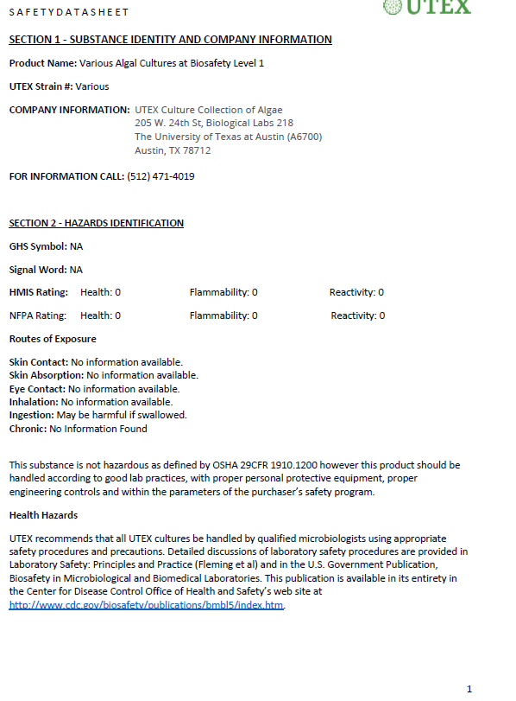

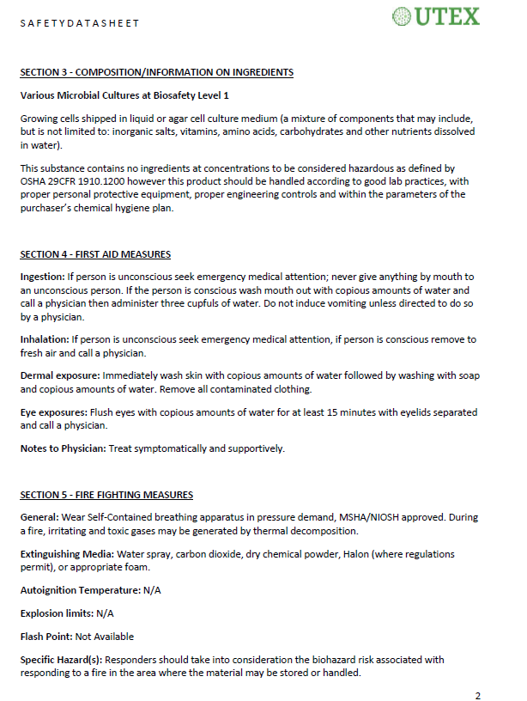



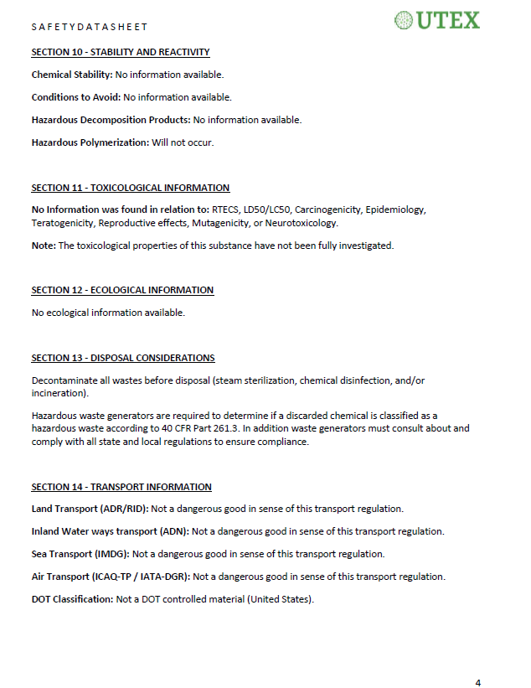

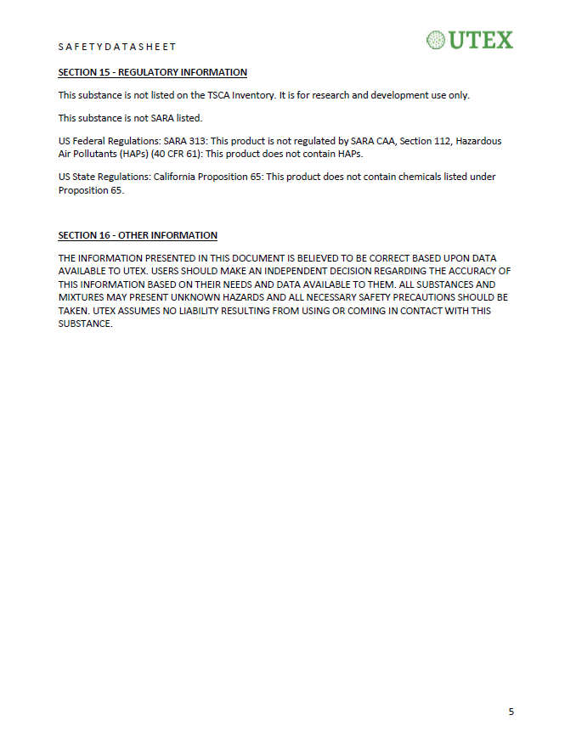

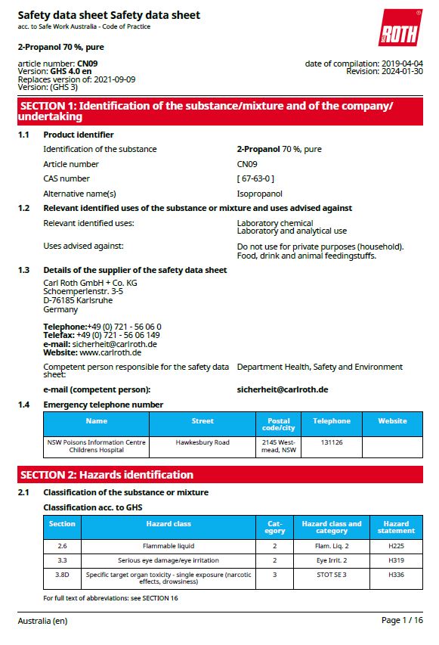

**b) MSDS Chemicals**

**Isopropanol 70%**

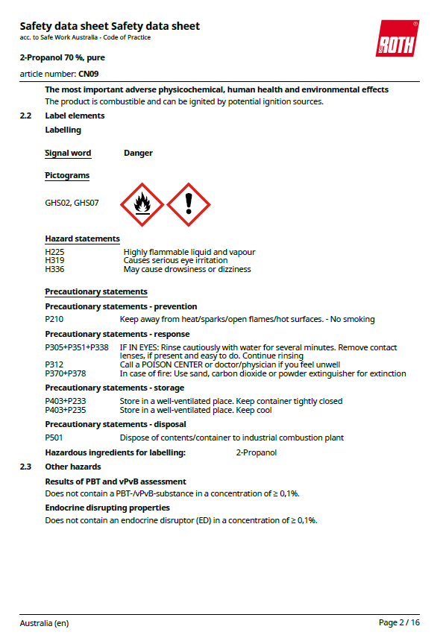

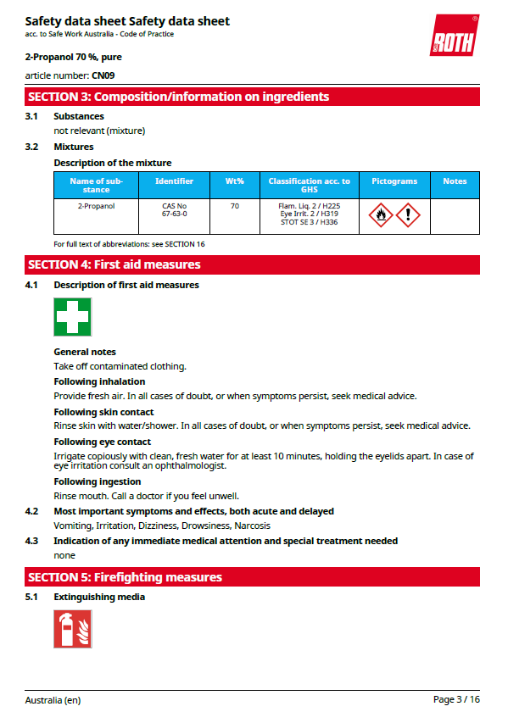

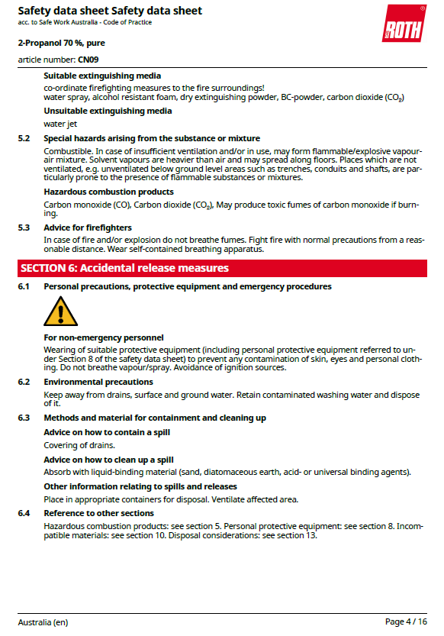

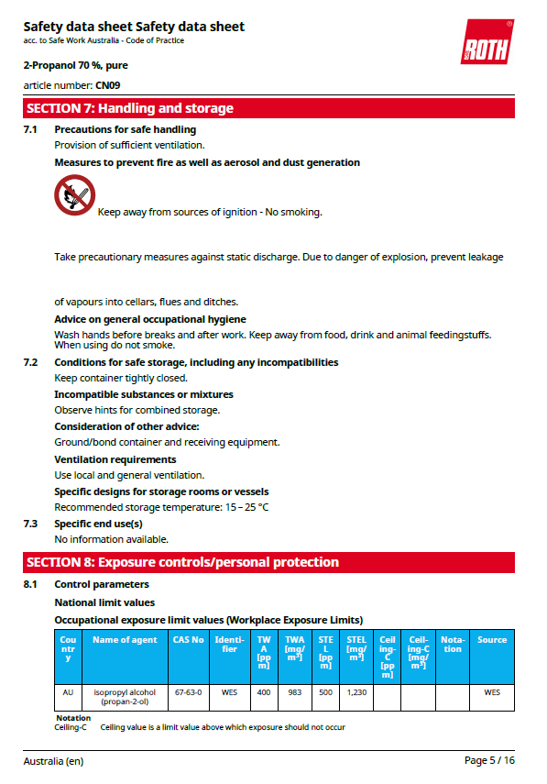

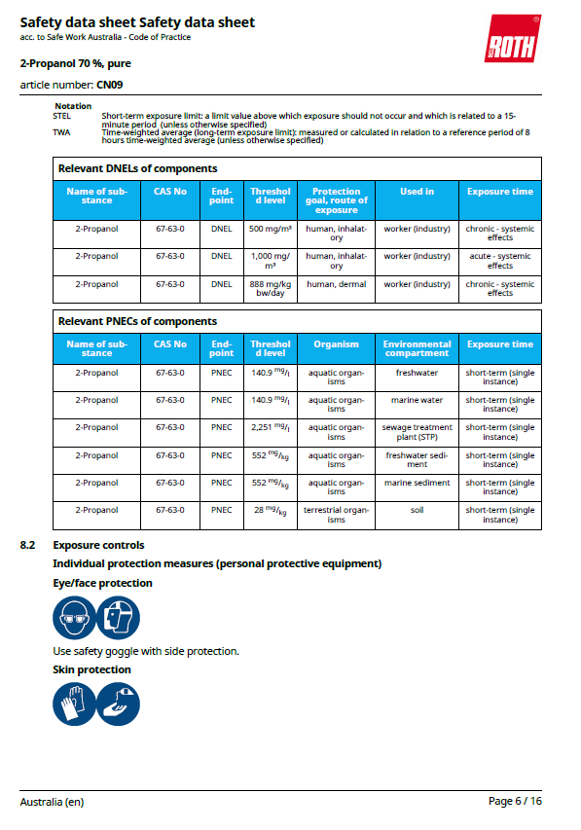

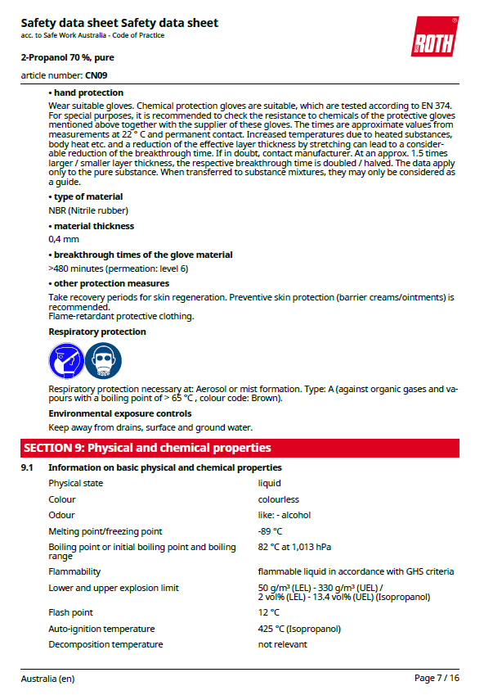

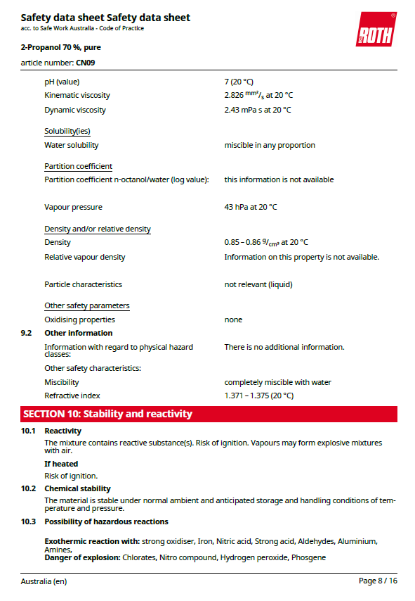

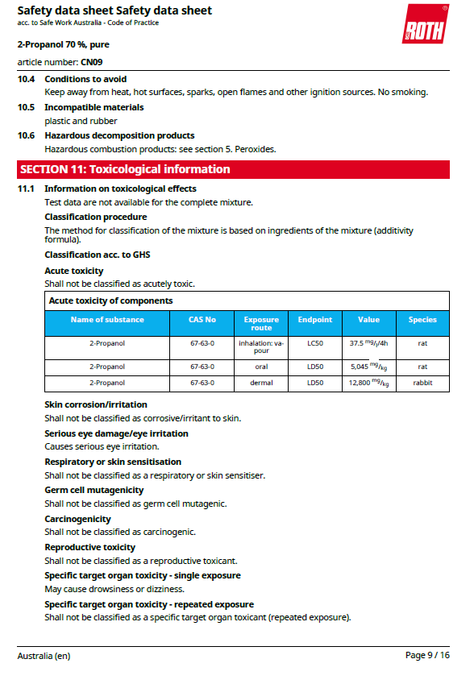

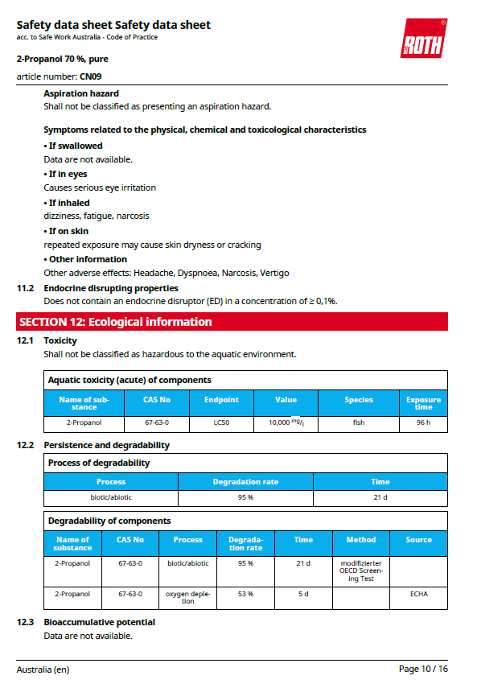

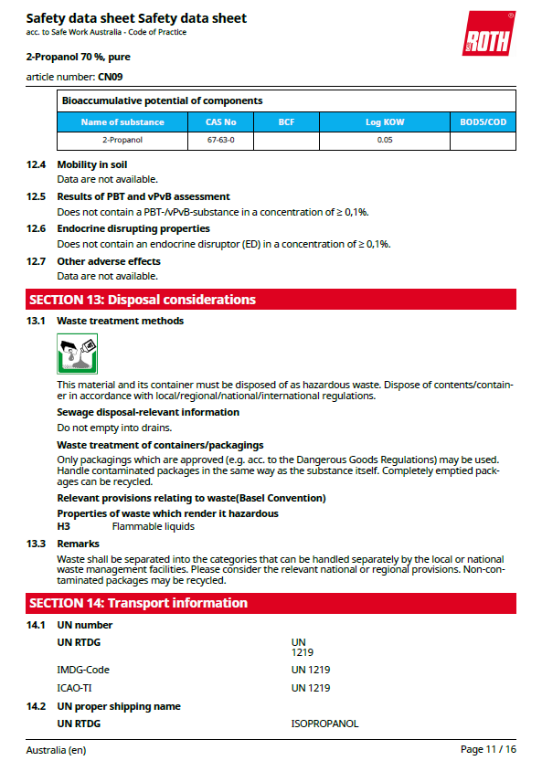

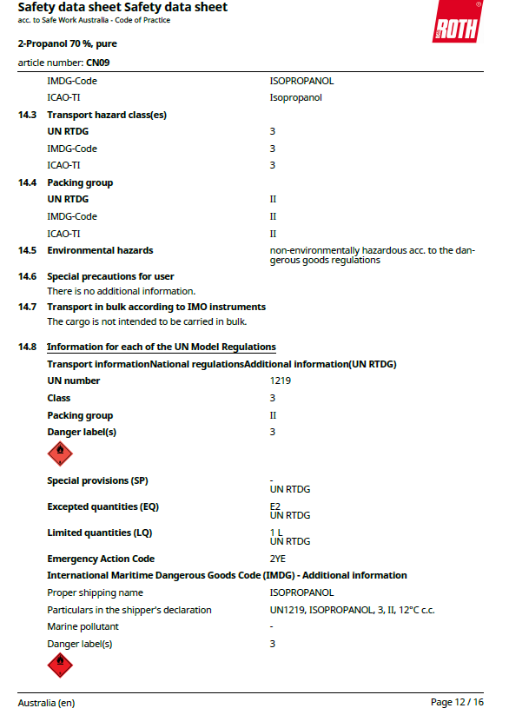

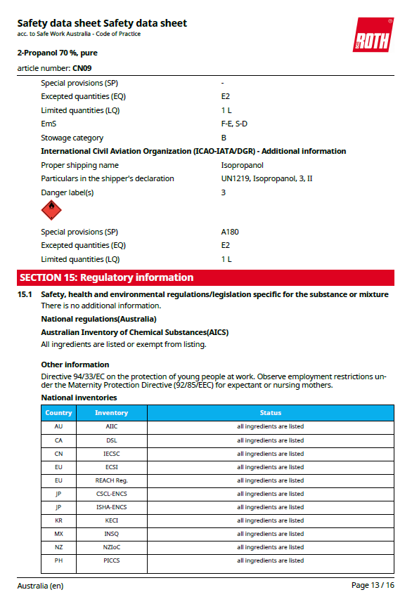

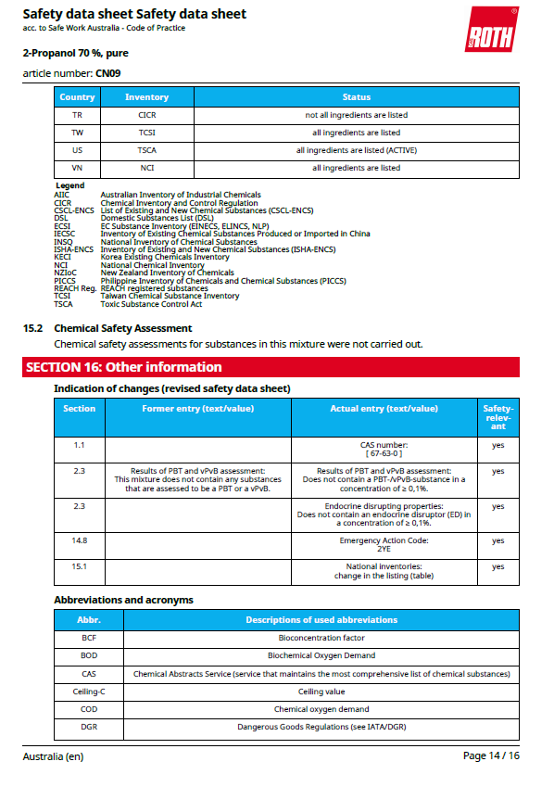

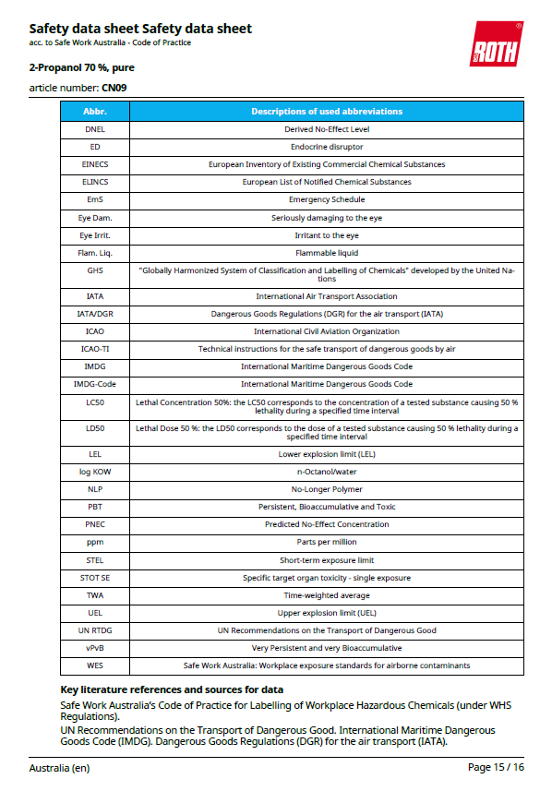

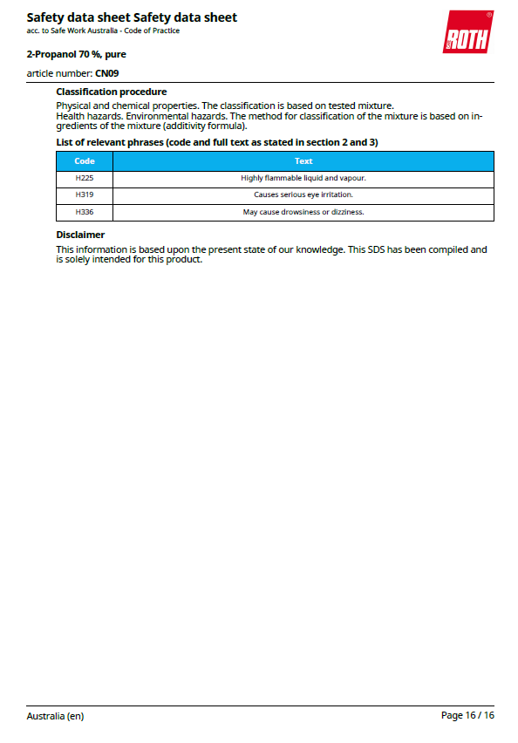

**Bacterial Medium M9**

* **Protocol:**

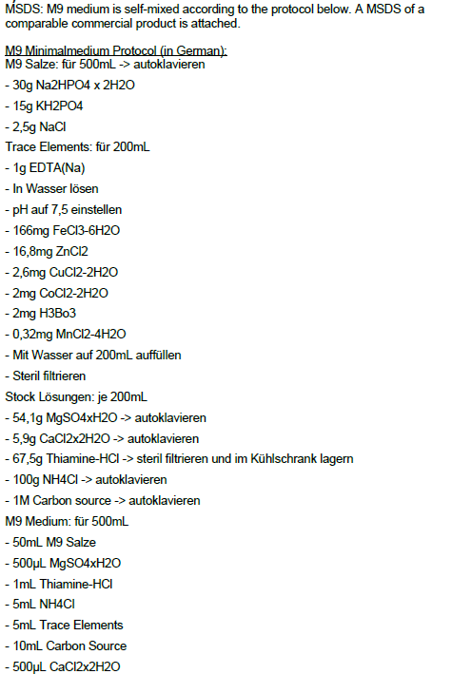

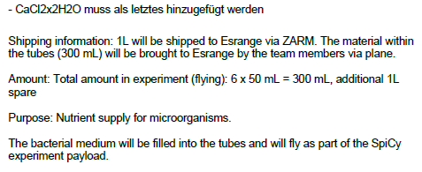

**MSDS Data Sheet of M9:**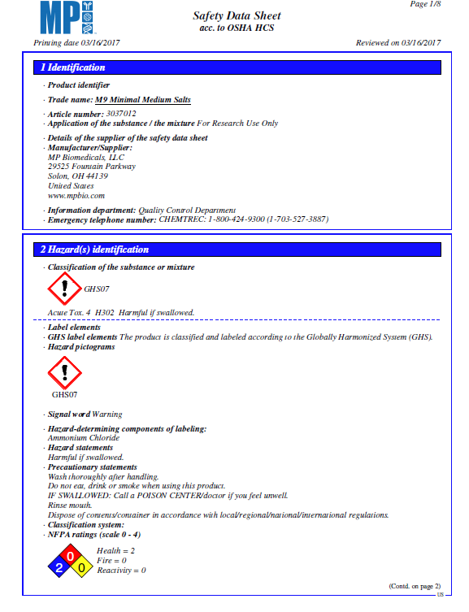

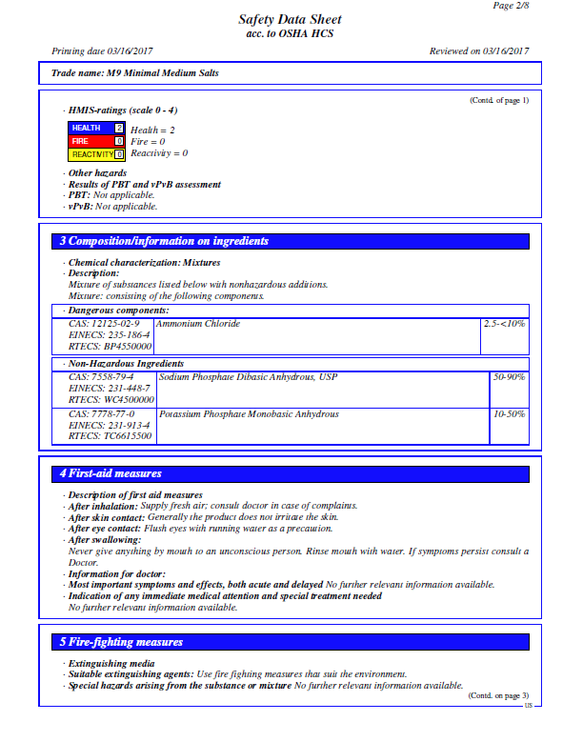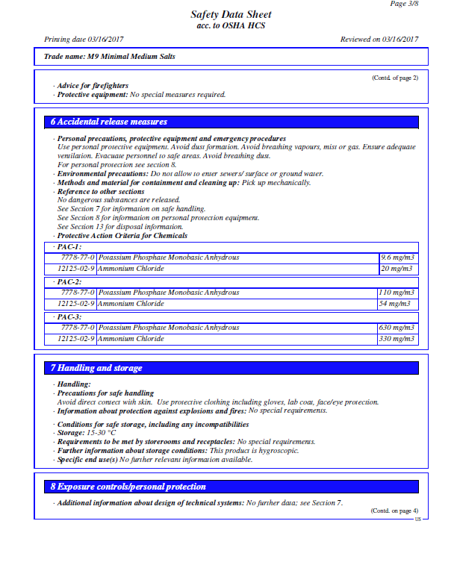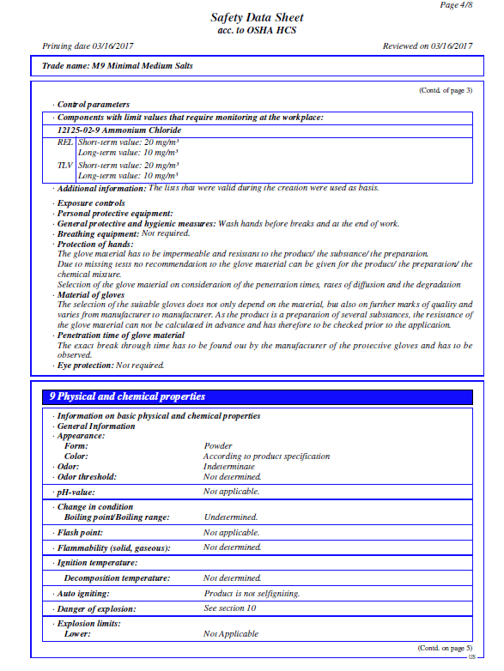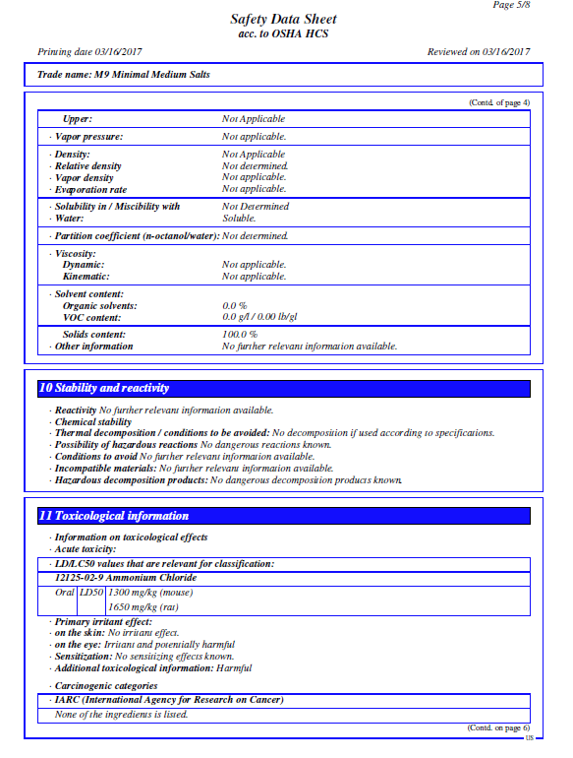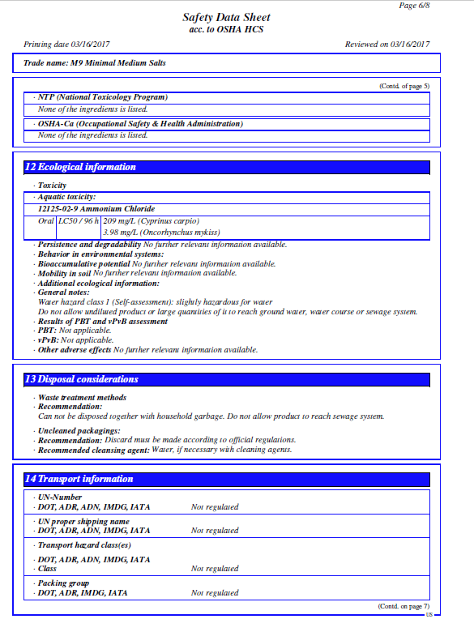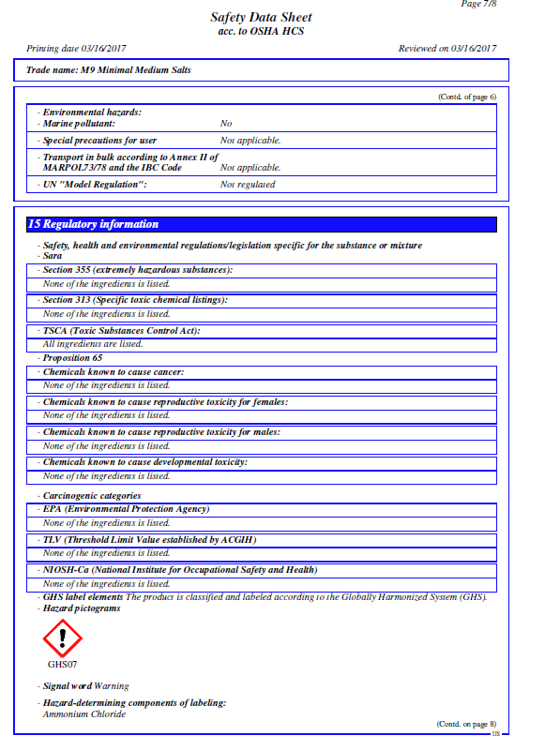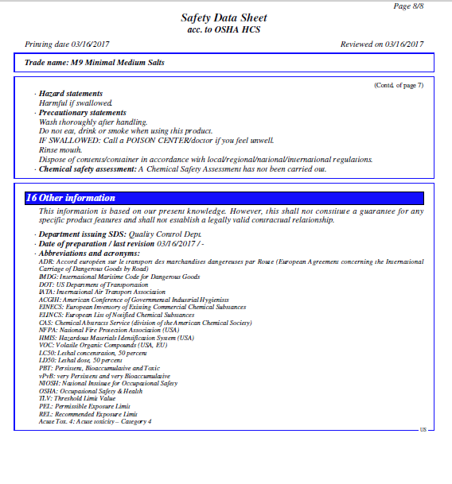

**Extended Gantt Chart**

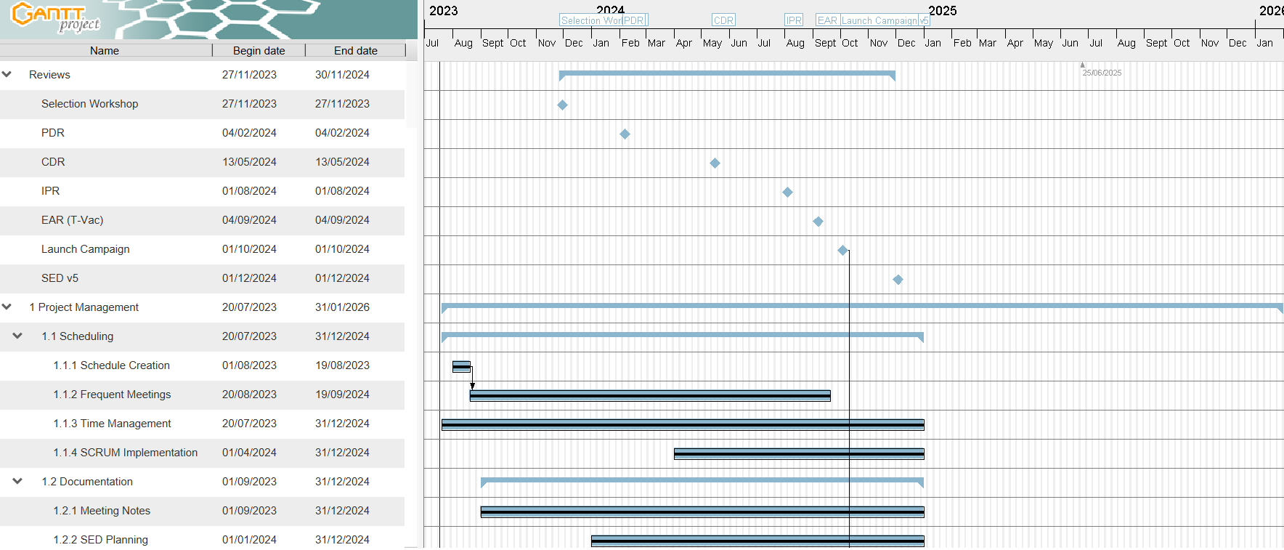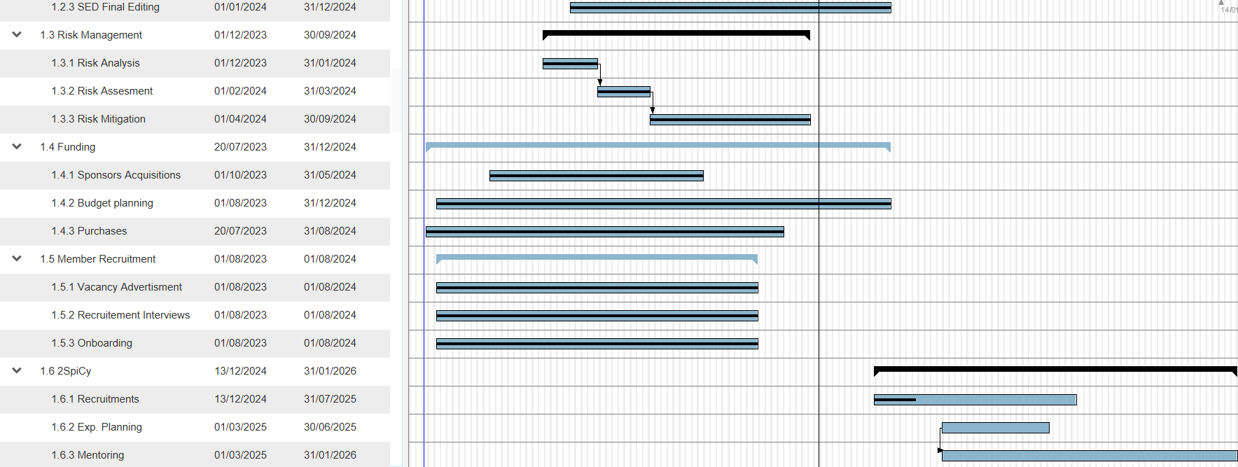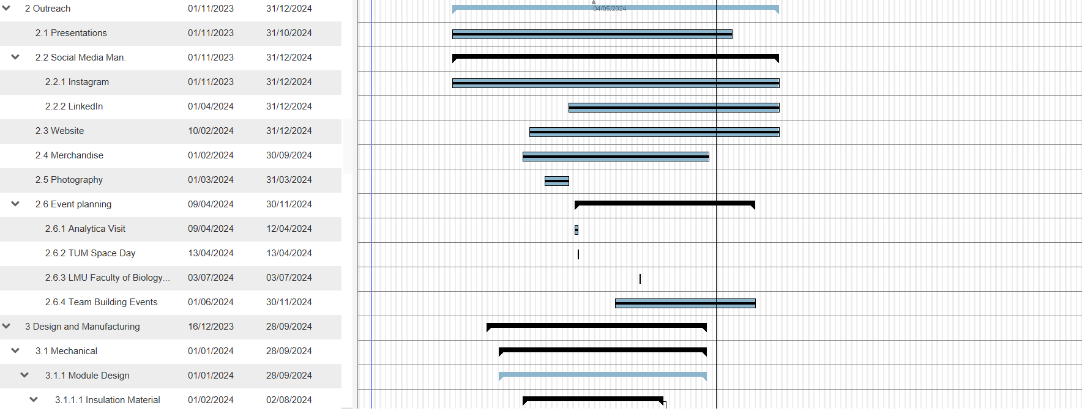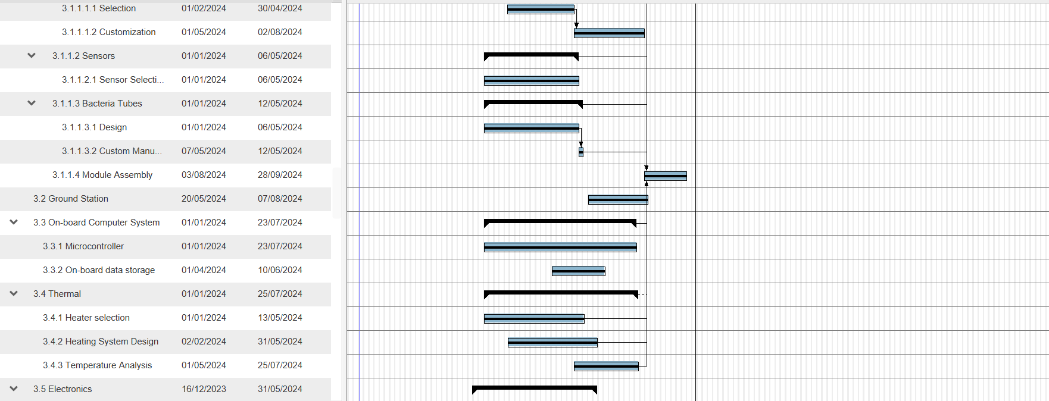

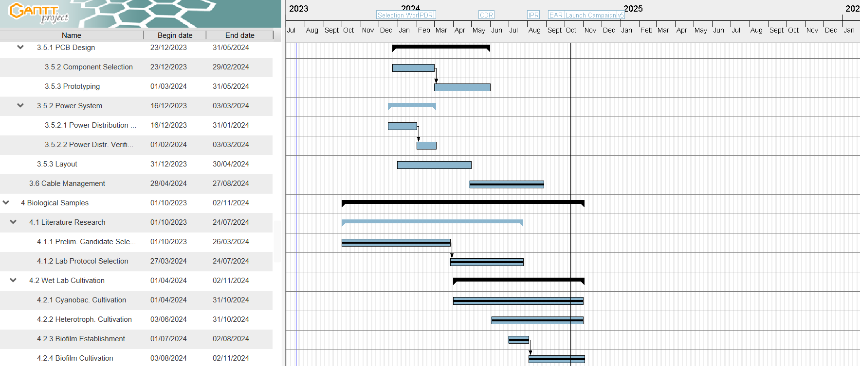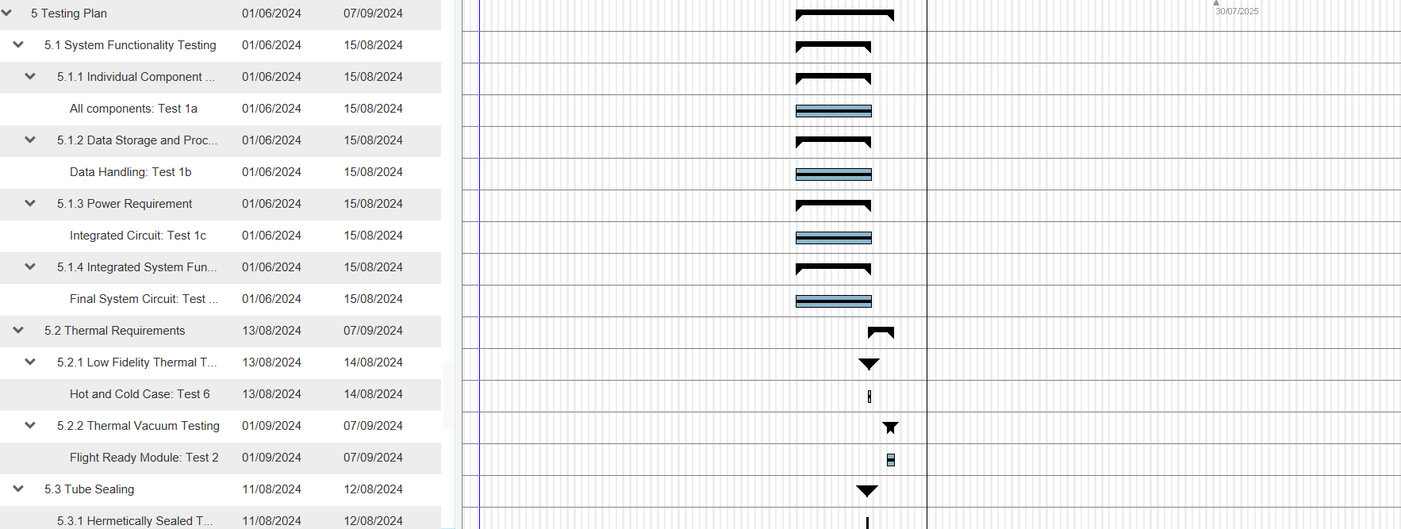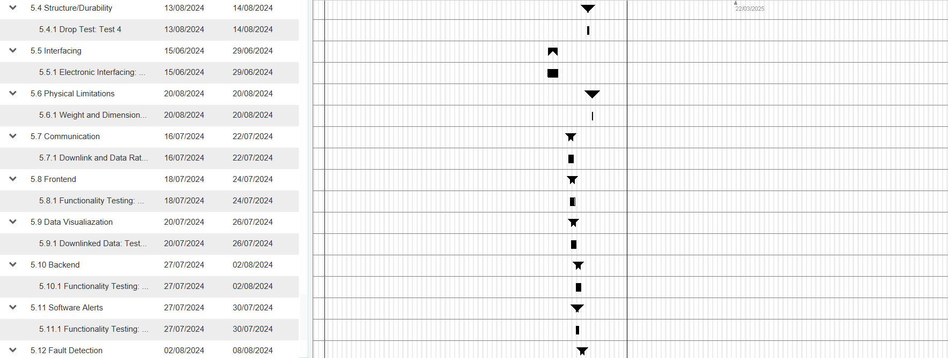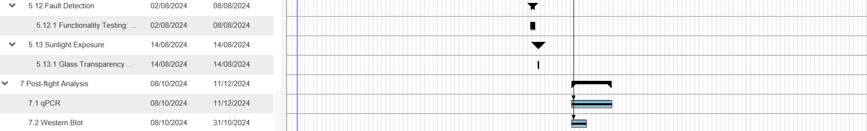

## CHECKLISTS

## Check electronics

1. Check if every plug is occupied except heater 6 and 7 as well as USB
2. Check if battery voltage is ok
3. Check if Vsys is 5V and Vheat is 7.75V
4. Check if sd_card is connected and working
5. Check if tcp_server is connected and working
6. Check perifals with /d in the debug console
7. Send test packet to benchmark connection strength and integrity
8. Check if the OTA firmware update is working correctly. Reflash with usb after.

## 

## Assembly of the SpiCy Module

### Probe Module

1. 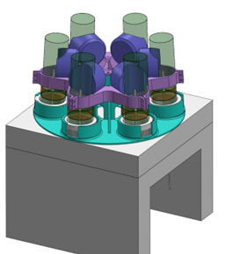Insert micro SD Card & tests if it works
2. Insert of the Tubes in the lower rack holder. It is glued to the foam already
3. Put cables of the heater and thermistors through the center hole
4. Insert upper part of the holder
5. Tighten the screw clamps for the probes (here pink)
6. Connect and put the wires of oxygen sensor through the center hole
7. Install mainboard and connect all cables

* battery cable which is already connected to foam plug
* ethernet
* NTC x6
* Heater x6
* Oxygen Sensors x6 (green for Oxy0 | red for Oxy 1-5)
* light sensors x2

### 

### Bottom Module

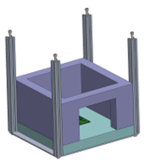

1. Insert Probe Module in Bottom Module

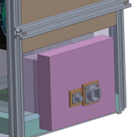

1. Connect Ethernet cable and insert plug
2. Fix plug on the wall with metal stripes

### Top Module

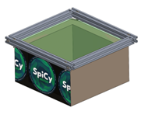

1. The top part just needs to be mounted on the lower part and fixed with 4 screws on the corner in the alum profiles.

## 

## 

## 

## 

## 

## Assembly of the SpiCy Bio-Tube

1. **Preparation of Components:**

Ensure all components are clean and free of dust, debris, or oil. Move all components to a sterile workbench. Clean the glass tube, 3D-printed plug, nuts, O-rings, cap, and any additional components with isopropyl alcohol.

Inspect the 3D-printed plug for any defects (e.g., cracks or uneven surfaces) that could affect water-tightness. Check the rubber O-rings for any damage or deformation.

1. **Install O-Rings:**

Slide the rubber O-rings onto the nuts of the 3D-printed plug. Ensure they are seated evenly and securely within the designated grooves to create a robust sealing interface.

1. **Insert the Plug into the Glass Tube while it is immersed in the Culture Medium.:**

Immerse the tube entirely under the culture medium. This is to avoid the air-bubbles that could be trapped in the medium. Carefully align the 3D-printed plug with the opening of the glass tube. Slowly push the plug into the tube, ensuring it remains centered and does not tilt. The O-rings should compress slightly against the inner wall of the tube, forming a tight seal.

1. **Secure the Plug with the Cap:**

Tighten the cap gradually. Avoid over-tightening, which could damage the plug or compromise the O-ring seals. Hand-tighten until you feel resistance, then use a wrench or pliers for an additional quarter-turn if necessary.

1. **Leak Test:**

Before operational use, conduct a leak test to ensure the assembly is watertight. Move the filled tubes and monitor for any signs of leakage around the O-rings, plug, or silicone-filled cable hole.

1. **Final Check:**

Verify that all components are securely assembled and no part is loose. Inspect the tubes and ensure the cables are fixed firmly.

1. **Operational Setup:**

Connect the tube assembly to the required system. Confirm proper alignment and ensure that the glass tube is not subjected to undue mechanical stress. Test the UV sensor, temperature sensor, oxygen sensor and other onboard sensors to ensure it is functional and properly calibrated within the assembly.